ETA Example: Curtailment with a Handwritten Check

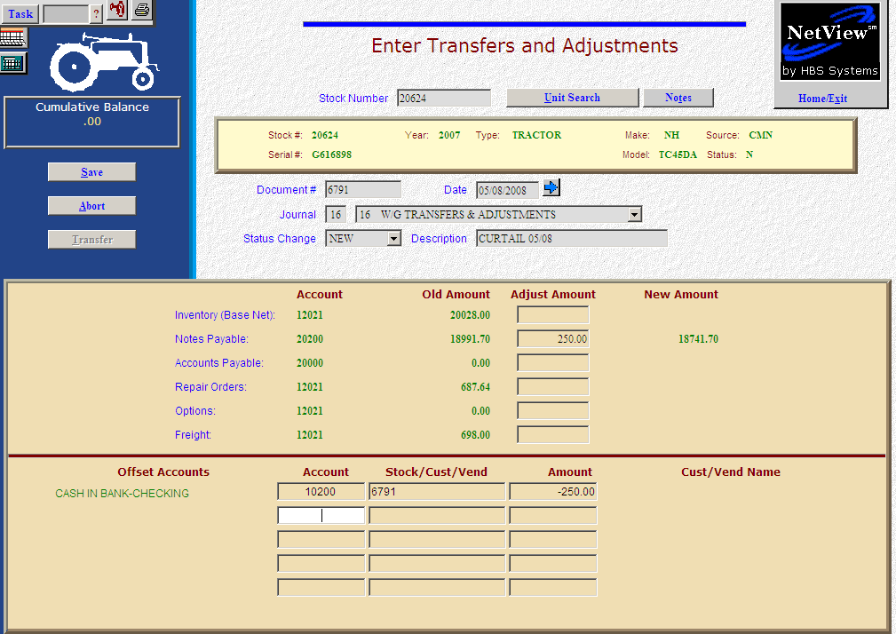

Here’s the scenario. You need to make a curtailment on a note. In this case, you have already written the check by hand or you will do so shortly.

- Fill in the Stock #.
- Put the check number in the Document # field.
- Put the check date in the Date field, provided it is within the open accounting periods on your system. Otherwise, use the first day of the oldest month open.
- Put in a good Entry Description that mentions you are making a curtailment, and the month and year.
- Leave the Status field as it is.
- On the Notes Payable line, fill in the curtailment amount. Enter a negative number as you are SUBTRACTING value. The system will convert the “subtraction” as a debit to the notes payable account.
- Enter through the remaining fields until you reach the Offset Accounts section. Fill in the account number of your checking account (10200 in our example).
- Fill in the check number in the Stock/Cust/Vend field.
- Fill in the Amount. Enter a negative number as you are SUBTRACTING value. The system will convert the “subtraction” as a credit to the checking account.
- Press Save (Alt S) to write your document.
- When you press “Save,” the units master for the stock number is INSTANTLY updated. The transaction has been created and will be posted when Journal 16 is run. If it involved A/P, it will be available for selection in A/P when the journal has been posted.

