ETA Example: Curtailment with an A/P Check

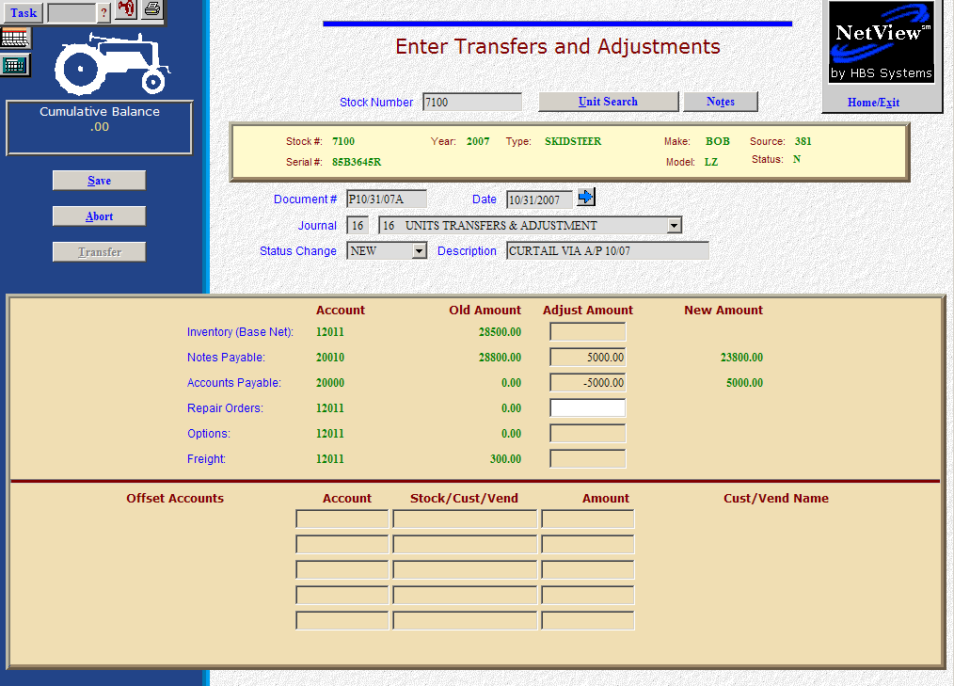

Here’s the scenario. You need to make a curtailment on a note. In this case you are going to cut an A/P check for it.

- Fill in the Stock #.
- Create the Document #. Here’s a document numbering idea:
  - P for payment (curtailment)
  - 053013 for the month (05)/day (30)/year (2013) of the correction
  - A for the first payment of the day, B for the second, and so on.
- Put the transfer to A/P date in the Date field, provided it is within the open accounting periods on your system. Otherwise, use the first day of the oldest month open.
- Put in a good Entry Description that mentions you are making a curtailment via A/P and the month.
- Leave the Status field as it is.
- On the Notes Payable line, fill in the curtailment amount. Enter a negative number as you are SUBTRACTING value. The system will convert the “subtraction” as a debit to the notes payable account.
- Fill in the curtailment amount on the Accounts Payable line (enter as a positive number as you are ADDING the value). The system will convert this “addition” to a credit to the accounts payable account.
  - You’ll be asked for the vendor number. There is a lookup in the vendor number field. Type in a few letters of the vendor’s name to look it up if you don’t know their number.
  - Also enter the due date, discount date, and amount, if any.
- Press Save (Alt S) to complete the transaction.
- When you press “Save,” the units master for the stock number is INSTANTLY updated. The transaction has been created and will be posted when Journal 16 is run. It will be available for selection in A/P to pay when the journal has been posted.

