Enter Transfers and Adjustments (ETA)

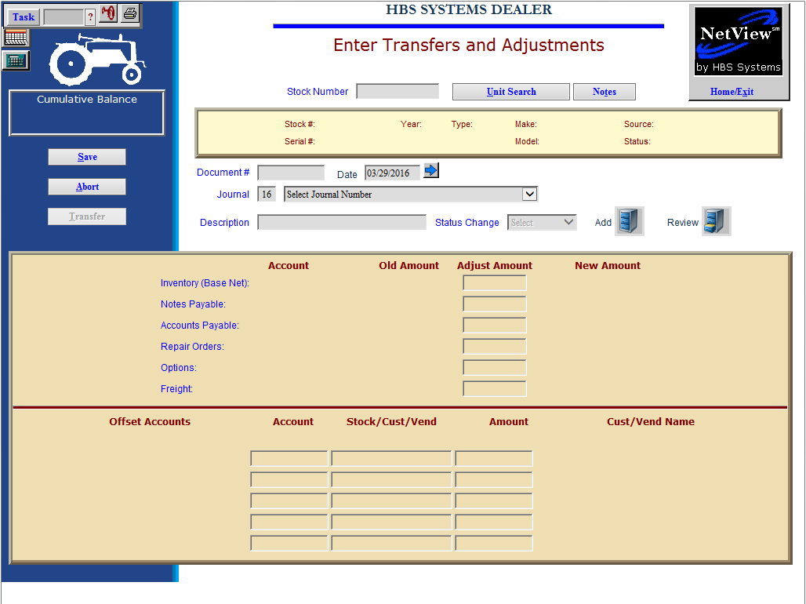

Once a unit has been added to the system, any accounting entries or adjustments to that unit are done in Enter Transfers and Adjustments (ETA). ETA is quite flexible and can handle a large variety of entries that affect a single stock number. NOTE: If you have a Consolidated location, you will need to use that location to perform operations in ETA.

To access this function, you can either:

- Select “Units” from the menu. Choose the “Data Entry” submenu and click “Enter Transfers and Adjustments.”
- Type “ETA” in the Shortcuts Bar.

Field Definitions

Stock #: Type in the stock number or use the Unit Search button to find it.

Document #: Enter a document number here that applies to the adjustment you are making. Be sure to use a UNIQUE document number here. Duplicate document numbers may cause confusion when trying to track down information at a later date. The number may be:

An invoice number

A check number

A “creative” document number when the transaction does not originate from a paper document

Date: Enter the date of the transaction here. This date determines the account period where this transaction belongs.

Be sure to pick a date that falls within an open accounting period.

You may also click on the blue arrow to access a calendar.

Journal: Journal 16 pre-fills in this field. Although you may enter any journal number here, we STRONGLY RECOMMEND that you use Journal 16 exclusively for any entries made here. When this journal is used consistently for all transactions, it makes searching for entries at a later time much easier, as they are all in one journal. By using Journal 16, it also provides confirmation that any entries found with this journal number were done in Transfers and Adjustments.

Status Change: This field will show the current status of the unit.

- The choices are:
  - History
  - New Order
  - Rental
  - Sold
  - Transfer
  - Used
- In most cases, the status will not change as a result of the entries made here. There are a couple of exceptions:
  - If you are transferring a unit to another source or to another dealer, you would change the status for that transaction.
  - Also, if you are reclassifying the unit from new to used, the status would change.

Description: Describe your entry here. Provide a very detailed description as it feeds a number of other programs. For example, if you are adding an invoice to a previously purchased zero balance unit, a good description might be “Add NH Invoice”

Adjust Amount Section: The center portion of the screen is where the changes to the identified stock number are noted. You will notice that you may change the following amounts for the identified unit:

Inventory

Notes Payable

Accounts Payable

Repair Orders

Options

Freight

Any existing dollars in these areas will display in the Old Amount field. Any adjustments necessary should be entered in the Adjust Amount field.

The concept of making changes on this screen is that you are either adding or subtracting from any of the fields shown. This is NOT an accounting sign function in that you are not required to determine if the entry needs to be a debit or credit to cover your entry. For example, if you are adding to existing inventory and notes payable, you type in whole or positive numbers on both the inventory and notes payable lines. Likewise, if you are reducing the inventory and notes payable amounts for a unit, type in a negative (-) figure for each line. As long as you indicate the desired type of change for each line, the system will interpret your entry and convert it to accounting debits and credits. Just remember the simple rule: you are only adding or subtracting on this screen, nothing more.

For any line where you enter adjustments, the system will calculate what the New Amount will be based on your entry. It is displayed in the far right hand column on the screen. It’s a good idea to review this as you are making your entry to ensure that the final result is the one you wanted.

Offset Account(s) Screen Section: The lower section of the screen where you see the Offset Accounts is for making adjustments outside the scope of the entries in the center portion of the screen. Remember, the focus of this program is on the stock number identified in the upper left hand corner. The center section points directly and only to that stock number and its current values.

The Offset Accounts are provided for those entries that are to be posted to accounts that are not specifically related to the stock number. In the offset area, you may reference virtually any type of account EXCEPT Inventory, Notes Payable, or Accounts Payable that apply to THIS stock number or ANY stock number. These three types of accounts can ONLY be used in the center section of this program where their names and account numbers are shown. In this way, the system fully ties the integration between Units, General Ledger, and Accounts Payable together.

If you need to make entries from one unit to another or multiple entries to Inventory, Notes, or Accounts Payable, we recommend the use of a “wash” account in the Offset Accounts section. This method can be used so you may get a balanced entry as you adjust one unit, then create a new document referencing another unit and use the same “wash” account in the Offset Accounts section to pull the dollars to balance that entry.

Acct #: Enter the account number to be affected by this offsetting entry. You can type in a portion of the number to do an account number look-up.

Stk/Cst/Vnd: This field provides the Control Number for Account Number referenced on this line. Most often it is used for supplying the Control Number for sub-ledger accounts.

Common Subledger Control Numbers

Type of Account Code Control Number
Units Inventory 5 Stock # NOT TO BE USED IN THIS SECTION!
Notes Payable 5 Stock # NOT TO BE USED IN THIS SECTION!
Warranty Receivables 5 Invoice #/Document #
Contracts in Transit 5 Customer Name or #
Customer Deposits 5 Customer Name or #
Notes Receivable 5 Customer Name or #

Amount: Put the amount to be applied to the account number for this line of the transaction. Keep the same thought for these lines: add or subtract to the account and the system will apply the correct accounting sign (debit or credit).

Cust/Vendor Name: This field will display the customer or vendor name selected in the control field.

There are five lines reserved for offsetting entries in a Transfers and Adjustments transaction.

ETA essentially works like a journal entry screen in that the entry must be in balance when you exit the screen. If it isn’t in balance, you’ll have the opportunity to do any of the following:

- Write it out of balance.
- Discard the transaction completely.
- Adjust the entry so it is in balance.

A special setting in WGDF, “Trade-in commission tracking,” makes the Offset Accounts portion of the screen behave a bit differently. With this turned to Yes, the first line of the Offset Accounts has the ability to write a record to the Commission File and to record the salesman’s initials in the GLDI entry to accompany it.

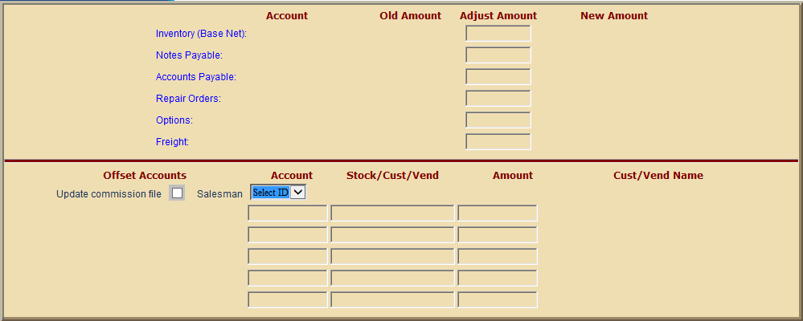

Example of screen change for the first line of the Offset Accounts.

