Fixed Asset Management (FAM)

[IMAGE HERE]

This package provides a complete solution to managing, tracking, and depreciating the fixed assets in your business. It provides a maintenance screen with the following capabilities:

- Ability to define assets
- Choice of straight-line and double-declining depreciation methods
- Asset and depreciation reports
- Automated depreciation

*** You will need assistance from the HBS Support Team when initially setting up this package. ***

All Fixed Assets are accessed from the same screen. To access the screen, type “FAM” in the Shortcuts Bar.

[IMAGE HERE]

Add/Maintain Fixed Asset Types and Accounts: This setup screen is where you create the categories of the fixed assets, known as “Types” in this package. These are somewhat like a Unit source, where it will hold the G/L accounts to be used for this category of fixed assets. In the simplest definition, you could create a Type record for each fixed asset G/L account you have: Building, Vehicles, Furniture & Fixtures, Leasehold Improvements, Shop Equipment, etc.

Asset Type: Enter up to a 5-letter asset type, a short name for the category. You can also use this field to select existing asset type records to edit.

Description: Enter a full description of the asset type (i.e. Furniture & Fixture, Shop Equipment, Company Vehicles, etc.).

Asset Account: Enter or look up the G/L account that holds the original value of the assets for this type.

Accumulated Depreciation: Enter or look up the G/L account that holds the accumulated depreciation of the assets for this type.

Depreciation Expense Account: Enter or look up the G/L account that receives the monthly depreciation of the assets for this type.

Gain/Loss Account: Enter or look up the G/L account that holds the gain or loss when assets for this type are sold.

Press Save to save the asset type. There are also buttons to clear the screen and delete an asset type. NOTE: Deleting an asset type is not recommended unless there are NO assets in this group.

Print Type Detail List: Select a printer and click this button to generate a listing of all defined types.

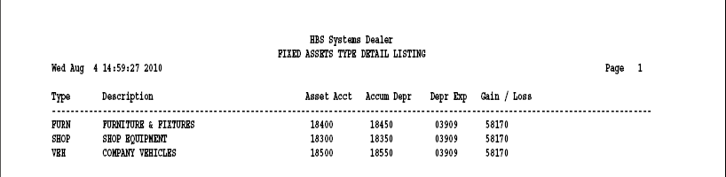

Report info includes:

Type: This field shows the asset type (short name).

Description: This field shows the type’s full description.

Asset Acct: This shows the G/L account number that holds the original value of the assets for this type.

Accum Depr: This shows the G/L account number that holds the accumulated depreciation of the assets for this type.

Depr Exp: This shows the G/L account number that receives the monthly depreciation
of the assets for this type.

Gain/Loss: This shows the GL account number that holds the gain/loss value of the assets for this type when they are sold.

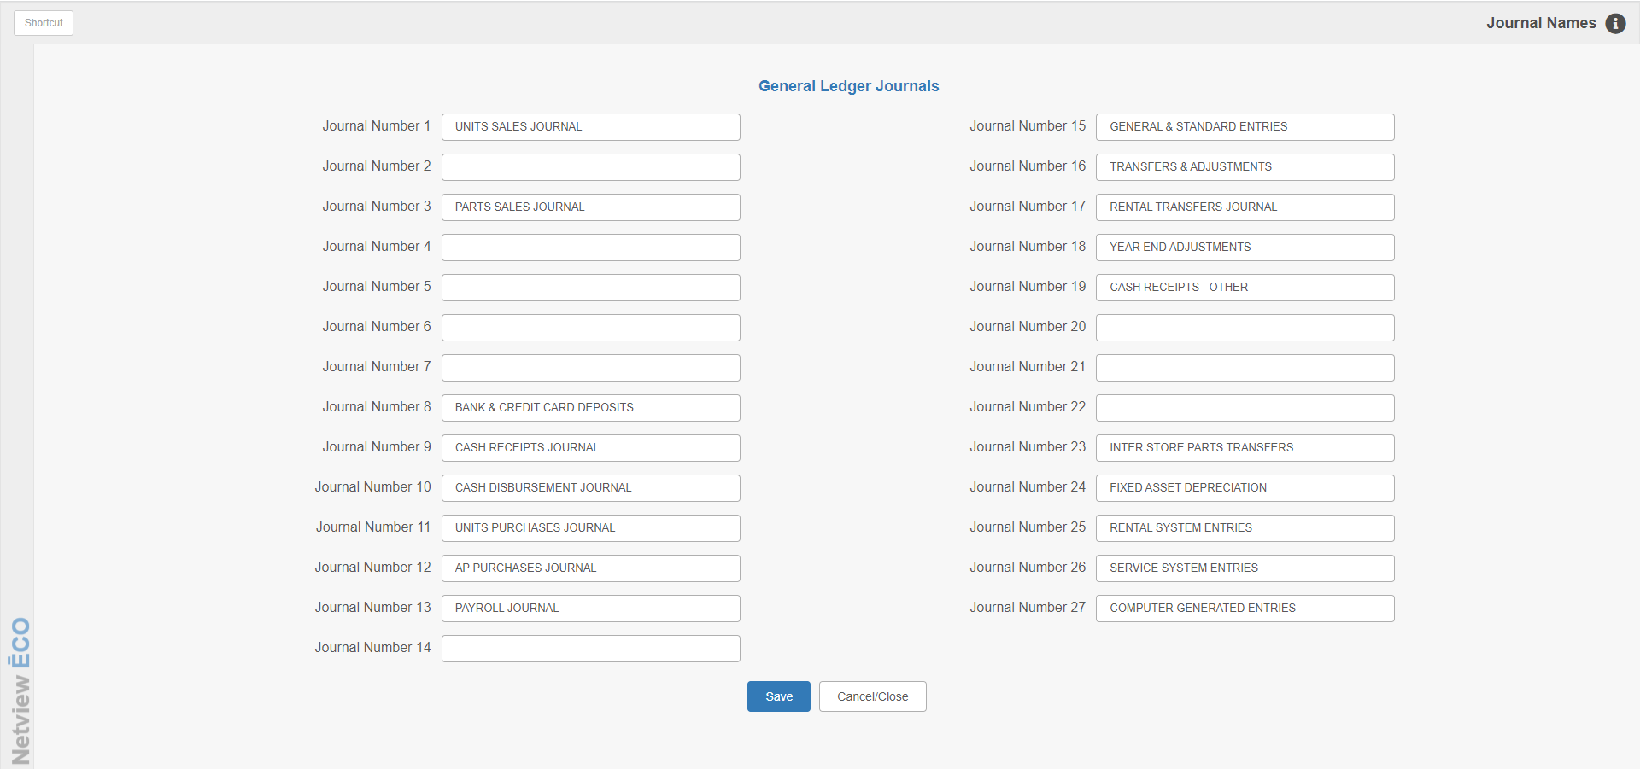

Fixed Asset Setup—JNAM: The depreciation from this package will be sent to Journal 24. We need to “name” that journal on your system.

- Type JNAM in the Shortcuts Bar.
- Nex to Journal 24, type “FIXED ASSET DEPRECIATION.”
- Click Save to save the change.

[IMAGE HERE]

Add/Maintain Fixed Asset: This maintenance screen is used initially to set up all existing assets at the dealership. Full details of each and every item that is part of the value of the G/L account must be entered in this screen, even if it is fully depreciated.

Asset ID: Each asset entered must be given an ID. The field allows for an up to 10-character alpha-numeric designation.

Asset Type: Choose the appropriate asset type for this asset from the drop-down menu.

Status: This field holds the current status of the asset.

Active means it is still part of a depreciation process.
- Inactive means it has been fully depreciated or is no longer active.
- Sold means that the dealership has sold the item and it is no longer in their possession.

Purchase Date: Enter the purchase date for this asset, i.e. the date the dealership acquired it.

Serial #: If this asset has a serial number, enter it here. It may also be:

Left blank.

Used for additional asset information.

New/Used: Indicate here if the asset was new or used when it was acquired.

Location Code: This field is appropriate for multi-location dealerships and holds the suffix that defines the location. If you are creating an asset in a Consolidated location, you will be able to designate which location the asset belongs to.

Location Name: This field is appropriate for multi-location dealerships and holds the name of the location owning the asset.

Description: Enter up to 30 characters of description for this asset.

Original Net Total: This field holds the original net total or purchase price of the asset. It is required for all assets.

Depreciation Type: Choose one of the following depreciation types:

- Straight Line
- Double Declining

Useful Life (Months): Enter the number of months this asset may be depreciated.

Depreciation Start Date: Enter the date this unit is/was eligible for depreciation. If you do not have the exact date, enter the last day of the month of purchase.

Residual Value: This field holds the residual value for this asset, which represents the non-depreciable portion of the asset. A zero can be entered here as not all assets have a residual value. Check with your accountant if you are unsure what to enter.

Last Run Date: This field is updated by the system when the automated depreciation process is run.

Month Depreciation: This field is system-maintained and holds the last monthly depreciation amount.

Total Depreciation: This field is system-maintained and holds all depreciation applied to this asset since its purchase.

Sales fields: These are all MEMO fields that are neither system-maintained nor required. You may enter any appropriate details in these fields as desired.

Sales Date: This can hold the date this asset was sold.

Salesman: This can hold the initials or number of the sales person who sold this asset.

Sales Invoice: This can hold the sales invoice number when the asset was sold.

Sale Price: This can hold the selling price for the asset.

Sale Cost: This can hold the cost of the asset when it was sold.

Sales Reserve Amount: This can hold the amount of accumulated depreciation as of the sales date.

Save: Press this button to add/change the asset.

Clear: This button clears the screen so you enter/edit another asset.

Delete: This button removes the asset. NOTE: This should NOT be used for assets that have been part of any depreciation cycle.

Print History: This generates an activity report for the asset currently shown on the screen.

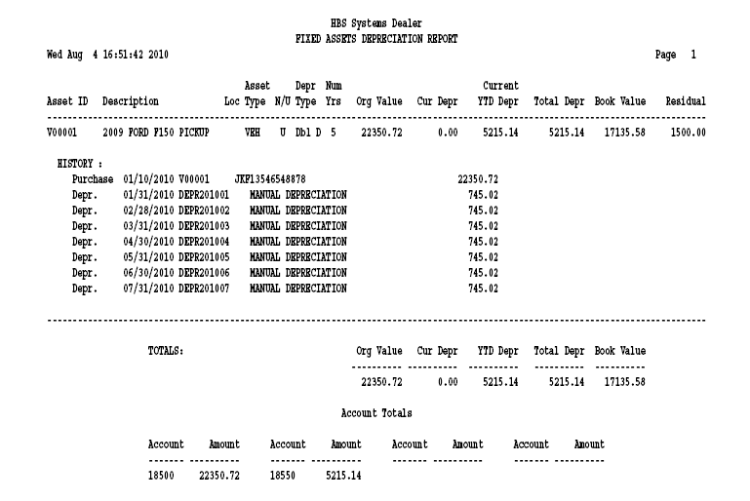

Initial Setup – Building History: For each asset in the system, we must identify the depreciation that has been previously taken. This must be done for active as well as inactive assets.

Inactive Assets:

- For assets that have completely been depreciated prior to this year, we recommend putting all prior depreciation in as a lump dated 12/31 of the previous year (unless you have the last month depreciation was calculated for the asset).
- For assets that have completely been depreciated, but it ended at some point this year, we recommend putting all prior years’ depreciation in as a lump dated 12/31 of the previous year and then build monthly depreciation detail for each month of the current year.

Active Assets:

- For assets that began depreciating prior to this year, we recommend putting all depreciation prior to this year in as a lump dated 12/31 of the previous year and then build monthly depreciation detail for each month of the current year.

For these historical entries, you will use the Manual Adjustment History Only tab to enter them. This screen creates the detail for the depreciation by asset without generating journal entries.

[INSERT IMAGE HERE]

Manual Adjustment History Only Tab:

Location Code: This field is only applicable for multi-location dealerships, particularly if building the asset’s history in the Consolidated location, where you will need to indicate the asset’s location code for the history record.

Asset ID: Enter the asset ID.

Depreciation Date: Enter the date of the original depreciation. Remember we suggest 12/31 of last year for the lump of all depreciation prior to this year.

Depreciation Amount: Enter the amount of depreciation for this date.

Press the Save button to record the entry. There is also a button to clear the screen and one to delete an entry. The Delete button on this screen just deletes the history entries recorded here—no G/L entries are changed. The entries can also be recalled by clicking on them, editing, and saving them once the changes are made.

[INSERT IMAGE HERE—ASSET ID WITH RECORDS]

Asset History Report: Once some depreciation history exists for each unit, you may return to the Add/Maintain Fixed Asset tab to generate a printout of it.
[INSERT IMAGE—HISTORY REPORT OPTIONS AT BOTTOM OF FIXED ASSET TAB]

Report Settings: There are two settings for the report: Current YTD and Prior YTD.

Use Show Prior YTD when you have passed the last month of your fiscal year, but that month and others beyond it are all open.

Use Show Current YTD when your last fiscal year has been closed.

Print History: Click on this button to run the report.

The report shows all the depreciation for this asset. It also includes the details of the asset as entered on the maintenance screen.

- The Current YTD Depr column summarizes all the depreciation for the year.
- The Total Depr column shows the life-to-date amount of depreciation for the asset.
- The Book Value is calculated by subtracting the Total Depr from the Original Value.
- The G/L accounts where the asset resides show toward the bottom of the report.

[INSERT IMAGE HERE—REPORT TAB]

Asset Reports: You may run a report of all assets in the system at any time from the Reports tab. From here, you may run either of the following reports:

- An Asset Listing
- A Depreciation Report

Report Options: Either report is selectable by any combination of:

- Location
- Asset type
- Type of depreciation
- Beginning/ending purchase date
- Status

Print Sort By: You can sort the report by:

- Asset ID
- Asset Type
- Purchase Date
- Location

Show YTD: You also choose the amounts to include for the report: Current YTD or Prior YTD.
- Use Show Prior YTD when you have passed the last month of your fiscal year, but that month and others beyond it are all open.
- Use Show Current YTD when your last fiscal year has been closed.

Sample Asset Reports:

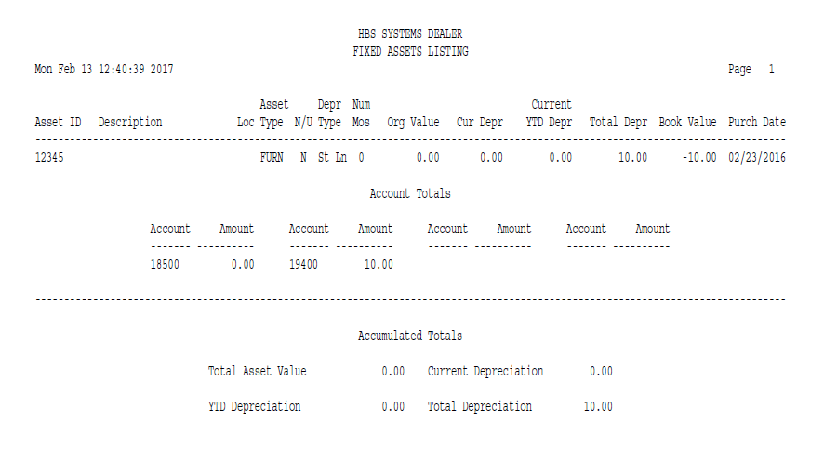

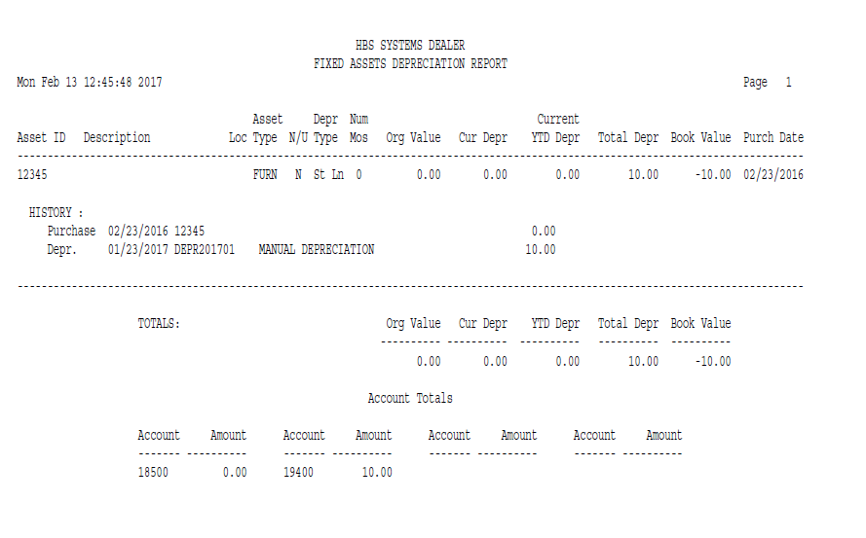

[INSERT IMAGE HERE]

Building History—Maintain Adjustment GL and History: There is another tab for adding history records. This one is identical to the prior one EXCEPT that it creates journal entries for each transaction entered. For most setups, this maintenance screen will not be used as the depreciation for the assets has probably already been added to the General Ledger.

[INSERT IMAGE HERE]

Actual Depreciation: Once all historical records have been, reviewed and reconciled, the next round of depreciation can be automatic. Open the Auto Depreciation tab to run automatic depreciations.

*** VERY IMPORTANT ***: This screen offers the ability to “try out” the process by running a Report Only preview.

- Set the Report Only option to Yes.
- Verify that the Depreciation Calculation Date is correct.
- Run the report.

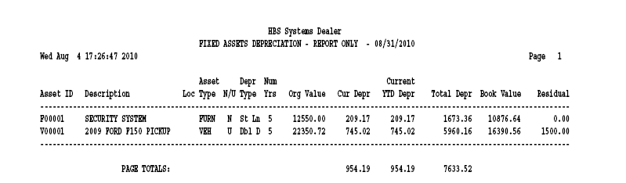

Report Only: The Report Only version shows you what will calculate for each asset based on the information currently in the system. It provides a great way to check out the calculations before the actual process is run (especially the first time).

Automatic Depreciation: When the automatic depreciation is run, it performs the following actions:

- Generates a final report of the depreciation activity for the month.
- Creates the necessary G/L entries to record the depreciation.
- Updates each affected asset with the change in depreciation.

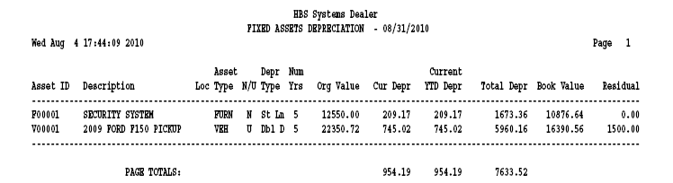

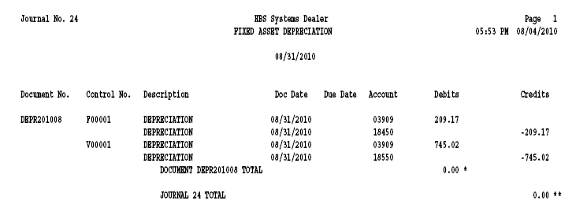

GLRR – Fixed Asset sections on the GL Reconciliation Report: The Fixed Asset Reconciliation portion compares the Fixed Asset details from FAM to the G/L balances in the corresponding accounts. The Depreciation Reconciliation portion compares the Depreciation details from FAM to the G/L balances in the corresponding accounts. In both cases, no detail lines will show on the report unless there are differences in the comparisons.

