Fixed Payment Schedule (FPS)

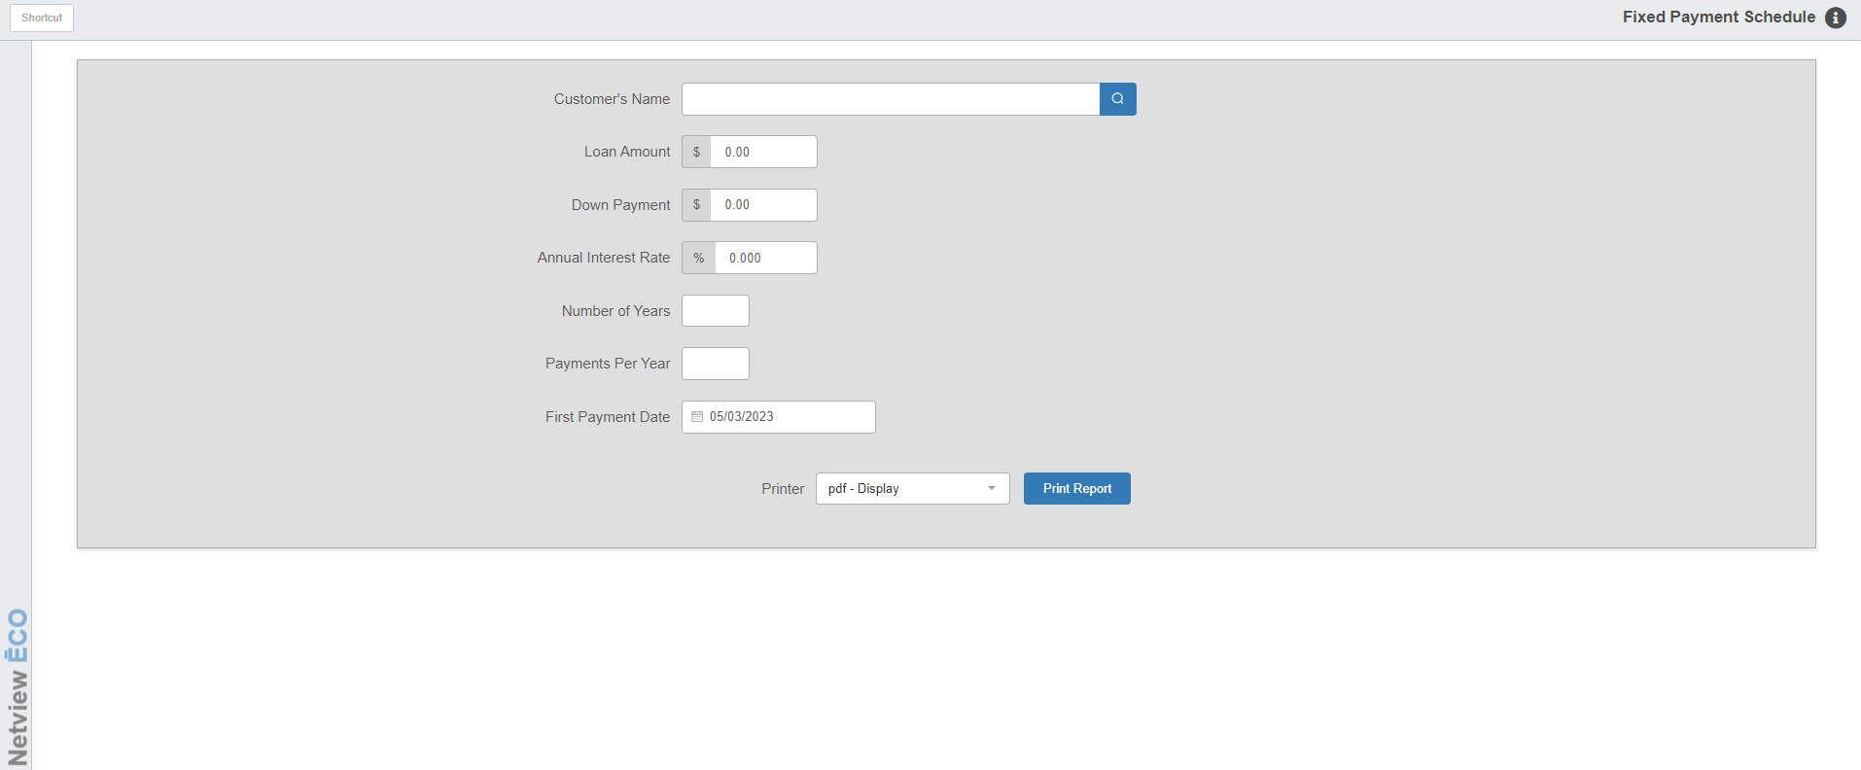

Fixed Payment Schedule (FPS) lets you generate, review, and print a fixed payment schedule for loan amounts.

- To access this function, you can either:
  - Select “Units” from the menu. Choose the “Amortization” submenu and click “Fixed Payment Schedule.”
  - Type “FPS” in the Shortcuts Bar.

Field Definitions

Customer’s Name: Type a customer’s name. The name entered is used only for printout purposes.

Loan Amount: Type the amount of the loan, without a decimal point. For example, type “400000” for $4,000.00.

Down Payment: Type the amount of the customer’s down payment on the unit, without a decimal point. For example, type “50000” for $500.00.

Annual Interest Rate: Type the amount of the annual interest rate on the loan, without a decimal point. For example, type “7000” for 7.000%.

Number of Years: Enter the number of years within which the customer will make loan payments.

Payments Per Year: Enter the number of payments the customer will make per year. Type 1 for annually, 4 for quarterly, 12 for monthly, etc.

First Payment Date: Type the date on which the customer will make the first loan payment. For example, type “101511” for October 15, 2011. You can also use the blue arrow to select it from a calendar.

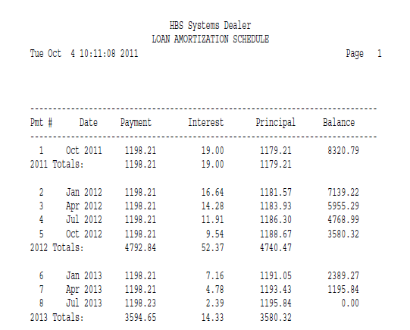

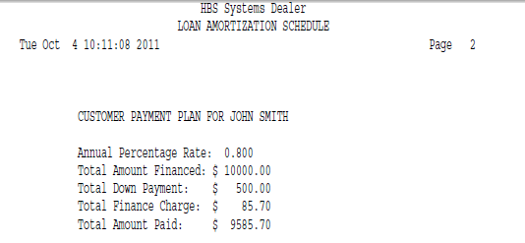

Report Details:

Pmt #: This column lists the numbers of the payments.

Date: This column lists the approximate dates of the payments.

Payment: This column lists the amounts of the payments.

Interest: This column lists the amount of each payment applied to interest.

Principal: This column lists the amount of each payment applied to the principal of the loan.

Balance: This column lists the remaining loan principal amount after each payment.

Year Totals: This line shows the following:

The total amount the customer paid the indicated year

The total amount of interest paid

The total amount applied to the loan principal

