Financial Statements (FS)

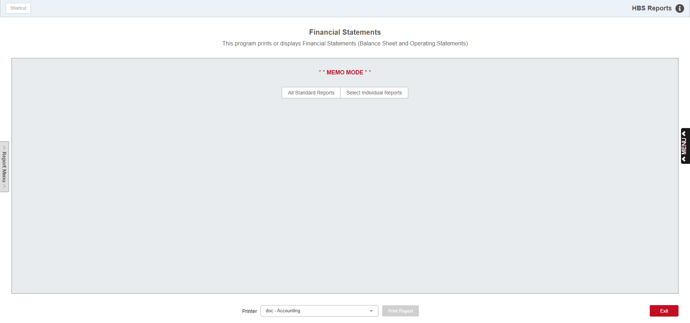

The Financial Statements report (FS) let you "take the pulse" of your business. They report on all facets of your business. You can check how you are doing for a specific month of the fiscal year in progress, and compare the activity to prior years or to a budgeted figure.

These reports can be selected by date within any open accounting periods, by department, or by the component of the financial statement itself—Balance Sheet or Operating Statement. You can also generate reports for closed accounting months and years.

To access this function, you can either:

- Select “General Ledger” from the menu. Choose the “Memo Reports” submenu and click “Financial Statements.”
- Type “FS” in the Shortcuts Bar.

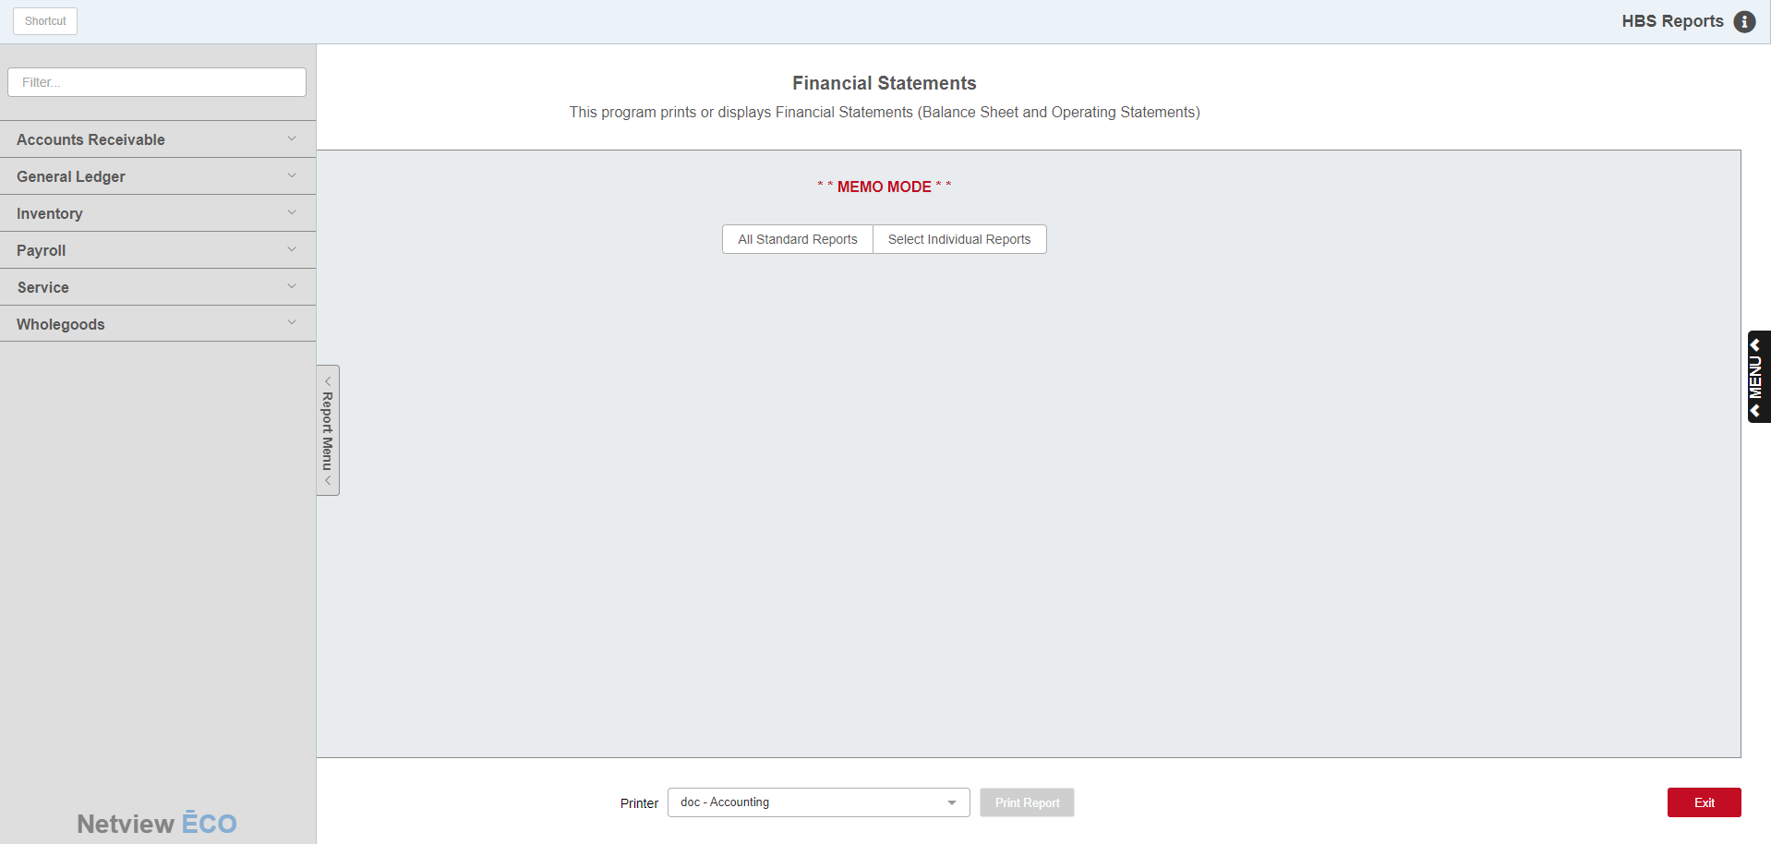

Reports Navigation Menu: This new menu appears on the left side of the screen for all reports and allows the user easy access to all report programs in the system. It is collapsable and can be easily hidden.

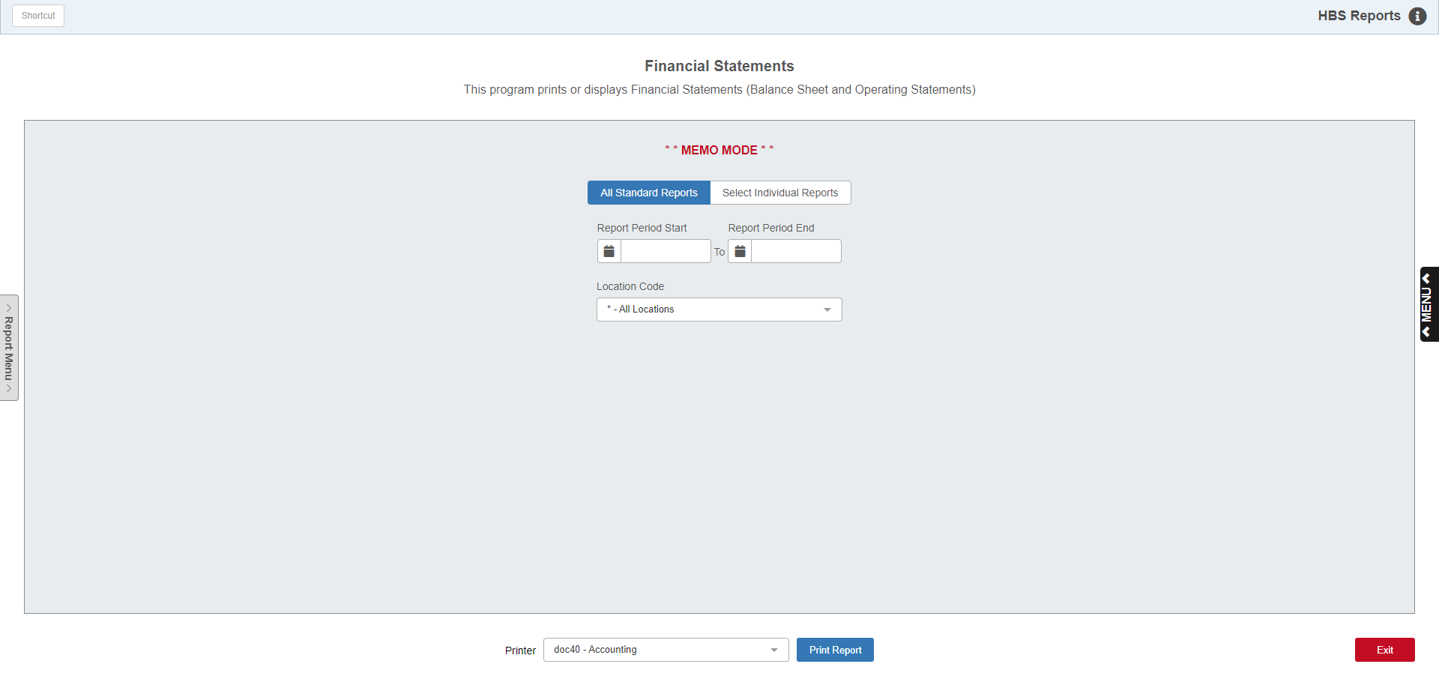

All Standard Reports: Select this option to generate a full set of reports (Balance Sheet and Operating Statements for all departments) or just a certain section, such as only a Balance Sheet or a particular department's Operating Statement.

Beginning Date / Ending Date: When generating all reports, simply choose the beginning and ending dates for the reports, pick your desired printer, and press the Print button.

Location Code: This option only appears when the program is opened in a Consolidated location. It allows you to specify if you want to print all reports for all locations or if you want to print the reports only at a specific location.

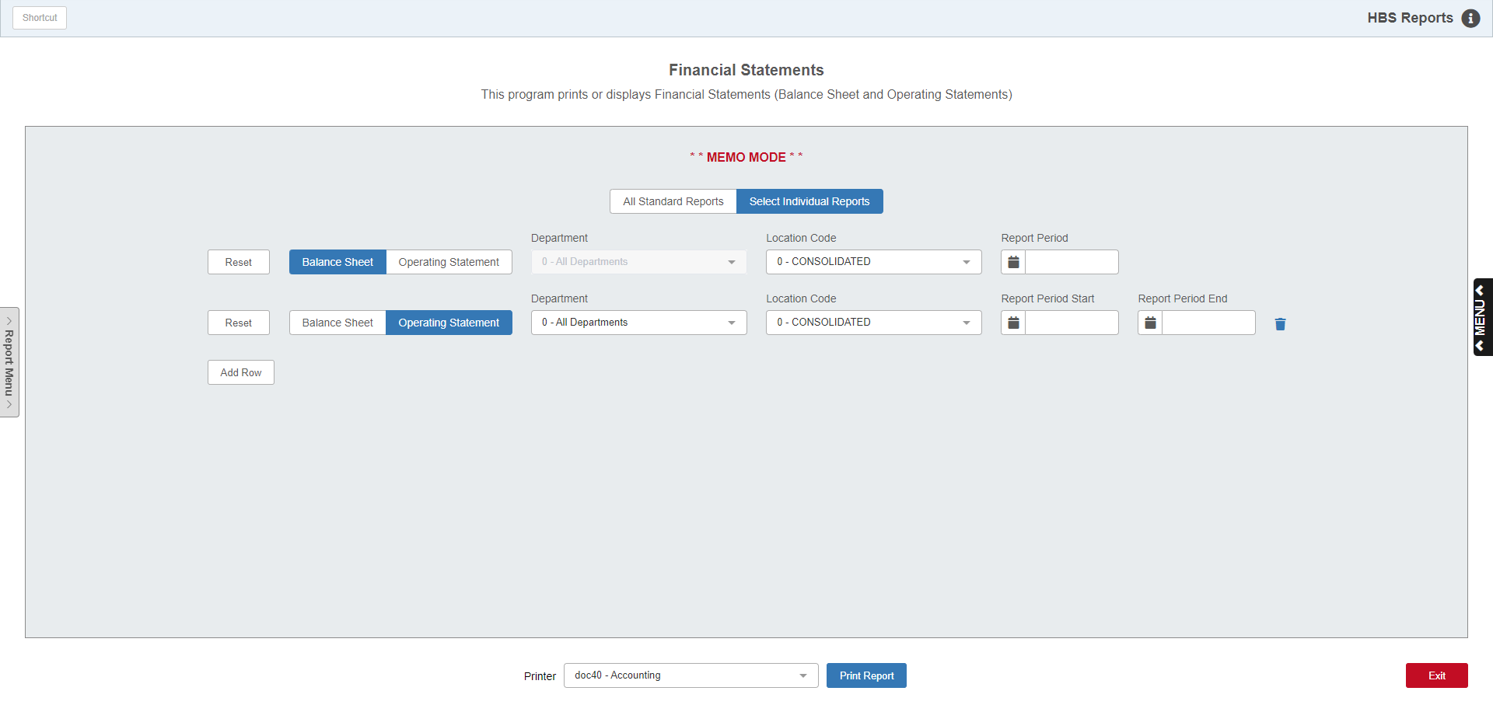

Select Individual Reports: This option lets you select individual reports to print. You may generate up to 10 reports at the same time with a mixture of Balance Sheets and Operating Statements as needed. Use the Add Row button to add additional reports after the first.

Balance Sheet: Click on this choice to generate a report of the Asset and Liability Accounts.

Operating Statement: Click on this choice to generate a report of the Sales, Gross Margins, Expense, and Other Addition/Deduction Accounts. The following field offers the ability to choose one or all departments for the report.

Department: This field is only active for the Operating Statement. Choose an individual department from the drop-down menu or ALL for all departments for the Operating Statement.

Report Period: This field is only active for the Balance Sheet. Enter the end date for the report time period or choose it from a calendar.

Report Period Start Date/End Date: These fields are only active for the Operating Statement. Enter the start and end dates for the report time period or choose them from a calendar.

Location Code: Multi-location dealers have an additional selection box for location when you choose individual reports. This drop-down menu will list the locations that are available and be selectable for both report types.

Printer Name: Identify the printer to receive your printout. A default printer is pre-filled but you may change it as necessary. Use the PDF printer to display the report.

Print Report: Click this button to print the report.

Balance Sheet—Assets:

HBS Systems Dealer
BALANCE SHEET – MEMO

Mon May 06 15:31:42 2013 04/30/2013 Page 1
Mix Pct to Var from
Account Title Acct Amount Pct Pr Year Plan

CASH ON HAND 10100 28,336.35 24.5 233.1 28,336.35
CHECKING ACCOUNT 10200 25,122.01 21.8 179.7 25,122.01
SAVINGS ACCOUNT 10210 7,040.41 6.1 137.3 7,040.41
ACCOUNTS RECEIVABLE 10300 31,541.99 27.3 14.0 31,541.99
CONTRACTS IN TRANSIT 10600 17,500.00 15.2 0.0 17,500.00
NOTES RECEIVABLE 10610 4,360.54 3.7 44.9 4,360.54
WARRANTY RECEIVABLES 10800 1,573.29 1.4 45.0 1,573.29
TOTAL CASH & RECEIVABLES 115,474.69 *** 9.4 22.2 115,474.69

NEW UNITS INV. 12001 452,439.69 64.0 98.1 452,439.69
USED UNITS INV. 13001 254,405.63 36.0 37.6 254,405.63
TOTAL UNITS INV. 706,845.32 * 57.3 123.4 706,845.32

PARTS INVENTORY 14003 279,471.56 100.0 117.9 279.471.56
TOTAL OTHER INVENTORIES 279,471.56 * 22.7 117.9 279.471.56

TOTAL INVENTORIES 986,316.88 *** 80.0 121.8 986,316.88

PREPAID INSURANCE 17750 339.96 100.0 100.0 339.96
TOTAL PREPAIDS & MISC 339.96 * 0.0 76.5 339.96

TOTAL CURRENT ASSETS 1,102,128.45 **** 89.3 107.5 1,102,128.45

LAND 18000 107,537.03 82.2 18.1 107,537.03
BUILDINGS 18100 24,302.88 18.6 100.0 24,302.88
ACCUM DEPR – BLDGS 18150 7,027.03- 5.4 24.1 7,027.03-
SHOP EQ. & TOOLS 18300 11,415.63 8.7 100.0 11,415.63
ACCUM DEPR - SHOP EQ 18350 11,092.00- 8.5 20.2 11,092.00-
FURNITURE & FIXTURES 18500 4,345.63 3.3 100.0 4,345.63
ACCUM DEPR - FURN/FIX 18550 3,904.00- 3.0 20.9 3,904.00-
DELIVERY EQUIPMENT 18700 19,036.65 14.6 100.0 19,036.65
ACCUM DEPR - DEL EQ 18750 13,783.00- 10.5 26.1 13,783.00-
TOTAL FIXED ASSETS 130,831.79 * 11.4 90.2 130,831.79

TOTAL ASSETS 1,232,960.19 ***** 100.0 117.7 1,232,960.19

- These first two columns identify the asset accounts that have any accounting activity.
  - The Account Title comes from Account Number Maintenance (ANM).
- Assets are divided into:
  - Total Cash and Receivables
  - Total Units Inventory
  - Total Other Inventories
  - Total Prepaids and Miscellaneous
  - Total Fixed Assets
- The accounts are grouped according to the account type codes found on each account number.

TIP—Interpreting the Financial Statement—Asset Page: The figures shown on the Asset page are “whole” numbers. This means that they show as positive numbers as long as their balance is the anticipated sign.

- Asset accounts typically show debit (+) balances.
- If the balance in an asset account is a credit (-), then it will appear on this page of the Balance Sheet as a credit (i.e. Accumulated Depreciation accounts).

Amount: The figures printed in the Amount column are the year-to-date balances for the fiscal year chosen as the report date. For example, for a fiscal year of January through December, a report date of April 30 would include activity for January 1 through April 30 of the current fiscal year.

Mix Pct: The Mix Pct or Mix Percentage column is a calculated field that compares the amount on the line of the report to the next appropriate subtotal or total on the report. For example, the percentage shown on the Checking Account line of the report compares it to the total for Cash and Receivables. Likewise, the percentage shown on Cash and Receivables Total line compares it to the Total Assets.

Percent to Prior Year Column: Like the "Mix Percent" column, this is a calculated field which divides the current year amount (per account number) into last year's balance for this same account number for the same month and expresses the result as a percentage. For example, if you find a percentage in this column of 117.7% it would mean that the balance on that line is 117.7% percent of last year’s results at the same point in time.

ANM stores the thirteenth-month balance. It is held in the Prior YTD Bal field. This is the account's balance when the month was closed thirteen months ago.

When GLME is run to close a current accounting period, the Prior YTD Bal figure is replaced with the thirteenth-month balance of the newest accounting period.

Var From Plan: If you have created a budget for the account numbers and have turned on the setting in CONA for budget numbers, then the Balance Sheet shows this Variance from Plan or Budget column. The figures in this column are the difference between what was projected for that account and the actual net balance posted in the Amount column.

Balance Sheet—Liabilities:

HBS Systems Dealer
BALANCE SHEET – MEMO

Mon May 06 15:31:42 2013 04/30/2013 Page 2
Mix Pct to Var from
Account Title Acct Amount Pct Pr Year Plan

ACCOUNTS PAYABLE 20000 75,073.98 10.4 21.9 75,073.93
A/P – MISC 20020 30,906.18 4.3 22.7 30,906.18
A/P – OTHER 20040 1,788.28 0.2 13.5 1,788.28
N/P – NEW TRACTORS FLOOR PLAN 20200 282,062.13 39.2 25.3 282,062.13
N/P - OTHER NEW FLOOR PLAN 20210 116,688.90 16.2 12.0 116,688.90
N/P - USED FLOOR PLAN 20400 107,118.68 14.9 56.7 107,118.68
STATE INCOME TAX W/H 21220 289.00 0.0 13.5 289.00
ACCRUED UNEMPLOYMENT TAXES 21310 1,239.63 0.2 30.3 1,239.63
ACCRUED SALES TAX 21400 212.30 0.0 64.8 212.30
NOTES PAYABLE – BANK 22800 105,000.00 14.6 0.0 105,000.00
TOTAL CURRENT LIABILITIES 720,379.08 * 58.4 121.7 720,379.08

COMMON STOCK 27000 60,000.00 11.7 100.0 60,000.00
RETAINED EARNINGS 27100 150,881.00 29.4 151.2 150,881.00
UNDIVIDED PROFITS 27150 217,721.40 43.4 100.0 217,721.40
CURRENT PROFIT OR (LOSS) 83,978.72 16.5 4.2 83,978.72
TOTAL NET WORTH 512,581.12 * 41.6 121.2 512,581.12

TOTAL LIABILITIES/NET WORTH 1,232,960.20 ***** 100.0 121.5 1,232,960.20

These first two columns identify the liability accounts that have any accounting activity.

The Account Title comes from Account Number Maintenance (ANM).

Liabilities are divided into:

Current Liabilities

Long Term Liabilities

Total Net Worth

The accounts are grouped according to the account type codes found on each account number.

TIP—Interpreting the Financial Statement—Liability Page: The figures shown on the Liability page are “whole” numbers. This means that they will show as positive numbers as long as their balance is the anticipated sign.

- Liability accounts typically show credit (-) balances.
- If the balance in a liability account is a debit (+), then it will appear on this page of the Balance Sheet as a credit (-).

Amount: The figures printed in the Amount column are the year-to-date balances for the fiscal year chosen as the report date. For example, for a fiscal year of January through December, a report date of April 30 would include activity for January 1 through April 30 of the current fiscal year.

Mix Pct: The Mix Pct or Mix Percentage column is a calculated field that compares the amount on the line of the report to the next appropriate subtotal or total on the report. For example, the percentage shown on the Accounts Payable line of the report compares it to the total for Current Liabilities. Likewise, the percentage shown on Current Liabilities Total line compares it to the Total Liabilities.

Percent to Prior Year Column: Like the "Mix Percent" column, this is a calculated field which divides the current year amount (per account number) into last year's balance for this same account number for the same month and expresses the result as a percentage. For example, if you find a percentage in this column of 117.7% it would mean that the balance on that line is 117.7% percent of last year’s results at the same point in time.

- ANM stores the thirteenth-month balance. It is held in the Prior YTD Bal field. This is the account's balance when the month was closed thirteen months ago.
- When GLME is run to close a current accounting period, the Prior YTD Bal figure is replaced with the thirteenth-month balance of the newest accounting period.

Var From Plan: If you have created a budget for the account numbers and have turned on the setting in CONA for budget numbers, then the Balance Sheet shows this Variance from Plan or Budget column. The figures in this column are the difference between what was projected for that account and the actual net balance posted in the Amount column.

Operating Statement—All Departments:

HBS Systems Dealer
OPERATING STATEMENT - MEMO
Mon May 06 15:31:42 2013 Period From 01/01/2013 to 04/30/2013 Page 1
ALL DEPARTMENTS
-- SELECTED DATE RANGE -- -- YEAR TO DATE -- - PRIOR YR –
01/01/2013 - 04/30/2013 01/01/13-04/30/2013
% to % to
Amount Sales Amount Sales Amount
SALES
UNITS 190,706 57.8 190,706 57.8 319,456
PARTS 110,049 33.3 110,049 33.3 220,224
SERVICE 29,388 8.9 29,388 8.9 44,315
TOTAL SALES 330,143 100.0 330,143 100.0 583,995

GROSS MARGIN
UNITS 8,475 4.4 8,475 4.4 10,003
PARTS 35,374 32.1 35,374 32.1 75,378
SERVICE 16,811 57.2 16,811 57.2 16,840
TOTAL GR MRG 60,660 18.4 60,660 18.4 102,221

DIRECT CONTROLLABLE EXPENSE
UNITS 14,647 7.7 14,647 7.7 23,481
PARTS 7,509 6.8 7,509 6.8 12,839
SERVICE 4,143 14.1 4,143 14.1 6,948
TOT DIR CNT EXP 26,299 8.0 26,299 8.0 43,268

CONTROLLABLE MARGIN
UNITS 6,172- 3.2 6,172- 3.2 13,478-
PARTS 27,865 25.3 27,865 25.3 62,540
SERVICE 12,668 43.1 12,668 43.1 9,892
TOTAL CNTRL MRG 34,361 10.4 34,361 10.4 58,954

DIRECT UNCONTRL EXPENSE
SERVICE 259 0.9 259 0.9 227
TOT DIR UNCN EXP 259 0.1 259 0.1 227

CONTRIBUTION MARGIN
UNITS 6,172- 3.2 6,172- 3.2 13,478-
PARTS 27,865 25.3 27,865 25.3 62,540
SERVICE 12,409 42.2 12,409 42.2 9,665
TOTAL CNTR MRG 34,102 10.3 34,102 10.3 58,727

INDIRECT EXPENSE 30,474 9.2 30,474 9.2 35,580
TOT OPER PROFIT 3,628 1.1 3,628 1.1 23,147

ADDITIONS/DEDUCT 6,949- 2.1 6,949- 2.1 1,287
NET INCOME 3,321- 1.0 3,321- 1.0 24,434

MEMO TOTAL EXP 57,033 17.3 57,033 17.3 79,075

The Operating Statement is divided into several reports:

An All Departments Operating Statement that summarizes data from all departments.

An Operating Statement for each department.

Each report shows the amounts and other calculated percentages in three sections:

Selected Date Range

Year To Date

Prior Year

Operating Statement—All Departments – Columns:

Selected Date Range Amount: The Selected Date Range Amount is the activity for the date range entered in the report date selection fields.

Selected Date Range % To Sales: This column compares the amount shown for this line to the Total Sales amount for this group for the selected date range.

Year to Date Amount: The YTD column will strictly show you the activity for the current fiscal year through the end of the MONTH selected, even if the prior year is still open. For example, if the prior fiscal year of January to December has not been closed, when you run a report for the month of April of the following year, the YTD column shows the activity only for the current fiscal year (January 1 to April 30).

Year to Date % To Sales: This column compares the amount shown for this line to the Total Sales amount for the current fiscal year.

Prior Yr Amount: This field provides last year's year-to-date balance for this line item.

The figures in the Amount columns are rounded to the nearest dollar. For example, if the balance of a sales account is $24,081.49, the Operating Statement rounds it down to $24,081. Likewise, if the balance is $7,350.67, it is rounded up to $7,351.

TIP—Interpreting the Financial Statement—Operating Statement: The figures shown on the Operating Statement are “whole” numbers. This means that they will show as positive numbers as long as their balance is the anticipated sign. Most amounts shown should be “whole” numbers unless the balance in the account is opposite of the anticipated sign.

- Typical accounts with credit (-) balances:
  - Sales
  - Other Income
- Typical accounts with debit (+) balances:
  - Cost of Sales
  - Expense
  - Other Deduction

Operating Statement—All Departments - Rows

Sales: The Operating Statement starts with the sales account totals for each of the defined departments (typically Units, Parts, Service). This area reports Gross Sales figures for these departments.

Gross Margin: In this row, the report recognizes the costs for those sales and calculates the Gross Margin for each department (sales minus cost of sales). The cost of sales amounts are not printed on the operating statement.

Direct Controllable Expense: The next group shown is the Direct Controllable Expenses. These are expenses that have been directed to the individual departments (account type code V). These may include wages and other expense accounts where the company has direct control.

Controllable Margin: The report then subtracts the value of these Direct Controllable expenses from the Gross Margin and provides the Controllable Margin. Gross Margin minus Direct Controllable Expenses equals Controllable Margin.

Direct Uncontrollable Expenses: Then the second group of departmental expenses may be shown under the heading Direct Uncontrollable Margin (account type W). These may include utilities, rent and interest, withholding taxes, etc., that are not under the company's direct control.

Contribution Margin: These Direct Uncontrollable expenses are then subtracted from the Controllable Margin to give the Contribution Margin. The Contribution Margin represents the Gross margin less ALL departmental expenses.

Indirect Expenses: The remaining expenses are then shown on the line called Indirect Expense. They are expenses in accounts that end with 9 and are generally considered as Dealership or Administrative expenses. They do not affect the other departments' Net Income figures. However, to see the whole picture, they need to be considered and used to calculate the Operating Profit.

Total Operating Profit: The Indirect Expenses are subtracted from the Contribution Margin to give the Total Operating Profit.

Additions/Deductions: Any Other Income and Deductions are shown on the Additions/Deductions line. These accounts might include Finance Charges, Interest Income, Cash Over & Short, Discounts Allowed, and so on.

Net Income: The Additions/Deductions amount is subtracted from the Total Operating Profit to give the Net Income. The Net Income is your profit or loss for the selected date range or running YTD time period.

Memo Total Expense: Since the expenses were broken out by department on previous lines, as a courtesy, the total expenses are shown below this number on the line titled Memo Total Expense. This figure represents the total of all Direct Controllable, Direct Uncontrollable, and Indirect expenses for the current month and year-to-date columns. This is a MEMO ONLY amount not directly related to the Net Income listed about it, as these expenses have been previously used to calculate the Net Income.

HBS Systems Dealer
OPERATING STATEMENT - MEMO
Mon May 06 15:31:42 2013 Period From 04/01/2013 to 04/30/2013 Page 1
UNITS - DEPT
-- SELECTED DATE RANGE -- -- Y E A R T O D A T E -- --PRIOR YR-
04/01/2013 - 04/30/2013 01/01/13-04/30/2013
% to Mix % to Mix
Amount Sales Pct Amount Sales Pct Amount
------ ----- --- ------ ----- ---- ------
** UNITS **
SLS-NEW KUBOTA 391,924 21.5 1,219,234 26.3 40,900
GROSS MARGIN 68,068 17.3 235,878 19.3 13,927
SLS-NEW BH 4,660 2.6 10,598 .2
GROSS MARGIN 441 9.5 1,447 13.7
SLS-NEW MF 1,419,910 78.2 3,407,741 73.5 349,430
GROSS MARGIN 146,053 10.3 379,564 11.1 51,659

TOTAL NEW UNITS 1,816,494 94.7 100.0 4,637,573 97.8 100.0 622,619
GROSS MARGIN 214,562 11.8 616,889 13.3 71,870

SLS-USED EQ 101,965 100.0 101,965 100.0
GROSS MARGIN 31,592 31.0 31,592 31.0

TOTAL USED UNITS 101,965 5.3 100.0 101,965 2.2 100.0 12,413
GROSS MARGIN 31,592 31.0 31,592 31.0 2,102

TOTAL UNITS 1,918,459 88.1 100.0 4,739,538 100.0 100.0 635,032
GROSS MARGIN 246,154 12.8 648,481 13.7 73,973

** DIRECT CONTROLLABLE EXPENSE **
SLS SALARY 184,217 9.6 366,318 7.7 50,974
TRAVEL 106 0.0 6
TRAINING 2,002 0.1 2,002 0.0
ADVERTISING 693 0.0 1,218 0.0 525
INTEREST 5,428 0.2 11,983 0.3 560
AFTER SALES EXP 1,099 0.0 1,112 0.0
FREIGHT 60 0.0 539 0.0 250
TOTAL DIRECT CONTROLLABLE EXPENSE
193,746 10.1 383,907 8.1 52,699
CONTROLLABLE MARGIN 81,623 4.3 246,025 5.2 21,274

** DIRECT UNCONTRL EXPENSE **
OFFICE SUPP 473 0.0 473 0.0
TELEPHONE 122 0.0 122 0.0 530

TOTAL DIRECT UNCONTRL EXPENSE
1,636 0.1 1,683 0.0 795-
CONTRIBUTION MARGIN 79,987 4.2 244,342 5.2 22,069

Department Operating Statement—Units: This page shows a sample Units Department Operating Statement.

On the department level of this report, you will see detail lines for all the Sales accounts that have had activity plus details lines for any expenses for this department.

The % to Sales column shows the gross margin for the line (for gross margin lines) and a comparison of that line to the total for any “total” lines.

The Mix PCT column compares that line of sales that line compared to the amount on the next subtotal line.

The last line of the report (Contribution Margin) shows “the bottom line” profit (+) or loss (-) for the department: Department Sales minus Cost minus Department Expenses.

HBS Systems Dealer
OPERATING STATEMENT - MEMO
Mon May 06 15:31:42 2013 Period From 04/01/2013 to 04/30/2013 Page 1
PARTS - DEPT
-- SELECTED DATE RANGE -- -- Y E A R T O D A T E -- --PRIOR YR-
04/01/2013 - 04/30/2013 01/01/13-04/30/2013
% to Mix % to Mix
Amount Sales Pct Amount Sales Pct Amount
------ ----- --- ------ ----- ---- ------
** PARTS **
SLS PARTS CTR ML 92,621 29.8 1,242,611 37.1 991,004
GROSS MARGIN 27,786 30.0 373,623 30.1 265,022
SLS PARTS CTR OTH 105,222 33.8 922,102 27.6 782,227
GROSS MARGIN 31,993 30.4 276,622 30.0 196,199
SLS PARTS SHOP ML 45,203 14.5 499,821 15.0 385,877
GROSS MARGIN 14,997 33.2 149,725 29.8 101,027
SLS PARTS SHOP OTH 55,687 17.9 502,278 15.0 484,007
GROSS MARGIN 16,559 29.7 150,742 30.0 137,224
SLS PARTS INTERNAL 6,228 2.0 71,987 2.2 60,133
GROSS MARGIN 678 10.9 2,015 2.8 13
SLS PARTS WARRANTY 4,741 1.5 62,789 1.9 57,117
GROSS MARGIN 352 7.4 1,841 2.9 1,017
FREIGHT SALES 1,542 .5 40,257 1.2 45,228
GROSS MARGIN 120 7.8 989 2.5 992

TOTAL PARTS 311,244 100.0 100.0 3,341,845 100.0 100.0 2,805,593
GROSS MARGIN 92,485 29.7 955,557 28.6 701,494

** DIRECT CONTROLLABLE EXPENSE **
WAGES - PARTS 18,997 6.1 201,100 6.0 4,710
FREIGHT-PARTS 2,502 .8 32,178 1.0 160

TOTAL DIRECT CONTROLLABLE EXPENSE
21,499 6.9 233,278 7.0 4,870
CONTROLLABLE MARGIN 70,986 22.8 722,279 21.6 696,624

** DIRECT UNCONTRL EXPENSE **
COMPUTER 2,547 .8 30,564 0.9
HEAT/GAS-PARTS 857 .3 11,898 0.4 92

TOTAL DIRECT UNCONTRL EXPENSE
3,404 1.1 42,462 1.2 92
CONTRIBUTION MARGIN 67,582 21.7 717,817 21.5 696,532

Department Operating Statement—Parts: This page shows a sample Parts Department Operating Statement.

On the department level of this report, you will see detail lines for all the Sales accounts that have had activity plus details lines for any expenses for this department.

The % to Sales column shows the gross margin for the line (for gross margin lines) and a comparison of that line to the total for any “total” lines.

The Mix PCT column compares that line of sales that line compared to the amount on the next subtotal line.

The last line of the report (Contribution Margin) shows “the bottom line” profit (+) or loss (-) for the department: Department Sales minus Cost minus Department Expenses.

HBS Systems Dealer
OPERATING STATEMENT - MEMO
Mon May 06 15:31:42 2013 Period From 01/01/2013 to 04/30/2013 Page 1
SERVICE - DEPT
-- SELECTED DATE RANGE -- -- Y E A R T O D A T E -- --PRIOR YR-
04/01/2013 - 04/30/2013 01/01/13-04/30/2013
% to Mix % to Mix
Amount Sales Pct Amount Sales Pct Amount
------ ----- --- ------ ----- ---- ------
** SERVICE **
SLS LABOR 10,521 54.1 110,265 53.4 106,528
GROSS MARGIN 10,521 100.0 110,265 100.0 106,528
SLS INTERNAL LABOR 4,229 21.7 40,689 19.7 39,209
GROSS MARGIN 4,229 100.0 40,689 100.0 39,209
SLS WARR LABOR 3,287 16.9 39,658 19.3 35,226
GROSS MARGIN 3,287 100.0 39,658 100.0 35,226
SLS OUTSIDE LABOR 1,412 3.5 15,559 7.6 12,256
GROSS MARGIN 689 48.8 7,004 45.0 8,002

TOTAL SERVICE 19,449 100.0 100.0 206,171 100.0 100.0 193,220
GROSS MARGIN 18,037 92.7 197,616 95.8 188,966

** DIRECT CONTROLLABLE EXPENSE **
SALARIES-SERVICE 18,988 97.6 196,008 95.1 189,766
SHOP SUPPLIES 389 2.0 4,568 2.2 4,001

TOTAL DIRECT CONTROLLABLE EXPENSE
19,377 99.6 200,576 97.3 193,767
CONTROLLABLE MARGIN 1,340- 6.9 2,960- 1.4 4,801-

** DIRECT UNCONTRL EXPENSE **
COMPUTER 437 2.2 3,258 1.6 3,002
HEAT/GAS 686 3.5 8,997 4.4 7,224
DEPREC EXPENSE 89 .5 896 .4 801

TOTAL DIRECT UNCONTRL EXPENSE
1,212 6.2 13,151 6.4 11,027
CONTRIBUTION MARGIN 2,552- 13.1 16,111- 7.8 15,828-

Department Operating Statement—Service: This page shows a sample Service Department Operating Statement.

On the department level of this report, you will see detail lines for all the Sales accounts that have had activity plus details lines for any expenses for this department.

The % to Sales column shows the gross margin for the line (for gross margin lines) and a comparison of that line to the total for any “total” lines.

The Mix PCT column compares that line of sales that line compared to the amount on the next subtotal line.

The last line of the report (Contribution Margin) shows “the bottom line” profit (+) or loss (-) for the department: Department Sales minus Cost minus Department Expenses.

HBS Systems Dealer
OPERATING STATEMENT - MEMO
Mon May 06 15:31:42 2013 Period From 04/01/2013 to 04/30/2013 Page 1
ADMINISTRATION - DEPT
-- SELECTED DATE RANGE -- -- Y E A R T O D A T E -- --PRIOR YR-
04/01/2013 - 04/30/2013 01/01/13-04/30/2013
% to Mix % to Mix
Amount Sales Pct Amount Sales Pct Amount
------ ----- --- ------ ----- ---- ------
** INDIRECT EXPENSE **
OFFICERS WAGES 5,950 4.9 62,500 18.9 60,500
BAD DEBTS 874 .7 3,257 1.0 1,980
WAGES-OFFICE 4,210 3.5 42,331 12.8 38,102
FICA & MED EXP 1,412 1.2 18,326 5.6 17,226
REPAIRS & MAIN 602 .5 4,879 1.5 5,987
JANITORIAL EXPENSE 127 .1 2,089 .6 2,459
HEAT/GAS 812 .7 9,877 3.0 9,578
MISCELLANEOUS 54 809 .2 488

TOTAL INDIRECT EXP 14,041 11.6 144,068 43.6 136,320

** ADDITIONS/DEDUCTIONS **
FINANCE INCOME 212 .2 3,784 1.2 3,547
OTHER INCOME 10,998 9.1 96,515 29.2 92,409
CASH DISC EARNED 8,526 7.1 22,330 6.8 19,457
CASH DISC GIVEN 556- .5 3,011- .9 2,987-

TOTAL ADD/DEDUCT 19,180 15.9 119,618 36.2 112,426

Department Operating Statement—Administration: This page shows a sample Admin Department Operating Statement.

On the department level of this report, you will see detail lines for any expenses for this department.

The % to Sales column compares that line to the total sales.

The Other Income and Deductions accounts are also included on this page.

