Financial Utilization Report: The Financial Utilization Report in Rental Reports (RR) reports on the dealer fleet’s financial utilization, i.e. how much revenue each unit and class contribute to the total Rental Revenue, over a set time period.

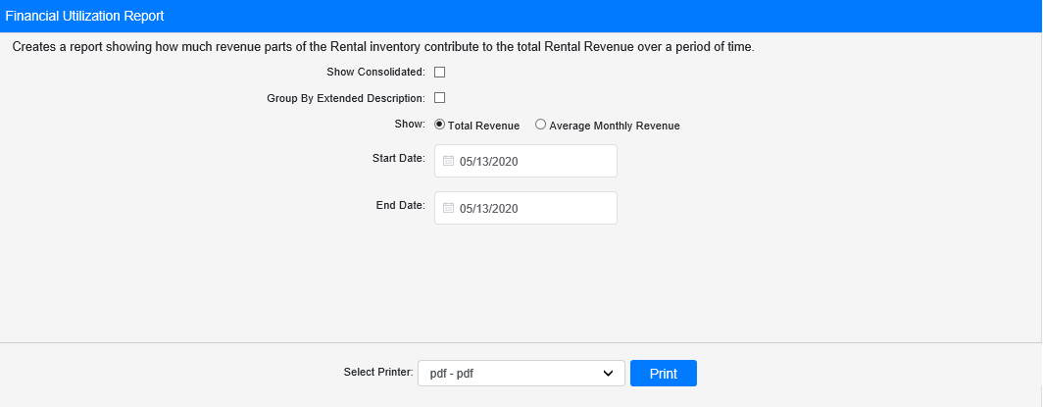

Field Definitions:

Show Consolidated: If you are a multi-location dealership with a Consolidated location, check this box to include the Consolidated location’s information on your report. Uncheck it to only print a report for your individual location. NOTE: If running the report in the Consolidated location, you must check this box to receive a report.

Group by Extended Description: Check this box to group the rental units on the report by their Rental Class’s extended description instead of by their Rental Group and Class.

Show Total Revenue/Average Monthly Revenue: Select whether you want the revenue amount displayed on the report to represent the unit’s total revenue for the period or its average monthly revenue for the same period.

Start Date/Time: Enter the start date/time for the report here.

End Date/Time: Enter the end date/time for the report here.

Select Printer: Select the printer to receive the report. Use the pdf printer to preview the report.

Click “Print” to print the report.

Sample Report:

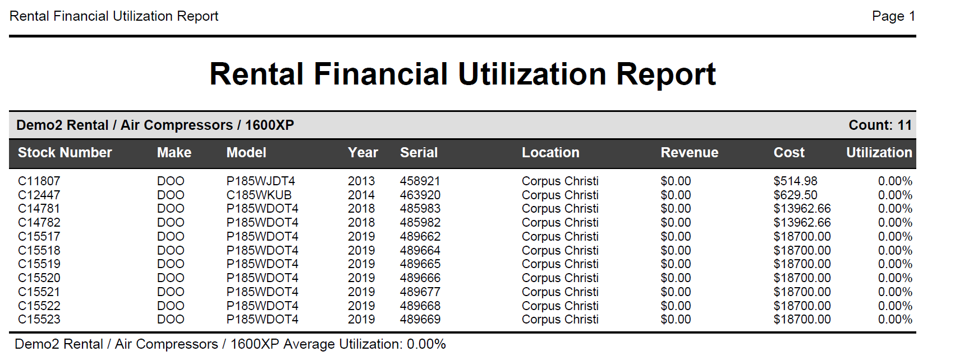

This is an example of a report run for Total revenue per unit over the report’s time period. The report shows a list of all Rental units grouped by family/group/class. Each unit is listed by its stock number, along with the following information:

- Make
- Model
- Year
- Serial Number
- Location
- Revenue over report time frame (either total or average by month)
- Cost
- Percent Financially Utilized

A total line at the bottom of the unit list shows the average percent financially utilized for the entire Class. Another total will appear after the last class in the Rental Group, showing the Group’s average percent financially utilized.

Sample Report Grouped by Extended Description: If you check the Group By Extended Description box, the report will provide the same data for each unit. However, they will be organized by their Rental Class’s extended description, which will alter the Class Average Utilization Percentage depicted, and the report will not provide any average percentage for Groups as a result.

