G/L Detail Inquiry (GLDI):

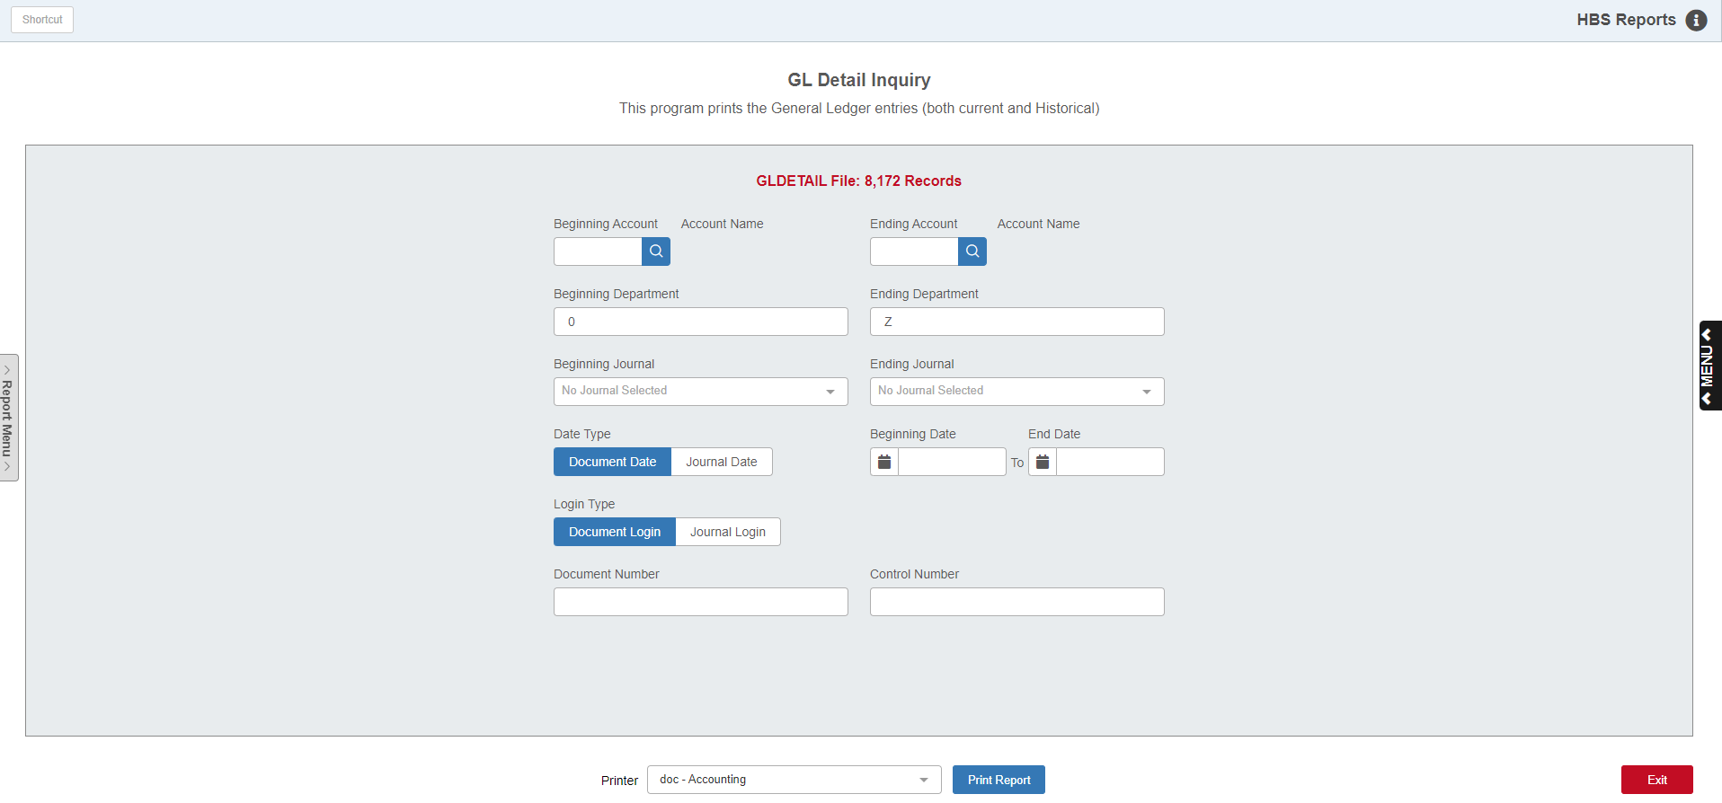

G/L Detail Inquiry (GLDI) accesses the database of historical General Ledger entries or detail on your system. This file contains the complete detailed Journal entries from when you began using the HBS System or as far back as the feature was introduced, whichever is more recent. This file captures each entry made to the system. Unlike the G/L Journal Entries (GLJE) memo report, this feature accesses both OPEN and CLOSED accounting periods.

To access this function, you can either:

Select “General Ledger” from the menu. Choose the “Memo Reports” submenu and click “GL Detail Inquiry.”

Type “GLDI” in the Shortcuts Bar.

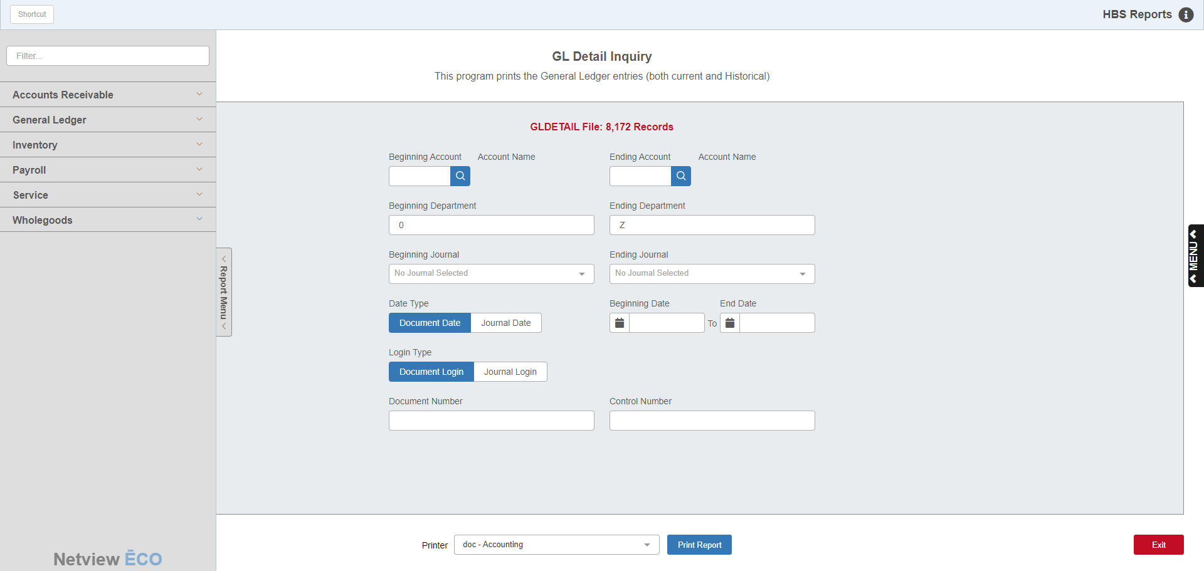

Reports Navigation Menu: This new menu appears on the left side of the screen for all reports and allows the user easy access to all report programs in the system. It is collapsable and can be easily hidden.

Field Details:

Beginning Account: If you are researching the activity of a specific account number or range of account numbers, enter your starting account number here. Type in an account number or look it up.

When examining a single account number, enter that number in both the Beginning and Ending Account fields.

If you are not searching by account number, you may leave the field blank.

Ending Account: If you are researching the activity of a specific account number or range of account numbers, enter your ending account number here. Type in an account number or look it up.

When examining a single account number, enter that number in both the Beginning and Ending Account fields.

If you are not searching by account number, you may leave the field blank.

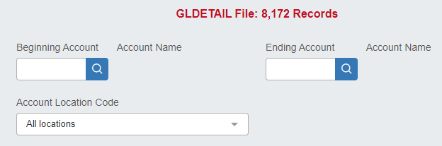

Account Location Codes: This field only appears for multi-location dealerships using GLDI in the Consolidated location. It allows you to limit your search to a single location’s G/L account numbers. Select the desired code from the drop-down menu. If you are not searching by location code, you may leave the field set to “All locations.”

Beginning Department: If your search involves a specific department code or range of departments, enter your starting department code here (example: 1-Sales, 3-Parts, 4-Shop, etc.).

When examining a single department, enter that code in both the Beginning and Ending Department fields.

If you are not searching by department, you may leave the field blank.

Ending Department: If your search involves a specific department code or range of departments, enter your ending department code here (example: 1-Sales, 3-Parts, 4-Shop, etc.).

When examining a single department, enter that code in both the Beginning and Ending Department fields.

If you are not searching by department, you may leave the field blank.

Beginning Journal: If your search involves a specific Journal or range of Journals, enter your beginning Journal number here or choose it from the drop-down menu.

When examining a single Journal number, choose it at both the Beginning and Ending Journal fields.

If you are not searching by Journal number, you may leave the field blank.

Ending Journal: If your search involves a specific Journal or range of Journals, enter your ending Journal number here or choose it from the drop-down menu.

When examining a single Journal number, choose it at both the Beginning and Ending Journal fields.

If you are not searching by Journal number, you may leave the field blank.

Date Type: Choose to search by either:

Document Date, or the creation date of the individual transaction itself (default selection)

Journal Date, or the date the entry was posted or journaled

Beginning Date/End Date: When searching by a specific date or range of dates, enter the dates in these fields or select them from the calendar. When examining a single date, enter that date in both fields.

Login Type: Choose to search by either:

Document Login, or the user ID that created the transaction shown (default selection)

Journal Login, or the user ID that posted the transaction shown

Document Number: This field offers the option to further specify your search by entering the primary reference or document number of the specific transaction. This option makes it possible to focus on a single transaction and see the complete Journal entry. If you do not want to search for a specific document, leave the field blank.

Control Number: This field lets you look up transactions related to a specific control number by entering it in. A control number is most commonly found used with subledgered accounts, but can apply to other transactions as well. The control number typically is a customer number, a vendor number, a stock number, an employee number, or a customer name. In the case of subledgered Contracts in Transit or Warranty Receivables accounts, this would be whatever you used to identity the contract or warranty (i.e. RO number or customer name). If you do not want to search for a specific control number, leave the field blank.

Printer Name: Identify the printer to receive your printout. A default printer is pre-filled, but you may change it as necessary. Use the pdf-Display printer to display the report before printing.

Print Report: Press this button to generate the report.

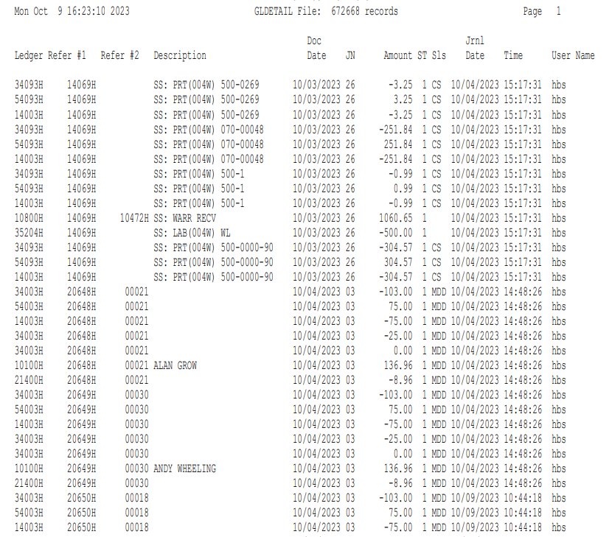

Report Columns:

Ledger: This column shows the General Ledger account number for this line of the transaction.

Reference 1: This column holds the primary reference number or document number for the transaction (Check #, Invoice #, Document #, etc.)

Reference 2: This shows the control number for the transaction, if applicable. It is usually a stock number, vendor number, or customer number.

Description: Here you will see the description of this transaction line, if applicable.

Doc Date: This column shows the date physically entered on the transaction (document date).

JN: This column displays the Journal number for this line of the transaction.

Amount: The amount here is the amount of this line of the transaction shown.

Sls: Point-of-Sale (POS) and Unit Sales (US) transactions will show a salesperson’s initials or number in this column.

JN Date: This column shows the date the entry was journaled in the system.

Time: This column shows the system time when the transaction was journaled or posted in the system.

User Name: This column shows the ID of either:

The user who created the transaction (if you chose to run the report by Document Login)

The user who Journaled the transaction (if you chose to run the report by Journal Login)

Total: A total is included at the end of the report.

If you selected to see a complete transaction, the total should be “0.”

If you chose to view the detail of a particular account number, Journal, or range of dates, the total represents the net total of the activity chosen.

