G/L Document Entry (GLED)

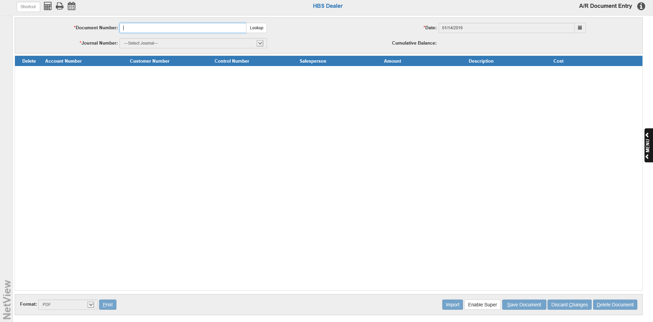

G/L Enter Documents is a place where you can enter documents into the Accounting system. Entries might include bank deposits; Units purchases, sales (if you do not have the Units module); vendor disbursements (if you do not have the Accounts Payable module); Payroll Checks (if you do not have the Payroll module); and miscellaneous adjustment documents. Generally, you should make the entry in the appropriate module. Therefore, use this screen for General Ledger documents only.

To access this function:

- Select “General Ledger” from the drop-down menu and click on “Document Entry.”
- Type “GLED” in the Shortcuts Bar.

NOTE: This program is identical to Accounting Document Entry (ARDI).

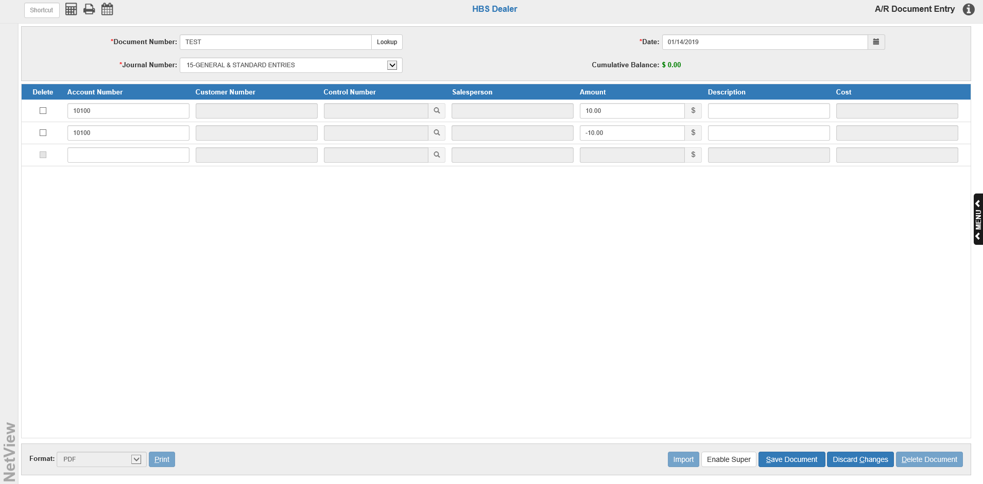

Field Definitions:

Document Number: To create a new document, type the document number in here. Examples: check number, invoice number, receipt id, or other reference.

NOTE: You CANNOT change the document number once you have entered it.

Document Lookup: If you want to reopen an unposted document you previously created in GLED, click this button to view a list of documents available for editing. If you know the specific document number already, you can simply type it in the Document Number field to access it.

Date: Enter the document date here or select it using the calendar. The field pre-fills with the current date.

Journal Number: Type in the Journal number to receive the transaction or select the Journal from the drop-down menu. Valid Journal Numbers are 01 through 27. Journals 03, 09, 12, and 27 are used exclusively by the system and are not available for manual entries.

TYPICAL JOURNAL NAMES

1 UNITS SALES JOURNAL 15 GENERAL & STANDARD ENTRIES
2 16 UNIT TRANSFERS AND ADJUSTMENTS
3 PARTS SALES JOURNAL 17
4 18 YEAR END ADJUSTMENTS
5 19
6 20
7 21
8 BANK & CREDIT CARD DEPOSITS 22
9 CASH RECEIPTS JOURNAL 23 INTER STORE PARTS TRANSFERS
10 CASH DISBURSEMENT JOURNAL 24 FIXED ASSET DEPRECIATION
11 UNIT PURCHASES JOURNAL 25 RENTAL MANAGEMENT ENTRIES
12 AP PURCHASES JOURNAL 26 SERVICE MANAGEMENT ENTRIES
13 PAYROLL JOURNAL 27 COMPUTER GENERATED ENTRIES
14

Account #: Enter the General Ledger Account Number for this line of the document. You may do a search by typing in the first number or two of the account number, or by typing in the name or part of the name on the account. The Account Number Lookup Screen (see below) will appear to provide the account numbers and descriptions, which you can scroll through and find the account number you want.

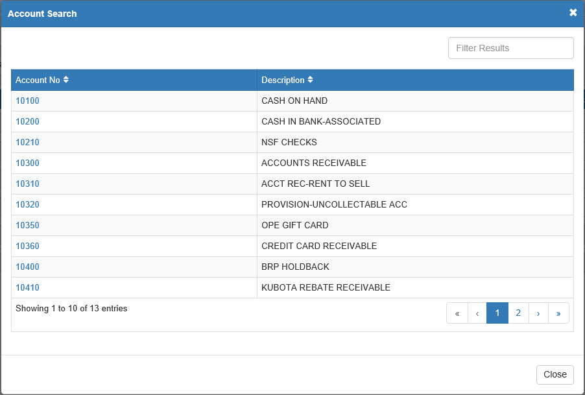

Additionally, if you type in part of the account number and there is only one account that contains that combination of numbers, the application will automatically fill the field with that account number.

TIP—GLED Account Validation:

- Units Payable/Floorplan: If you enter a Unit Notes Payable or Floorplan account number, it will validate the stock number you enter in the Control # field. It may tell you the stock number does not exist, or it may advise you that it has corrected the account number based on the G/L accounts found in the entered stock number’s Unit Source.
- Units Inventory: If you enter a Unit Inventory G/L account, it will validate the stock number you enter in the Control # field. It may tell you the stock number does not exist, or it may advise you it has corrected the account number based on the G/L accounts found in the entered stock number’s Unit Source.
- Units Inventory (Sold Unit): If you enter a Unit Inventory G/L account, and you type in a Sold stock number in the Control # field, it will advise you it has changed the account number because the unit has been sold. In this case, it will be changed to the After Sales account (New or Used, based on the unit’s PREVIOUS status) found in the Sold stock number’s Unit Source. The account is typically either a cost of sales or an expense account. This process ensures that the amount of this entry will be applied to the sold unit’s After Sales Expense field. For a sold unit, it is IMPERATIVE that you begin with the INVENTORY account and let the system switch to the correct one based on the Unit Source. Otherwise, the system will NOT update the sold unit’s After Sales Expense field.

Customer #: This field is only active for 10300 (Accounts Receivable, customer account number required) and possibly 10100 (Cash on Hand, account optional). Type the customer number or search for it by typing in the first few letters of the customer's last name.

Control #: If the account number has a subledger code, you will need to enter the appropriate Control Number here. This can be a stock number, vendor number, reference number, or customer name, depending on the type of account.
Common Subledger Codes
Type of Account Code Control Number
Unit Inventory 5 Stock #
Notes Payable 5 Stock #
Warranty Receivables 5 Invoice #/Document #
Contracts in Transit 5 Customer # or Customer Name
Customer Deposits 5 Customer # or Customer Name
Checking Account 8 Check # or Deposit #

Salesperson: An entry in the Salesperson field (initials or employee number) is only required if the account number is a sales account (examples: 32001, 34003).

Amount: Enter the amount to pass to the account number for this line of the entry. If you need to enter a credit amount, type the “-” before or after the amount. You may type the amount with or without the decimal point (type in 2537 or 25.37 to enter $25.37). In the case of entries to a Unit Inventory account, you can select the type of amount being added. Click on the letter in the Amount field to choose if the amount concerns the Base Net (B), Freight (F), an Option (O), or a Repair Order (R).

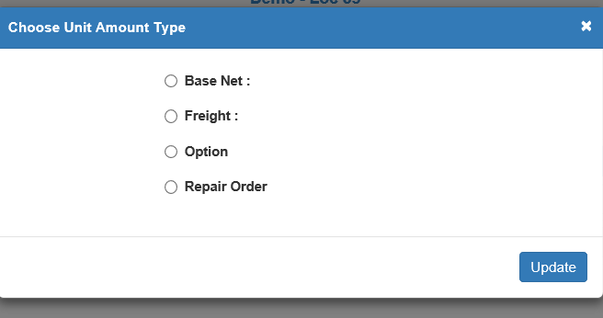

Description: Type a brief description of this transaction. The description should be unique for this document. For example, typing PARTS for your parts inventory account number 14003 does not tell you much since you probably know that 14003 is the Parts Inventory account. However, a description of PARTS-AGCO or PARTS-AUTOZONE would give you a better idea of what you bought and where it came from.

Cost: When you make an entry to a sales account, you may enter the cost of the sale in this field (if the cost and inventory accounts are referenced to it in Account Number Maintenance (ANM)). It will then make two automatic entries: a debit (+) to the Cost of Sales account and a credit (-) to the Inventory account. Type the amount of the cost in this field. If you are reversing a sales entry, you would enter a credit amount here. You can also make your own Cost of Sales and Inventory entries by entering the appropriate account numbers on following lines and ignore the Cost field. The use of this field would probably be limited to entry of manual sales and should be used with caution.

Cumulative Balance: This field on the right side of the screen shows a running balance for the transaction. The entry is balanced when this field shows a zero. If you attempt to save the document when the cumulative balance is not zero, you will require a password to continue (see image).

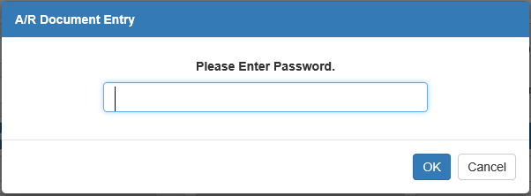

Do NOT enter the password unless you are trying to create an out of balance document.

Active Keys:

Save Document: This button saves a new document or any changes made to an existing document. It is only active when there is an active document on the screen.

Discard Changes: This button discards any changes made to the document on the screen that have yet to be saved. It is only active when there is an active document on the screen.

Delete Document: This button permanently deletes the document on the screen. It is only active when there is an active document on the screen.

Print: This button generates a proof sheet of additions, changes, and deletions in the format you have selected. Select the type of printout you want from the Format drop-down menu next to the button. A default format name is pre-filled, but can be changed as necessary using the drop-down menu. Click the button to print out your proof sheet.

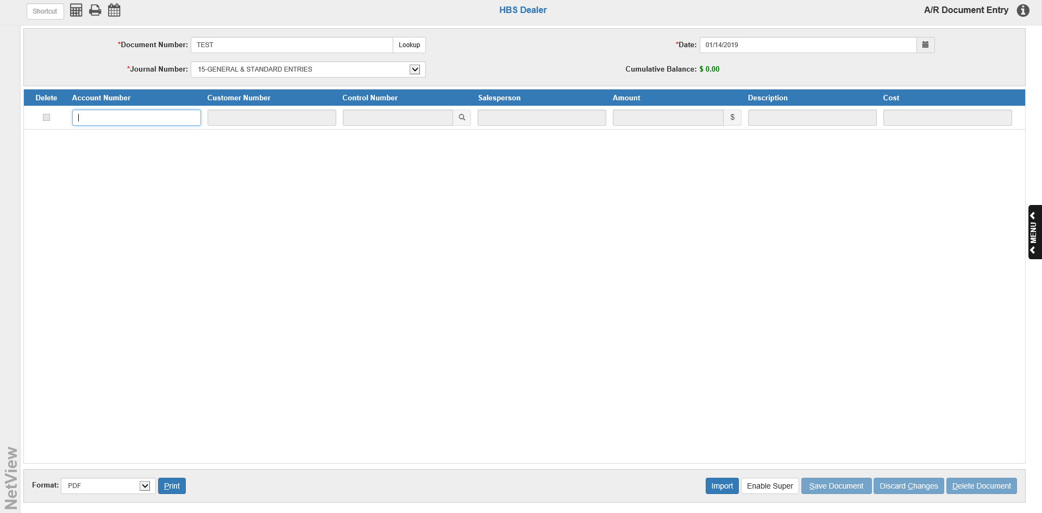

Import: This new feature allows you to directly import ledger information from an outside source into GLED, rather than having to re-enter it manually. The button allows you to import entries like month depreciation, or payroll, or even your accountant’s year-end adjustments. It could also handle the recurring entries you may make each month. NOTE: This feature is not available to all users; you must have specific permissions in order to use the G/L Import.

This only works when creating a new document—you cannot use the feature when editing an existing document. Additionally, the import process utilizes a specific formatted spreadsheet, which must be formatted as follows:

- Spreadsheet has just 4 columns.
- All info must in capital letters.
- Format the ENTIRE spreadsheet as TEXT, then format just the 3rd Column, Column C as Number.
- Column A holds the 5 or 6 character G/L account number (leading zeroes have to be present and any LETTERS must be in CAPS).
- Column B holds the Control number if the G/L account is Accounts Receivable or a subledgered account (Customer number MUST be five characters long including any leading zeroes).
- Column C holds the amount for the transaction line (it will have numeric formatting because the column is formatted that way – i.e. 147.23 or -1528.44).
- Column D holds the Description of the transaction line (Holds 28 characters, just as in GLED).
- There can be NO autosum lines.
- It only works with single worksheet spreadsheets.
- It can import an out of balance entry if that is what is in the spreadsheet–but you can edit it in GLED once imported.
- You may use all the Standard accounts that can be used in GLED in the spreadsheet, including Allocation Accounts.
- Save the spreadsheet as CSV (Comma Delimited). CAUTION: When you save a file as CSV with the special formatting needed to be imported, you should not open the file to check it before importing as that opening will undo the special formatting you applied to the spreadsheet. Save the spreadsheet with the formatted described and import it without opening it again. Once the spreadsheet has been imported into GLED, it can be edited.
  - If the imported entry is out of balance, additional lines can be added once it has been imported or the lines imported can be changed as needed.
  - In the case of entries to a Unit Inventory account, you can edit the line to select the type of change desired for that line. Click on the letter in the Amount field to make a selection.

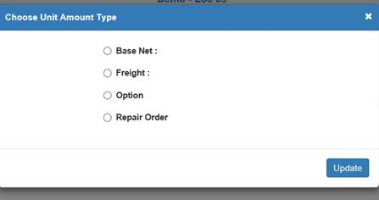

Once your spreadsheet is ready, access GLED and fill in the Document number desired, along with the date and Journal number. The Import button will only activate at this point. Click it to open the Import window:

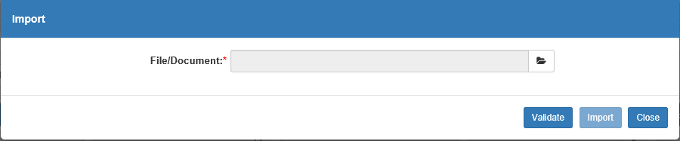

Use the Browse feature to the right of the File/Document field to select the file you want to import.

Once you’ve done so, click Validate. This will run the following checks on the spreadsheet:

- Checks the G/L account numbers to see if they are valid.
- Verifies that any customer number entered in the Control Number column (column 2) for the A/R account is a valid customer number.
- Verifies that any stock number entered in the Control Number column (column 2) for a unit inventory or notes payable/floorplan account is a valid stock number.

NOTE: The process does NOT validate the match-up between the G/L account and the stock number entered.

If there are problems with any values on the spreadsheet, you will see a “Validation Error” message like the one displayed below:

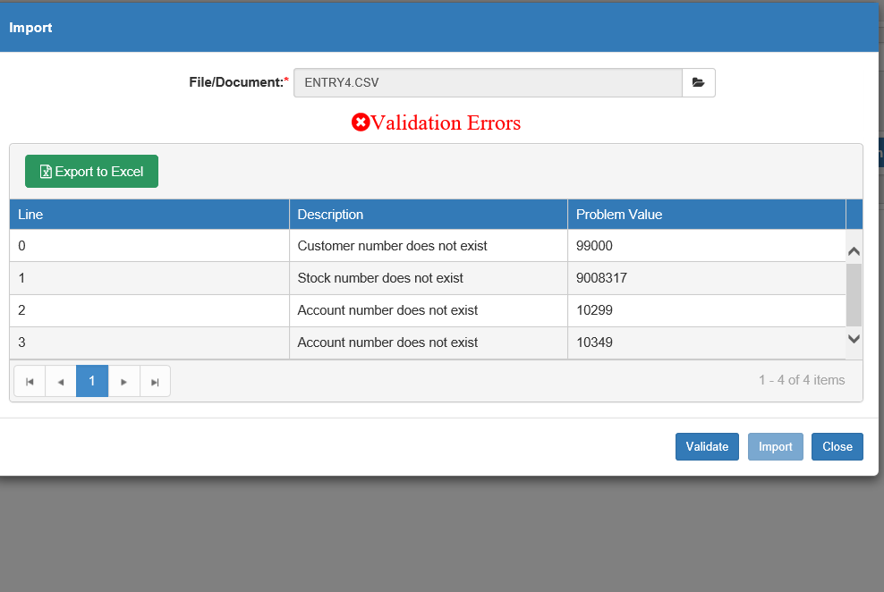

The error message identifies the line with the error (lines begin with 0, 1, 2 and so on), a description of the error, and the value with the error. The spreadsheet would have to be edited and values corrected before it can be imported into GLED.

If all columns and rows in the spreadsheet are validated, you will see a “Validation Successful” message like the one displayed below:

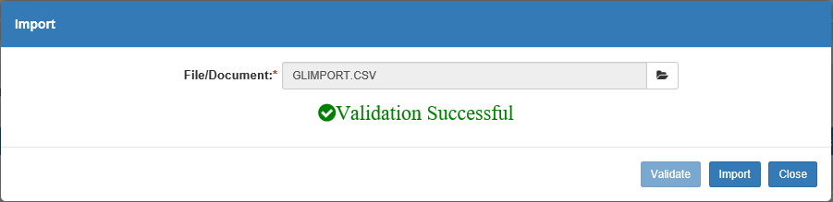

Click Import to import the file. The account entries on the main screen will automatically fill with the information from the file. You can then edit it as needed, as you would with any other document. Click Save Document to save the file.

Editing Existing Documents: You can edit any documents created here until you post them to the General Ledger. Recall them on this screen by entering the document number in the Document Number field or use the Lookup button to the right of the field to search for a document (see image below).

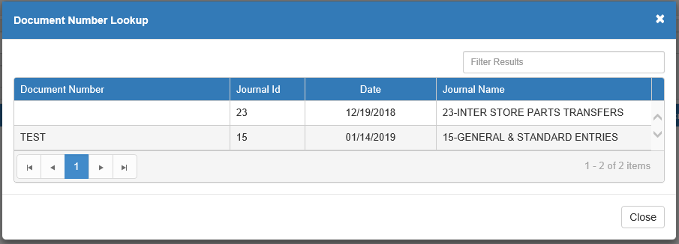

You may change ALL aspects of the document except the document number. Make your changes and press Save Document.

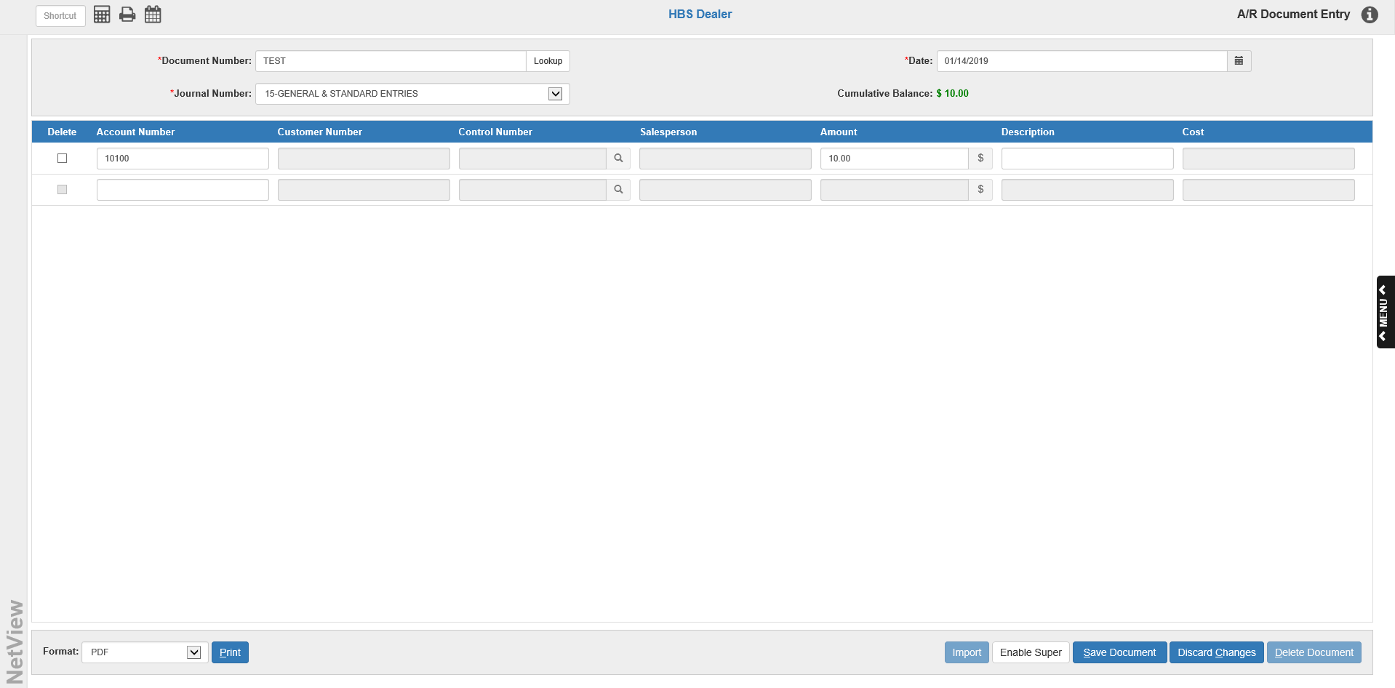

Correcting Out of Balance Documents: If you save a document that has a cumulative balance other than 0.00, you will be asked for a password to continue. If you are not trying to create an out of balance transaction, you DO NOT want to record this transaction. Press the Cancel button in the window to return to the document, where you can make the necessary adjustments to create a balanced transaction.

Adding a One-Sided General Ledger Document: Occasionally there is a need to create a one-sided Journal entry (perhaps to correct an out of balance in the Trial Balance). Please check with HBS Support before making this entry to verify that it is needed for your situation.

- Enter the Document Number, the Journal Number, and the Document Date. The one-sided document often contains only one account number line entry which will leave a balance in the Cumulative Balance field (see above image).
- Press Save Document. The following window will appear:

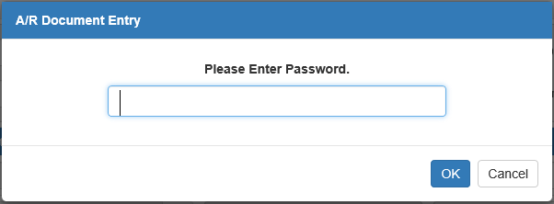

- Type in the appropriate password and press OK to record your out-of-balance document.
- Press Print button to receive the proof sheet.
- Post the single-sided document through Post Journals (GLPJ). Notice that the Journal Total does not equal 0.00.
- Print a Trial Balance (TB) and a G/L Reconciliation Report (GLRR) to verify that the accounting system is now in balance.

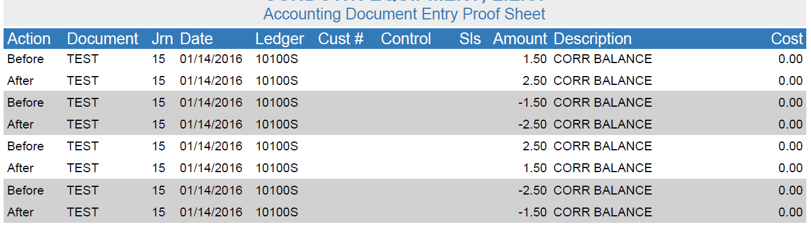

GLED Proof Sheet:

Action: This field shows the final status of the entry lines. For an initial Journal entry, all lines will show after to indicate the final version of the entry. If you edit the entry before it is posted, the proof sheet will show before in this field on any line you changed and after on the revised line. You may also see deleted to show the lines you removed from the entry.

Document: This field shows the document number for this line.

Jrn: The Journal Number (01 through 27) will show here.

Date: This field shows the document date entered.

Ledger: This is the General Ledger account number for this line of the transaction.

Cust#: If a customer number was used on this line, it will appear in this space. Most transactions will not have an entry in this field.

Control: If the account number entered in the Ledger field has a subledger code, you will see the control number here (Stock Number, Vendor Number, Reference Number, or Customer Name).

Sls: If the salesperson’s initials were entered, they will show in this field.

Amount: The dollar amount for this line of the entry will be shown here.

Description: The description for this line of the transaction will display in this field.

Cost: If a cost entry was made, you will see the amount entered in the cost field here. This amount also will be credited to the appropriate inventory account.

