Financial Statements Totals & Parameters (GLFT)

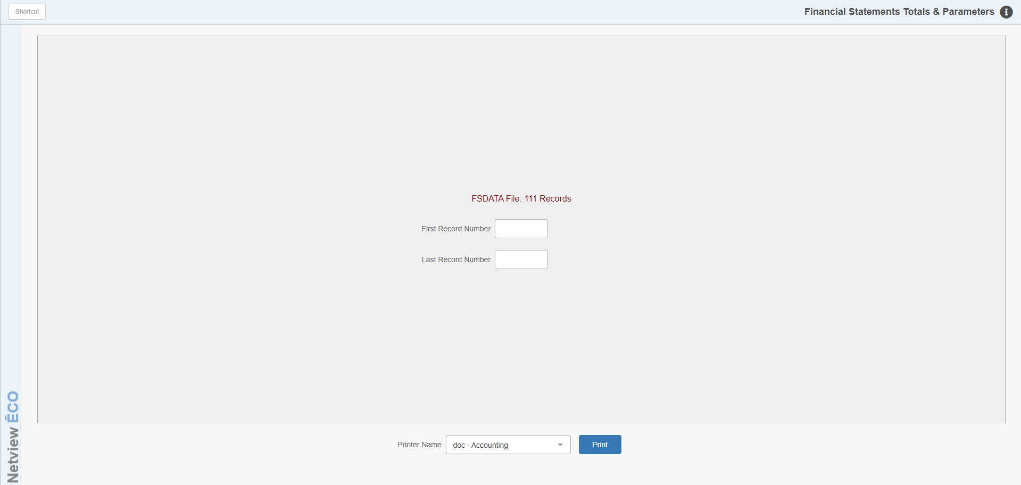

The Financial Statements Totals/Parameters Report (GLFT) prints information from the FSDATA file. The program shows you how many records are included in the file and lets you set a range of record numbers to include on the report.

To access this function, you can:

- Select “System Maintenance” from the menu and choose the “Data File Review” submenu. Expand the “General Ledger” submenu beneath that and click “Financial Stmt. Totals/Parameters.”
- Type “GLFT” in the Shortcuts Bar.

First Record Number: Enter the first record number you want printed on the report. NOTE: If you only want to look at a single record, enter the number in both fields.

Last Record Number: Enter the last record number you want printed on the report. NOTE: If you only want to look at a single record, enter the number in both fields.

Printer Name: Set the printer to receive the report here. Use the PDF printer to preview the report on your screen.

Print: Click this button to generate the report.

Sample Printout:

