General Ledger Memo Report (GLGL)

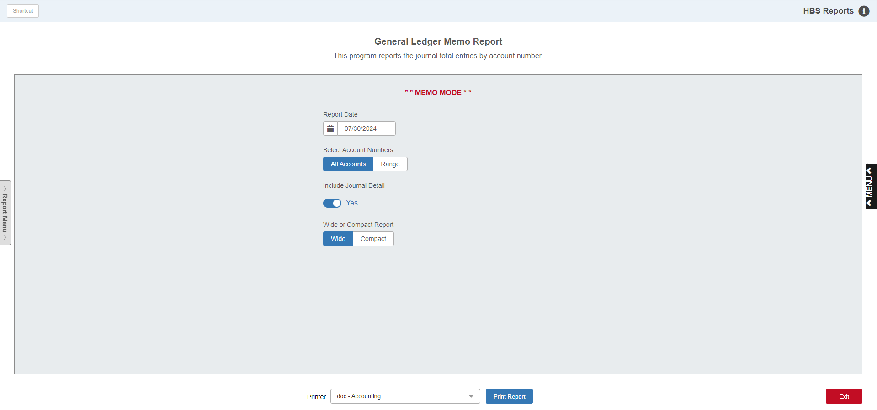

General Ledger Memo Report (GLGL) is a Journal activity report for G/L accounts in the open accounting periods. It prints (or displays) the account number and itemizes all Journals posted to it, then gives a Net Activity and New Balance figure for the account. The accounting information available for this report is current to the most recent date of journalized documents.

To access this function, you can either:

- Select “General Ledger” from the menu. Choose the “Memo Reports” submenu and click “General Ledger.”
- Type “GLGL" in the Shortcuts Bar.

Use this report to check Journal activity for all accounts or a range of accounts. It can provide quick insight to the activity for a group of accounts. Depending on your needs, the summary style may suit the situation. If you need more, the detailed style shows the detail for the totals.

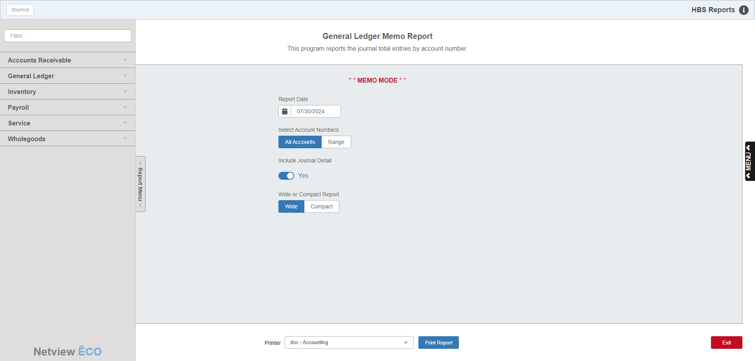

Reports Navigation Menu: This new menu appears on the left side of the screen for all reports and allows the user easy access to all report programs in the system. It is collapsable and can be easily hidden.

Field Definitions:

Report Date: Select the report date for any open accounting period you wish to see. The report will be generated “as of” the date you specify.

Select Account Numbers: This report can be generated for all accounts with a balance or activity within the scope of the report date selected. The “All Accounts” choice provides a report for all G/L accounts. If you want to examine a select group or range of accounts, choose “Range” to specify a range of account numbers. NOTE: To check a single account number, choose “Range” and enter that number in both the starting and ending account number fields.

Include Journal Detail:

- Select Yes for a full detail report with Journal details of the amounts posted to the accounts.
- Select No for a summarized General Ledger with a total for the open period activity and the YTD Balance for the report date selected.

Wide or Compact Report: This choice defines the layout of the report. The compact version is a bit more compressed. The wide version is best for a printed version.

Printer Name: Identify the printer to receive your printout. A default printer is pre-filled but you may change it as necessary. Use the PDF printer to display the report.

Print Report: Press this button to print your report.

Sample Report – Detail Style - Wide

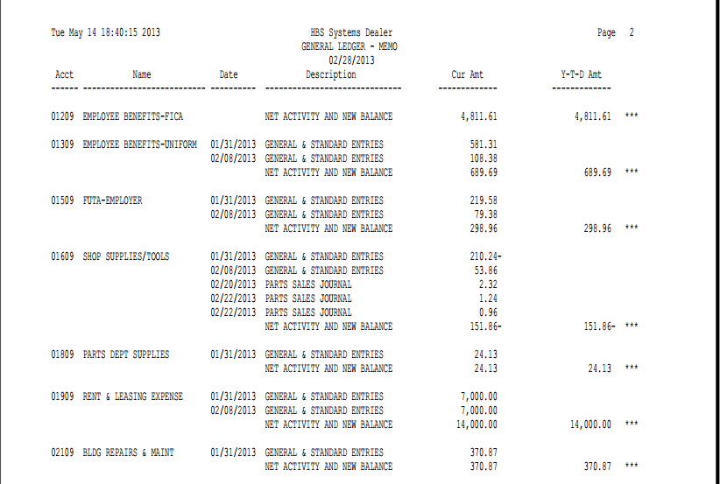

Report Columns:

Acct: This field shows the G/L account number for the detail line of the report.

Name: This field shows the description of the account number for this line of the report.

Date: The date field shows the date of this line of the report.

Description: The first line of each account’s activity may show the Balance Forward (balance as of the last accounting period closed). Subsequent lines of activity name the Journal where the activity occurred. The final line shows Net Activity and New Balance.

Cur Amt: All account numbers on the "Detail" version are organized into paragraphs. The figure in this column is the account number's amount of activity for the open accounting period.

Y-T-D Amt: The YTD Amt (Year-to-Date) column may contain two figures: the account number's beginning balance total plus the sum of the open accounting period's net activity. If the ledger number has a beginning balance (closing balance of last accounting period closed), then this figure is placed on the first line of the Account Number Paragraph, followed by two (**). The grand total figure that includes both the open accounting period's net activity, and the new balance figure shows on the last line of the Account Number Paragraph with three (***) behind it.

Sample Report - Summary Style – Wide

