G/L Journal Entries (GLJE):

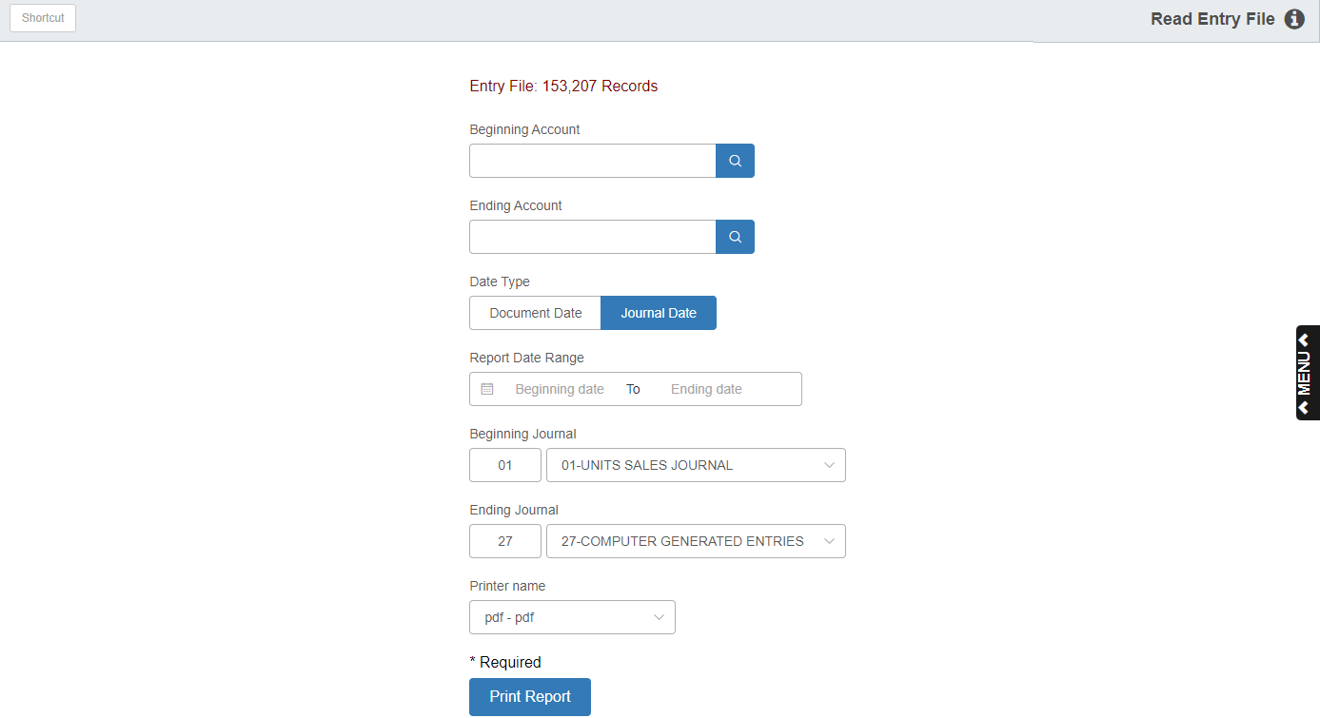

Journal Entries (GLJE) is a listing of all the journalized documents in the current open accounting periods (all posted data since the last time the G/L Month End (GLME) function was run). GLJE is a function for finding data—a General Ledger Journal Inquiry function.

To access this function, you can either:

- Select “General Ledger” from the menu. Choose the “Memo Reports” submenu and click “Journal Entries.”
- Type “GLJE” in the Shortcuts Bar.

The report may be either printed or displayed. You may search for accounting records by the Document Date or the Journal Date. You may also select a particular date or a range of dates for your inquiry. You may inquire about data for a particular Journal or for a range of Journal numbers. You may even examine a single account number as well as a group of account numbers.

Field Details:

Beginning Account: To examine the activity of a specific account number or range of account numbers, enter or look up an account number here. When examining a single account number, enter that number in both the beginning and ending account fields.

Ending Account: To examine the activity of a specific account number or range of account numbers, enter or look up an account number here. When examining a single account number, enter that number in both the beginning and ending account fields.

Date Type: Choose which date you want the report to look at when pulling information:

Document Date (the date entered on the individual transaction itself)

Journal Date (the date the entry was posted or journaled)

Report Date Range: When searching for a specific date or range of dates, enter the beginning and ending dates here, or select them using the calendar icon. When examining a single date, you would enter that date in both fields.

Beginning Journal: If your search involves a specific Journal or range of Journals, type in or select a Journal number here. This field defaults to Journal 01, but can easily be changed. When examining a single Journal number, enter that number in both the beginning and ending Journal number fields.

Ending Journal: If your search involves a specific Journal or range of Journals, enter or select a Journal number here. This field defaults to Journal 27, but can easily be changed. When examining a single Journal number, enter that number in both the beginning and ending Journal number fields.

Printer Name: Identify the printer to receive your printout. A default printer is pre-filled, but you may change it as necessary. Use the PDF printer to display the report.

Print Report: Press this button to run your report.

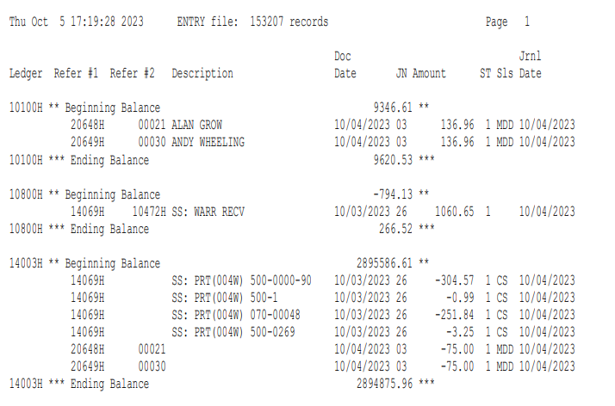

Report Detail: The report is broken down into sections by Ledger Number. The detail for the Ledger Number is shown between the Beginning Balance and the Ending Balance lines.

- The Beginning Balance is the account's Year-to-Date balance as of the last month closed.
- The Ending Balance line is the sum of the Beginning Balance figure and the open period detail.

NOTE: Because the report has these figures to work with, it may calculate differently than the G/L Detail report (GLDI).

Ledger Number: This is the account number for the transaction detail. The number will only be recorded in this column on the Beginning Balance and Ending Balance lines, signifying the first and last lines of a Ledger Number section.

Reference 1: This field holds the primary document number (i.e. a check number or a sales invoice number).

Reference 2: This shows the control number (i.e. a stock number or a customer account number).

Description: This is the description of the transaction. It may be the comments originally entered on the description line of a manual entry or supplied by the system.

Document Date: This shows the actual date the document was created (i.e., the date of the invoice or a check).

Journal Amount: This field shows the dollar amount of the transaction.

ST: This field references the Journal Number where the transaction was entered.

Sls: This field shows the initials of the salesperson for the transaction (POS, ROM, and Units transactions).

Journal Date: This field shows the date the transaction was journaled.

