G/L Month End (GLME)

G/L Month End (GLME) is the process to finalize and close an accounting month. There are no rules about when you have to run this program, but generally suggest you close an accounting month as soon as you are comfortable with the figures for that period. As a suggestion, you might try to close the previous month’s accounting by the 15th of the following month.

*** Preparation for the G/L Month End ***

- Enter and post all outstanding documents for the period to be closed—the list of journals on your End of Day List plus Parts/Service too.
- Review the financial reports. Be sure to date the list of reports to the LAST day of the month you will be closing.
  - Trial Balance:
    - Run the report for the last date of the period you are closing.
    - Check that it is in balance (Beginning and Ending Totals=0.00).
    - Verify that no balance exists in Invalid Accounts (27990, 27980, 34993, and 14093).
  - Financial Statement: Run the report to check the Balance Sheet's "Current Profit/Loss" figure and the Operating Statement's "Total Net Income."
  - Expense Analysis: Run report to check expenses.
- If you have any adjustments, make them and run the END OF DAY steps again (plus Parts/Service)
- Rerun the reports as needed once they have been posted.

*** G/L Month End Reports ***

The Month End process provides the following collection of reports for the period closed. Each of these will be saved on the system and can be printed from Financial Reprint Data (GLRP).

- Trial Balance
- General Ledger Memo Report – Detail
- General Ledger Memo Report – Summary
- Standard Financial Statements
- Subledger Reports
- Expense Analysis Report

*** Additional Reports to run at the G/L Month End ***

In addition to this set of reports that is generated for the month end, we suggest you print the following reports:

Unit Accounting Report: Run this report for the default settings, but change the date to the last day of the month being closed.

*** General Ledger Month End - The Process ***

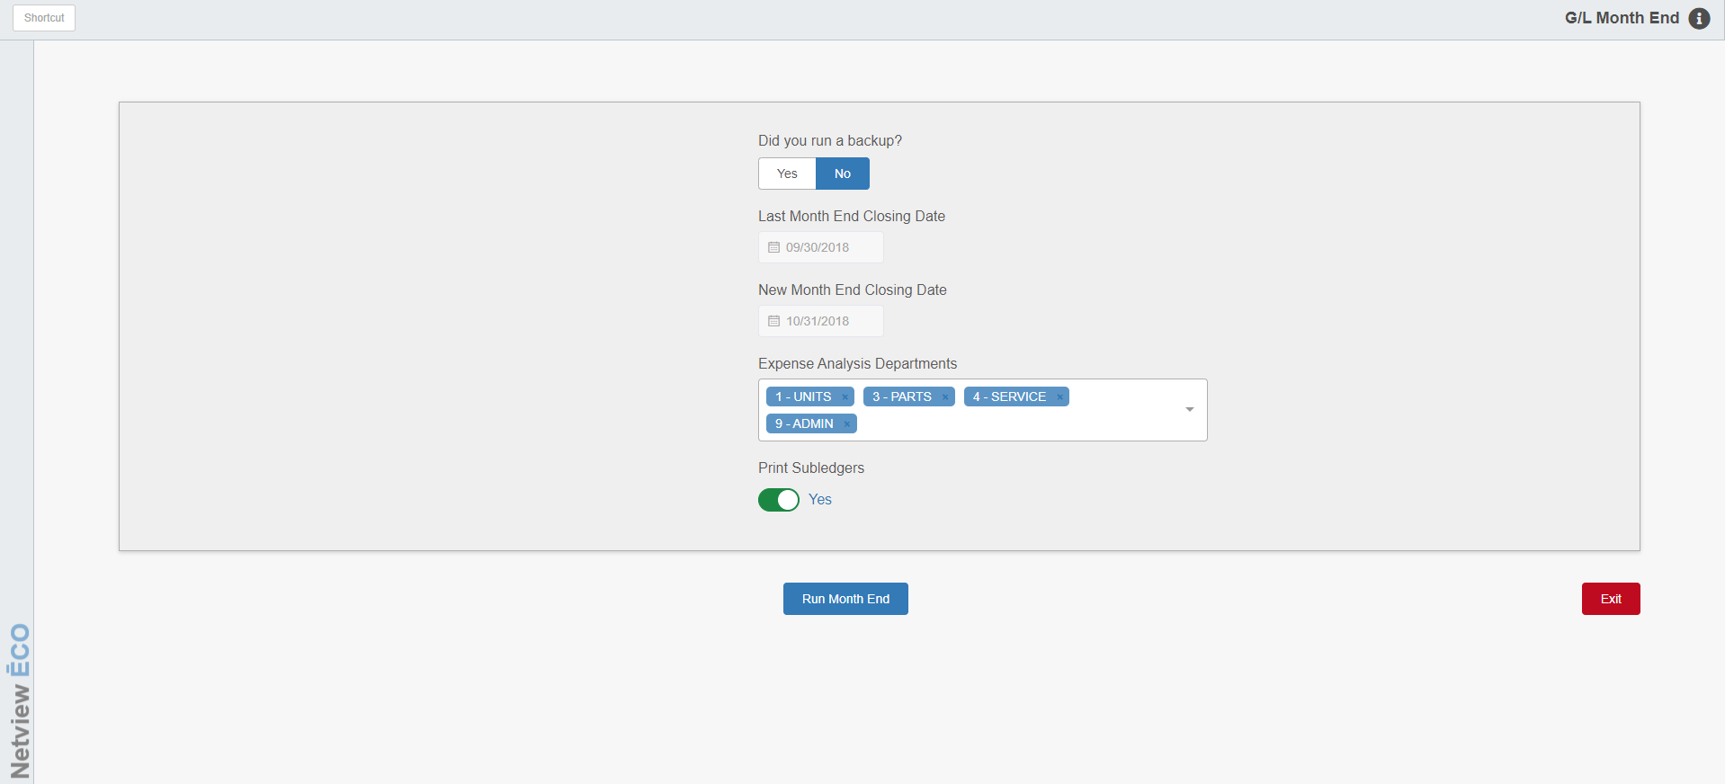

Run this ONLY first thing in the morning. It does not matter what other activity is running on the system at the time, but do not run any journals while it is processing.

To open this application, type GLME in the Shortcuts Bar (for multi-location dealerships, this should be run in the Consolidated location).

Field Definitions

Did you run a backup?: CHOOSE YES. The overnight backup tape is a safeguard in the event a problem occurs and provides the ability to restore data if necessary.

Last Month End Closing Date: This is an information-only field. It tells you the last time you ran G/L Month End. Use this information to verify that you haven't "skipped" a month end process.

New Month End Closing Date: This is an information-only field. It shows you the date of the month you will close. If the date is incorrect, call HBS Support for assistance before continuing.

Expense Analysis Departments: Select the following Accounting Departments, if they are not already pre-set:

#1

#3

#4

#9

Print subledgers: Choose YES to generate all Subledger Reports with the rest of the Month End.

Run Month End: When ready, click this button to start the process. The G/L Month End itself runs for up to a few minutes. When completed, you will be returned to the main Desktop screen.

*** Printing Month End Reports***

To print out the Month End Reports, you will need to go to Financial Data Reprint (GLRP).

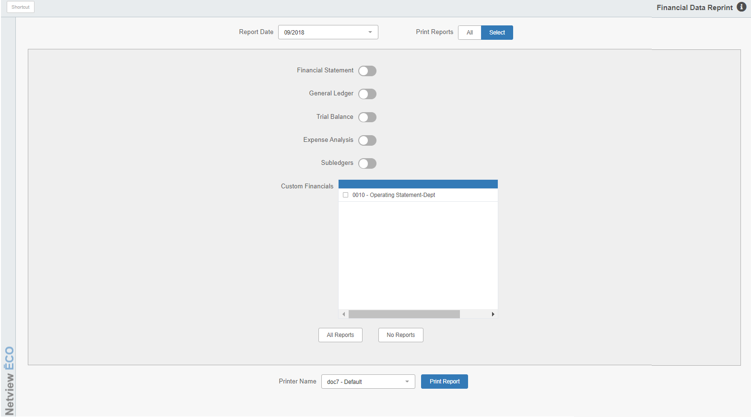

Select the Month End date and print out the available reports as desired.

