G/L Post Journals (GLPJ)

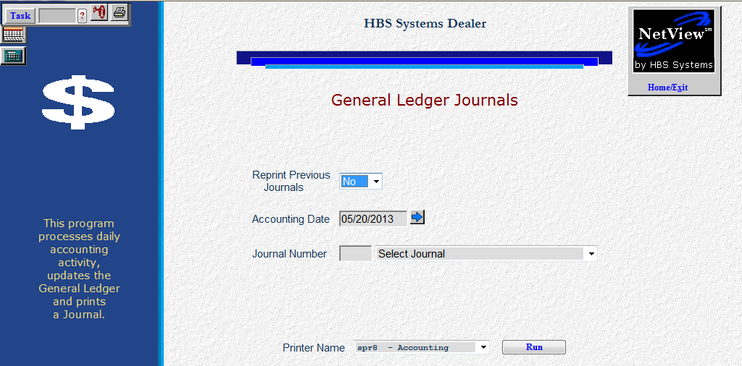

G/L Post Journals (GLPJ) takes any pending accounting documents and posts them to the General Ledger. It will post transactions from both the General Ledger and Accounts Receivable modules.

- To access this function, you can either:
  - Select “General Ledger” from the menu and click “Post Journals.”
  - Type “GLPJ” in the Shortcuts Bar.

Date Validation: A setting in the company files helps you validate the dates entered. The Date Check Feature lets you limit the number of months back and forward from the current date that can be entered. When you set a limit (i.e. 1 month for both), the system will provide a message to have you check the date you just entered and correct it if it is the wrong date. If you want to keep the date entered, you will have to enter the password to continue. You also cannot enter a date for a closed accounting month. To set this feature up, use the Company Defaults screen (CONA).

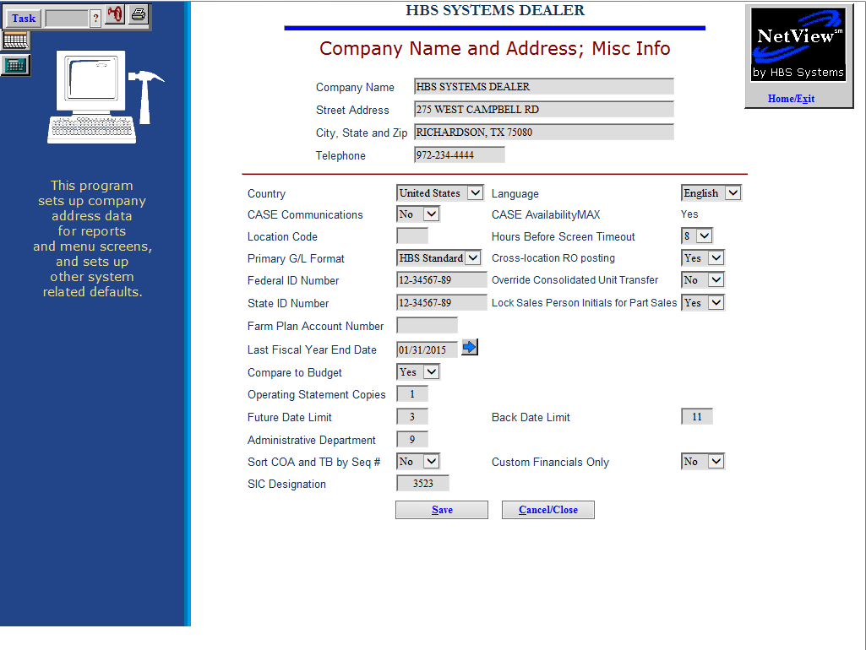

Date Check Feature Setup:

Choose the Future Date Limit field to limit the future dates in Cash Applications and the GL/AR journals. The field accepts the number of months into the future you want to allow before needing to enter a password.

We recommend that you use “1” for this choice. By limiting your future entries to one month, you can eliminate incorrect future dated payments in Cash Applications and limit the posting of future dated entries in the GL and AR journals.

A zero or blank in this field means there is no date limit set.
- Choose the Back Date Limit field to limit the dates PRIOR to the current date. This limit applies to entries made in Cash Applications and the GL/AR journals. The field accepts the number of months prior to the current date you want to allow before needing to enter a password.
  - We recommend that you enter a number of months no larger than the number of accounting months you usually keep open. By limiting your prior dated entries to that number, you can eliminate incorrect prior dated payments in Cash Applications and limit the posting of prior dated entries in the GL and AR journals.
  - A zero or blank in this field means there is no date limit set.

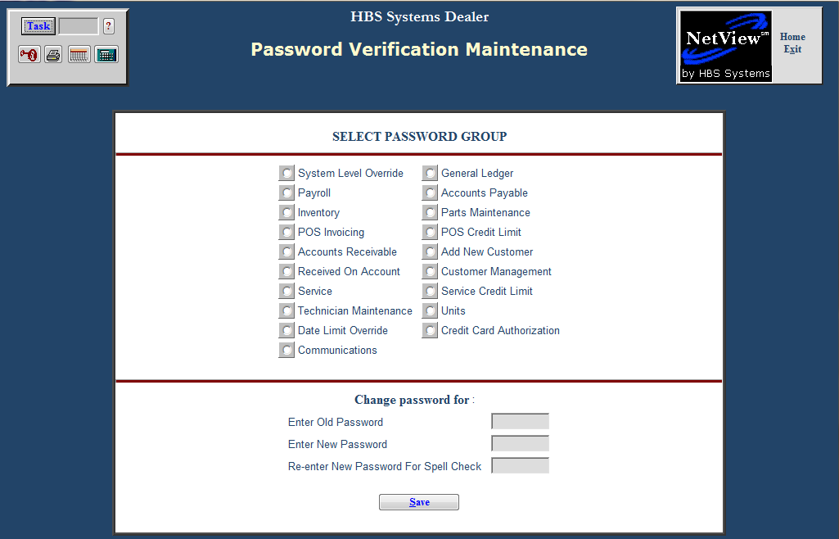

Date Check Feature Setup (Continued): If you want to activate the password portion of the date check feature, use Password Verification Maintenance (PVM) to change the Date Limit Override.

The first time you select this field, it will prompt you for the old password.

Press “Enter” through the old password field and then enter the new password in the field provided.

The new password will remain in force until you return to this screen and change the password at a later time.

With a date limit in place, you will see the following message in GL Post Journals when you enter a date outside the range defined by the Back or Future Date Limit.

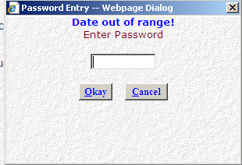

- If you want to keep the date even though it is outside the limits, type in the appropriate password and press the Okay button.
- If you want to correct the date, press the Cancel button on the message box and correct the date.

Field Definitions

Reprint Previous Journals: This option lets you reprint the last journal posted here.

Choose Yes or select it from the drop-down menu to reprint the last journal printout. This is handy if the printer jammed while printing it.

In most cases, No will be the typical choice.

Accounting Date: The current date pre-fills in this field, but you may change the date as needed. You may type a date or select one using calendar button to the right of the field.

Use the current date to post all un-posted transactions up to and including today’s date.

If you are posting entries from a previous month, use the last day of that month as the Accounting Date and it will post all un-posted transactions for that period.

You cannot enter a date for a closed accounting month.

- If you have activated the Date Check Feature and type in a date outside the date limits you chose, you will receive the message “Date out of range. Enter Password.”
  - If you want to keep the date even though it is outside the limits, type in the appropriate password and press the Okay button.
  - If you want to correct the date, press the Cancel button on the message box and correct the date.

Journal Number: Type in any individual journal number or select it from the drop-down menu. Choose ALL to post all entries from all journals.
JOURNALS POSTED WITH “ALL”
01 EQUIPMENT SALES JOURNAL 10 CASH DISBURSEMENT JOURNAL 19 CASH RECEIPTS-OTHER
04 USED EQUIPMENT SALES JOURNAL 11 WHOLEGOODS PURCHASES JOURNAL 20
03 PARTS SALES JOURNAL 12 OTHER PURCHASES JOURNAL 21
04 PARTS SALES-MANUAL ENTRY 13 PAYROLL JOURNAL 22
05 14 VOID & MANUAL PAYROLL JRNL 23
06 15 GENERAL & STANDARD ENTRIES 24 FIXED ASSET DEPRECIATION
07 16 WHOLEGOODS TRANSFERS & ADJ 25 RENTAL SYSTEM JOURNAL
08 17 RENTAL TRANSFERS 26 SERVICE MANAGEMENT SYSTEM
09 CASH RECEIPTS JOURNAL 18 POST CLOSING ENTRIES 27 COMPUTER GENERATED ENTRIES

Printer Name: Select the printer to receive the printout. A default printer name is pre-filled but can be changed as necessary. Use the “see” printer or the PDF printer to view the report on the screen without printing a copy of it.

Run (Alt R): Press this button to run the journal posting process.

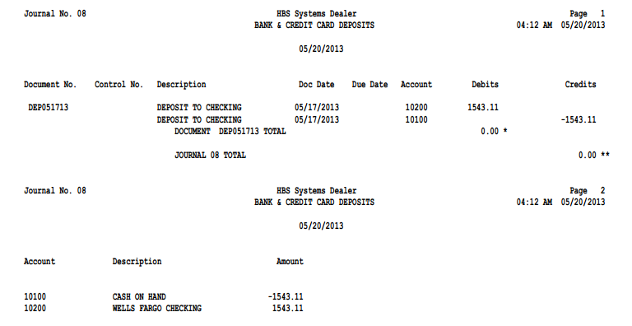

Sample Journal Printout: The Journal printouts consist of two sections per Journal: the detail of the entries posted and the Account Activity Summary. If the posting process affects more than one journal number, a set of these printouts will be printed for each journal posted.

Journal Number Detail Section: The header of this printout includes:

The date and time the journal was posted

The journal number

The description of the journal itself

Document No.: This field shows the document number for this transaction, which could be one of the following:

Check number

Invoice number

Receipt number

Other reference

Control No.: If the account number has a subledger code, you will see the control number here, which could be one of the following:

Stock Number

Vendor Number

Reference Number

Customer Name

Description: The description for this line of the transaction will display in this field.

Doc Date: This field shows the document date entered.

Due Date: This field shows the due date for the transaction where appropriate.

Account: This shows the General Ledger account number used for each line of the transaction.

Debits: If the amount for this individual line was a debit amount, it will appear in this column.

Credits: If the amount for this individual line was a credit amount, it will appear in this column.

Document Total: For each transaction posted, a document total is printed.

If the transaction posted is in balance, the document total will be 0.00.

If an amount other than 0.00 shows for the document total, the document posted out of balance and should be reviewed.

Journal Total: For each journal posted, a journal total is printed.

If the journal posted is in balance, the journal total will be 0.00.

If an amount other than 0.00 shows for the journal total, the journal was posted out of balance and should be reviewed.

Account Activity Summary: The final page of each journal printout shows the Account Activity Summary. This section simply summarizes the net dollar amount passed to various account numbers when the journal was posted. It also shows the following for each affected account number:

Account number

Description

Net amount posted

