G/L Detail Purge (GLPU)

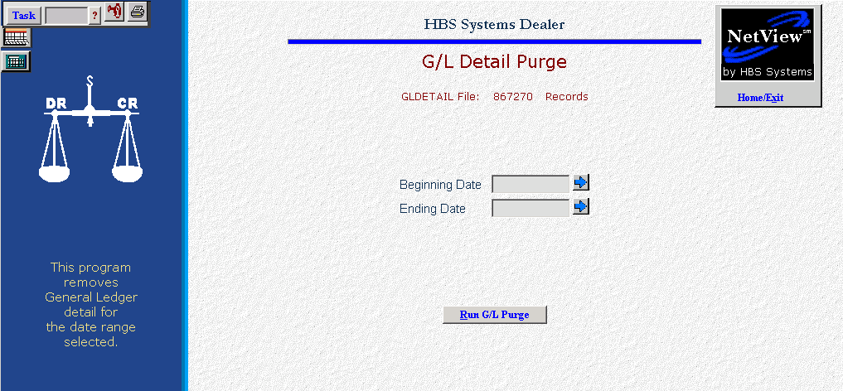
We DO NOT recommend the purging of ANY detail.

