Financial Data Reprint (GLRP)

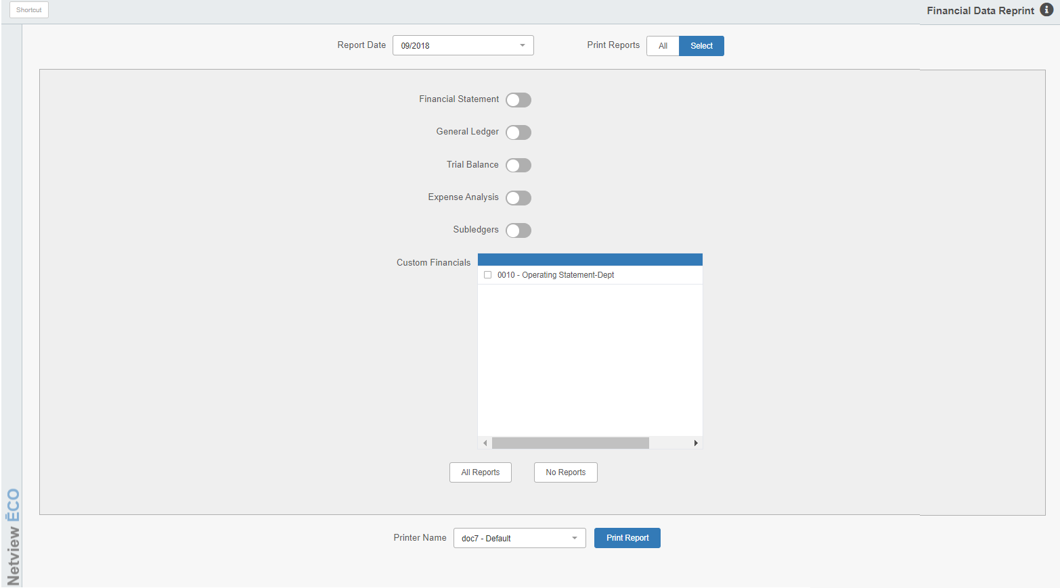

Financial Data Reprint (GLRP) lets you print any or all of the reports generated at the G/L Month End. It accesses the EXACT data from ANY G/L Month End you have closed since you have been using the system, as it reads the file that was captured when you ran the process. The reports can be reprinted from here as many times as you wish after the Month End’s completion.

To access this function, you can either:

- Select “General Ledger” from the menu. Choose the “Memo Reports” submenu and click “Financial Data Reprint.”
- Type “GLRP” in the Shortcuts Bar.

Field Definitions

Report Date: Choose the closed month’s reports you want to print from the drop-down menu.

Print Reports: Indicate which reports you want to print:

Choose All to reprint all the month end reports for the month end selected.

Choose Select to choose from the list of available reports for the selected month. This is the default option.

Financial Statement: This option reprints the entire standard Financial Statement for the chosen month. It will print the following:

Balance Sheet

Consolidated Operating Statement

Departmental Operating Statement (for each department)

Choose Yes to print this collection of reports.

General Ledger: Here you can choose to reprint the General Ledger report. Choose Yes to print this report.

Trial Balance: Here you can choose to reprint the Trial Balance report. Choose Yes to print this report.

Expense Analysis: Here you can choose to reprint the Expense Analysis report. Choose Yes to print this report.

Subledgers: Here you can choose to reprint the Subledgers report. Choose Yes to print this collection of all subledger reports.

Custom Financials: If you have the Custom Financials package, you can you this feature to:

Choose to reprint individual reports by selecting the individual reports desired from the list presented here

Choose to reprint all Custom Financial Reports by clicking the All reports button.

Choose not to reprint any Custom Financial Reports by clicking on the No reports button.

Printer Name: A default printer name is shown here, but can be changed as necessary.

Press the “Print Report” button to generate the selected reports.

