G/L Reconciliation Report (GLRR)

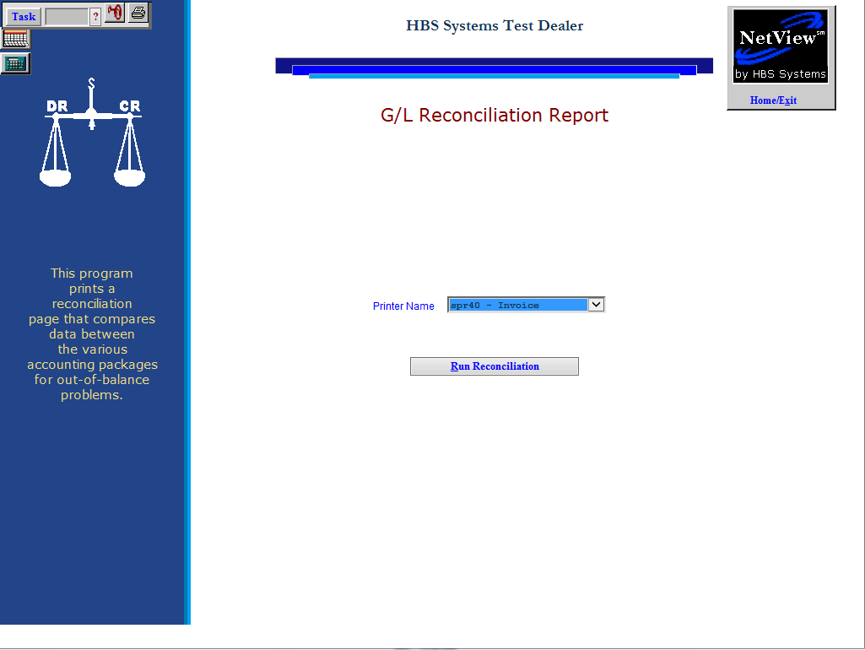

The G/L Reconciliation Report (GLRR) monitors the accounting activity on your system. It checks the following portions of the system:

- Trial Balance
- Accounts Receivable
- Unit Inventory/Notes Payable
- Subledgers (SLED)
- Accounts Payable
- Fixed Asset
- Depreciation

The report notifies you when different components are out of balance. It prints out automatically every morning after the daily backup has finished, but can also be run as needed. The G/L Rec Report should be reviewed each day. File the copies with your accounting reports.

- To access this function, you can either:
  - Select “General Ledger” from the menu. Choose the “Memo Reports” submenu and click “G/L Reconciliation Report.”
  - Type “GLRR” in the Shortcuts Bar.

Run Reconciliation: Press this button to run the report (see below image).

Since the G/L Reconciliation Report prints every morning at 5:00 a.m., it provides a "heads up" for any potential issues for you to review. We suggest that you review the report EVERY day so any information to be reviewed will be the transactions from the previous day and not many months or years ago.
HBS SYSTEMS DEALER
GL RECONCILIATION REPORT
Wed May 15 05:25:12 2013 Page 1

********************************************************************************************************
***************************************** TRIAL BALANCE ************************************************
********************************************************************************************************

Beginning Balance: 0.00 Current Activity 0.00 Ending Balance: 0.00

********************************************************************************************************
*************************************** A/R RECONCILIATION *********************************************
********************************************************************************************************

10300 Amount: 200048.58 Open Invoice Amount: 200048.58 Difference: 0.00

********************************************************************************************************
************************************** UNIT RECONCILIATION *********************************************
********************************************************************************************************

Acct #: 12001 G/L Bal: 438768.80 W/G Bal: 509011.28 Difference: -70242.48
Acct #: 12021 G/L Bal: 224097.22 W/G Bal: 217664.68 Difference: 6432.54
Acct #: 13001 G/L Bal: 192668.35 W/G Bal: 195668.35 Difference: -3000.00
Acct #: 20220 G/L Bal: -64874.95 W/G Bal: -119874.95 Difference: 55000.00
Acct #: 20240 G/L Bal: -81602.99 W/G Bal: -68310.00 Difference: -13292.99

*********************************************************************************************************
*********************************** MASTER / SLED RECONCILIATION ****************************************
*********************************************************************************************************

Totals JRNTOT: 0.00 ENTRY: 0.00 Difference: 0.00

*********************************************************************************************************
************************************* A/P RECONCILIATION ************************************************
*********************************************************************************************************

A/P Open Invoice Amount: -235397.96 Pend Jrn: 0.00 Total 20000 Amount: -235347.96 Difference: -50.00

*********************************************************************************************************
******************************** FIXED ASSET RECONCILIATION ********************************************
*********************************************************************************************************

*********************************************************************************************************
********************************* DEPRECIATION RECONCILIATION *******************************************
*********************************************************************************************************

The following pages provide some insight as to where to look for common out-of-balance issues on the GL Reconciliation Report. Be advised that they are only suggestions and may NOT be appropriate in every instance. Once you have identified the source of the difference, please call HBS Support for assistance in making the necessary corrections.

TRIAL BALANCE

Trial Balance Research Tips:

- Make sure all entries are posted. Check:
  - DRAD
  - PPS
  - OIR (Entered & Paid)
  - INPD
  - DRPD
  - PP
- Using the Trial Balance, determine which day the report went out of balance. The easiest way to find it is to display a Summary version by date in the month that it happened to pinpoint the exact date.

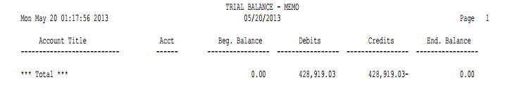

- Using the display function in G/L Detail Inquiry (GLDI), isolate the journal where the out of balance occurred.
  - When a specific journal completes, the journal total should also equal -0-. If it does not, print or re-display each document in that journal until you identify the out of balance document.
  - Each document that is displayed should total to -0-.

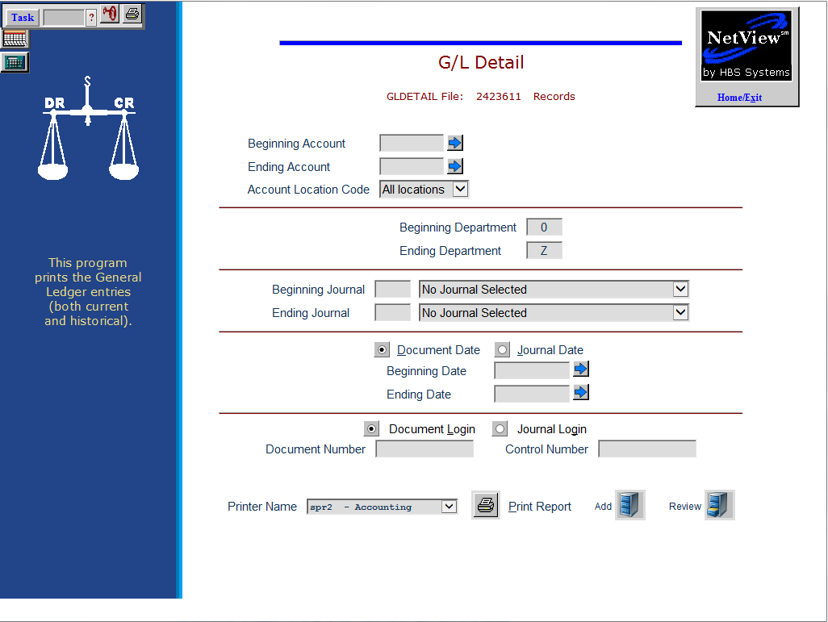

- Call HBS Support for assistance when you find the out of balance document.

A/R RECONCILIATION: It is very difficult to create an out-of-balance in Accounts Receivable. It could possibly be from someone in Balance Forward making adjustments or possibly from a power outage.

A/R Research Tips:

- Make sure all entries are posted. Check:
  - DRAD
  - PPS
  - INPD
  - DRPD
  - RDSS
- Review a detailed A/R Aging Report (ARA) to make sure it is complete and correct.
- Use GLDI to get the transactions for the A/R account for the time period involved and verify that all detail is on the customers' accounts. If you find an entry that is not shown on the A/R Aging Report, that piece of detail can be entered to reconcile the detail to the balance.

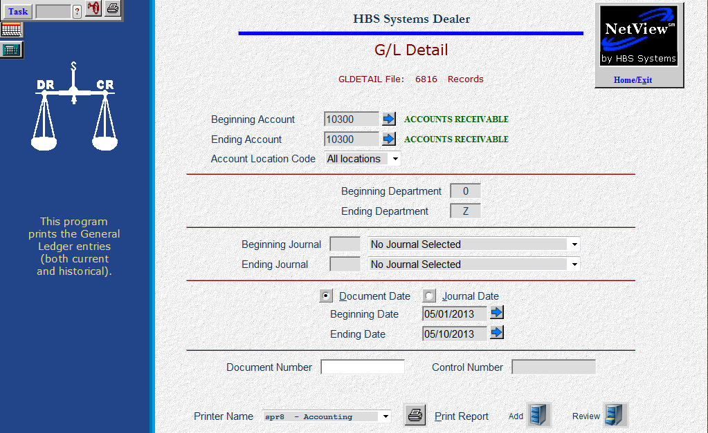

- Call HBS Support for assistance when you find the missing details.

UNIT RECONCILIATION: Improper entries in Enter Transfers and Adjustments (ETA) are often the source of Unit out of balance situations on the GL Rec.

Unit Research Tips:

- Make sure all entries are posted. Check:
  - DRAD
  - PPS
  - OIR (E & P)
  - INPD
  - DRPD
  - RDSS
  - PP
- The Subledger detail (SLED) and the Unit Accounting Report (UAR) provide the details for this portion.
  - The Unit Balance is made up of the detail on the UAR report.
  - The GL Amount is backed up by the SLED report.
  - Print the report for each and then compare the details, stock number by stock number between the two reports.
  - Circle the differences you find, and then determine why the information is different and which report is correct.

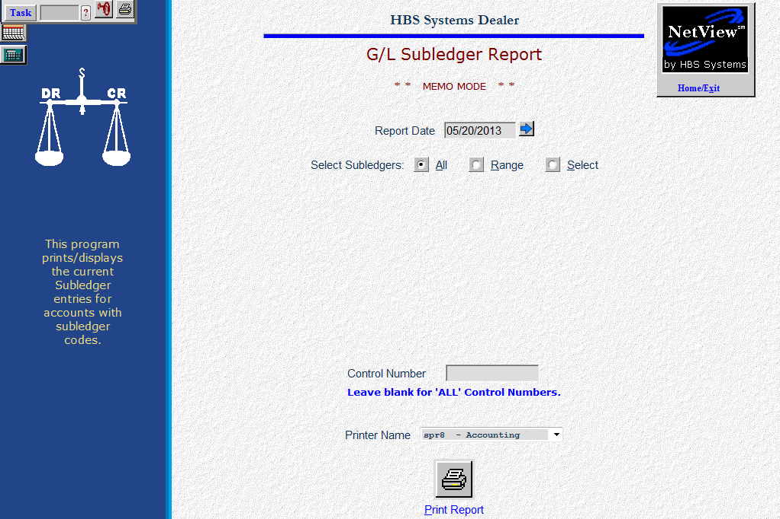

- Call HBS Support for assistance when you have found the differences and determined which information is correct.

MASTER/SLED RECONCILIATION: This section will show you any discrepancies between the current SLED detail and the balance of the account with a subledger code. Frequently, differences in these areas stem from improper unit transactions and the differences mirror the Units reconciliation differences.

Master/SLED Research Tips:

- Make sure all entries are posted. Check:
  - DRAD
  - PPS
  - OIR (E & P)
  - INPD
  - DRPD
  - RDSS
  - PP
- If the differences on these lines are exactly the same accounts and amounts as the lines in the Unit Reconciliation portion of the report, resolve the Unit issues first. It is quite likely that their resolution will also remove the entries from this section of the report.
- Print a SLED report for the affected account(s). Missing details on the report may indicate an improper transaction.
  - Missing detail can be added to eliminate the difference shown.
  - Remember that adjustments made in Balance Forward do not affect the general ledger nor the subledgers.

- Call HBS Support for assistance when you find the differences.

A/P RECONCILIATION: This section compares the total of A/P open invoice detail with the balance in the General Ledger.

A/P Research Tips:

- Make sure all entries are posted. Check:
  - PPS
  - OIR (E & P)
  - PP
- The tool for resolving this section is the A/P Open Invoices Report. You may find it helpful to print the entire listing of the report if the amount of the difference is unfamiliar. You may also need to review the actual journal entry in GLDI.

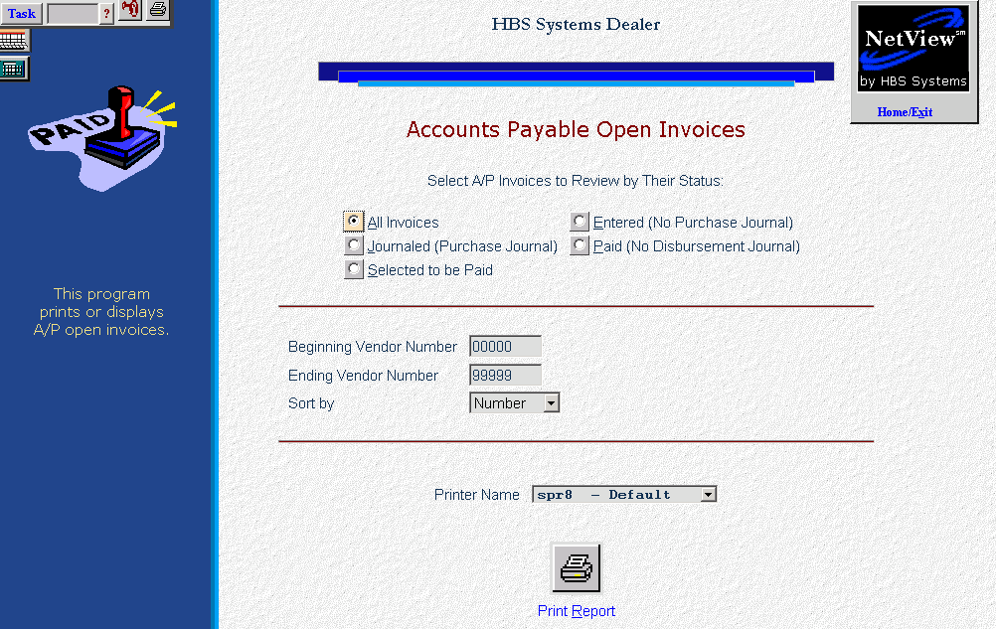

- If the amount involves a stock-numbered unit, run a Unit A/P Report (UAPR) to see if the unit in question is on that report.
- If the accounting looks ok, differences may be remedied by entering details to cover the discrepancies.
- You may also need to compare the information on the Open Invoices Report to the actual invoices that are unpaid.
- Call HBS Support for assistance when you find the discrepancies.

FIXED ASSET RECONCILIATION: This section compares the total of Fixed Asset detail with the balance in the General Ledger.

Fixed Asset Research Tips:

- Make sure all entries are posted. Check DRAD.
- The tools for resolving this section are the Fixed Asset Summary Listing and the Subledger Report for the G/L account identified. You may find it helpful to print the entire listing of each of the reports if the amount of the difference is unfamiliar.
- Call HBS Support for assistance when you find the discrepancies.

DEPRECIATION RECONCILIATION: This section compares the Fixed Asset depreciation detail with the balance in the General Ledger.

Depreciation Research Tips:

- Make sure all entries are posted. Check DRAD.
- The tools for resolving this section are the Depreciation History Listing and the Subledger Report for the G/L account identified. You may find it helpful to print the entire listing of each of the reports if the amount of the difference is unfamiliar.
- Call HBS Support for assistance when you find the discrepancies.

