G/L Fiscal Year End

General Ledger Fiscal Year End (GLYE) is run when you are ready to close a year’s accounting on your system. GLYE needs to be run immediately after you run a back-up and close the last month of your Fiscal Year.

Adjusting Entries and Fiscal Year-End Closing: Most dealerships like to get their accountant’s adjusting entries in the year’s books before they are closed out. This can be easily done as long as the last month of the Fiscal Year is kept open until the adjustments are made.

However, if you keep the last month of the year (and the year itself) open, all months following it will remain until that year is closed. We would suggest that you get the year-end adjustments from your accountant as soon as you can after the year closes so that the number of open months does not become a “staggering” number. Closing your accounting months in a timely fashion assist in cleaning up subleger details, which accumulate in larger numbers the more months you keep open.

The preparation for a fiscal year end is very similar to that of the month end. Before closing your fiscal year, you may want to review the suggested preparation steps.

Additional Reports to run at Fiscal Year-End: Since you will close out the last month of the year immediately before running GLYE, any necessary printouts would likely be included in the ones you run for it. Be sure to include the Unit Accounting Reports (UAR). You should run this report for all accounts. This provides a complete detail of all units in inventory and their liability status as of that month. Be sure to use the last day of the month being closed as the Report Date.

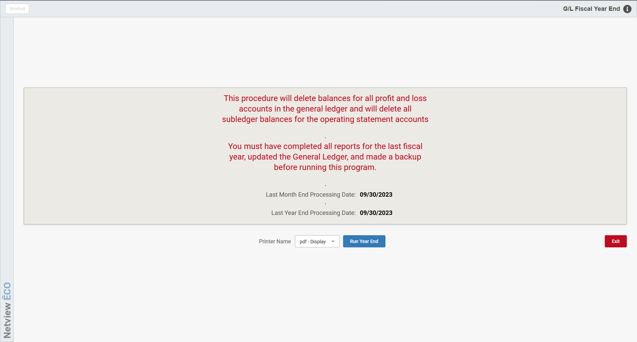

General Ledger Fiscal Year-End—The Process (GLYE)

- Run a back-up.
- Close the last month of your fiscal year. NOTE: If you just ran a back-up before you closed the last month of the year, no extra back-up is necessary before you run GLYE.
- Run G/L Fiscal Year End (GLYE).

To access this function, you can either:

- Select “General Ledger” from the menu and click “Fiscal Year End.”
- Type “GLYE” in the Shortcuts Bar.

Once you access the screen, a strong warning is shown. It states that this function will zero the balances for all accounts of the following types:

- Sale
- Cost
- Income
- Deduction
- Expense

To run the Year End, select a printer to receive the GLYE report and click Run Year End.

The process runs rather quickly. When it finishes, a report of the accounts that have been cleared as well as the amount applied to the Retained Earnings Account prints.

WARNING!!!: YOU WILL NOT BE ABLE TO REPRINT THIS REPORT. Print it immediately after running, or you will lose it.

Thu Jan 9 17:29:42 2013 Page 1

Acct No. Account Name Amount

00904 FLOOR PLAN INT & CHGS-SERV 0.00 ***
00909 FLOOR PLAN INT & CHGS-ADMIN 0.00 ***
01003 SALARIES - PARTS 4,078.93 ***
01101 FREIGHT EXPENSE-SALES 0.00 ***
01103 FREIGHT EXPENSE-PARTS 855.06 ***
01104 FREIGHT EXPENSE-SERV 0.00 ***
01105 FREIGHT EXPENSE-BRISK 0.00 ***
01109 FREIGHT EXPENSE-ADMIN 0.00 ***
01204 SALARIES-SERVICE 790.00 ***
01304 UNAPPLIED TIME-SERVICE 260.00 ***
01404 SUPPLIES & EQUIP REP.-SHOP 2,157.11 ***
01414 WARRANTY EXPENSE OVER/UNDER 0.00 ***
58100 FINANCE INCOME 6,474.72-***
58110 INTEREST EARNED 0.00 ***
58120 MILEAGE INCOME 1,260.00-***
58130 VOLUME DISCOUNTS EARNED 0.00 ***
58140 OTHER INCOME 50.00-***
58150 INVENTORY CHANGE 0.00 ***
58160 BAD DEBTS RECOVERED 0.00 ***
58170 SALES TAX ADJUSTMENTS 0.00 ***
58180 POP & CANDY 0.00 ***
58190 OTHER INCOME FREIGHT 0.00 ***
58200 CASH DISCOUNTS EARNED 56.25-***
58220 CASH DISCOUNTS GIVEN NONTAX 0.00 ***
58250 CASH OVER & SHORT 0.00 ***

Net Posted to Location 'loc1' 27100 : 159,321.88 ***

Total Retained Earnings Posted: 159,321.88 ***

Report Detail: The GLYE report includes the following information:

Account Number: Each account of the following types in your chart of accounts will be listed on this report, regardless of the balance at the end of the year:

- Sale
- Cost
- Expense
- Income
- Deduction

Account Name: This field shows the name of the account shown.

Amount: For any of those that had a balance at the end of the year, the “clearing” amount to take the balance to zero is shown on this report. Those accounts that did not have a balance will show a 0.00 in this field.

Totals:

- A total appears at the bottom of the report for each location.
- If you are a multi-location whose accounting is linked, you will see subtotals for each location.
- The last line of the report will show the total amount posted to the Retained Earnings Account.

