Gross Profit Report (GPR)

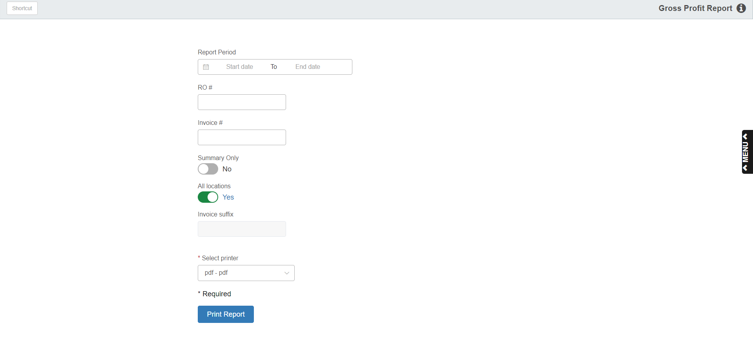

This program allows you to view and print the Service Gross Profit Report

To access this function, type “GPR” in the Shortcuts Bar.

Field Definitions:

Report Period: Type or select the starting and ending dates for the report. The report examines closed repair orders, so the dates you choose are the dates the ROs were closed on.

RO #:

- Type an RO# to generate the report for just a single repair order.
- Leave it blank to include all repair orders for the date range.

Invoice #:

- Type an invoice number here if you want to generate a report for a specific invoice.
- Leave it blank to include all invoices on the report.

Summary Only: Set this option to “Yes” to only print the report summary, without individual invoice details.

All Locations: In some multi-location dealerships, you can:

- Set this option to “Yes” to generate the report for all stores.
- Set it to “No” to focus on a single location.

Invoice suffix: This field will only activate if “All Locations” is set to “No.” Enter the letter for the desired location to generate the report for that store only.

Select Printer: Select a printer from the drop-down menu. Select a pdf printer to view a copy of the report.

Print Report: Click this button to print the report.

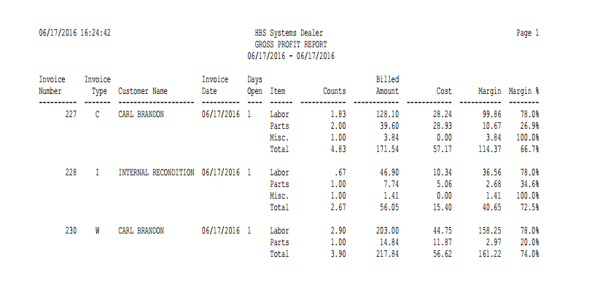

Sample Detail Report-Report Columns:

Invoice Number: This column shows the invoice number.

Invoice Type: This column shows the invoice type.

- (C)=Customer
- (I)=Internal
- (W)=Warranty
- (O)=Other

Customer Name: This column shows the customer’s name.

Invoice Date: This column shows the invoice date.

Days Open: This column shows how many days the invoice has been open.

Item: This column shows the items listed on the invoice, along with a line for a total of all items. The items could by any of the following:

- Labor
- Parts
- Sublet
- Other
- Miscellaneous (Misc.)

Counts: This column shows how many counts of each item are listed on the invoice, as well as the total overall counts.

Billed Amount: This column lists the billed amount for each item on the invoice, as well as the invoice’s total billed amount.

Cost: This column lists the costs for each item on the invoice, as well as the invoice’s total cost.

Margin: This column lists the margin amount, which is the billed amount minus the cost.

Margin %: This column lists the margin percent, which is the margin amount divided by the billed amount.

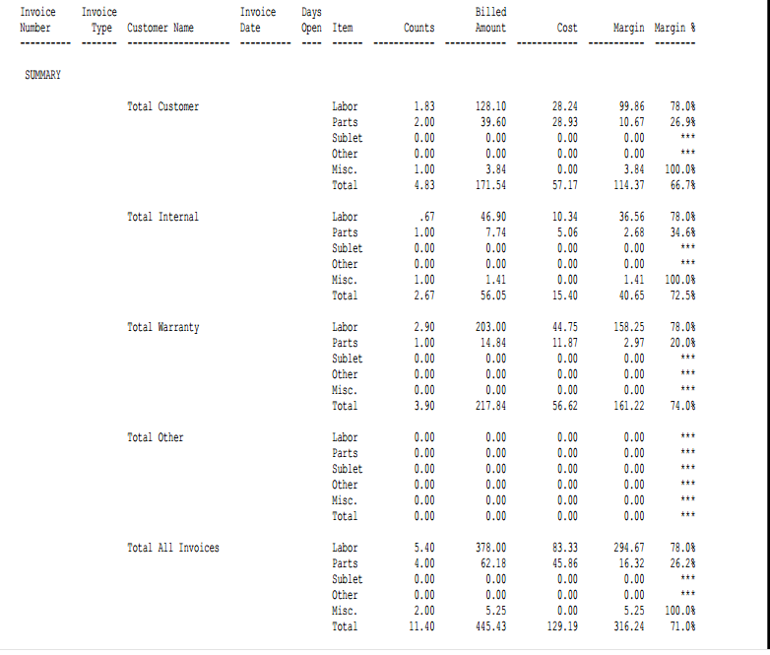

Sample Summary Only Report-Report Columns:

Invoice Number: This column is not in use on this report.

Invoice Type: This column is not in use on this report.

Customer Name: This column lists the invoice types that have their totals displayed on the Summary report:

- Customer
- Internal
- Warranty
- Other
- All Invoices

Invoice Date: This column is not in use on this report.

Days Open: This column is not in use on this report.

Item: This column shows the items that could be listed on an invoice, along with a line for a total of all items. The items are:

- Labor
- Parts
- Sublet
- Other
- Miscellaneous (Misc.)

Counts: This column shows how many counts of each item are listed on the invoices, as well as the total overall counts for that invoice type.

Billed Amount: This column lists the total billed amount for each item type on the invoices, as well as the invoice type’s total billed amount.

Cost: This column lists the costs for each item type on the invoices, as well as the invoice type’s total cost.

Margin: This column lists the total margin for each item type on the report, as well as the invoice type’s total margin amount.

Margin %: This column lists the total margin percent for each item type on the report (if applicable), as well as the invoice type’s total margin percent.

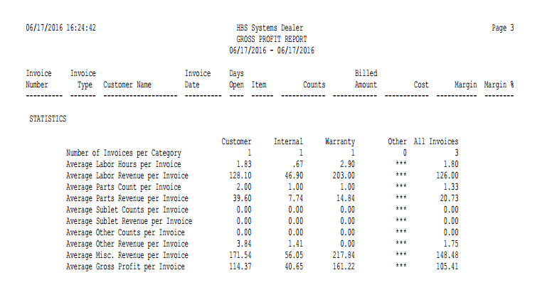

Sample Statistics-Report Columns: This section appears at the end of every version of the report. The statistics are grouped into columns by invoice type (Customer, Internal, Warranty, Other, and All Invoices) and consist of the following:

- Number of Invoices per Category
- Average Labor Hours per Invoice
- Average Labor Revenue per Invoice
- Average Parts Count per Invoice
- Average Parts Revenue per Invoice
- Average Sublet Counts per Invoice
- Average Sublet Revenue per Invoice
- Average Other Counts per Invoice
- Average Other Revenue per Invoice
- Average Misc. Revenue per Invoice
- Average Gross Profit per Invoice

