A/P Information Defaults (ID)

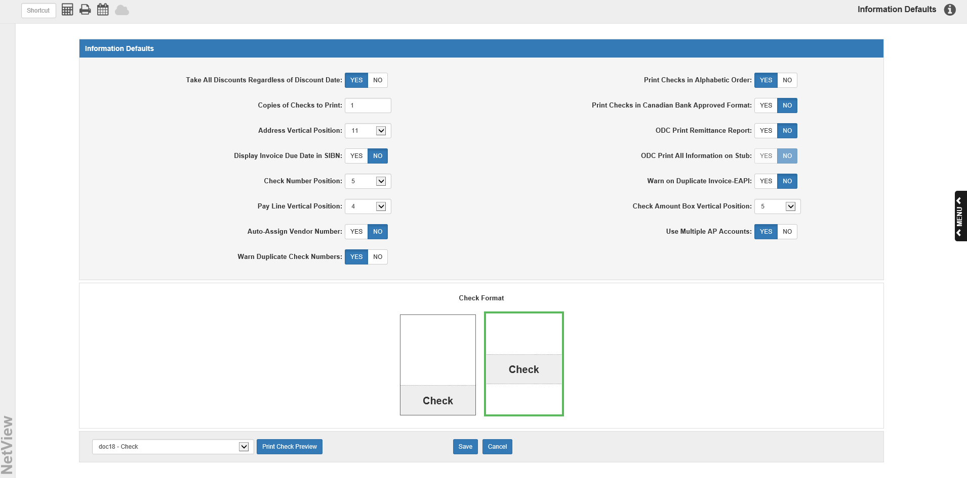

You can regulate certain Accounts Payable payment functions through the A/P Information Defaults (ID) application. To access this function, you can either:

- Select “System Maintenance” from the menu and choose the “Company File” submenu. Click on “A/P Info Defaults.”
- Type “ID” in the Shortcuts Bar.

Field Definitions:

Take all discounts regardless of discount date: This field regulates the Select A/P Invoices (SIBD/SIBN) function. If you want A/P to automatically deduct all discounts from the check amounts regardless of the entered discount dates, choose Yes. Choose No if you want A/P to continue deducting discounts according to the entered discount date. Example: If you select an invoice for payment that includes a discount, the system deducts this amount only if you are paying this invoice at or before the posted discount date (that is, if Payment Date = 05/28/2018 and Discount Date = 05/15/2018, no discount is deducted from the payment amount).

Print Checks in Alphabetic Order: Select how the A/P Print Checks (PC) program should sort your checks.

- Choose Yes to print A/P checks in Vendor Name order.
- Choose No to print checks in Vendor Number order.

Copies of Checks to Print: Enter the number of copies the printer should generate for each A/P check.

Print Checks in Canadian Bank Approved Format: This prompt offers the option to print checks in the Canadian Bank approved format.

- Canadian dealers should choose “Yes.”
- U.S. dealers should choose “No.”

Address Vertical Position: This option lets you set the position of the address on your checks so that it matches your check stock.

Display Invoice Due Date in SIBN: Choose Yes to be able to see the Due Date for each invoice on the SIBN screen.

ODC Print Remittance Report/ODC Print Information on Stub: These two fields together control if and how you will receive Check Stub/Remittance Report information in On Demand Checks (ODC).

- If you choose Yes at ODC Print Remittance Report and Yes for ODC Print Information on Stub, all the invoice information will print on the check stub. If the lines exceed the space on the stub, it voids across as many check stubs as necessary. It will void any checks where only the stub section is used and uses the last check number for the live check and journal entry.
- If you choose Yes at ODC Print Remittance Report and No for ODC Print Information on Stub, all the invoice information will print on the first check stub only if it fits. If the number of stub lines exceeds the space printed on the check, then all of the stub information will be put on a Full Stub Invoice Remittance Report. A “See Remittance Report” message will be written on the check stub to indicate the information is on the report.
- If you choose No at ODC Print Remittance Report, ODC Print Information on Stub will automatically set to No. Only an invoice line total will be reported on the stub.

Check Number Position: This option lets you set the position of the check number on your checks so that it matches your check stock.

Warn on Duplicate Invoice-EAPI: Set this option to Yes to have the system automatically warn you when you create a duplicate invoice in Enter A/P Invoices (EAPI).

Pay Line Vertical Position: This option lets you set the vertical position of the pay line on your checks so that it matches your check stock.

Check Amount Box Vertical Position: This option lets you set the vertical position of the check amount box on your checks so that it matches your check stock.

Auto-Assign Vendor Number:

- Set this option to Yes to have the system automatically assign the vendor number when a new vendor is added to the system.
- Set it to No to manually assign the number yourself when you add the vendor.

Use Multiple AP Accounts:

- Set this option to Yes to have multiple accounts available for use on your A/P invoices, which will enable you to use the Select A/P Invoices (SAPA) program and the multiple A/P account features in several other A/P programs.
- Set it to No to only use the default A/P account set up in Account Numbers (ACCN) on invoices (this account will generally be 20000-Accounts Payable).

Warn Duplicate Check Numbers: Set this option to Yes to have the system prevent you from reusing starting check numbers during a check run for a period of 1 year.

Check Format: Click one of the two available check formats to match the check stock for your checks.

- The example on the left shows a check style that a longer check stub with the check at the bottom.
- The one on the right has a shorter stub at the top, check in the middle and an unused section at the bottom.

Print Check Preview: To preview how your printed checks will appear based on your settings, select a printer from the drop-down menu and click Print Check Preview.

Save: Click this button to save your settings.

Cancel: Click this button to undo any changes you made to your settings before saving.

