Inventory Master Pad (IMP)

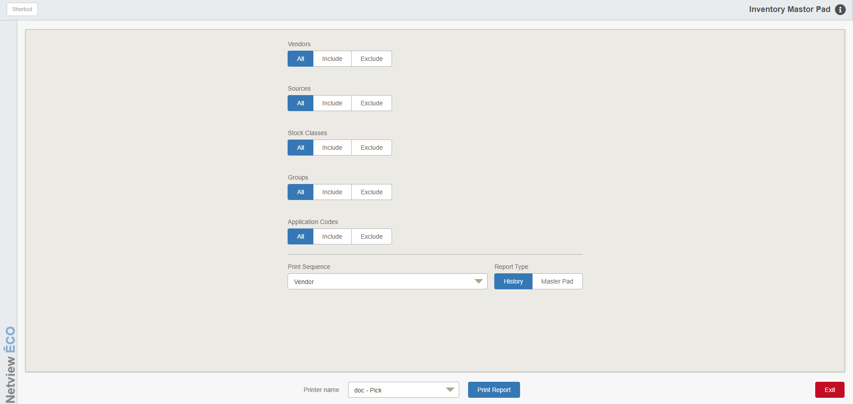

The Inventory Master Pad provides a listing of all inventory items for a selected vendor, source, stock class, group, or application code. The history version provides up to four years summary of sales activity. The master version provides inventory and pricing information.

To access the program, you can:

- Select “Inventory” from the menu. Choose the “Reports” submenu and click “Inventory Master Pad.”
- Type “IMP” in the Shortcuts Bar.

Field Definitions:

Vendors:

- Click All to include all vendors.
- Click Include to type in or select up to ten vendors to include in the report.
- Click Exclude to type in or select up to ten vendors to exclude from the report.

Sources:

- Click All to include all sources.
- Click Include to type in or select up to ten sources to include in the report.
- Click Exclude to type in or select up to ten sources to exclude from the report.

Stock Classes:

- Click All to include all stock classes.
- Click Include to type in or select up to ten stock classes to include in the report.
- Click Exclude to type in or select up to ten stock classes to exclude from the report.

Groups:

- Click All to include all group codes.
- Click Include to type in or select up to ten group codes to include in the report.
- Click Exclude to type in or select up to ten group codes to exclude from the report.

Application Codes:

- Click All to include all application codes.
- Click Include to type in or select up to ten application codes to include in the report.
- Click Exclude to type in or select up to ten application codes to exclude from the report.

Print Sequence: Select the sorting order from the drop-down menu. Choose one of the following:

Vendor

Source

Part number

Application code

Report Type: Choose a history report or an inventory master report.

Show Cost: This selection is available for a Master Pad only.

Select Yes to show the cost on the report.

Select No to exclude cost from the report.

Include Zero On Hand: This selection is available for a Master Pad only.

Select Yes to include parts with zero on hand.

Select No to exclude parts with zero on hand from the report.

Printer Name: Select the printer to receive the printout. A default printer name is pre-filled but can be changed as necessary. Use the pdf printer to view the report on the screen without printing a copy of it.

Print Report: Press this button to print your report.

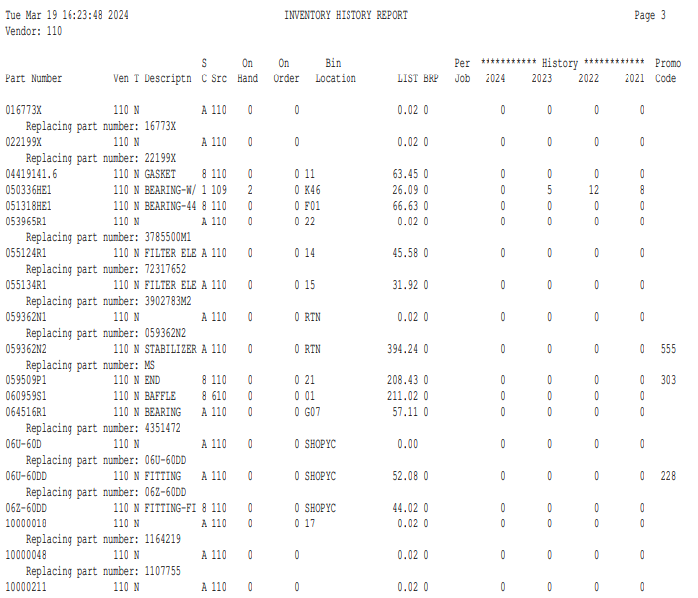

History Report: The History Report contains the following information:

Part Number: This is the part number for the source and vendor you selected.

Ven: This indicates the vendor that you selected.

T: This is the part’s type. It could be:

New

Reman

Used

Core

Memo

Descriptn: This is the part’s description.

SC: This is the part’s Stock Class.

Src: This is the part’s source.

On Hand: This is the number of parts your have on hand for the part number listed.

On Order: This is the number of parts you have on order for this part number.

Bin Location: This is the part’s primary bin location as recorded in the Parts Master.

LIST: This is the factored list price for this part number. NOTE: This column may have a different name depending on the name given to Price Code 2/Retail 1 in Inventory Point of Sale Defaults (IPOS).

BRP: This is the part’s Best Reorder Point.

Per Job: This is the amount of this part number it requires to complete a particular job.

History: This is the yearly history of sales on this part number for up to 4 years.

Promo Code: This shows the promo code for the part number listed, if applicable.

Replacement Part Number: This is the part number that supersedes or replaces the part number listed from the Parts Master. It will always appear below the relevant part’s line on the report.

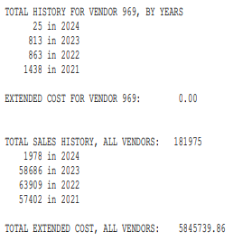

History Report—Report Totals:

Total History Vendor Total: This total shows the sales history counts by year for the vendor. It will only appear on the report if you set the “Print Sequence” to group the parts by Vendor.

Extended Vendor Cost: This total shows cost value of the parts for the vendor. It will only appear on the report if you set the “Print Sequence” to group the parts by Vendor.

Total History All Vendors Total: This total shows the sales history counts by year for all vendors. It will appear as the end of the report regardless of how the report is sorted.

Extended Cost All Vendors: This total shows cost value of the parts for all vendors. It will appear at the end of the report regardless of how the report is sorted.

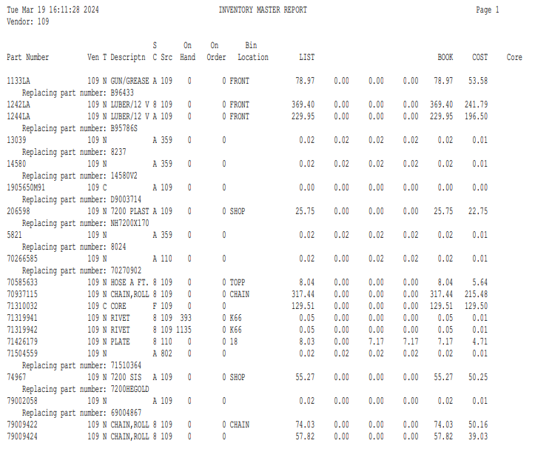

Master Report: The Inventory Master Report provides the following information:

Part Number: This is the part number for the source and vendor you selected.

Ven: This indicates the vendor that you selected.

T: This is the part’s type. It could be:

New

Reman

Used

Core

Memo

Descriptn: This is the part’s description.

SC: This is the part’s Stock Class.

Src: This is the part’s source.

On Hand: This is the number of parts you have on hand for the part number listed.

On Order: This is the number of parts you have on order for this part number.

Bin Location: This is the part’s primary bin location as recorded in the Parts Master.

LIST: This is the factored list price for this part number. NOTE: This column may have a different name depending on the name given to Price Code 2/Retail 1 in Inventory Point of Sale Defaults (IPOS).

Special Price Codes: This set of columns shows the special price codes defined for the parts on the report (including the MSRP, labeled as “BOOK” in the example).

COST: This field shows the cost for the part number.

Core: This field shows the part’s core charge, if any.

Replacement Part Number: This is the part number that supersedes or replaces the part number listed from the Parts Master. It will always appear below the relevant part’s line on the report.

Master Report - Report Totals

Extended Vendor Cost: This total shows cost value of the parts for one vendor’s section on the report. It will only appear on the report if you set the “Print Sequence” to group the parts by Vendor.

Extended Cost All Vendors: This total shows the cost value of the parts for all vendors on the report. This total will appear as the very last line of the report regardless of how the report is sorted.

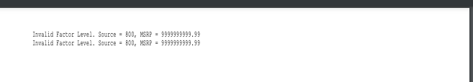

Error Report: If while printing either report the program finds that certain parts or part sources are missing information, this error report will print after the main report. It will provide details on which part or source has a problem, and what information listed on its record is missing or incorrect. This can be anything from missing core part numbers to invalid source factors.

NOTE: If you print to PDF, there will be a Next button at the bottom of the preview window in place of the normal “Close” button, which will take you to the error report after you are done reviewing your main report.

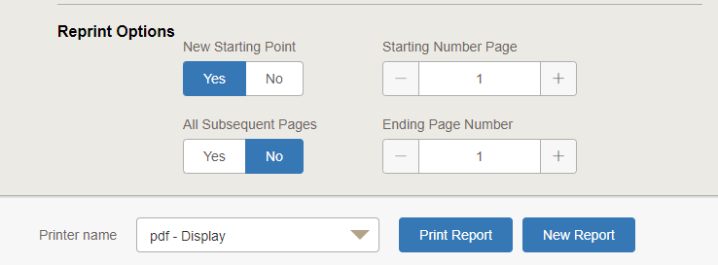

Reprint Options: This function gives you the option to reprint a portion of the printout or the full printout in the event of a printer failure. You have the ability to reprint based on starting and ending page numbers as well as the option to select another printer to receive the printout.

New Starting Point:

- To reprint the full report, select No and go to “Printer Name.”
- If you want to start on a specific page of the report, choose Yes.

Starting Page Number: This field allows you to start reprinting the report at any page number you choose. Example: If the first 9 pages of the report are okay, start printing on page 10 of the report.

All subsequent pages:

- Select Yes to print all pages after your starting page number.
- Select No to have the option to select your ending page number.

Enter ending page number to print: This field only appears if you answer “No” to the “All subsequent pages” option. Here you have the option to choose the ending page number. Example: The last page of this report may be page 100. You only need pages 10-26. Here you would enter page 26 and your reprinted report would end at page 26.

Printer Name: The default printer is shown but you may change it as necessary. Select the pdf printer to display the report without printing.

Print Report: Click this button to reprint your selection.

New Report: If you do not need to reprint the report and would instead like to print a different report, click this button to remove the reprint options and let the program know you will be generating a new report.

