Select Custom Prompts (INCP)

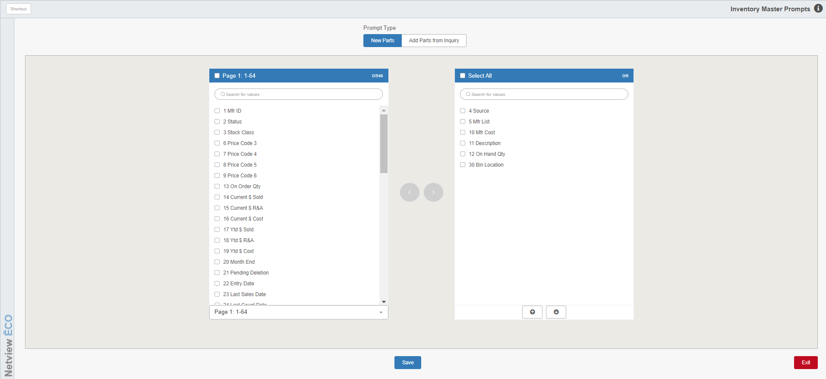

Select Custom Prompts (INCP) lets you choose the fields to use for Custom Parts Maintenance (CPM). You may choose a new set of prompts, add to existing prompts, or delete existing prompts. The fields you choose can be set and reordered in any order you like. Since this process streamlines adding a new part or changing an existing one, use INCP to make the process work as efficiently as possible.

To access this program, either:

- Select “Inventory” from the menu and choose the “Parts/Source Update” submenu. Click “Inventory Custom Prompts.”
- Type “INCP” in the Shortcuts Bar.

Field Descriptions:

Prompt Type: This asks which fields you are modifying: New Parts (regular CPM) or Add Parts from Inquiry, which lets you add parts from one of the inquiry screens.

New Parts: Displays the available fields and those that are already selected for CPM. By checking the box next to a field and using the arrow keys between the boxes, you can add or remove it from the CPM selection.

Add Parts from Inquiry: Displays the screens with available fields and those that are already selected for adding new parts through the Parts Search, Parts Inquiry (PI), and Manufacturer Price File Inquiry (PFI).

Available Fields List: The list box on the left shows the list of available fields that have not been selected for use. Check the box next to an individual field to select it, then click the right-pointing arrow button in the middle of the page to select it for use in CPM.

Select/Deselect All:

Check the box in the list header to automatically select all available fields on the currently selected page.

Remove the check to automatically deselect all selected fields on the page.

Page #: The page number indicates which page of available fields you have selected and which set of fields (by number) are listed on that page. This is mirrored by the dropdown menu at the bottom of the list box.

Number of Fields Selected: The numbers on the upper right-hand corner of the list box indicate how many available fields you currently have selected compared to the total available number of fields.

Search: If you want to find a specific field on the current page, and you don’t initially see it, you can either scroll down till you find it, or you can use this field to filter the list for the desired field. Type in the field’s number or all/part of its name to trigger the filter.

Page Selection: The dropdown menu at the bottom of the list box allows you to select which page of available fields you want to look at. The options show the page number and the set of fields (by number) listed on that page, mirroring what will appear in the list box’s header should you choose that page.

Select/Remove Fields: In between the two list boxes are two arrow buttons, which when clicked move any checked boxes from one list box to the other.

Remove Fields: Click the left-pointing arrow button to move checked fields from the Selected Fields List to the Available Fields list, thereby removing them from CPM.

Select Fields: Click the right-pointing arrow button to move checked fields from the Available Fields List to the Selected Fields List, thereby selecting them to appear in CPM.

Selected Fields List: The list box on the right shows the list of fields selected for use, meaning they currently appear in the version of CPM opened via the prompt type (either CPM regular or CPM as accessed through an inquiry). Checking a box next to an individual field in this list, then clicking the left-pointing arrow button in the middle of the page, will remove the field and put it back in the Available Fields List.

Select/Deselect All:

Check the box in the list header to automatically select all fields in the list box.

Remove the check to automatically deselect all selected fields in the list box.

Number of Fields Selected: The numbers on the upper right-hand corner of the list box indicate how many fields you currently have selected in the list box compared to the total number of fields listed in the box.

Search: If you want to find a specific field and you don’t initially see it, you can either scroll down till you find it, or you can use this field to filter the list for the desired field. Type in the field’s number or all/part of its name to trigger the filter.

Move Up/Down: There are 2 arrow buttons at the bottom of the Selected Fields List box, which allow you to re-order the list of selected fields. You can move multiple fields at the same time, as long as the box next to each field is checked.

- Clicking the up-pointing arrow will cause all currently checked fields in the list to move up in the list order.
- Clicking the down-pointing arrow will cause all currently checked fields to move down in the order.

Save: Click this button to save any changes made.

