Invoice Fill Report (INFR)

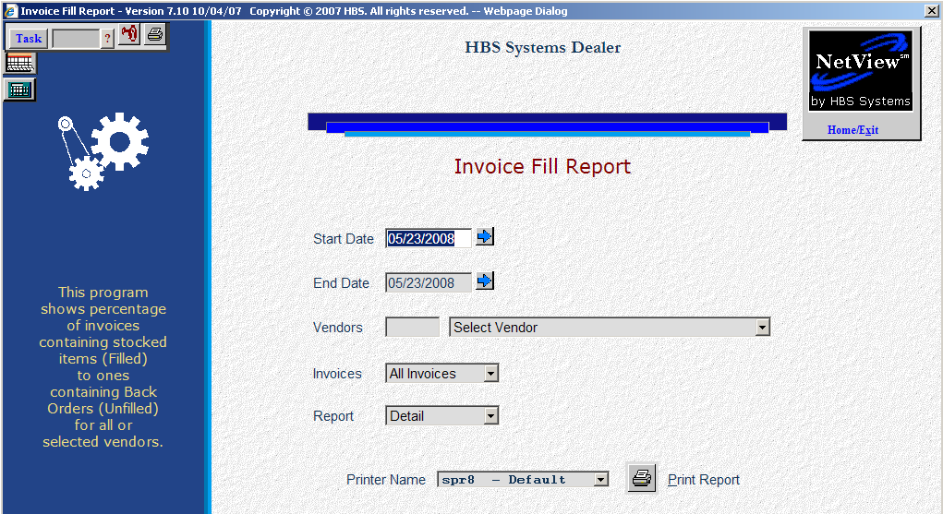

The Fill report provides information about the number of invoices that are filled from inventory versus those that require an item to be back ordered. The Back Order feature in POS and Service must be used in order for this report to be able to distinguish the filled invoices from the not-filled ones. This report compares the amount of invoices that were filled from stock to the ones containing back orders for all or selected vendors. It is selectable by date and invoice range. This report is included on both the Parts End of Day Process Page and menus of Inventory Reports.

To access the Fill Report, you can:

Select "Inventory" from the menu and click "Inventory Fill Report."

Select “Inventory” from the menu. Choose the “Reports” submenu and click “Inventory Fill Report.”

Select “Inventory” from the menu and click “End of Day Process.” When the program opens, choose "Inventory Fill Report (Optional)."

Type “INFR” in the Shortcuts Bar.

Field Definitions

Start Date: Type or select the starting date of the report.

End Date: Type or select the ending date of the report.

Vendors: Select “All” for all vendors or select individual ones from the drop-down menu.

Invoices: Choose one of the following:

All Invoices

Filled Invoices

Not Filled Invoices

Report:

- Choose Detail for a detailed report that includes:
  - The invoice number
  - The invoice date
  - The vendor
- Choose Summary for a report that only lists how many invoices were filled or not filled.

Printer Name: Select the printer to receive the printout. A default printer name is pre-filled but can be changed as necessary. Use the see printer to view the report on the screen without printing a copy of it.

Print Report: Press this button to print your report.

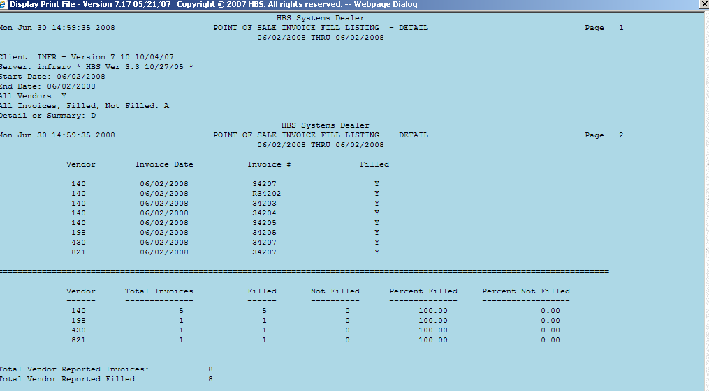

Detail Report (first section)

Vendor: This is the vendor(s) that you selected. If you selected ALL vendors, they will appear in invoice date order.

Invoice Date: Here you will find the invoice date for the invoice listed. The dates will appear in sequential date order.

Invoice #: This is the invoice number that was filled or not filled for the selected vendor(s).

Filled:

- A Y in this field indicates that the invoice was filled from current stock.
- An N here means that the invoice has one or more items on backorder and is not filled.

Detail Report (second section): The second section of the Detail report is a subtotal by vendor of the invoices and a grand total section for all vendors and invoices. It contains the following information:

Vendor: This is the vendor(s) that you selected. If you selected ALL vendors, they will appear in invoice date order.

Total Invoices: This is the total number of invoices for this vendor.

Filled: Here you will find the number of invoices filled for this vendor.

Not Filled: This field contains the number of invoices NOT filled for this vendor.

Percent Filled: The Percent Filled is the percentage of filled invoices to the total number of invoices.

Percent Not Filled: The Percent Not Filled is the percentage of NOT filled invoices to the total number of invoices.

Detail Report (third section): The last section of the Detail report is a summary of all of the vendors and invoices listed on the report. It contains the following fields:

Total Vendor Reported Invoices: This is the total number of invoices included in the report.

Total Vendor Reported Filled: Here you will find the total number of invoices on the report that were filled.

Total Vendor Reported Not Filled: This number is the total number of invoices that were not filled and one or more items had to be backordered.

Total Percent Filled: The Total Percent Filled is the percentage of filled invoices to the total number of invoices.

Total Percent Not Filled: The Total Percent Not Filled is the percentage of NOT filled invoices to the total number of invoices.

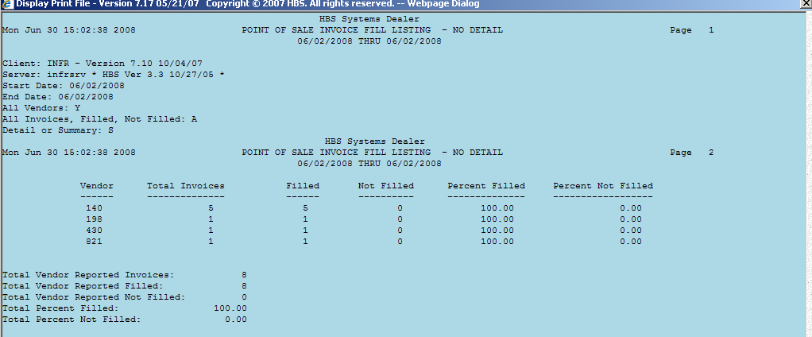

Summary Report (first section): The first section of the Summary report contains the following information:

Vendor: This is the vendor(s) that you selected. They will appear in numerical order.

Total Invoices: This is the total number of invoices for this vendor.

Filled: Here you will find the number of invoices filled for this vendor.

Not Filled: This field contains the number of invoices NOT filled for this vendor.

Percent Filled: The Percent Filled is the percentage of filled invoices to the total number of invoices.

Percent Not Filled: The Percent Not Filled is the percentage of NOT filled invoices to the total number of invoices.

Summary Report (second section): The last section of the Summary report is a summary of all of the vendors and invoices listed on the report. It contains the following fields:

Total Vendor Reported Invoices: This is the total number of invoices included in the report.

Total Vendor Reported Filled: Here you will find the total number of invoices on the report that were filled.

Total Vendor Reported Not Filled: This number is the total number of invoices that were not filled and one or more items had to be backordered.

Total Percent Filled: The Total Percent Filled is the percentage of filled invoices to the total number of invoices.

Total Percent Not Filled: The Total Percent Not Filled is the percentage of NOT filled invoices to the total number of invoices.

