Parts Month End Process (INME)

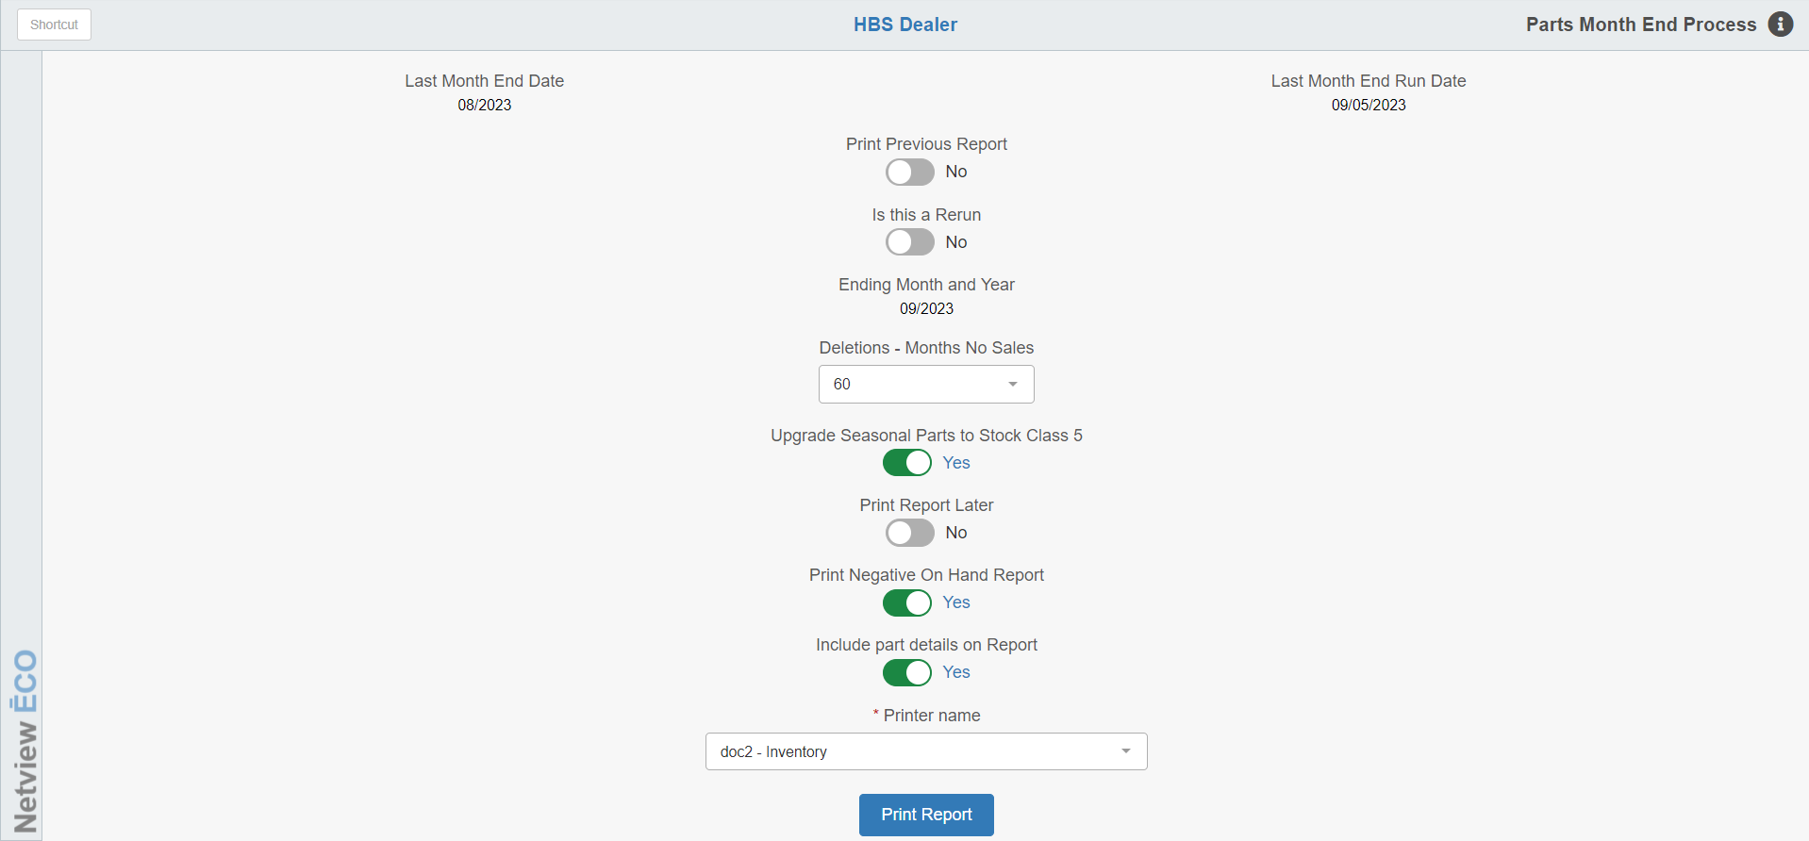

On the last business day of the calendar month (or on the first business day of the next calendar month), the Parts Month End Process must be run. This function closes the Parts month and prepares for the new month’s activities.

To access this function, you can either:

- Select “Inventory” from the menu and click “Month End Process.”
- Type “INME” in the Shortcuts Bar.

Field Definitions:

Last Month End Date: This is the month of the last Parts Month End run.

Last Month End Run Date: This is the date you actually ran your last Parts Month End.

Print Previous Report:

Select No if you are closing a current month and do not need another copy of last month’s report.

If the printer jams while running the current month end, you can get another copy of the printouts by selecting Yes at this field.

Print by Vendor or Source: This prompt only appears when you choose to print a previous report. This option provides the opportunity to print the Month End reports sorted by Parts source or Parts vendor. The source option may be appropriate for AGCO dealers who want to see the Parts Month End details by the various Parts sources within the single 110 vendor line. To produce a listing by source, you need to run the Month End as usual. Once it has finished, choose to print previous report and then choose to print by SOURCE.

Select Month/Year for Reprint: This prompt only appears when you choose to print a previous report. Select the specific month/year of the report you want to reprint.

Is this a Rerun: A rerun may be needed if the Month End Process was interrupted, such as in a power outage. If this occurs, run the same month end process by selecting Yes. The process picks up where it left off at the time of the interruption. Please confirm any rerun activity with the HBS Support Team before proceeding. Choose No if it is not a rerun.

Ending Month and Year: This date is filled in by the system and is dated one month following the last month end date as shown at the top of the screen.

Deletions – Months No Sales: The default is 60 months. This means that part number records are flagged for deletion after 5 years if the files:

- Show no on-hand or on-order quantities
- Show no superseded part numbers
- Show no sales activity in 5 years
- Contain a stock class code of 8, 9, or U
- Was already flagged as pending deletion

If you want part numbers deleted sooner than the 60-month period, select one of the other options. The pending deletion flag gives you a 30-day grace period before the part is actually deleted from the system. When a part number meets the above criteria, the Month End process flags it for deletion. If there has been no activity for that part when the next Parts Month End is run, it is deleted.

Upgrade Seasonal Parts to Stock Class 5: If you have entered seasonal indicators such as a # or * in the seasonal part number records, then leave the default answer as Yes. Instead of using Stock Class 1, the program uses 5 when upgrading these part records from a non-stocking (8, 9, or U) or new-stocking (6) status. Select No if you have not set up seasonal indicators in your inventory.

Print Report Later: This defaults to No. However, you may choose Yes so that the program will complete the Month End process, but not print any reports at this time. You can use this feature if you know you will not be around should a paper jam occur. When you are ready to print the Month End reports, answer “Yes” at the “Print Previous Report” field (make sure you do this BEFORE running another Month End).

Print Negative On Hand Report: Select Yes here if you have not printed this report while preparing for the Month End run. This report shows all part number records with negative on-hand quantities. Choose No if you do not need the report.

Include part details on Report: This prompt gives you the option to print the Month End reports with parts details or without.

- If you select Yes, the month end report prints all of its three components:
  - Parts Stock Analysis
  - Parts Management By Vendor – Parts Sales
  - Parts Management by Vendor – Parts Inventory Value
- If you choose No, the report excludes the Parts Stock Analysis Report (part number detail of parts changed by the Month End run).

Printer Name: Select the printer to receive the printout. A default printer name is pre-filled but can be changed as necessary. Use the pdf printer to view the report on the screen without printing a copy of it.

Run: Press this button to process the Month End.

The Month End Process generates 4 reports:

- Negative On-Hand Report (Optional)
- Parts Stock Analysis Report Per Vendor (Optional)
- Parts Management Report Per Vendor
- Parts Management Report - Grand Totals (All Vendors)

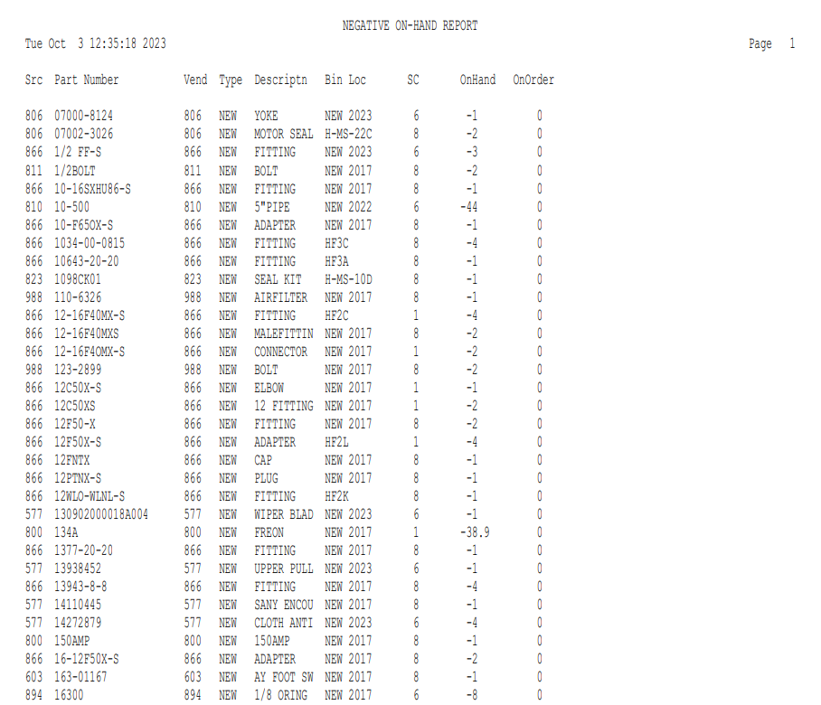

Negative On-Hand Report: This report shows all part numbers with negative on-hand quantities. You should take time to review all the part numbers listed on the report. Most of them need corrections of some type.

Src: This is the source number for this part. Every Part Master (PI/PMM) includes a vendor number and a source number. Often, they are the same. The source number directs the pricing, BSL/BRP, and stock class, and drives the sales entries to the correct sales accounts in the accounting system.

Part Number: This column lists the part number.

Vend: This displays the part’s vendor number. The Vendor file contains important information about part orders and price updates.

Type: Here you will find a part type of New, Used, Core, Memo, or Reman. This information comes from the Part Master for this part.

Description: Here is an abbreviated description of the part number that helps you to identify this part.

Bin Loc: This field shows the primary bin location for the part. This information is valuable for helping you check actual stock quantities.

SC: This is the current stock class of this part.

On Hand: Here you see the negative quantity for this part number.

On Order: This is the quantity you currently have on one or more parts orders for restocking this part. Use this information to find out if one or more orders or back orders have arrived but were not receipted in the system.

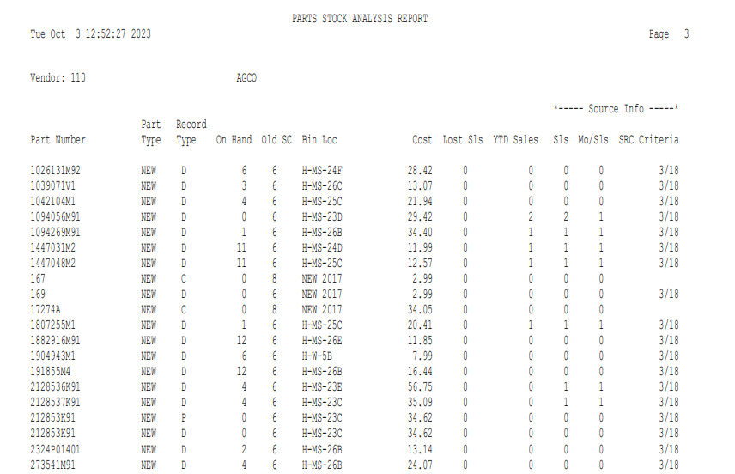

Parts Stock Analysis Report: This report indicates a status change on the part number listed, and as such a part will only appear on it if it has:

Had a change in stock class

Had a lost sale added

Been marked with a pending deletion flag

Been deleted by the system

It is sorted by vendor number and only prints if the user sets “Include Part Details on Report” to “Yes.”

Vendor: The vendor number shows here for this particular section of the report.

Name: The vendor’s name shows here.

Report Columns:

Part Number: This lists the part number that showed a status change during the calendar month you are closing.

Part Type: This identifies if the part number is:

New

Used

Reman

Core

Memo

Record Type: A code letter shows the status change for this part. A list of these "type codes" prints at the bottom of this report:

- S = Upgrade to Stocking (Either changed to Stock Class 1 or 5)
- L = Lost Sales
- D = Downgrade to Non-Stocking (Changed to Stock Class 8)
- C = Deleted
- P = Pending Deletion
- F = Stock Class Corrections

On Hand: This shows the current on-hand quantity for the part number.

Old SC: This shows the Stock Class code for the part prior to the status change.

Bin Loc: This is the primary bin location for the part number.

Cost: Your current dealer cost per unit of this part number shows here. This can be a factored cost calculated by using the source's price factoring information.

Lost Sls: This lists the total lost sales recorded for this part number during the month you are closing.

YTD Sales: This is the year-to-date sales based on the number of units sold for this part. This figure is based on the calendar year (January 1 through December 31).

Sls (Sales): The shows the quantity sold for this part during the time range set up in the source. For example, if the NS Months field of this part’s source is 24, the value here would be the quantity sold in the last 24 months.

Mo/Sls (Month/Sales): This is how many months had sales, as specified in the time range set up in the source. For example, the part may have sold a total of 5 during the past 24 months, yet all of these sales may have occurred in only 1 month of that period. To verify this, go to Parts Master Maintenance (PMM) and look at the part number's sales history. If this is the case, when you look at the first 24 months of sales history, one of these fields shows “5” and all of the others show “0.” You might also have to look at the part’s lost sales history because the system considers lost sales when evaluating stock class status.

SRC Criteria: This column repeats the stock class information from the source (NS Months and NS Sales or New Months and New Sales).

The first number before the slash (/): This is the number of months that sales are required during the specified time range (NS Months/New Months). This number must never be less than 1 month.
- The number after the slash (/): This is the range of months for sales to occur in for that part to meet the sales criteria. For example, if the SRC Criteria column lists 2/24, the part must sell in 2 months out of the 24-month time range to be fast-moving.

Parts Management Report Per Vendor: For every vendor number in your inventory (except 900-999), the Parts Management Report analyzes what you currently have in stock, on-order, and sold (current month sales and year-to-date sales). The analysis is based upon the stock class codes. The report is divided in two sections:

Parts Inventory Value by Stock Class

Parts Sales by Stock Class.

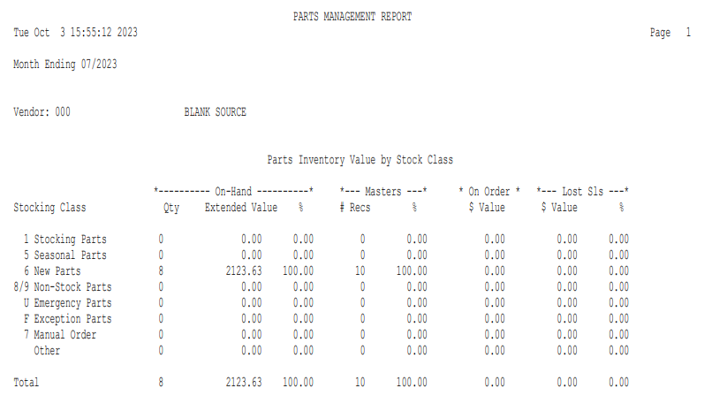

Parts Inventory Value by Stock Class: This section breaks down the vendor’s current inventory by stock class. Values are based on the current dealer cost. Most of the other information in this section of the report comes from the Parts Master.

On-Hand: This is the quantity on hand as of the end of the calendar month you are closing.

Qty: This indicates the total number of units per stock class.

Extended Value: This is the total value of all units on hand per stock class.

Formula: Multiply on-hand units by current dealer cost.

On-Hand Percent (%): The percentage of inventory value retained in each stock class for this vendor compared to the vendor's total inventory value. For example, if Stock Class 1's percentage is 26.91, the report is telling you that 26.91% of this vendor's total current inventory value is in fast-moving parts.

Formula: Divide the stock class's extended value by the vendor's total value.

Masters: This second subcategory reviews the current number of part masters you have for this vendor per stock class.

# Recs: This shows the number of part records contained in each stock class.

NOTE: This is not the same as the value in the “Qty” column. For example, “Qty” may print "5" while the “# Recs” column may show only “1.” This means you have only 1 part number record with this stock class, but this part number has 5 units in stock.

Masters Percent (%): This indicates the percentage of part records in each stock class for this vendor compared to the vendor's total inventory records.

Formula: Divide the Stock Class's # Recs by the Vendor's Total # Recs.

On Order $ Value: This column shows the extended value (cost) of parts currently on orders per stock class for this vendor.

Lost Sls: This last subcategory reviews the relationship of lost sales per stock class for this vendor.

$ Value: The total value of the lost sales calculated at the current dealer cost per stock class shows here.

Lost Sales Percent (%): The percentage of lost sales per stock class designation compared to the vendor's total lost sales value for the month you are closing is shown here.

Formula: Divide the Stock Class's "$ Value" by the Vendor's Total "$ Value."

Totals: This prints the totals of all of the above-described columns.

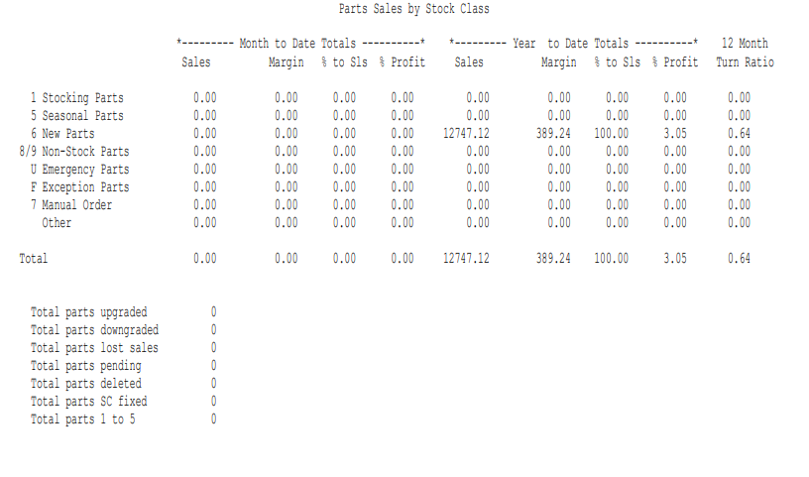

Parts Sales by Stock Class: This section reports the specified vendor's sales for the month you are closing and for year to date based on the calendar year. Sales amounts are drawn from the Part Master for each part number record in the stock classes shown.

Month to Date Totals: This subset of columns shows the vendor's total sales for the month you are closing according to the stock class.

Sales: This lists the month's sales made in each stock class for this vendor in actual dollars.

Margin: This reports the current month's profit margin by stock class for this vendor. Parts Month End reviews quantity sold in the month you are closing and multiplies this by the current dealer cost. Then it uses the following formula for determining the profit margin.

Formula: Subtract the Total Cost of Units Sold from the Actual Sales Amount in the Part Master.

% to Sales: This compares the total monthly stock class sales to the vendor's total monthly sales.

Formula: Divide the total monthly stock class sales for this vendor by the vendor's total monthly sales.

% Profit: This shows the month's percent of profit made in the designated stock class for this vendor.

Formula: Divide the Stock Class Profit Margin (Margin) column by the Stock Class Monthly Sales for this Vendor.

Year to Date Totals: This lists the vendor's total sales for the calendar year according to the stock class. This section includes the following columns:

Sales: This shows the year-to-date sales made in each stock class for the vendor in dollars.

Margin: This shows the year-to-date's profit margin according to stock class for this vendor. Parts Month End reviews the quantity sold in the year and multiplies it by the current dealer cost before applying a formula to determine the profit margin.

Formula: Subtract the Total Cost of Units Sold for the Year from the Actual Sales Amount.

% to Sales: This compares the year-to-date stock class sales to the vendor's total year-to-date sales.

Formula: Divide the year-to-date stock class sales for this vendor by the vendor's total year-to-date sales.

% Profit: This reports the year-to-date's percent of profit made by stock class for this vendor.

Formula: Divide the Year-to-Date Stock Class Profit Margin (Margin column) by the Total Year-to-Date Stock Class Sales for this Vendor.

12 Month Turn Ratio: This is the stock class's ratio of the cost of monthly units sold compared to the stock class's cost of monthly units on hand. For example, if the ratio is 2, it indicates that you have sold two units for every one you carry in inventory for this stock class. The turn ratio is a weighted average of the total turnover ratio for the specified vendor (consult your past month end reports to find the optimal turn ratio.)

The turn ratio’s calculation is done by vendor and then by stock class groups within the vendor. Parts with negative on-hand quantities are excluded from the calculation of the current inventory value. The value of the cost is taken from the cost field in the part master. Note that the source master may play a role in this as it may indicate that the cost is a calculated field. If so, the formula from the source master is used in the calculation of the current inventory value.

- 12 months cost of sale = Qty sold for each of the last 12 months, including the month of the month end process (for example, the October Month End includes the months of October back through the previous November), TIMES the current COST of the part.
- Current inventory value = Qty on hand times the current COST of the part plus core value. Negative on-hand quantities are excluded from the calculation.
  - NOTE: If the part has a connected core number and there is an on-hand quantity on the NEW part number, the quantity on hand of the NEW is multiplied by the core charge on the NEW number. The resulting value is added to the inventory value to give the current inventory value.
- 12 months cost of sale DIVIDED by the current inventory value = 12 month turn ratio

Total Line: This prints the totals of all of the above-described columns. However, the % Profit totals are not the result of adding the columns. They are calculated by dividing the vendor's total profit margin (all stock classes) by the vendor's total sales (all stock classes). The total 12-month turn ratio is also calculated for all units sold for the month you are closing compared to all units on hand, regardless of stock class.

Summary Totals: The last section of this report summarizes the Parts Analysis Report for this vendor.

Total parts upgraded: This shows the total number of parts upgraded to stock class 1 or 5 (the original stock class may have been 8, U, or 6).

Total parts downgraded: This is the total number of parts downgraded to stock class 8 (the original stock class may have been 1, 5, or 6).

Total parts lost sales: This lists the total number of parts that had lost sales quantities.

Total parts pending: This is the total number of parts now flagged as pending deletion. These records should be reviewed before the next month end.

Total parts deleted: This lists the total number of parts removed from the Inventory Master file. These records were flagged as pending deletion during the last month end and were not saved in the system.

Total parts SC fixed: This indicates the total number of parts whose stock class was corrected.

Total parts 1 to 5: This shows the total number of parts moved from stock class 1 to stock class 5. These changes occur for dealers that have the system set to auto calculate the seasons and season ranges for seasonal parts.

Grand Totals Parts Management Report:

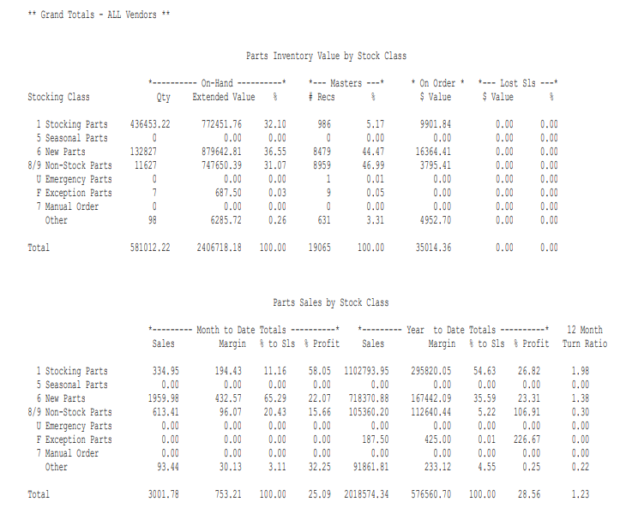

NOTE—12 Month Turn Ratio "Total" figure: This is a weighted average of the total turnover ratio for the span of vendors processed through INME. It represents the average number of units sold compared to the number of units on hand. Optimal turnover ratios are 2 or more, which indicate that you sell, on the average, 2 or more units of a part for every one unit you keep on hand. Ratios less than 2 indicate that the dealership is overstocking or contains a surplus of obsolete, used/salvage, or non-returnable parts.

Factors that may cause negative margins: There are a variety of factors that may cause Negative Margins on the Parts Management Report. Negative margins result when the cost is greater than the selling price.

Terms, Fields and Formulas:

- Monthly Margin: Monthly Sales $ less Factored Cost of Sales
- Yearly Margin: YTD Sales $ less Factored Cost of Sales
- Monthly Margin %: Monthly Margin divided by Monthly Sales $ times 100
- Yearly Margin %: Yearly Margin divided by YTD Sales $ times 100
- Factored Cost of Sales uses the source master of a part to calculate the cost of the number of units sold in that period. The factored cost is the current replacement cost of a part.

Field terms in Part Master:

CUR $ SLD: Actual sales dollars in the current month since the last month end.

YTD $ SLD: Actual sales dollars in the current calendar year not including the current month.

- The YTD history field does contain current month information.
- The margin for a part may be incorrect if there is a discrepancy between the accumulated sales unit buckets and the current and/or year to date sales dollars fields.

Symptom: The sales history quantity fields (current month bucket and/or current year bucket) are incorrect. The quantity sold field may be higher than the actual dollars sold for the same period. This situation would likely be a result of manual changes in the part master.

Symptom: The source record is incorrect. Verify that each source number file contains the correct price flag and factored percentages for cost, list (Dealer's Selling Price), and MSRP. For example, if the cost flag is set up as 2 (MSRP) instead of 1 (Cost), the program calculates factored cost at 100% of MSRP. If the selling price is changed on the POS or SMS Invoice to reflect an amount that is equal to or less than MSRP, the profit margin is either 0.00 or a negative amount.

Symptom: The Source Number File contains the wrong price level ranges for MSRP. When you set up two or more price levels in the Source Master, be sure that there are no gaps or overlaps in the ranges. You may have from 1 to 99 price levels, but the first price level must begin with 0.00 in the Min MSRP field and the last price level must end with 9999999.99 in the Max MSRP Field. See the example below:

Price Level 01 Min MSRP 0.00 Max MSRP 10.00
Price Level 02 Min MSRP 10.01 Max MSRP 50.00
Price Level 03 Min MSRP 50.01 Max MSRP 9999999.99

Symptom: Low volume may create negative margins. A negative margin will result if the number of parts returned exceeds the number of parts sold in the same selling period. A negative margin does not always mean there is a problem. In this case the monthly margin is negative, but the yearly margin is not.

Symptom: Units from a package or case are sold with an incorrect cost. This situation happens if, for instance, you are selling one gallon of oil from a five-gallon drum case. The selling price on the invoice is adjusted, but the cost is not. Therefore, a one-gallon oil unit sells with a correct selling price but incorrect cost.

Symptom: The Cost/C (cost per hundred) field in the part master is used on all parts pricing calculations. An incorrect margin will occur if a part was sold and the cost per hundred field was changed after the sale in the same selling period. NOTE: The number entered in the COST/C field prompts the system to divide the Factored List and Cost by that number. If you have a part number for a 5-gallon oil drum case (and you want to sell this item by the gallon), enter “5” in the COST/C field. The program divides the current price file's factored cost and list by 5, resulting in a new list and cost for one gallon.

Symptom: An invoice was entered that contained a core charge greater than the selling price. The core charge may have been changed while writing the invoice or the incorrect core charge is in the part master. The core charge is updated from the manufacturer’s price tape or may be manually updated.

Symptom: Manufacturer cost is typically updated by the manufacturer price tape update. Some vendors no longer update the cost field. If the manufacturer cost field is zero or the value is incorrect, and the source bases the cost on that field the margin may calculate incorrectly. The solution would be to either update the manufacturer cost field or change the source.

Correcting a Negative Margin:

- Review the source records for problems. Look for and change any incorrect cost flags and invalid MSRP ranges.
- Review the Inventory Transaction Report(s) (ITR) for that period. Look for abnormally large negative or positive quantities. If necessary, edit the year dollars and/or units sold fields in the Part Master. Since you are in a new month, there should be no adjustments to the current month dollar fields. However, you may decide to adjust the monthly units sold bucket for the month where the problem occurred.
- Print a Negative On-Hand Report (NOHR). This report can be used to identify possible problem part records. Negative sales may result if an incorrect quantity is entered on a part return, such as if “100” is entered rather than “1.” To correct this situation, adjust the on-hand, sales dollars, and sales unit fields in the part master.
- Print a suggested order only Custom Stock Order (CSO) Report as shown below. This report provides both the yearly sales totals and the monthly sales totals. Look for large sold quantities and inconsistencies between the yearly totals and the monthly totals. Then enter the adjusted sales quantities in both the monthly and yearly history buckets in the Parts Master.

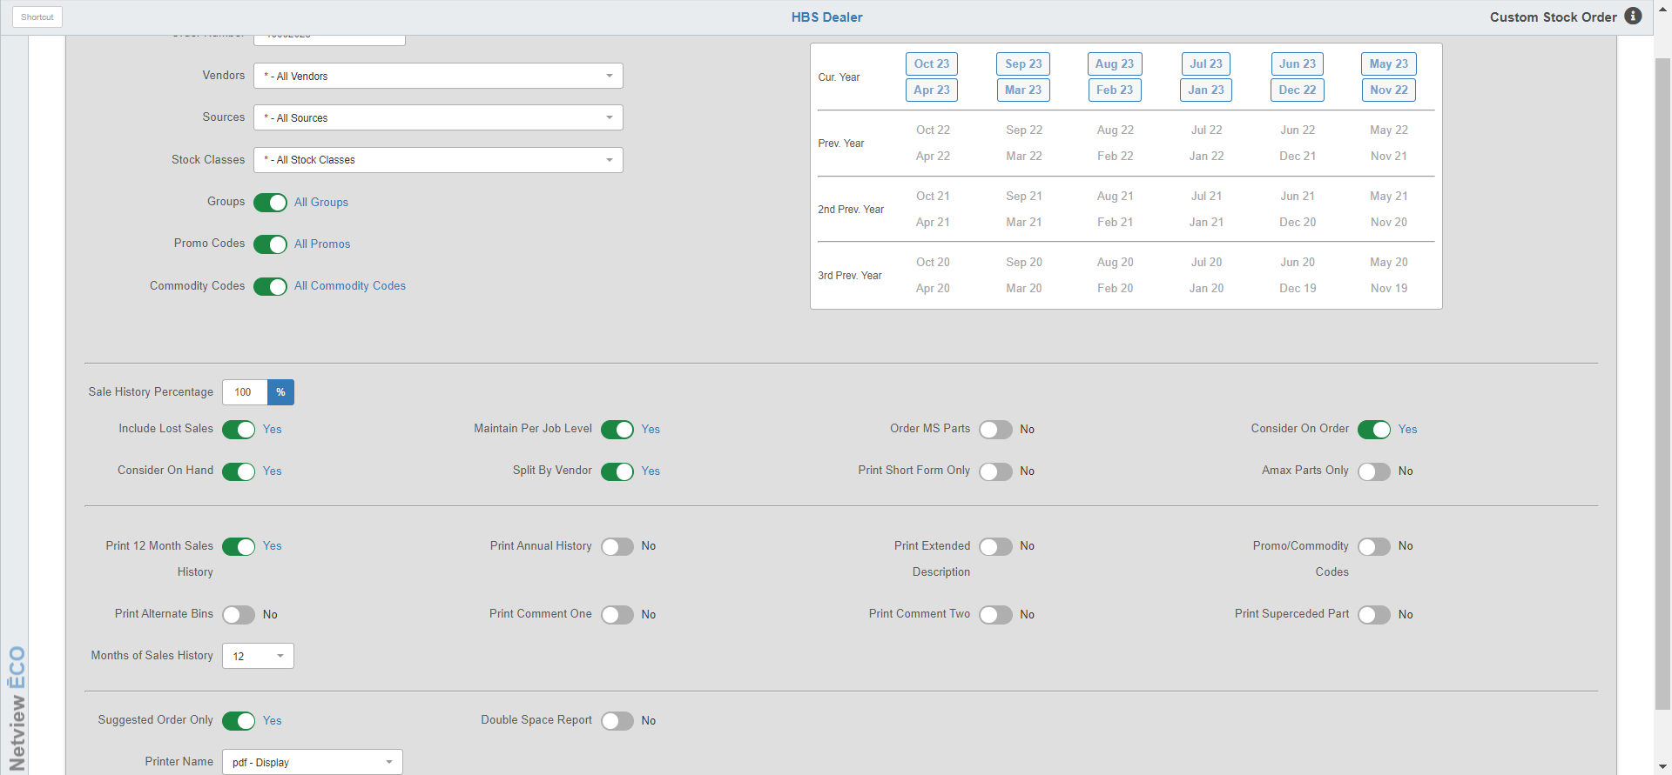

- Create a report using the Report Writer (RW) to print all parts with negatives in the current month, year units, and dollars sold fields. Print cost and list to verify those values.

Pending Deletion: One of the functions of the Month End Process is to examine part numbers and flag them for deletion if they meet the following criteria:

- No on-hand quantities.
- No on-order quantities.
- No sales history in the specified time range when you run the Month End Process (12/24/36/48/60 months).
- Not linked (through the NEW # field) to another active number record that contains recent sales history.
- Stock Class Code is not A (History).

If the part number meets all of the above specifications, INME marks this record with a “D” in the PEN DEL Field. The month end printout includes this part number record as Pending Deletion so that you can review this file before the next month end.

To save a part record marked for deletion, you may want to do one of the following:

- Take a physical count. If you really have stock on hand, be sure to post this information into the system through post order/adjustments. The system does not delete records with on-hand amounts. However, you want accurate files, so do not fake on-hand quantities.
- Change the time range for deletion the next time you run the Parts Month End. Perhaps you chose 24 months which means you told the program to flag all part numbers as pending deletion if they have not sold in the last 24 months. Just extend the time to a longer selection. This preserves many of the records with the D flag.
- Cross-reference the record flagged as pending deletion to an active file that contains current sales history, or on-hand and/or on-order quantities. Enter the active part number in the NEW # field. This action keeps the pending deletion part number as history to the newer record (change the stock class code to “A” as well.) You may also want to enter this old number in the OLD field of the active part number record to complete the cross-reference circle. You could also use the Part Number Changes Program (PNC) to make these changes.
- Change the stock class code to “A.” If you want to save a part number record flagged for deletion but none of the above suggestions fit (no physical shelf quantities, no sales in over 60 months, not a cross-reference to a newer part number), change the stock class code to “A,” the historical stocking class. The system never removes these.

Only the above suggestions save the part number from deletion during the next month-end procedure. Please note: You cannot remove the “D” from the PEN DEL field to save the part.
HBS Systems Dealer
Jun 3 2008 PARTS W/PENDING DELETE STATUS Page 1

Part No. Description Ven Typ SRC PD SC Bin Loc Entry Date Last Sls D
247647 SHIM 140 NEW 140 D 8 US213 05/01/1997 08/01/1997
362578A1 VALVE 140 NEW 140 D 8 10/30/2001
601145 COVER SOLI 140 NEW 141 D 8 06/01/1996 06/01/1996
639508 SPROCKET, 140 NEW 141 D 8 US104 05/01/1995 06/14/2001
682836 REINFORCEM 140 NEW 141 D 8 US111 05/01/1995
717820 PLATE 140 NEW 140 D 8 US213 04/01/1998
82011472 PLUG 140 NEW 140 D 8 A49/5 10/27/1998 08/14/2001
86570558 BELT 140 NEW 141 D 8 NW3/8 03/10/1999
86588772 P.T.O. ASM 140 NEW 140 D 8 US423 06/08/2000
9842662 DISC 140 NEW 141 D 8 US104 05/01/1995

Parts w/Pending Delete Status – Report Writer Report: You can also use the “Parts w/Pending Delete Status” report in Print Establish Reports (PER) to review all part number records flagged as pending deletion. This report lets you examine the parts that may be deleted when the upcoming parts month end is run. It prompts for a vendor number so you can check the parts from one vendor or all of them. The “Last Sales Date” column could show activity for purchases, returns, voided lines on tickets, or terminated invoices.

Print the report after you finish each month end. You can then review any Pending Deletion part records before the next month end removes them from your inventory. There may be some records you will want to save.

Report Columns:

Part No.: This is the part number that has a pending deletion code of “D.”

Description: Here you will find the description for the part number listed.

Ven: This is the vendor number for this part.

Typ: This is the part type. This information is from the Part Master and could be:

New

Reman

Core

Used

Memo

SRC: This is the source number that you have this part in. The source number drives the accounting for your parts sales.

PD: This is the Pending Deletion code from the “Pen Del” field in the Part Master.

SC: This is the part’s stock class.

Bin Loc: This is the part’s primary bin location.

Entry Date: This is the date that the part was first entered into the system.

Last SLS D: This is the last time that this part was sold.

