Daily Parts Profit Report (INPR)

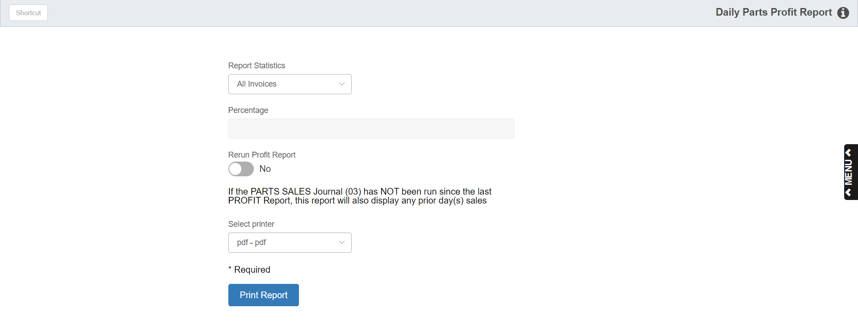

The Profit Report provides information about daily Parts Sales made in POS invoicing. The report format sorts the information in numerical order by invoice number.

To access this function, you can:

- Select “Inventory” from the menu and click “Profit Report.”
- Type “INPR” in the Shortcuts Bar.

Field Definitions

Report Statistics:

- Choose All Invoices to generate the entire Profit Report, showing all parts sold regardless of the margin percentage.
  - Always select this choice because otherwise the posting of the Parts Journal will be incomplete.
- Choose High to print sales that are equal to or higher than the percentage entered.
- Choose Low to print sales that are equal to or lower than the percentage entered.

Percentage: This field only activates for the High or Low selection, and provides the percentage to you as a base for the report. For example, if you want a report of those parts with 35% margin or higher, type in “35” with the High selection. For low profit parts, type in “15” for a 15% margin with the Low selection.

Rerun Profit Report: If you want to see a report of the High or Low Profit parts, you may go back and rerun the report AFTER the complete report has been run.

Select Yes if you have already run the complete Profit Report and you are running a second copy or a high or low variation.

No indicates you are running the Profit Report for the first time and that it is being run for ALL parts.

Printer Name: Select the printer to receive the printout. A default printer name is pre-filled but can be changed as necessary. Use the pdf printer to view the report on the screen without printing a copy of it.

Print Report: Press this button to produce the report.

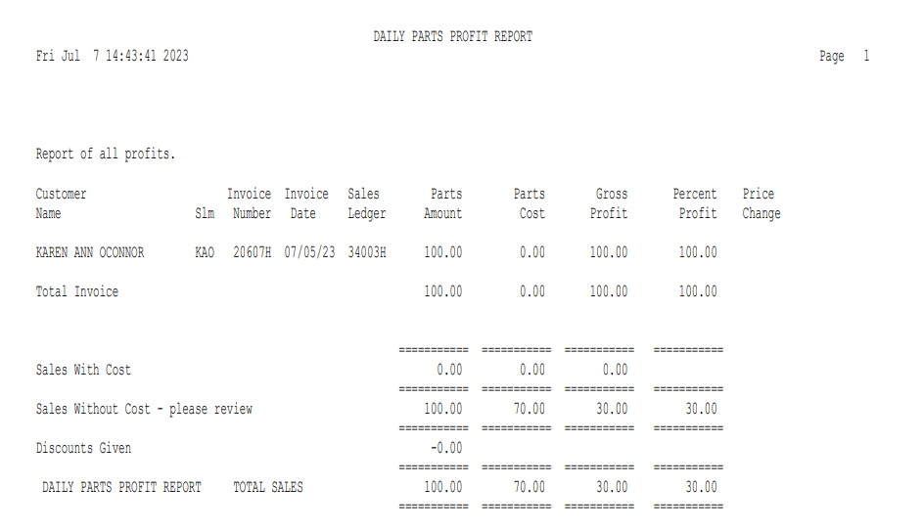

Report Definitions

Customer Name: This column prints the customer’s names as found in the Customer Master. In most cases, this information should match the actual invoice itself, except when the sales person overrides the name on the account number and supplies another name or spelling. This change in POS is not reflected on this report.

Slm: This column prints the initials or number of the sales person who wrote the invoice. This information could be used by the Parts Manager for tracking commission data or the invoices generated by each salesperson.

Invoice Number: Here the report prints the Invoice Number assigned by POS. It is useful to compare back to the original invoice as necessary.

Invoice Date: The date shown in this column is the date the invoice was written.

If the End of Day process is consistently run each day, the date here should match the one on the invoice.

If you elect to run the End of Day process the following morning, then the date may reflect that day, not the date the invoice was printed.

Sales Ledger: This column prints the General Ledger account number where the sale for the item shown will be posted. This account number corresponds with the Sales Code used on the sale. A Sales Ledger line prints for each part number on the invoice. The lines actually are in the same order as the part numbers on the invoice itself. This makes it easy to find the part number involved if there is a reason to double-check it.

Parts Amount: The amount that prints in this column is the actual selling price of the individual part or parts on that line of the invoice. It represents the extended selling price of that part number (quantity sold x selling price).

Parts Cost: This amount is the actual cost of the individual part or parts on that line of the invoice. It represents the extended dealer cost of that part number taken from the Part Master (quantity sold x dealer cost).

Gross Profit: This amount is the calculated gross profit for the individual part or parts on that line of the invoice. It is calculated by subtracting the Parts Cost column (total cost) from the Parts Amount (total selling price).

Percent Profit: This figure is the percentage of profit for the individual part or parts on this line of the invoice. It is calculated by dividing the Gross Profit (profit dollars) by the Parts Amount (total selling price).

Price Change: This column prints an asterisk (*) if a salesperson has manually changed something about this line on the invoice. It may also indicate if the part does not have a cost in the Part Master or that the part number was an override entry on the invoice.

- Manual changes on this line could be a change to any of the following:
  - Price
  - Tax Code
  - Sales Code
  - Discount Percentage
  - Sales Amount
- Missing Cost entries indicate there is no cost for this part in the part master.
  - The invoicing routine does prompt for the cost, and if zero or nothing it is entered here.
  - The system will use the default percentage for cost found in the Company File Setup.
  - These items are noted in a total line at the bottom of the report “Sales Without Cost.”
- Override parts sales entries (space O) are also flagged here. In this case, it would indicate the sales person did not enter a cost as mentioned above.

Total Invoice: This line summarizes the amounts for this invoice. It subtotals the Parts Amount, Parts Cost, Gross Profit, and Percent Profit columns for this invoice.

Sales With Cost: This subtotal line totals the Parts Amount, Parts Cost, Gross Profit, and Percent Profit columns for those invoices where the parts all had costs from the Part Master.

Sales Without Cost- please review: This subtotal line totals the Parts Amount, Parts Cost, Gross Profit, and Percent Profit columns for those invoices where the parts did not have a cost.

- Override parts sales entries:
  - Determine if the average profit generated by the system is correct for these parts.
  - Think about adding this part number to the system so that it may have a proper cost entry, a bin location, on hand amounts, and sales history tracking.
- Surplus/Salvage part number sales entries:
  - These items may be override entries.
  - They may also be records on your system with no cost in the Part Master.
  - One solution to this would be to use $0.01 for the cost on these items so the system does not calculate the cost for these using the default percentage.
  - These items usually carry a higher margin of profit (typically from 80-99%).
- Missing Cost entries:
  - Check Parts Inquiry to see if there is a cost for these items.
  - If not, you may re-run the Manufacturer’s Price File or manually enter the cost if needed.
  - If you have cost corrections to be made, give this information to the bookkeeper so they can be made in addition to any corrections you need to make.

Grand Total Sales: This line totals all parts sales for the period by Parts Amount, Parts Cost, Gross Profit, and Percent Profit.

High or Low Total Percent Profit Reasons:

- Majority of Invoices are Internal or Warranty: When Picking Tickets with a Price Code of 1 (Cost) are run, they will drag down the overall profit percentage. Lower profit percentages are likely toward the end of the month as Internal or Warranty Tickets are run in greater quantity at that time to get them booked before the close of the month.
- Many of the Part Number Sales Entries Came from Price Level 01: If you have set up multiple Price Levels per Source, Level 01 is likely to be the one with the highest factoring. Parts sold in this level will have a higher profit margin and have a favorable impact on the total percentage.

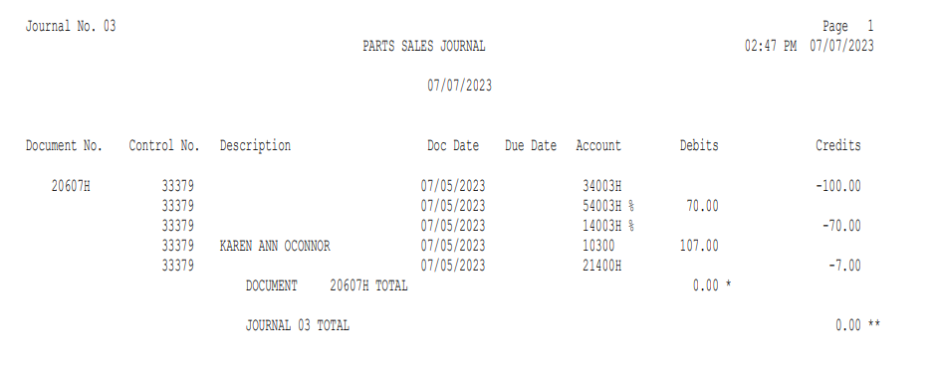

Parts Sales Journal (INPJ): The Parts Sales Journal report shows the accounting detail for the statistics found on the Daily Profit Report. Each invoice is itemized and shows line by line detail for each part number “transaction.” The sample above shows the detail available for each part number of the transaction (Sale Account, Cost Account, and Inventory Account). For more information on this Journal, see its separate topic page.

