Inventory Obsolescence Report (IOR)

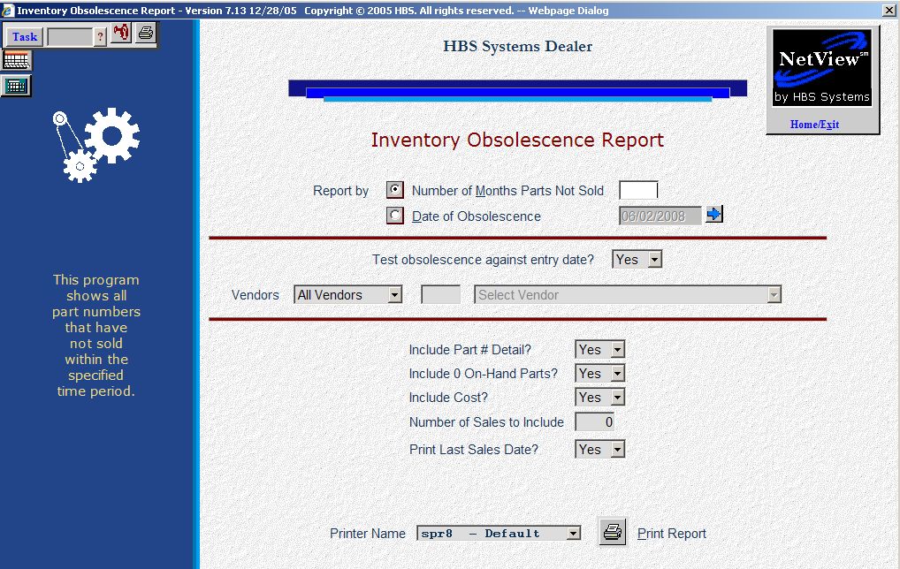

This report examines the parts inventory masters for obsolescence. It can be helpful when preparing a Parts Return as well as analyzing your inventory for obsolescence.

- To access the Inventory Obsolescence Report, you can either:
  - Select “Inventory” from the menu. Choose the “Reports” submenu and click “Inventory Obsolescence Report.”
  - Type “IOR” in the Shortcuts Bar.

Field Definitions

Number of Months Parts Not Sold:

Click on Number of Months Parts Not Sold to base your report on the number of months of inactivity.

Enter the number of months in the field provided.

Date of Obsolescence:

Click on Date of Obsolescence to base the report on no activity from that date to the present date.

Enter the date in the field provided.

Test obsolescence against entry date?:

- Select Yes if you want the system to use the entry date of the part (from the Parts Master) as the comparison date.
- Choose No if you do not want to consider parts based on their entry date.

Vendors:

- Choose All Vendors to include all vendors on the report.
- Choose Include and select up to 10 vendors to include on the report.
- Choose Exclude and select up to 10 vendors to exclude from the report.

Include Part # Detail?:

- Choose Yes to print the part numbers on the report.
- Choose No to see only totals for each vendor.

Include 0 On Hand Parts?:

- Choose Yes if you want to include parts with an on hand quantity of zero.
- Select No to exclude parts with an on hand quantity of zero.

Include Cost?:

- Choose Yes to print the unit cost of the parts on the report.
- Choose No to exclude it.

Number of Sales to Include: Enter the number of sales to include on the report.

Print Last Sales Date?:

- If you want to include the last sales date on the report, select Yes.
- Choose No to exclude it.

Printer Name: Select the printer to receive the printout. A default printer name is pre-filled but can be changed as necessary. Use the see printer to view the report on the screen without printing a copy of it.

Print Report: Press this button to print your report.

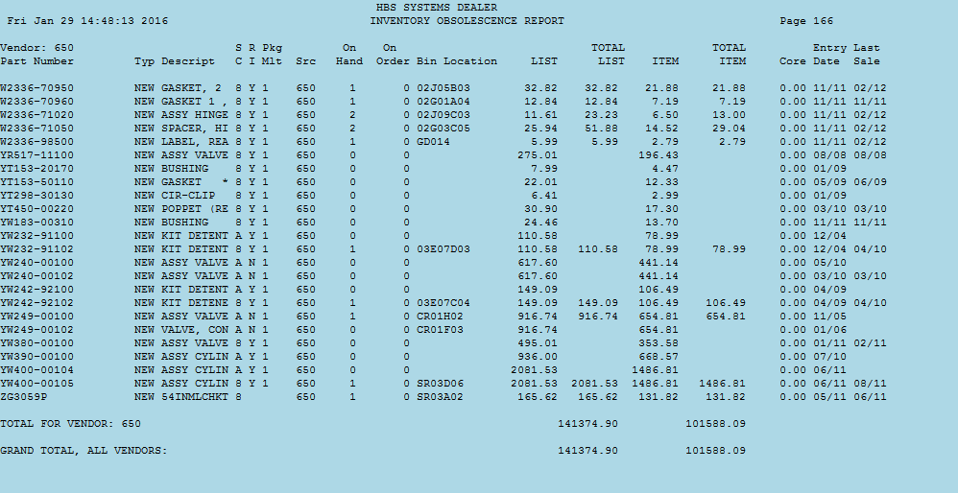

Detailed Version

Vendor: This field shows the number of the vendor you selected.

Part #: This field shows the Part Number.

Type: Here you will find the part type from the Part Master, which could be:

New

Used

Core

Memo

Reman

Descript: The Description of the part number listed is pulled from the Parts Master.

SC: This is the Stock Class of the part number listed.

RI: This field shows the Return Indicator of the part number selected.

Pkg Mult: This area prints the Package Multiple for the item selected.

Src: This is the Source of the part number listed.

On Hand: This is the quantity you currently have on hand.

On Order: This is the quantity you currently have on order for this part.

Bin Location: This lists the primary Bin Location for the part number.

List: This is the List price of the part number shown. It is a calculated amount based on the Parts Source factor applied to the value in the Parts Master.

Total List: This is extended List value (List price times quantity on hand).

Item: This is the cost of the part number shown. It is a calculated amount based on the Parts Source factor applied to the value in the Parts Master.

Total Item: This is the extended cost value (cost times quantity on hand).

Core: This is the dollar value of the core if the part number listed has a core charge.

Entry Date: This is the date the part number was added to the system.

Last Sale Date: This is the date of the last time this part was sold.

Total for Vendor: This line totals the Total List and Total Cost for all parts for this vendor.

Grand Total, All Vendors: These fields total the List and Cost for all parts for all vendors on the report.

