Inventory Point of Sale Defaults (IPOS)

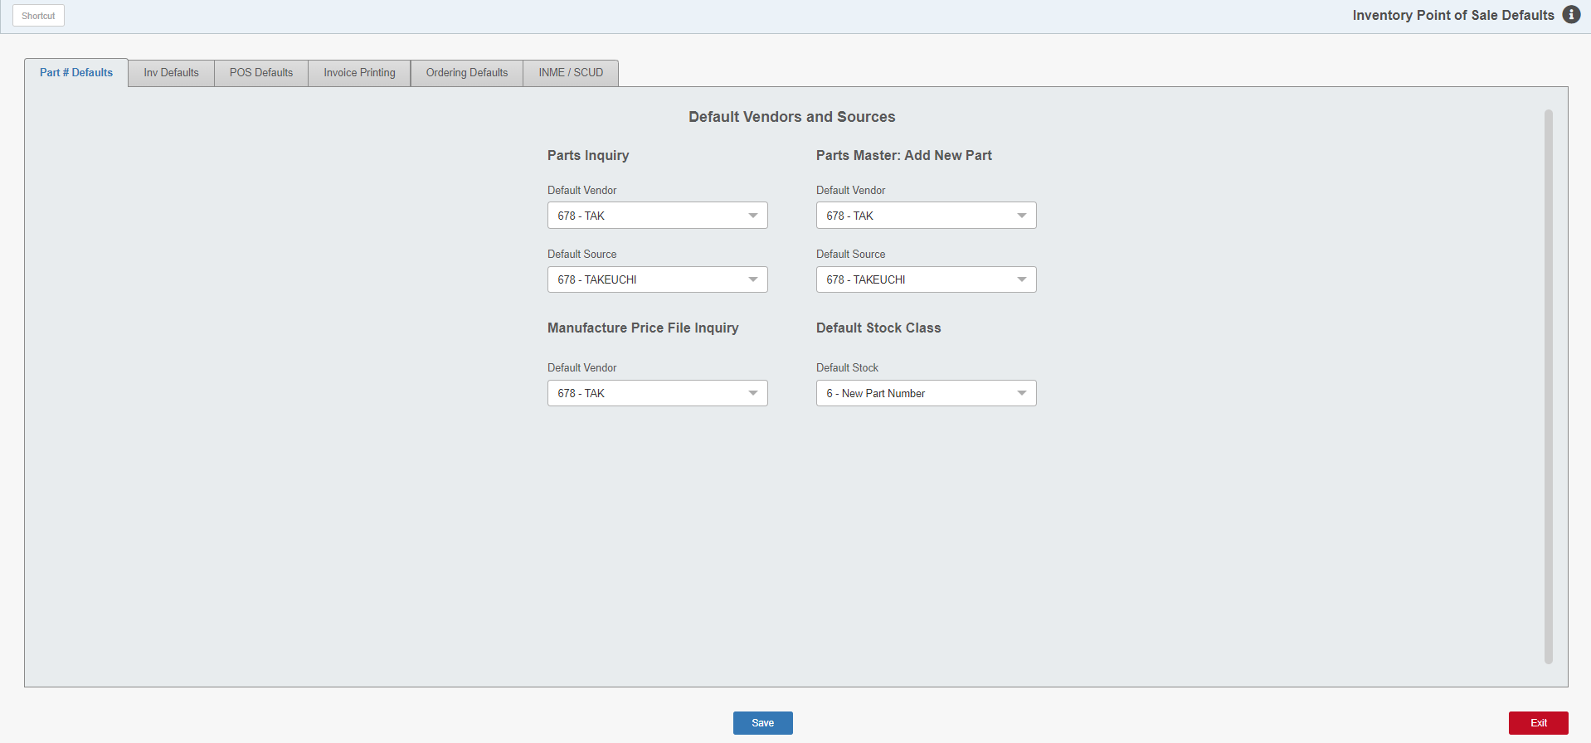

Inventory/Point of Sale Defaults is for setting up a variety of parameters that affect Parts Inventory, POS Invoicing and Ordering.

To access this function, either:

- Select “System Maintenance” from the menu. Choose the “Company File” submenu and click “Inventory POS Defaults.”
- Type “IPOS” in the Shortcuts Bar.

General Features

Save: Click this button to save any changes made to the record.

Exit: Click this button to close the application without saving any changes made.

Part # Defaults Tab

Parts Inquiry—Default Vendor/Default Source: These fields are no longer in use.

Parts Master: Add New Part:

Default Vendor: This field holds the Vendor Number to auto-fill as a default vendor when new parts are added to the system. Usually, the Vendor Number for the dealership's primary manufacturer is entered here, and is typically the same as the Default Source. This Vendor will be preset in Custom Parts Maintenance (CPM) when the user opens it on its own to add the part.

Default Source: This field holds the Source Number to auto-fill as a default source when new parts are added to the system. Often the Source Number for the dealership's primary manufacturer is entered here. This Source will be preset in Custom Parts Maintenance (CPM) when the user opens it on its own to add the part.

Manufacturer Price File Inquiry—Default Vendor: This field holds the Vendor Number to auto-fill as a default vendor when new parts are added to the system through Price File Inquiry (PFI). This Vendor will be preset in Custom Parts Maintenance (CPM) when the user accesses it by clicking “Add Non-Price File Part” inside Price File Inquiry.

Default Stock Class: When setting up a new part number record, the system uses the default Stock Class shown here. This Stock Class will be preset in Custom Parts Maintenance (CPM) when adding parts from a Price File and when adding non-price file parts. Typical settings are:

U (customer-ordered parts)

6 (new parts)

Stock Class Definitions

Stock Class |  | Definition
1 |  | For fast moving parts or regular stocking parts. These parts meet the criteria defined in the Source Master. These parts show sufficient history to be considered on a suggested stock order. The system automatically includes a minimum order quantity of one (1) for all Stock Class 1 parts on a Standard Stock Order.
 |  | Automatic Change (when Parts Month End is run): When a Stock Class 1 part number has insufficient sales activity for the period specified in the Source Master, the system changes the Stock Class to 8.
5 |  | For fast moving parts sold primarily during specific times of the year or seasons. Parts with specific selling seasons are candidates for this Stock Class because they fall into predictable, defined selling times. This identification gives them special handling in the ordering routines. The selling seasons defined become part of the criteria used by the ordering routines. When the ordering period is outside the defined seasons for the part, the system will suggest a 5% demand for the parts identified with Stock Class 5 on a Standard Stock Order.
 |  | Automatic Change (when Parts Month End is run): When a Stock Class 5 part number has insufficient sales activity for the period specified in the Source Master, the system changes the Stock Class to 8.
6 |  | For new parts with sales potential. If this Stock Class is selected, usually some specific stocking levels are provided. For example, enter a BSL Override of 1 or more on these parts until they generate enough sales history for the system to calculate the BSL.
 |  | Automatic Change (when Parts Month End is run): When a Stock Class 6 part number has insufficient sales activity for the period specified in the Source Master, the system changes the Stock Class to 8. The system can also change the Stock Class to 1 or 5 as the sales reach the minimums set in the Source Master.
7 |  | For dealer-controlled or manually ordered parts. It can be used to identify parts with special purchase discounts, sporadic sales history or other special ordering considerations.
 |  | Automatic Change (when Parts Month End is run): This Stock Class will not be changed by the system. Any changes to the stock class must be done manually.
8 |  | For parts without sufficient sales activity to meet the minimums set in the Source Master. This is commonly referred to as the Non-Stocking class.
 |  | Automatic Change (when Parts Month End is run): The system may change parts with Stock Class 8 to a designation of Stock Class 1 or 5 if they qualify based on sales activity.
9 |  | For slow moving or non-stocking parts that do not meet the minimums set in the Source Master. This code is typically used for surplus parts.
 |  | Automatic Change (when Parts Month End is run): The system may change parts with Stock Class 9 to a designation of Stock Class 1 or 5 if they qualify based on sales activity.
U |  | For non-stocking parts ordered on emergency orders for customers. These are parts that may have some sales potential.
 |  | Automatic Change (when Parts Month End is run): The system can change the Stock Class to 1 or 5 if sales history deserving of these Stock Classes accumulates. However, the system will not downgrade these parts to a Stock Class 8.
F |  | For dealer-controlled parts or parts stocked by exception. This means that a part could be on a special order for a customer or is an expensive part such as engines. Typically, the absolute stocking levels are coordinated with this Stock Class to specify your preference or ordering habits.
 |  | Automatic Change (when Parts Month End is run): This Stock Class will not be changed by the system. Any changes to the stock class must be done manually.
A |  | This Stock Class is used for two purposes. It could be a designation by the manufacturer that this part has been replaced by another part number. This is typically added when a price file update is done or when manually entered. It is also used for “non-part” numbers like labor or freight when they have been added for POS. This Stock Class prevents a part number from being considered for deletion by the Month End process.
 |  | Automatic Change (when Parts Month End is run): This Stock Class will not be changed by the system. Any changes to the Stock Class must be done manually.

Additional Stock Class Designations: You may also set up your own manually-controlled stock classes. Any of the following codes may be used for that purpose:

2 3 4 B C D E G H I J K L M N O P Q R S T V W X Y Z

TIP—Manually Defined Stock Classes: The stock classes manually defined MUST be manually maintained. The system will not perform maintenance of the Stock Class. It is a good idea to review the history of these numbers/stock classes periodically to determine if a change to a traditional stock class is warranted. Run a Parts Inventory Master Pad (History style) to make this determination.

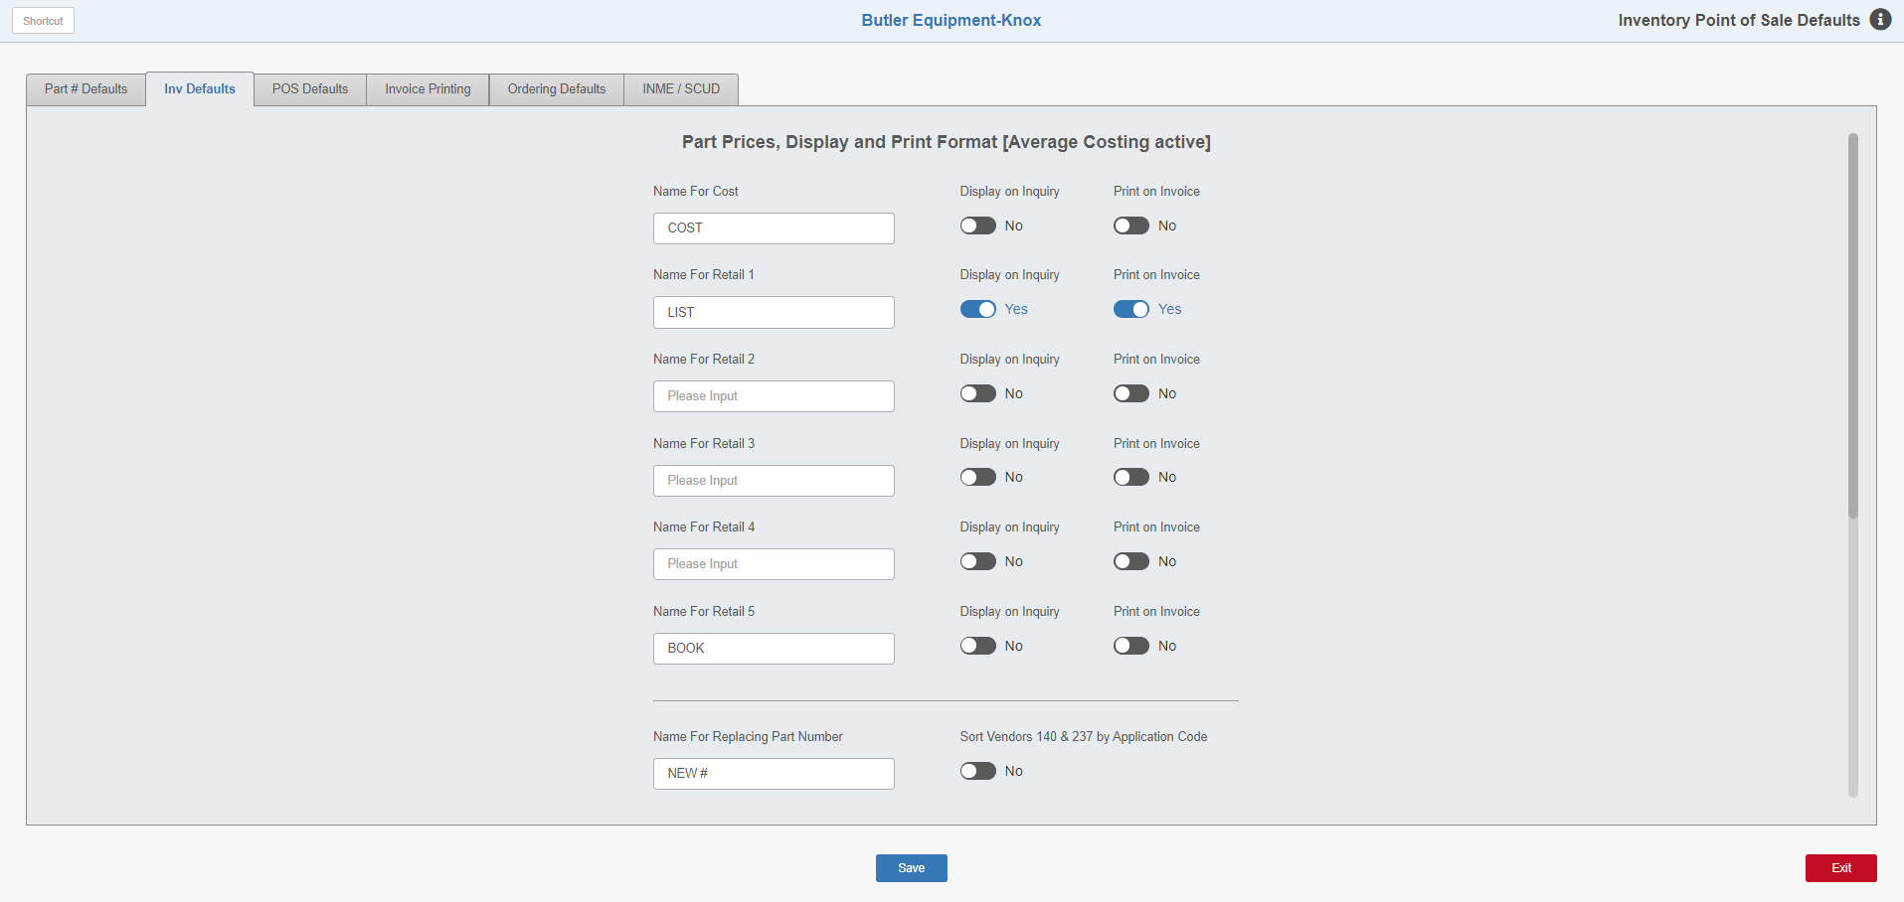

Inv Defaults Tab: Note that this tab will indicate whether or not you have Average Costing turned on for your system.

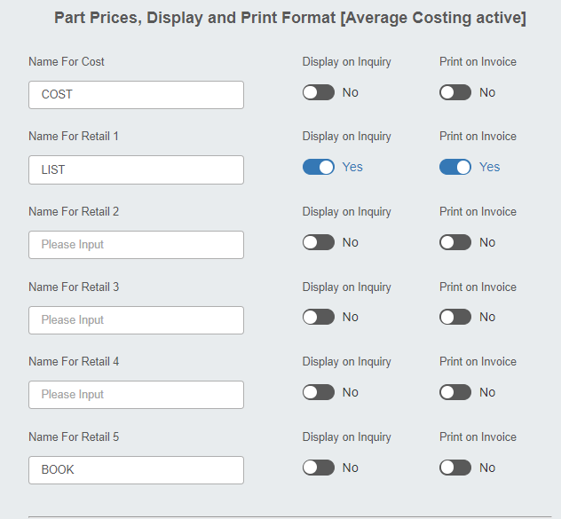

Price Code Definition Fields:

IPOS Definition | Price Code | Common Definition
Cost | 1 | Cost (Mfr Cost)
Retail 1 | 2 | List (Dealer selling price)
Retail 2 | 3 | DS01 or other dealer-defined code
Retail 3 | 4 | Dealer-defined code
Retail 4 | 5 | Dealer-defined code
Retail 5 | 6 | Book or MSRP (Mfr List)

These fields set the preferences for prices and names shown in the Inquiry functions and on POS and Service Invoices. All lines include three fields:

- The name of the price code.
- The choice of whether or not to display the price for that code in Parts Inquiry (PI) and Price File Inquiry (PFI).
- The choice of whether or not to print the price for that code on the invoice.

Name (Price Codes for Cost, Retail 1, Retail 2, Retail 3, Retail 4, Retail 5): The fields listed under the Name column are tied to the Source Master’s price factoring screen. Here, enter the names of the price codes used at the dealership. For example, Cost has been entered as the name of the Cost. Retail 1 is named List, and Retail 5 is called Book. If you not using some of the codes listed, they can be left blank.

Display on Inquiry: These fields determine which price codes are automatically shown on the Parts Inquiry (PI) screen.

Set the option in this column to Yes to show the price in Parts Inquiry. NOTE: Most dealers have Price Code 2 shown in PI.

Set the option in this column to No if the price for this code is not to be shown automatically in PI. NOTE: At any time in PI you can press the “i” button to reveal these hidden prices.

Print on Invoice: These fields determine which price codes are printed on the POS Invoice.

- Set the option in this column to Yes to print the price for this price code on the invoice. NOTE: Most dealers have at least Price Code 2, normally used as the selling price, printed on the invoice.
- Set the option to No if the price for this code is not to be printed on the invoice.

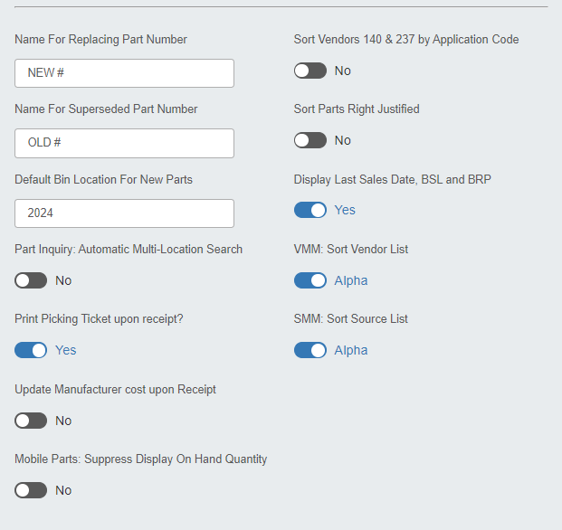

Name for Replacing Part Number: Name the field that contains the part number’s Replacing Number or Superseding Number in the Parts Master. The name entered appears in PI and PFI. In the above example, the field is called “NEW #.”

Name for Superseded Part Number: You can also designate a name for the part numbers’ Old or Substitute Number in the Parts Master. The name displays in PI and PFI. The field is named “OLD #” in the above example.

Default Bin Location for New Parts: If this field is filled in, the bin location indicated will pre-fill on parts added in CPM. When adding a part in that program, you may keep the default bin location or change it as needed. If there is no default bin location specified here, then the Bin Location field will be left blank by default.

Parts Inquiry: Automatic Multi-Location Search: Set this option to Yes to ensure that any parts inquiry made will look at all available locations for the dealership instead of just the location being worked in. This applies chiefly to multi-location dealerships, as a single-location store will not need this feature to see all their available parts.

Print Picking Ticket Upon Receipt?: When set to Yes, Quick Receipts (QR) and Automatic Receipt/Cancel (ARC) print a picking ticket for any backordered parts receipted. If the order has multiple parts from multiple picking tickets, all of the picking tickets are printed with the backorder receipted information, as well as any other parts or comments on the picking ticket.

Update Manufacturer Cost upon Receipt: This field only appears if you have Average Costing turned on. It controls whether or not Quick Receipts (QR) can overwrite the parts cost when the order is receipted in and the user enters a cost.

Mobile Parts: Suppress Display of On Hand Quantity: This option is used when a Mobile Inventory Gun is used for taking inventory. It offers the option to suppress or show the On Hand quantity on the gun’s screen.

Sort Vendors 140 & 237 by Application Code: This field permits part number sorting on the order printouts by base number. Select Yes to sort the part numbers for these vendors by their base number (application code). Base number is the application code that applies mainly to New Holland (Vendor 140) and Ford Motor (Vendor 237) dealers.

Sort Parts Right Justified: Part numbers can be specified on the order printouts to sort in a right justified format (i.e., 1, 2, 3, 4, 5, 6, 7, 8, 9,10, etc., sequentially).

Select Yes to sort part numbers on order printouts in right justified format.

Select No to sort part numbers on order printouts in left justified format (i.e., 0001, 0002, 0200, 1, 100, w, etc).

Display Last Sales Date, BSL and BRP:

- Set this option to Yes to have a part’s Last Sales Date, BSL, and BRP show in the part’s Master record in PI.
- Set the option to No to not show this information in the program.

VMM: Sort Vendor List: This sorting option affects how parts vendors are displayed. If you change the prompt to Alpha, the display of Vendors will be in alphabetical order rather than numeric by vendor number. In that case, the Vendor drop-down menus sort alphabetically in Vendor Master Maintenance (VMM), Standard Stock Order (SSO), Inventory Master Pad (IMP), and other screens where you can select the vendor.

SMM: Sort Source List: This sorting option affects how parts sources are displayed. If you change the prompt to Alpha, the display of sources will be in alphabetical order rather than numeric by source number. In that case, the Source drop-down menus sort alphabetically in Source Master Maintenance (SMM), SSO, IMP, and other screens where you can select the source.

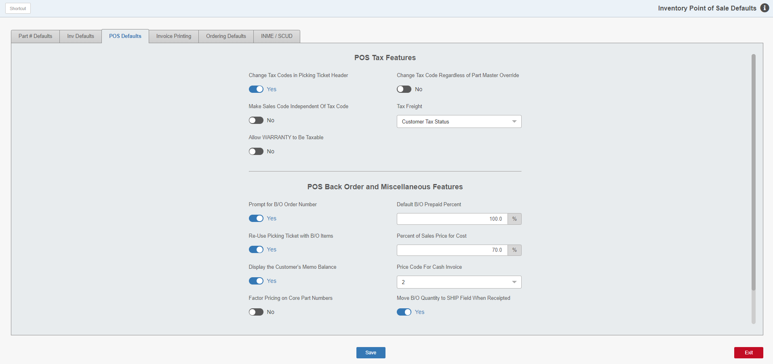

POS Defaults Tab

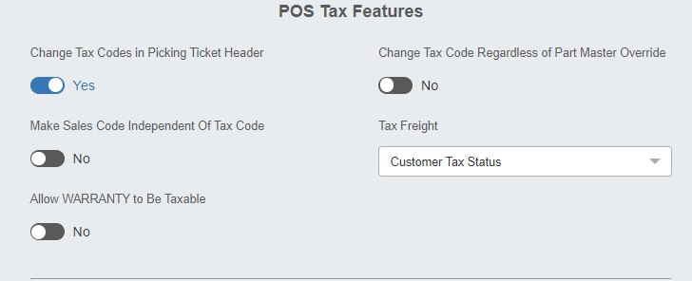

Change Tax Codes in Picking Ticket Header: This field allows for the change of the entire picking ticket’s taxable status, even if the ticket contains one or more part number lines. With this feature on, the tax status of every part number listed on the ticket can be modified in the ticket header at once.

- Select Yes to enable the feature.
- Select No to turn it off. NOTE: The tax code may still be changed on each part number line individually even if this feature is turned off. The user simply will not be able to edit the tax code in the header after it is initially saved.

Make Sales Code Independent of Tax Code: This option offers flexibility for the relationship between sales codes from the Parts Source Master to the tax codes used in POS and Repair Order Maintenance (ROM) invoicing. The choice offers the ability to have the sales codes work independently of the tax code. These sales codes, defined in the Parts Source Master, show where various selling situations (i.e., Taxable Counter Parts, Non-Taxable Counter Parts, Taxable Shop Parts, Non-Taxable Shop Parts, Internal Parts, Warranty Parts, etc.) are posted for accounting. Before making ANY changes to this setting, consult with the HBS Support Team.

- Typical settings for this are:
  - Yes for Canadian dealers
  - No for U.S. dealers
- The setting defaults to No, which means the system will attempt to make the sales codes match the selected tax code for an invoice. This applies to Sales Codes of 01, 02, 03, and 04 only. For example, if using the Non-Taxable Tax Code 00, the system will suggest 02 (front) and 04 (back) as the sales codes for non-taxable counter sales and non-taxable shop parts sales. Likewise, if the Taxable Tax Code of 01 is selected, the system will suggest 01 (front) and 03 (back) for taxable counter sales and taxable shop parts sales. The remainder of the sales codes will follow the lead and act independently of any set relationship to taxable or non-taxable tax codes.

Allow WARRANTY to Be Taxable: This setting applies to only Point-of-Sale (POS). NOTE: In Canada, the needed setting is determined by the dealership’s Province.

Set the option to No to have all POS warranty picking tickets be exempt from sales tax/GST charges.

Set the option to Yes to charge sales tax on POS warranty tickets based on the customer’s sales tax status from the Customer Master.

Change Tax Code Regardless of Part Master Override: The part number record contains several fields that allow you to select a permanent tax and sales code for both parts and shop sales. This feature allows certain parts to be always taxable or always nontaxable. With this feature turned on, you can override the taxable/nontaxable status in the picking ticket.

- Set the option to Yes to allow the change of the tax code where a tax override is set in the Part Master.
- Set the option to No to force the sale to charge tax based on the tax code in the Parts Master.

Tax Freight: This field sets how Point of Sale (POS) should determine if Freight is taxable or not.

- Select Taxable to have Freight always be taxable.
- Select Prompt to have the program prompt for a tax status.
- Select Customer Tax Status to have Freight follow the customer’s taxable status.
- Select Nontaxable to have Freight always be nontaxable.

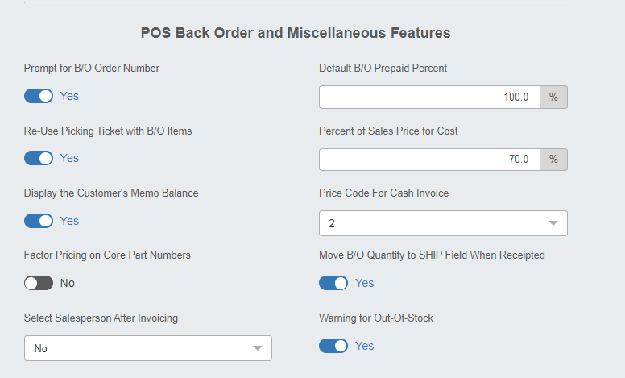

Prompt for B/O Order Number:

- Select Yes to have POS display the Enter Order Number prompt when a part number is placed on a customer order through the POS Back Order feature, allowing the user to designate the order number they want used for the backorder.
- Select No to prevent the prompt from appearing. In this case, all part numbers placed on a customer order through the POS Back Order feature are automatically assigned to the Daily Customer Order Number (the current date). You can then use the Order Merge Program (CPOR) to “split” the daily orders into other files based upon vendor, source, and customer direct ship criteria.

Re-Use Picking Ticket with B/O Items: This field sets up defaults for the POS Back Order functions. It allows the dealership to re-use a picking ticket containing part numbers placed on back order. For example, an invoice is written for the parts on hand, then the same picking ticket is re-used when the back ordered parts arrive to write a second, third, etc., invoice. After everything has finally been written as an invoice from this picking ticket, POS closes the picking tickets. Choose Yes to allow a picking ticket that has a back-order on it to be recalled.

Display the Customer’s Memo Balance: This field allows you to display a customer’s Memo Balance (the up-to-the moment balance for Accounts Receivable) when first setting up a picking ticket. This makes the customer balance readily available in case the customer wants to make a payment along with their purchase.

- Choose Yes to display the total balance of all posted and un-posted A/R transactions for the customer on the POS screen along with their picking ticket (Recommended choice).
- Choose No to display ONLY the posted A/R transactions (NOT recommended).

Factor Pricing on Core Part Numbers: This field determines if the system will mark up core pricing according to the price levels in the Source Master.

- Select Yes to have PI and POS use the source file’s price factoring percentages to calculate the core charge on both the original part number and core part number records. This means that both the core credit given to a customer when returning a core, as well as the core charge charged to a customer when the good core is not returned, will be marked up according to the price levels set up in the Parts Source Master for the affected parts.
- Select No to use only the price file’s data for calculating core charges and ignore the source file’s pricing scheme. This means that the dealership prefers not to mark up the core credit or the core charge.

Select Salesperson After Invoicing: This field’s options affect how the Salesperson field in POS functions once the picking ticket has been invoiced. The three choices for this field are:

- Yes: After you write a POS invoice, the Salesperson field will be highlighted with the previous initials/numbers still shown. Press “Enter” to accept the pre-filled initials/numbers, or type new ones without deleting the already-completed invoice information.
- No: After you write a POS invoice, the Salesperson field will be pre-filled with the previous initials/numbers and the focus is on the Customer Number field ready for input.
- Clear: After you write a POS invoice, the Salesperson field will have the focus and be blank.

Default B/O Prepaid Percent: This field lets the dealership set up a default percentage to be charged against the sale of a back ordered part in advance of its arrival. For example, it may be policy to collect 50% up front for parts placed on back order. When a back ordered part is entered, POS displays a Prepaid % for the B/O parts prompt. If there is a default percentage, it displays automatically in the prompt. Press “Enter” to accept the default, or type a different percentage (or even 0 (zero) to charge nothing at the time of the order). On the picking ticket screen, another B/O prepaid % line displays with the percentage amount (under the Ship field) and the amount charged to the customer.

Percent of Sales Price for Cost: When an Override part number (Space O part) or a part without a cost is entered, POS and ROM use this percentage to calculate an approximate cost. This default “kicks in” when the cost is not known or filled in. A popular percentage for cost is 70.0% of the selling price. This field will take any percentage.

Price Code for Cash Invoices: This field is currently not in use.

Move B/O Quantity to SHIP Field when Receipted:

- Choose Yes to have QR update the picking ticket file while updating the inventory and order files. If you select “Yes,” QR automatically updates the order file (receipts the on-order quantity), updates the inventory file (increases the on hand quantity), moves the back order quantity from the picking ticket's “B/O” field to the “Ship” field, and updates the inventory file again (reduces the on hand quantity by the quantity in the “Ship” field). This process makes it simpler to recall the picking ticket and then sell the once back ordered part(s) on an invoice.
  - There will be two lines per back ordered part number:
    - The original B/O part number line
    - A new Ship line for this part number record
  - NOTE: Users must choose “Yes” at the “Re-use picking ticket with B/O?” field for this function to work.
- Choose No if you do not want this process done automatically.

Warning for Out-of-Stock: This field controls if a warning is show when the part entered has no quantity On Hand.

- Choose Yes to be warned that you are about to sell a part with zero on hand.
- Choose No to bypass the warning.

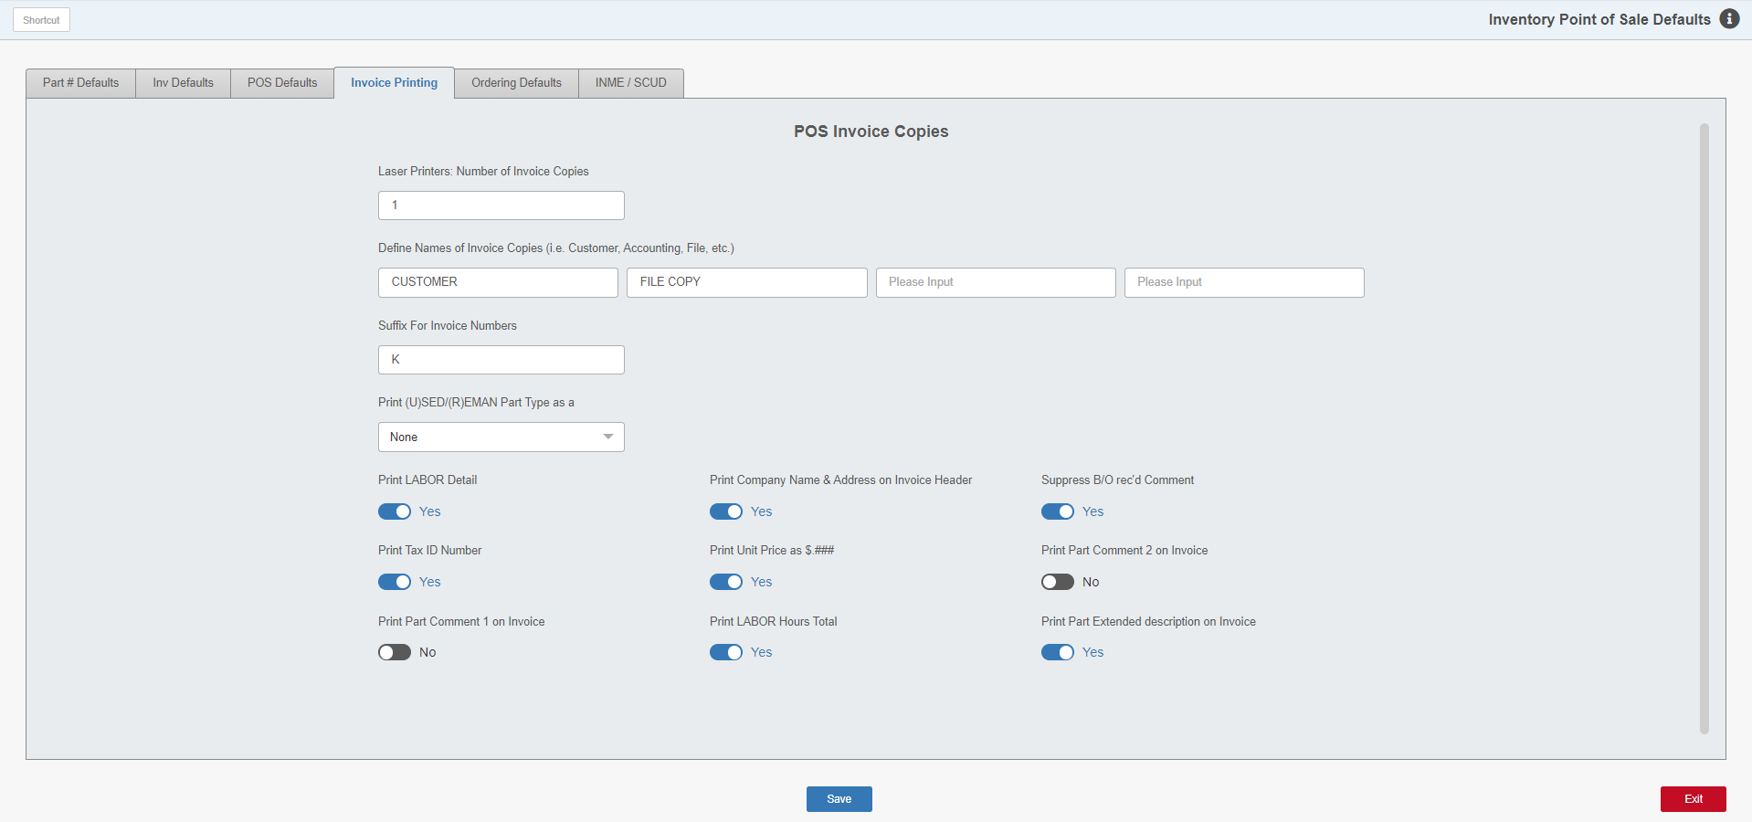

Invoice Printing Tab

Laser Printers: Number of Invoice Copies: Here you can enter the number of copies of EACH defined invoice copy name below. For instance, if you have “Customer” and “Office” as the copy names and you have “1” for the number of copies, you will receive 1 copy of the invoice named “Customer” and 1 copy named “Office.” If you set it to 2 copies, you will receive 2 copies of the one named “Customer” and 2 copies of the one named “Office.”

Define Names of Invoice Copies: These fields let you “name” the copies of the POS invoices. This field works with the “Number of Invoice Copies” field above.

Suffix for Invoice Numbers: This field shows the suffix letter that POS adds to invoice numbers to distinguish them from other system documents (checks, Unit invoices, service invoices, etc.) or even POS invoices generated outside the dealer location. For multi-location dealers, most identify each store with its own invoice suffix. If Customer A/R Statements are printed through the Consolidated Location, it can be easily seen which store processed them. If the field is blank, then no suffix is used at this location. NOTE: After the initial dealer location setup, this field can only be modified by HBS personnel.

Print (U)SED/(R)EMAN Part Type as a: This choice applies to Parts invoicing and allows the Part type (like “U” for “Used” or “R” for “Reman”) to be included as part of the part number on the invoice.

Print LABOR Detail: If you use POS to write Service/Shop invoices, you may choose how the labor part number entries print on the invoices.

Choose Yes to have every labor charge line entry print on the POS invoice.

If you choose No, then all the labor charges entered on the picking ticket are only totaled in the lower right-hand corner of the invoice in the Amount block.

Print Tax ID Number: This feature prints the customer’s Tax ID Number on POS invoices. This information is from the Tax ID field in the Customer Master (ECI).

- Select Yes to print the customer’s Tax ID Number on the POS invoice.
- Select No to have the information not print on the invoice.

Print Comment 1 on Invoice: This field lets you print the Comment 1 field from the Part Master on the invoice. It applies to POS parts invoices, POS repair orders, and NetView Service invoices.

Print Company Name & Address on Invoice Header: This setting is specifically for those who do not have pre-printed invoice forms or e-forms. In that case, a blank invoice form is used that does not have a company name and address, which requires “Yes” in this field. Typically, this field is set to No.

Print Unit Price as $.###: POS can calculate unit prices to the third decimal place, (i.e., $1.333). Even though part number line price displays/prints with the three decimal places, the total unit amount is rounded to the nearest center (i.e., $1.33).

- Select Yes to have POS calculate and print the unit price to the third decimal place.
- Select No if you only want two decimal places.

Print LABOR Hours Total: This field controls the printing of the total amount of labor hours at the bottom of the invoice printout (i.e., HOURS: 5.75). This amount is calculated from the entries made in the Ship column for every labor charge entered on the picking ticket.

- Select Yes if the invoice should show the total amount of labor hours in the Amount block.
- Select No to exclude the total hours from the POS invoice.

Suppress B/O rec’d comment: This setting allows you to suppress the B/O Received Comment Lines on the POS invoice, though the picking ticket will always show the comment lines.

- Select Yes to keep the comment lines off the invoice.
- Select No to have the lines printed on the invoice.

Print Comment 2 on Invoice: This field lets you print the Comment 2 field from the Part Master on the invoice. It applies to POS parts invoices, POS repair orders, and Netview Service invoices.

Print Extended Description on Invoice: This field lets you print the Extended Description field from the Part Master on the invoice. It applies to POS Parts invoices, POS repair orders, and NetView Service invoices.

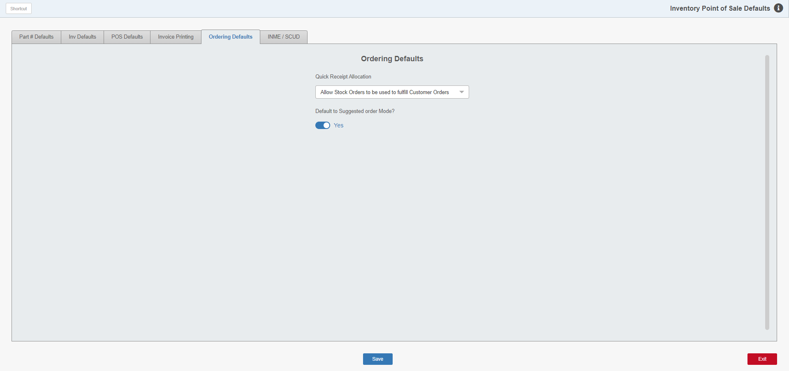

Ordering Defaults Tab

Quick Receipt Allocation: This prompt gives you the option to utilize stock ordered parts to fulfill customer back orders. This applies to Quick Receipts (QR) only, where there will be an “A” button to the right of the “Delete” button. This means you have the ability to receive parts from this stock order to a backorder ticket. When you receive parts that are on a customer back order, the program will open a second screen asking you if you would like to receive against a particular picking ticket. In doing so, your back order for the customer parts remains open. However, the parts received from stock order will update shipping quantity on the picking ticket thus allowing you to invoice and complete your invoice.

Default to Suggested order Mode?: This field affects Standard Stock Orders (SSO) and Custom Stock Orders (CSO).

- Choose Yes to set the screen to default to generating a “suggested” order instead of live order.
- Choose No to have the screen default to creating a live order.

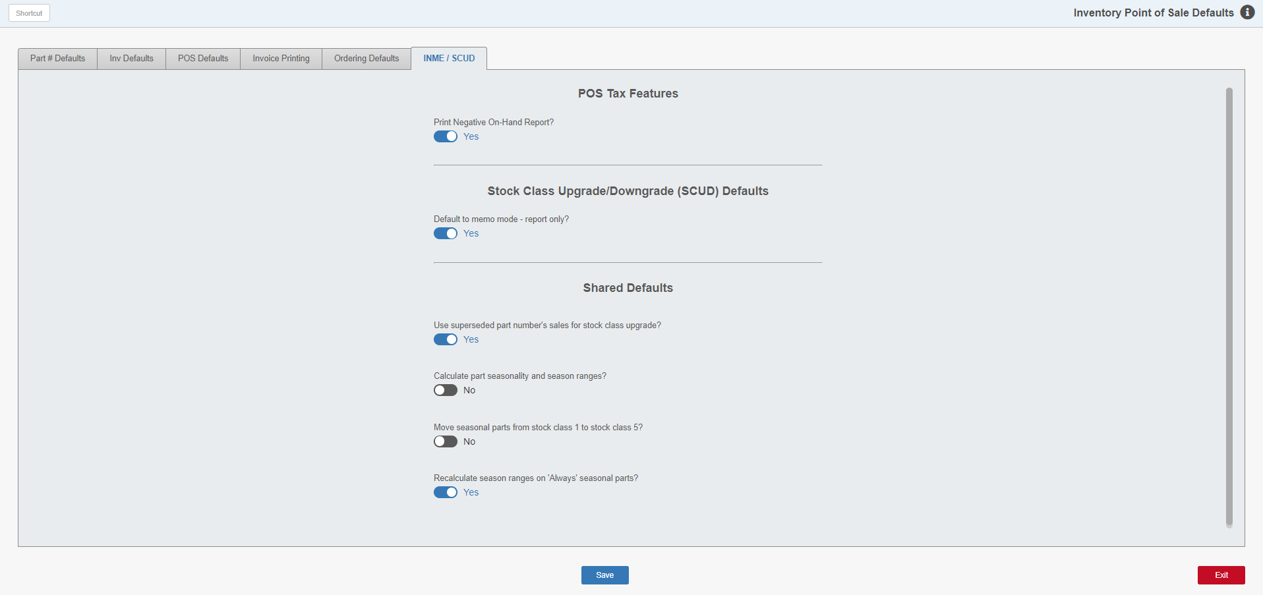

INME/SCUD Tab: This tab deals in part with seasonal settings. We recommend discussing the seasonal settings with a member of the HBS Support Team before implementing them.

Print Negative On-Hand Report?: This presents the option to print the Negative On-Hand Report (NOHR) when you run INME.

- Choose Yes to include printing the report. NOTE: We recommend you select “Yes.”
- Choose “No” to not have it print.

Default to memo mode-report only?:

- Select Yes if you want to make “memo mode-report only” your default setting in Parts Upgrade/Downgrage Process (SCUD).
- Select No to have it default to generate a live report.

Use superseded part number’s sales for stock class upgrade?: This option only applies to parts with replacement numbers.

- Select Yes to use the sales history of the old part number when upgrading the new number.
- Select No to keep the sales history of the old part number separate.

Calculate part seasonality and season ranges?: Selecting Yes here turns on the auto calculate portion. You will need to confirm the setting change at the prompt that appears. This feature, when turned on, erases ANY previous values in the seasons fields and put values it calculates in the fields.

Move seasonal parts from stock class 1 to stock class 5?: This setting gives permission for the system to determine what parts are seasonal and what are not seasonal. It will even move fast moving parts from stock class 1 to stock class 5. Select Yes to activate the feature.

Recalculate season ranges on “Always” seasonal parts?: If you select Yes, this setting will continually monitor the parts set as always seasonal and maintain the seasons on them.

