POS—Internal Parts Tickets

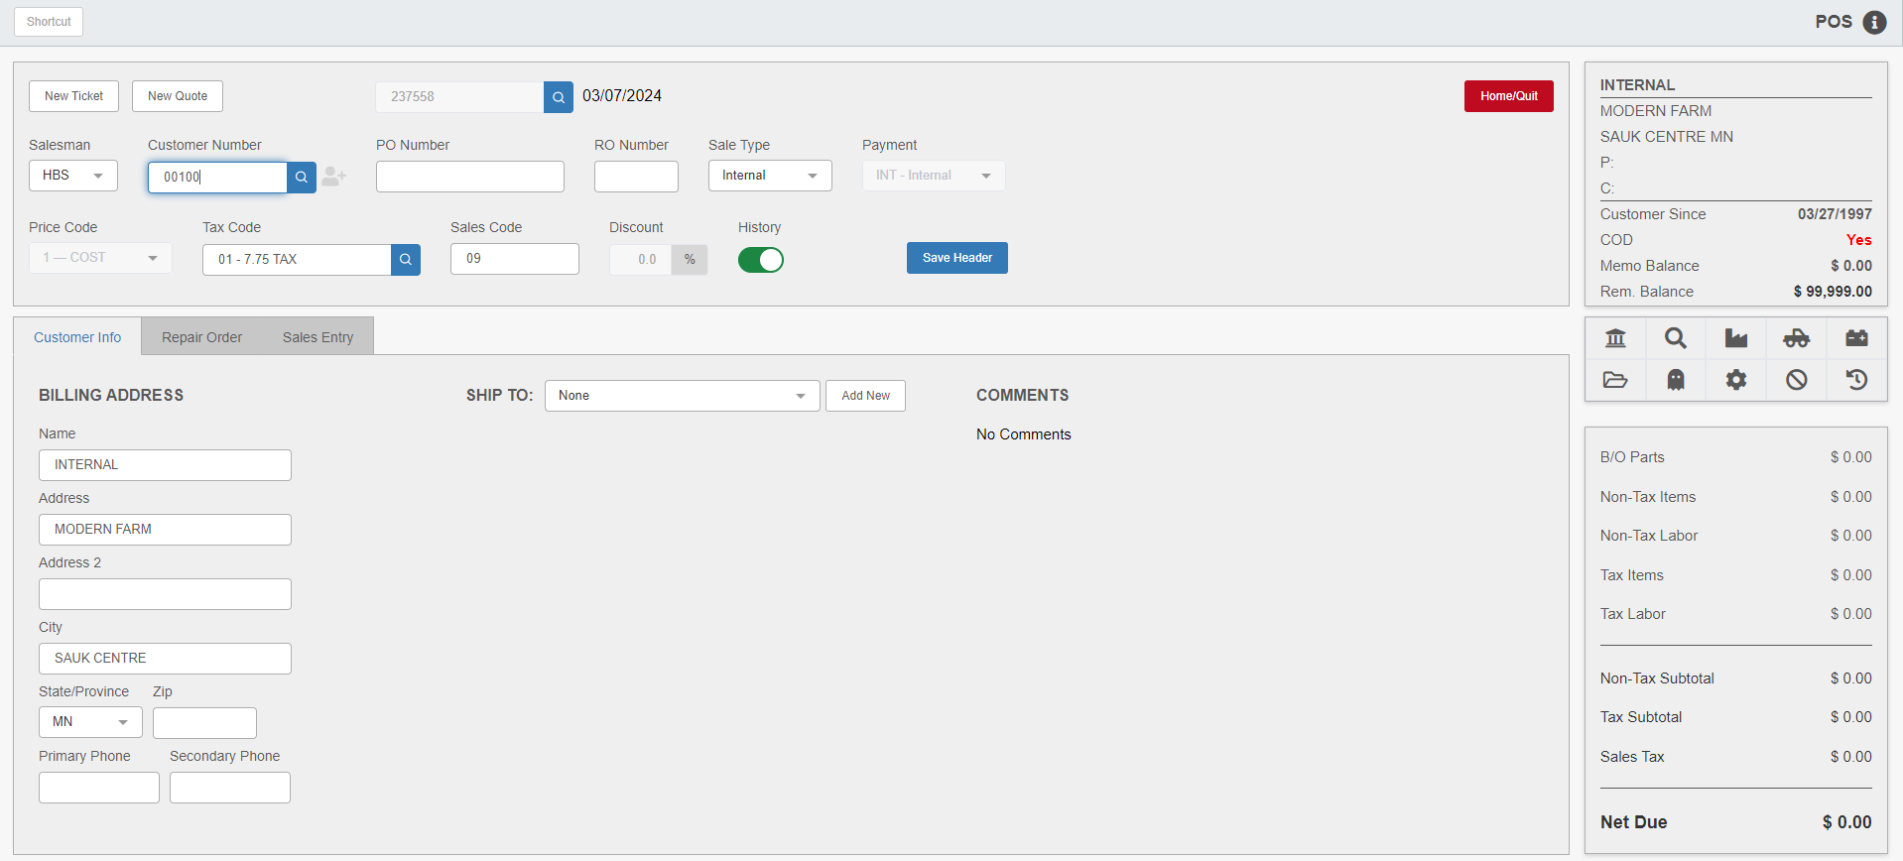

Use picking tickets to handle miscellaneous internal charges, such as using in-stock motor oil in the company truck, spending 15 minutes cleaning an oil spill, or cleaning the windows on a company vehicle. These are valid internal charges since the dealership must "absorb" them. To handle these charges, we recommended opening picking tickets for your designated Internal customer at the beginning of each month, and closing (writing) the tickets on the last business day of the month.

Opening Internal Ticket: To open a miscellaneous internal picking ticket:

Add the salesperson’s initials in the header.

Enter the customer number for your Internal customer. The system will then auto-fill the ticket header.

Make sure that the “Sale Type” field is set to Internal, and that the “Payment” field correctly sets to the Internal payment method you have set up in Method of Payment (MOP).

Click Save Header to create the ticket.

You can now enter the parts being used internally in the Sales Entry tab.

Adding Entries/Comment and Blank Lines: As used or performed, add any miscellaneous items to the appropriate ticket. Comment lines may be added after the parts or labor entries to describe the purpose for the part or the time spent. To add a Comment line, place the cursor in the “Part Number” field and hit the “Enter” key. These lines can be used with the product, part, or labor charges, which will help in deciding which expense ledger number to use to post these transactions. Use the same procedure to add blank lines between sales entries and Comment lines.

Task Code “C”: To enter a Comment line using the Task button, click the button, type “C” in the Task Code field, and press “Enter.”

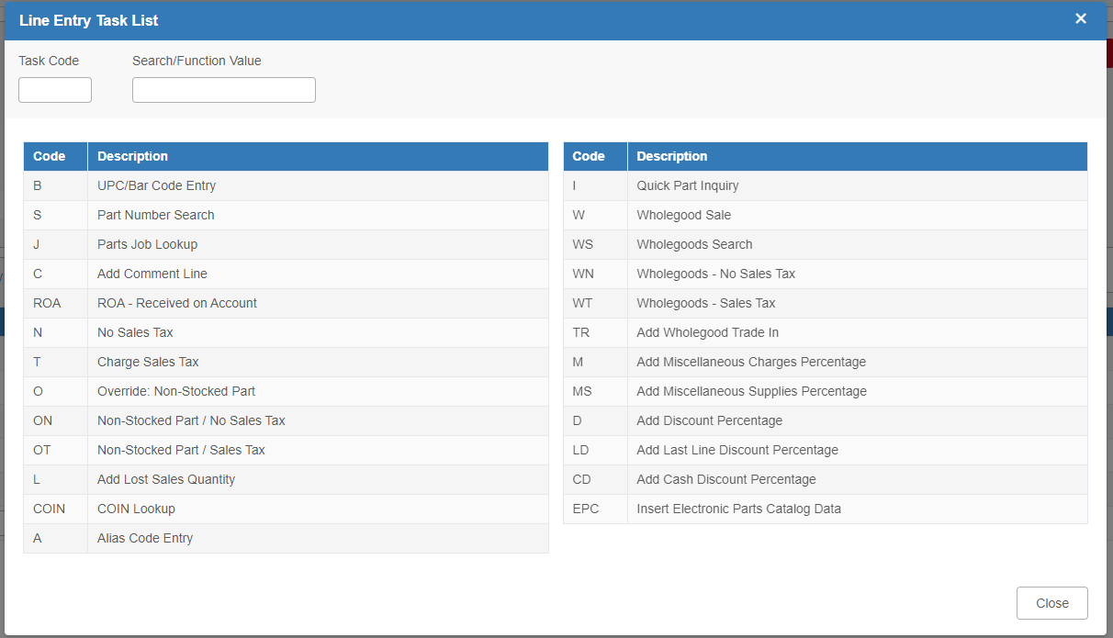

An empty comment line will appear in the Sales Entry tab.

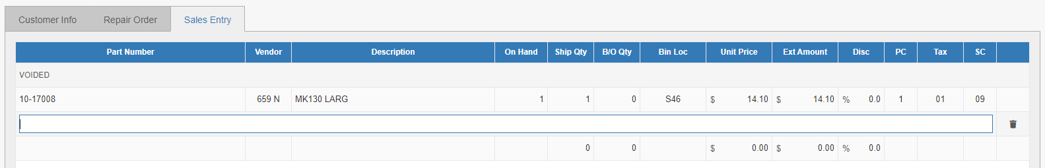

Writing the Internal Parts Ticket: Miscellaneous internal picking tickets must be closed (written as invoices or cash receipts) no later than the last business day of the month. Remember the sales data is not posted to the General Ledger until the picking ticket becomes an invoice and the End of Day (EOD) process is run. Therefore, if these parts, supplies, and charges are to be included in the current accounting period, invoices for all internal picking ticket files must be written.

