Inventory/Note Schedules (IS)

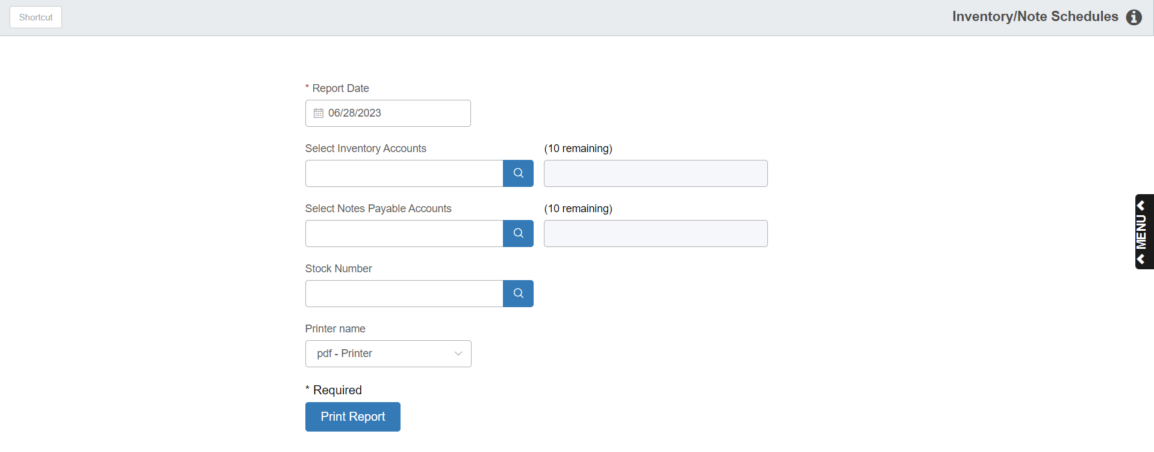

Inventory/Notes Schedule (IS) is a Units report that consists of subledger information based on selected accounts. Ideal usage includes corresponding inventory and notes payable account numbers.

- To access this function, you can either:
  - Select “General Ledger” from the menu. Choose the “Memo Reports” submenu and click “Inventory/Notes Schedule.”
  - Type “IS” in the Shortcuts Bar.

Screen Fields

Report Date: Choose the date for the report. The current date will pre-fill. You can select any date within the opening accounting periods.

Inventory Accounts: Choose which Units Inventory accounts to include on the report. Type in the account numbers or look them up in the left field. The chosen numbers will show in the right field.

Notes Payable Accounts: Choose which Units Notes Payable accounts to include on the printout. Type in the account numbers or look them up in the left field. The chosen numbers will show in the right field.

Stock Number: This section lets you limit the report to just the details for one stock number. To choose a stock number, type it in or look it up. If you want to see the details for all stock numbers in the selected accounts, leave this field blank.

Printer Name: Identify the printer to receive your printout. A default printer is pre-filled but you may change it as necessary. Use the PDF printer to display the report.

Print Report: Press this button to print your report.

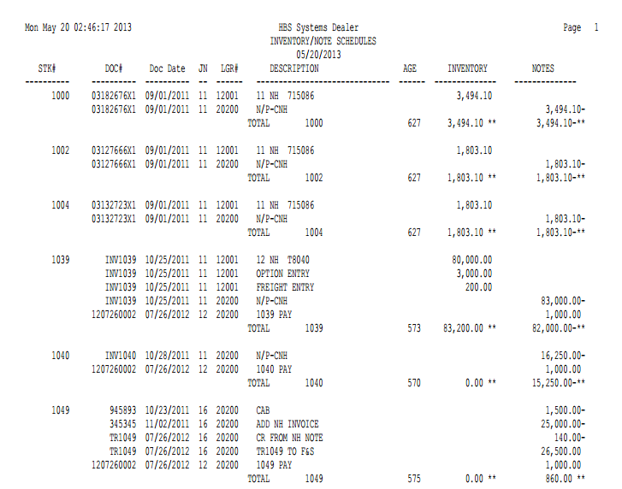

Report Fields

Stk#: This field shows the stock number of the unit.

Doc #: This is the document number for the transaction shown.

Doc Date: This is the date of the document/transaction shown.

JN: Here you will see the journal where the activity occurred.

Lgr#: Here you will see the general ledger account number for the Units Inventory or Notes Payable accounts selected.

Description: This field displays the description of the transaction.

Age: Here you will find the number of days the unit has been in inventory. The entry date is compared to the report date to arrive at the number of days in inventory.

Inventory: This column will show the dollar amounts added or subtracted from the inventory value of this unit for the general ledger account number shown. A total of this column is also provided.

Notes: This column will show the dollar amounts added or subtracted from the notes payable amount of this unit for the general ledger account number shown. A total of this column is also provided.

Totals are provided by stock number and a grand total for the report.

