Inter-Store Parts Transfer (ISPT)

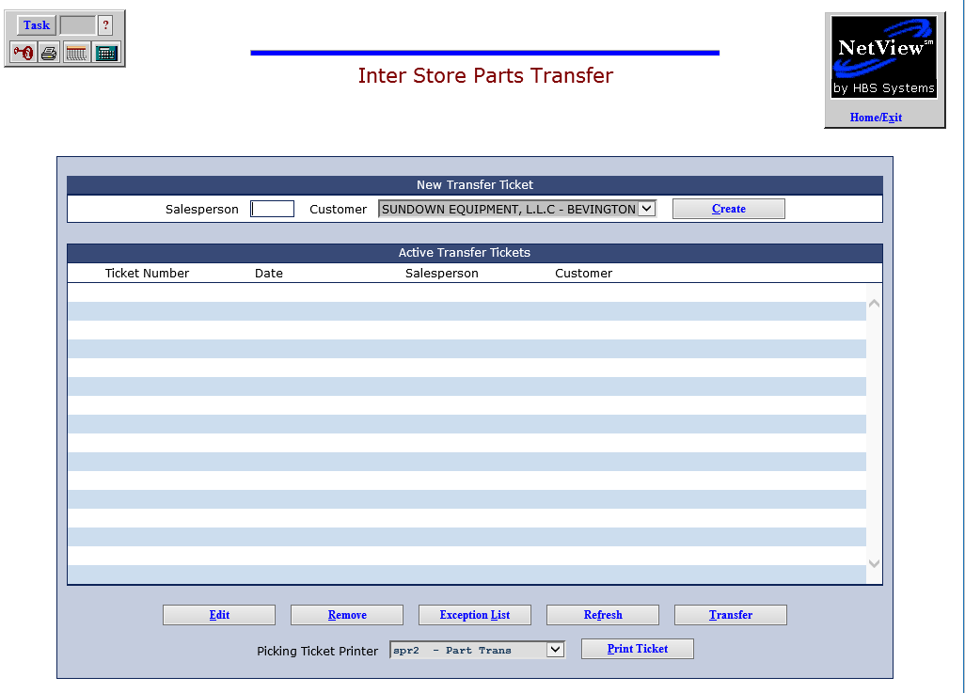

Inter-Store Parts Transfer (ISPT) allows you to create and maintain inventory part transfers between your dealer location and another store. From the initial screen, you can:

- Create a transfer.
- Edit any unsent transfer.
- Remove any unsent transfer.
- Run an Exception List to re-check inventory for current quantities of the parts to transfer.
- Refresh the screen with up-to-moment transfer info.
- Transfer any unsent transfer.
- Create a Parts transfer ticket, save and edit it at a later time, and ultimately transfer it when you choose or when the goods arrive at the other location.

To access this function, you can either:

- Select “Inventory” from the menu and choose the “Multi-Store Processing” submenu. Click on “Inter-Store Parts Transfer.”
- Type “ISPT” in the Shortcuts Bar.

Active Transfer Tickets: A list of pending transfers is shown as soon as you enter the program.

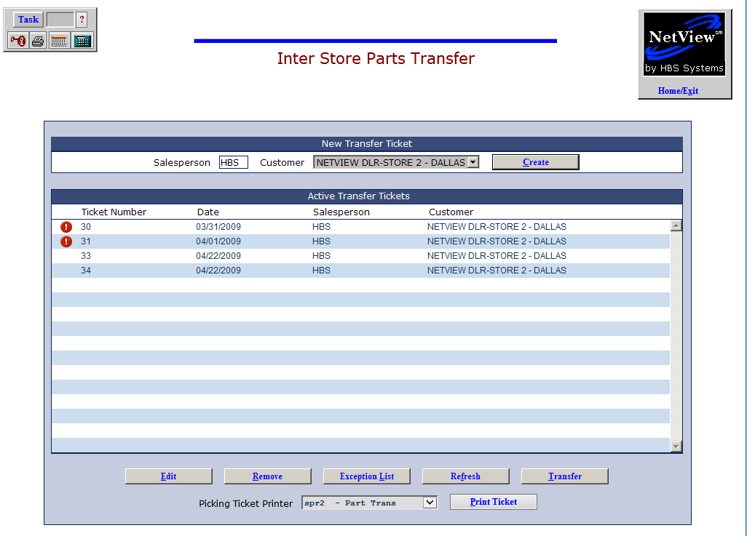

Ticket Number: This column shows the transfer ticket number.

Date: This column shows the date the transfer ticket was written.

Salesperson: This column shows the ID for the salesperson who wrote the ticket.

Customer: This column shows the store that will receive the transferred part(s).

Create a New Transfer: To create a parts transfer, start with the fields in the New Transfer Ticket section of the screen, located above the Active Transfer Tickets list.

Salesperson: Enter your Salesperson ID in the Salesperson field.

Customer: Select the receiving location from the drop-down menu.

Create: Press this button to open the Edit Parts Transfer Ticket screen.

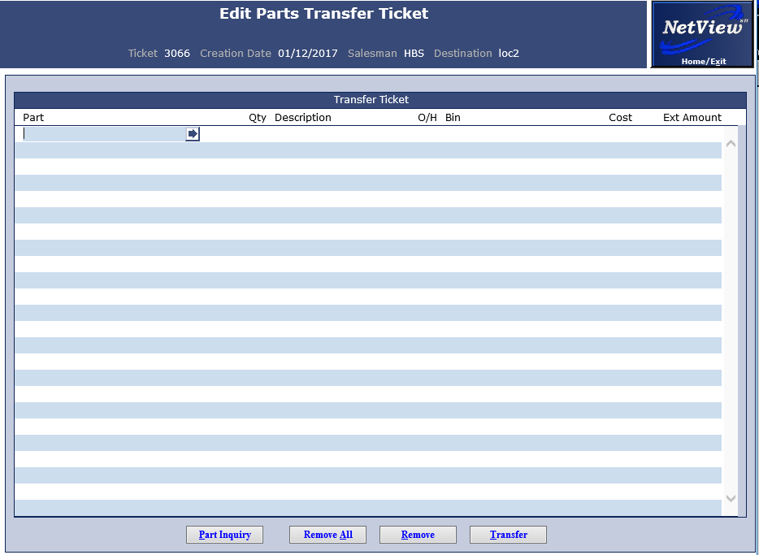

From the Create/Edit screen, each line that you add or change is saved as you finish that line.

Adding Parts: To add parts to the pending transfer, type the part number in the active field in the Part column. If you don’t know the number, type in a portion of the part number or description, and click on the arrow to the right of the part number. This will open the Part Search.

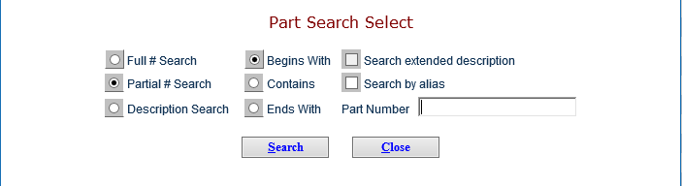

Use the search to locate the desired part number, and click on it to insert the number in the Part column.

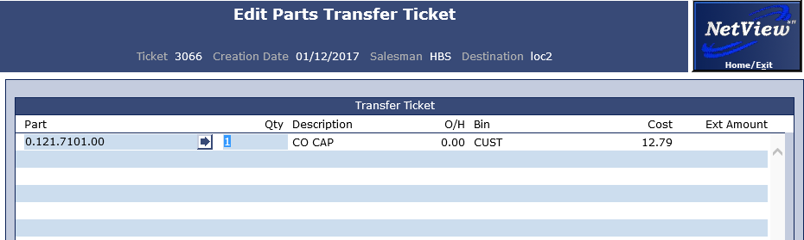

Once the part number is filled in, hit “Tab” on the keyboard. The system will then fill in the part’s description, the quantity of the part you have on-hand, the part’s bin location in the transferring store, and the part’s cost. Enter the quantity of the part to be transferred in the Qty column, and hit “Tab” again to see the extended amount of the transfer (quantity x cost).

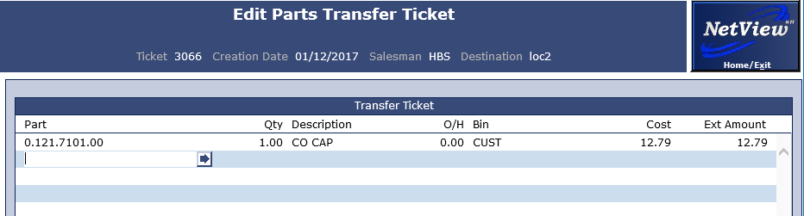

Hitting “Tab” after filling in the quantity will also complete and automatically save the line on the ticket. A new line will then become available. You can include multiple different parts on the ticket.

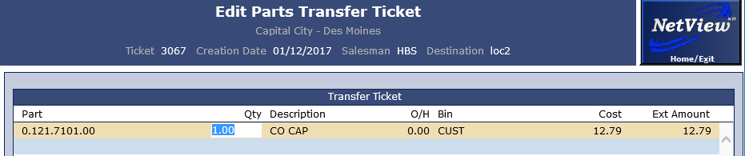

To edit a line after completing and saving it, click on the line to highlight it. You can then make the necessary changes.

Part Inquiry: Press this to access the Part Inquiry (PI) application.

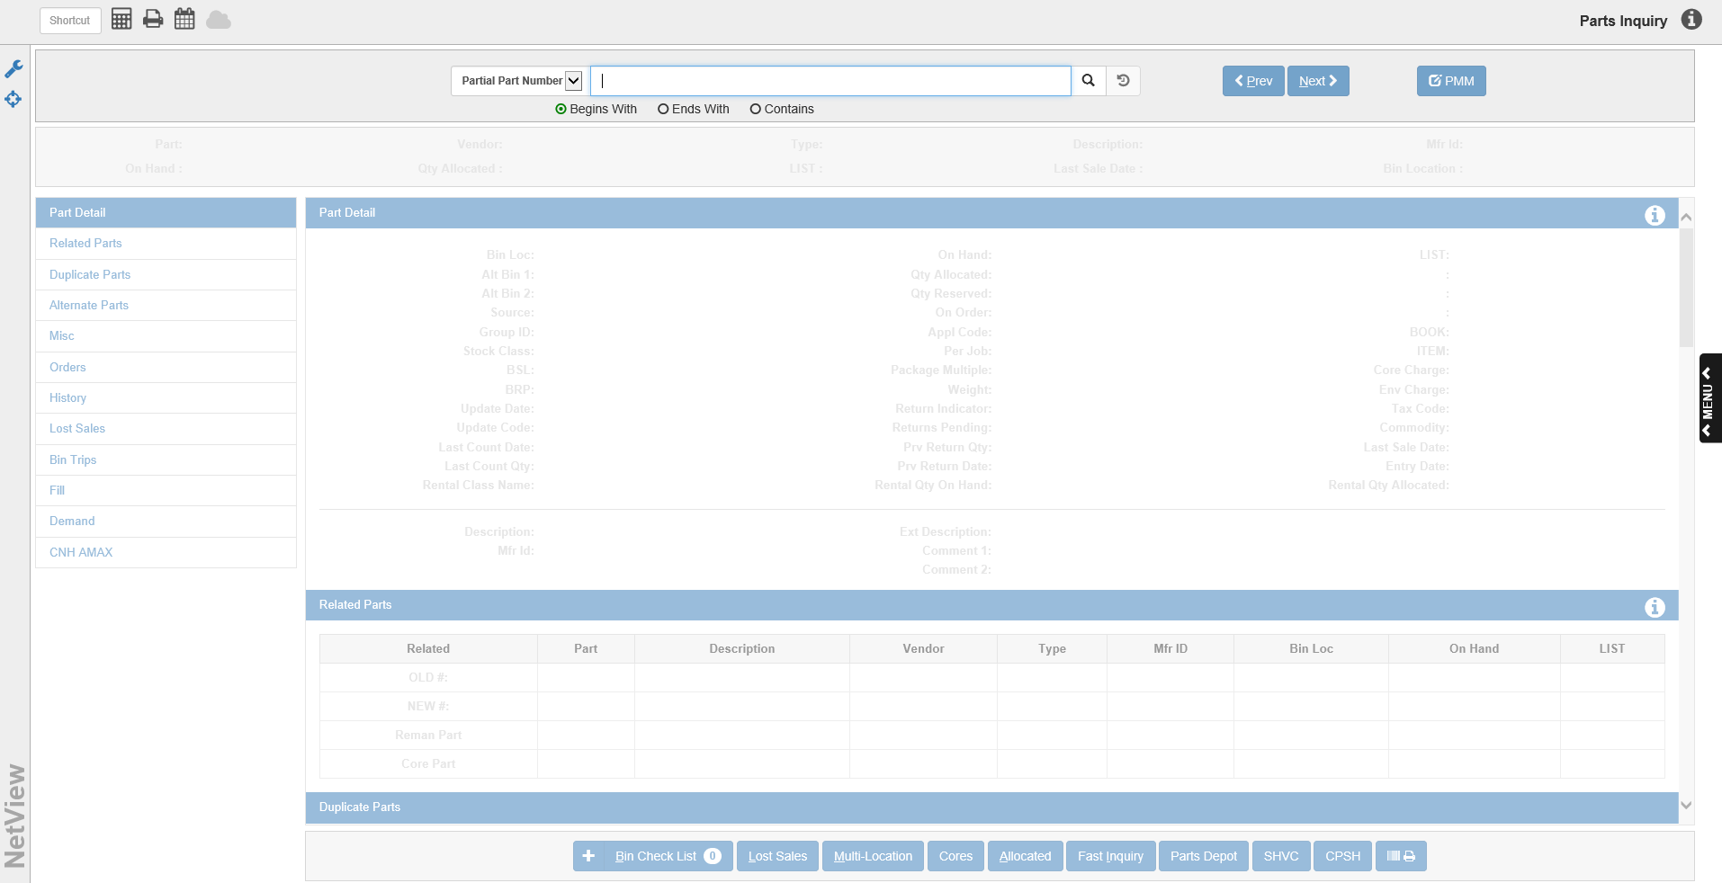

Remove/Remove All: To remove a single part number, click on the line to highlight it and click on the Remove button. You can remove all part numbers by clicking on the Remove All button.

Transfer: Press this button to initiate the transfer process. The box that appears offers the ability to add freight (and a description), and to specify the printer for the transfer reports at the local and remote store. Press the Submit button to process the transfer.

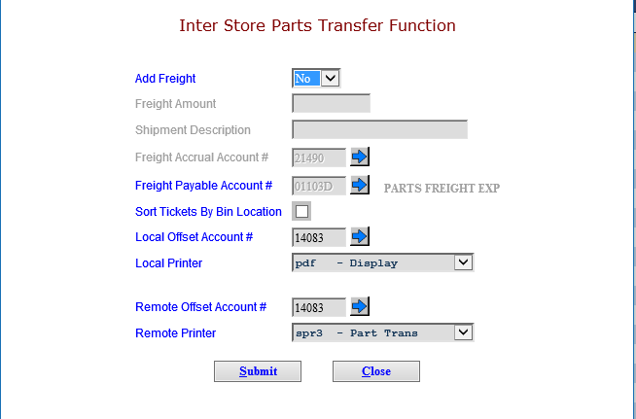

At this time, the program will print the Transfer Report, which shows the details of the transfer.

Sample Transfer Report

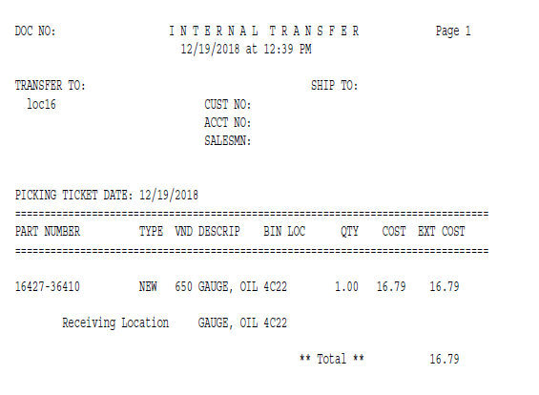

The transfer process prints a report at the transferring location as well as the receiving location. At this point in time, the parts have been removed from the transferring location’s inventory and placed in the receiving location’s inventory. In addition, accounting entries have been created in each location to cover the transfer transaction. The ticket is now closed, and will be removed from the list of pending transfers on the main screen.

Saving a Transfer Ticket: It is entirely possible for you to create a new transfer ticket, then save it for completion at a later time. As mentioned previously, completing a line on the ticket automatically saves that line’s information. After you have finished filling out the ticket, if you don’t want to initiate the transfer at that point, then simply click the NetView Home/Exit icon in the top right-hand corner of the screen. This will return you to the main screen, where you will see your saved ticket listed with the other pending transfers. You can then return to it later for editing.

Editing a Transfer: From the main ISPT screen, highlight the pending transfer to edit.

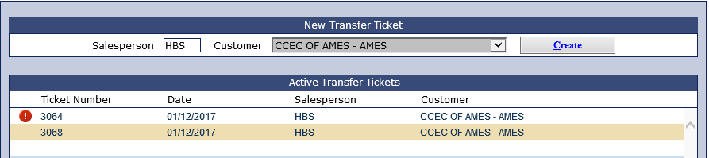

Press the Edit button to maintain or modify the transfer.

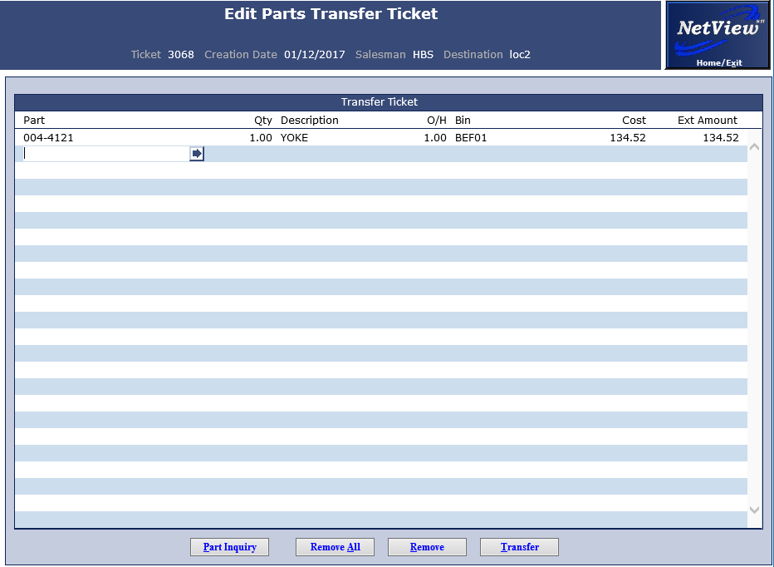

From the Edit screen, each line that you add or change is saved as you finish that line.

- To edit a specific line on the ticket, click on the line to highlight it and make the necessary change.
- To remove a line from the ticket, click the line to highlight it and click the Remove button.
- To add parts to the pending transfer, type the part number in the place provided. To do a Parts search, type in a portion of the part number or description and click on the arrow to the right of the part number.

Once you are finished editing the ticket, you can either use the NetView Home/Exit button to return to the main screen, or click the Transfer button and submit the ticket.

Removing a Transfer: To remove a transfer from the system, click on the line to highlight it and click on the Remove button. This will delete the transfer and clear it from the pending transfers list.

Exception List: Sometimes, after saving a transaction line, you may see a red exclamation point to the left of a transfer ticket number (see above image). This indicates that there is an insufficient on-hand quantity to accommodate at least one of the parts on the transfer ticket. To review these parts, highlight the transfer and press the Exception List button.

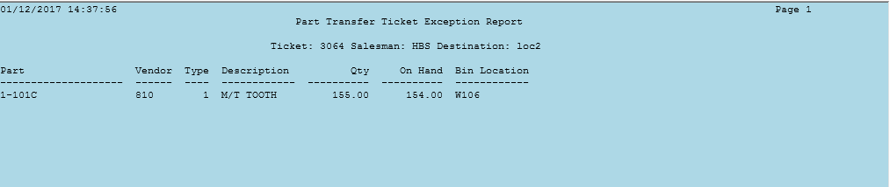

Exception Report: The report shows which part(s) do not have sufficient on-hand quantities to cover the transfer.

Refresh Transfer(s): At any time, you can press the Refresh button to check the quantities on transfers against current inventory. If the quantities on the transfer now exceed those available, the exclamation point will appear to the left of the ticket number.

Completing Pending Transfers: You can also complete the transfer process from the main screen by clicking the line to highlight it and pressing the Transfer button. The box that appears offers the ability to add freight (and a description), and to specify the printer for the transfer reports at the local and remote store.

Press the Submit button to process the transfer.

Transfer Printout: To generate a printout of a pending transfer, click the ticket to highlight it on the main screen. Select the printer you want from the Picking Ticket Printer drop-down menu, then click Print Ticket to generate a printout of the transfer before it is transferred.

- The program will ask if you want the printout sorted by Bin Location or Part Number.

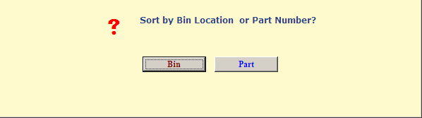

- The printout provides the information about the parts included on the transfer:

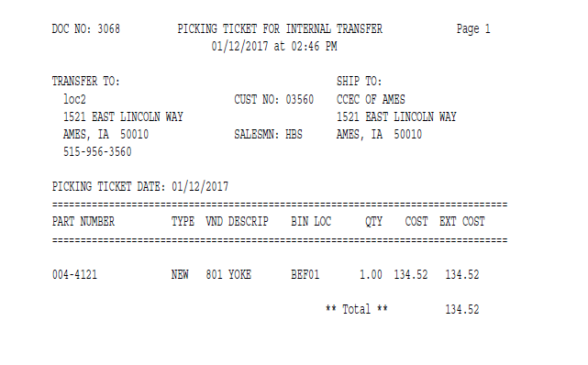

Manual Mode: In Parts Transfer Configuration Setup (PTCS), you now have the option to set the receipting of Parts Transfers for Automatic (current method) or Manual. The manual mode means that the parts will be “removed” from the originating location, but put on a “transfer order” for the receiving location to receipt when they get the parts.

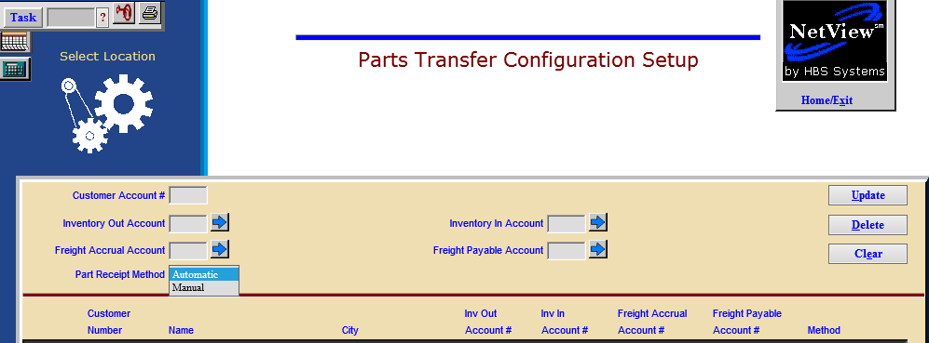

If you choose the manual receipt method, then a new field will appear in the Inter Store Parts Transfer Function window when you go to complete the transfer. The Parts Order # field shows the “order number” of the transfer that will be created in the receiving location.

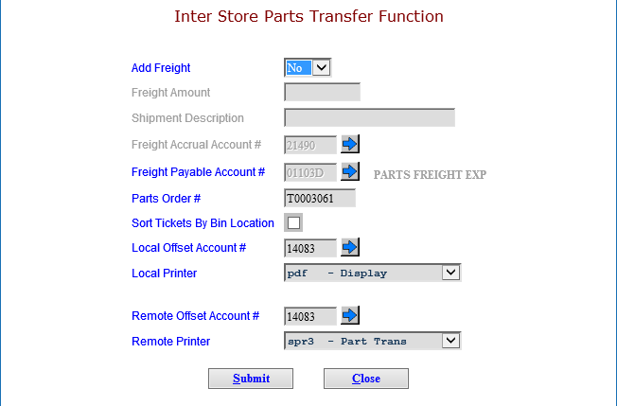

The manual Parts Transfer has now been created as an order in the receiving location that can be receipted with Quick Receipts (QR) or Automatic Receipts/Cancel (ARC) when the parts are received.

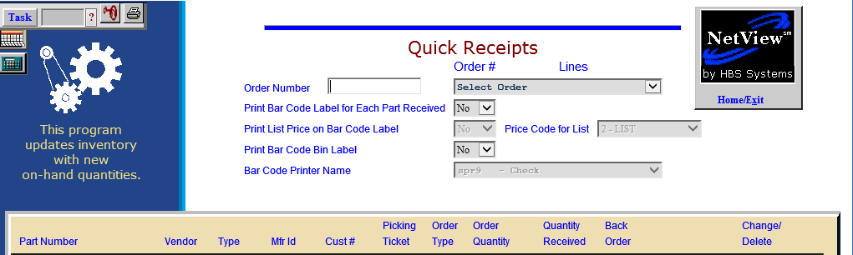

Manual Receipts in Quick Receipts (QR): In QR, the Parts Transfer Order Number can be typed in or selected from the drop-down menu.

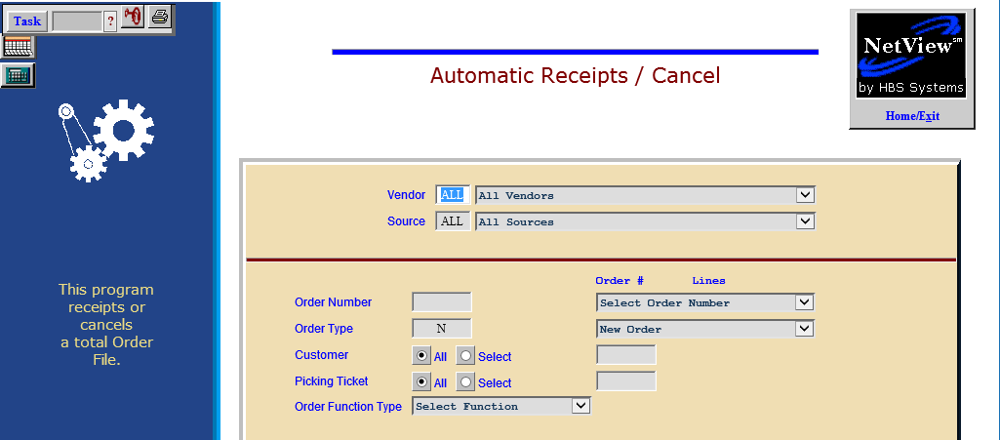

Manual Receipts in Automatic Receipts/Cancel (ARC): In ARC, the Parts Transfer Order Number can be type in or selected from the drop-down menu.

