POS—Internal Shop Tickets (Repair Orders)

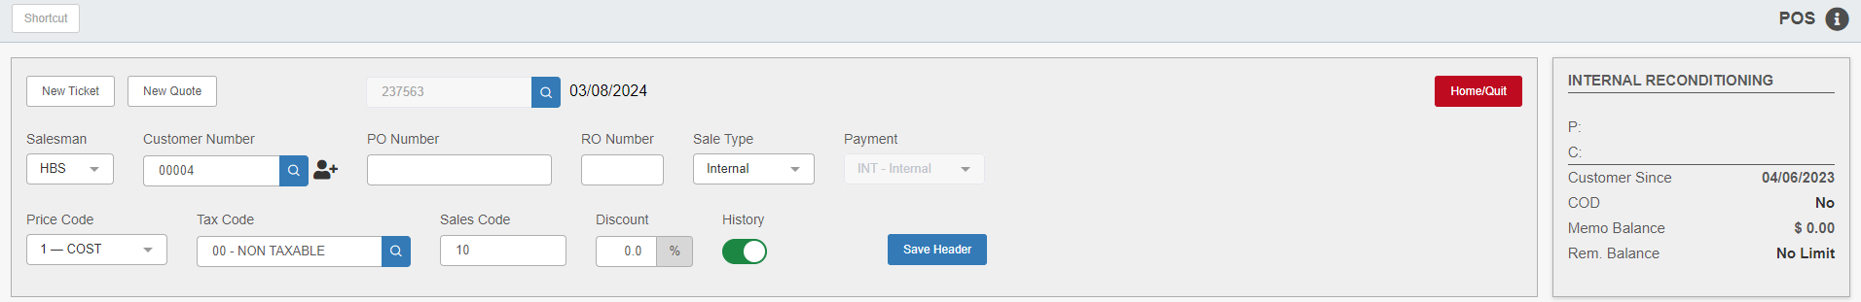

Besides shop tickets for customer repairs and maintenance, POS can create and maintain tickets for internal jobs such as:

- Work on new equipment to prepare it for sale
- Repair or reconditioning of used equipment (i.e. trade-ins for resale)
- Repair of dealership property and equipment (i.e. buildings, tow trucks, and rental equipment)

Generic Accounts: To open an internal ticket, enter account number 00004 (Internal Reconditioning) in the “Customer Number” field. This is the account most internal shop tickets are typically charged to. However, each dealership may define and use other accounts numbers as needed.

Header Fields: The following fields are auto-filled with dealership-specific values:

Type of Sale

Price Code

Tax Code

Sales Code

Discount

For some dealerships, all internal shop tickets are either taxed or non-taxed, while others generate a mixture of the two. As with any ticket, make sure the following field values agree:

- Type of Sale
- Sales Code
- Price Code
- Tax Code

Creating the Ticket: Upon typing in the customer number, any open tickets for the customer will display. Select one of these or press Start New Ticket.

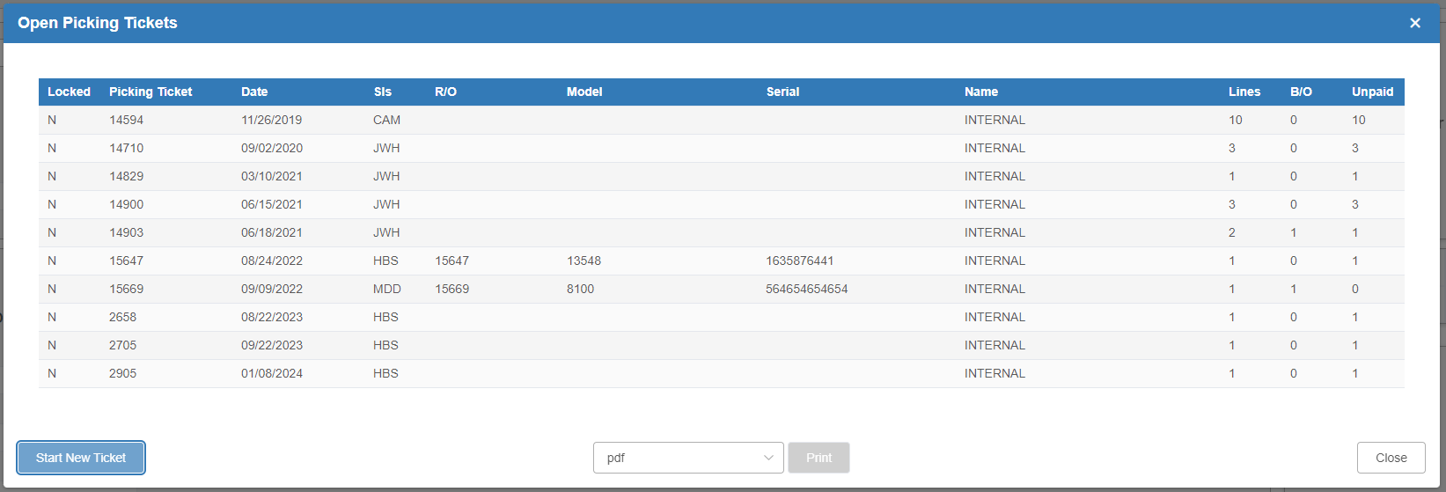

Next open the Repair Order tab to find a specific piece of equipment, if appropriate. If the stock number is known, type it in the “Stock Number” field.

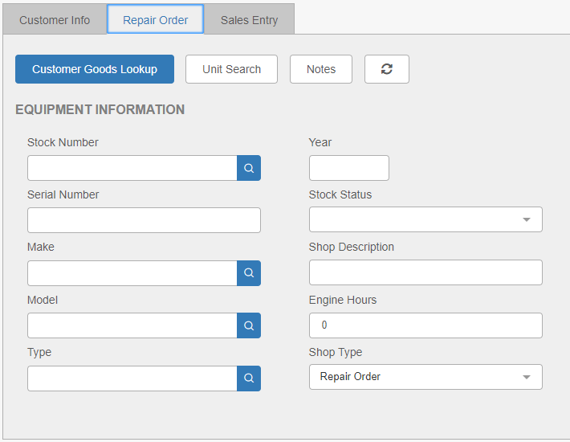

Pressing the Customer Goods Lookup button will display a list of the equipment registered to the specific customer.

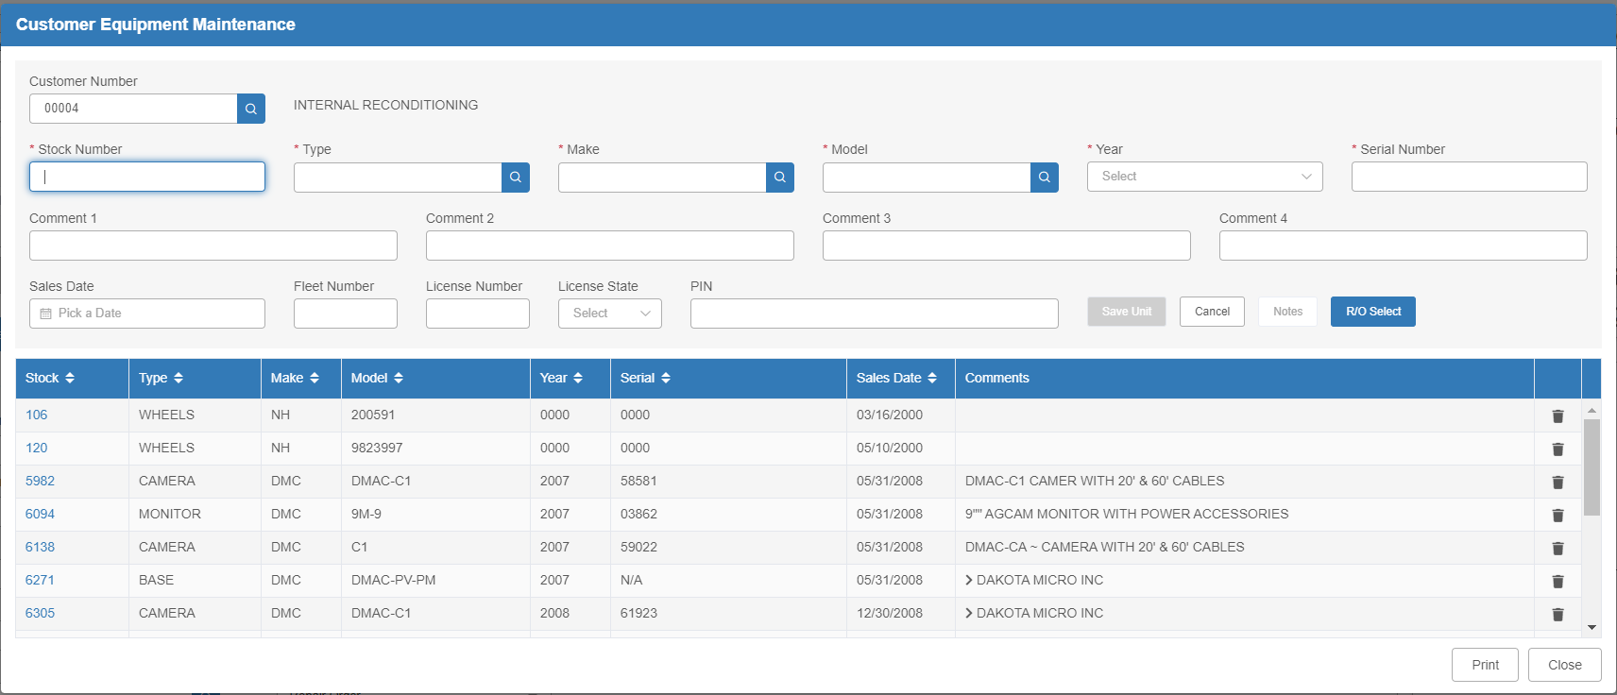

Select the piece of equipment to be worked on. This information transfers to the Repair Order tab. Proceed to add any products from stock to be added to the ticket on the Sales Entry tab, as you would for a normal parts sale or customer shop ticket.

Labor Charges: Labor on an internal shop ticket is handled the same as a customer shop ticket. Enter the part number that applies to internal labor for the dealership on the ticket to add the labor charge.

