Inventory Transaction Report (ITR)

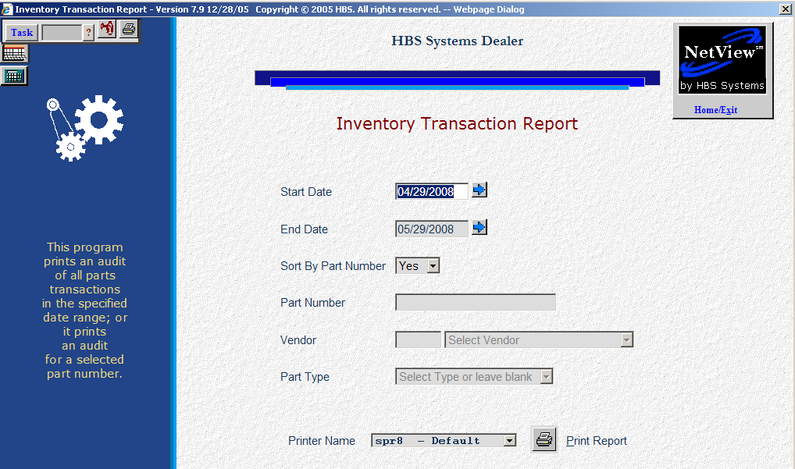

This report shows an audit trail for activity that affected your Part Masters. These changes could come from activities like opening a picking ticket, writing a POS or SMS invoice, or changing the quantity on hand in one of the many Parts Maintenance programs. This is a permanent database of the transactions that affect your inventory. Reports can be drawn from any dates of the information currently in the file.

- To access the Inventory Transaction Report, you can:
  - Select “Inventory” from the menu. Choose the “Reports” submenu and click “Inventory Transaction Report.”
  - Type “ITR” in the Shortcuts Bar.

Field Definitions

Start Date: Enter the starting date of the report or use the blue arrow icon to select it.

End Date: Enter the ending date of the report or use the blue arrow icon to select it.

Sort By Part Number:

- Choose Yes to sort the report in part number order.
- Choose No to select a specific part number and sort the activity in date order.

Part Number:

Leave the field blank to print a report for all part numbers.

Type in a part number to limit the report to that part’s activity.

Vendor: If you are printing the report for a single part number, you can optionally choose the vendor number here.

Part Type: If you are printing the report for a single part number, you can optionally choose the part type here. Choose one of the following:

New

Reman

Core

Used

Memo

Printer Name: Select the printer to receive the printout. A default printer name is pre-filled but can be changed as necessary. Use the see printer to view the report on the screen without printing a copy of it.

Print Report: Press this button to print your report.

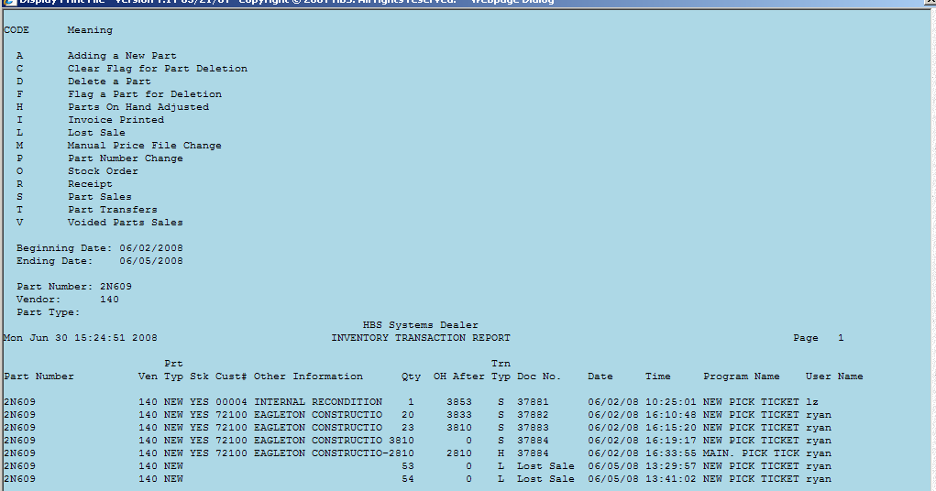

Tran Type: This is a description of the activity that occurred to this part number. This listing prints at the top of the Inventory Transaction Report and contains the following codes:

CODE Meaning
A Adding a New Part
C Clear Flag for Part Deletion
D Delete a Part
F Flag a Part for Deletion
H Parts On Hand Adjusted
I Invoice Printed
L Lost Sale
M Manual Price File Change
P Part Number Change
O Stock Order
R Receipt
S Part Sales
T Part Transfers
V Voided Parts Sales

Report Detail: This report contains the following information:

Part #: This is the part number that had changes made to it.

Ven: This is the vendor number assigned to this part number.

Prt Typ: This is the part type from the Part Master.

N=New

R=Reman

C=Core

U=Used

M=Memo

Stk: This field indicates whether or not you carry this part in your inventory.

YES means it is a stocking part.

NO means it is non-stocking part.

The majority of the non-stocking parts will be “space O” parts.

Cust #: If this part was put on a picking ticket for a customer, this is the Accounts Receivable customer number you assigned to this customer.

Other Info: This is the POS ticket number, customer P.O., or other information that was printed on the invoice or entered into the system about the part number.

Qty: This is the quantity of the transaction listed on the report.

Qty O/H After: This is the quantity on hand AFTER the change was recorded.

Trn Typ: This is type of transaction that occurred. See the list above under “Tran Type” for the different types of transactions.

Doc #: This is the Invoice number or type of change that occurred with this part number.

Date: This is the date that the change took place.

Time: This is the time that the change took place.

Program Name: This is the program that was used to make the change to this part number.

User Name: This is the login used by the person that made this change.

