POS—Internal Warranty Shop Tickets

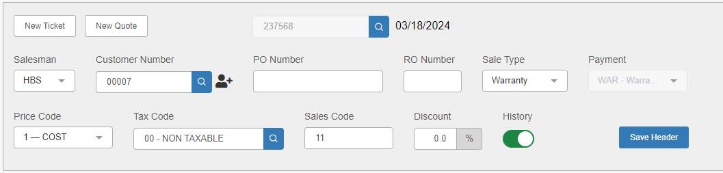

POS simplifies warranty repair and warranty parts sales. Like internal picking tickets, internal warranty tickets use specific accounts and codes. The system has a pre-set warranty account number (00007 – WARRANTY) for internal warranty shop tickets, which enables the linking of all warranty tickets to a single “Warranty” customer. Your dealership may choose to set up additional warranty accounts for manufacturer lines supported by the dealership (i.e., WARRAGCO, WARRCASE, etc.).

Creating the Ticket: Start a new internal warranty ticket by simply entering 7 (or 00007) in the Customer field and pressing “Enter.” The system auto-fills the remaining Header fields.

As with any ticket, make sure that the following fields’ values agree:

- Type of Sale
- Sales Code
- Price Code
- Tax Code

Header Fields:

Salesperson: Enter or select the salesperson’s ID (if it is not already filled in).

Customer #: For the internal warranty shop tickets, the warranty account number (00007) is used here.

Purchase Order Number (PO #): This field is optional, but some dealers use them for internal tracking purposes.

Repair Order Number (RO #): The picking ticket number can be typed into this field, or you can enter a number specified or chosen by the dealership.

Type of Sale: Type of Sale should be auto-filled with Warranty when the customer number is 00007. This information is from the COD Status field of the Customer Master (ECI).

Price Code: The system usually auto-fills this field with Price Code 1 (Cost) from the Price Code field of the Customer Master.

Tax Code: This field holds the tax code, which should be auto-filled with a nontaxable code of “00,” or another nontaxable code.

Sales Code: The Sales Code field is often auto-filled with code 11 (parts sales, warranty, nontaxable). This information is from the “S/C Front” field in the Customer Master.

Discount: The system pre-fills this field with the Discount rate from the Customer Master, if any.

Open Tickets: After entering the customer number 00007, any open picking tickets using the customer number will display.

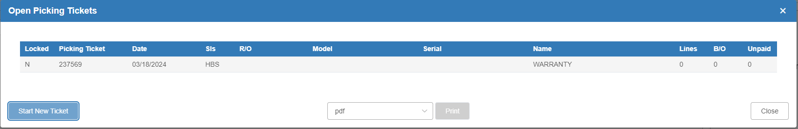

Select one if you wish to use it for the sale. If you do not, click Start New Ticket to return to the Header, fill it in, and save it to create the ticket.

Creating the Repair Order: Open the ticket’s Repair Order tab to create the actual RO.

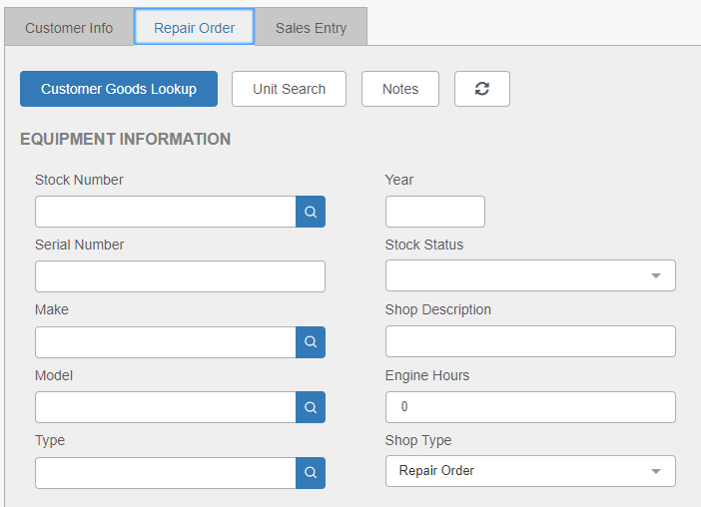

R/O Info Tab:

Stock Number: Type in the stock number of the unit to be worked, or click the Unit Search button to find and select the piece of equipment requiring the work. The Equipment Information fields will auto-fill based on the selected unit.

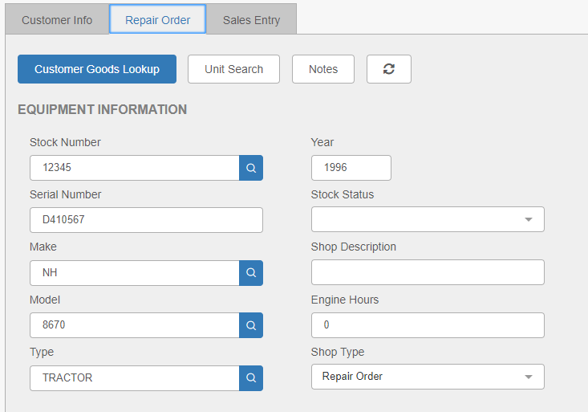

The warranty picking ticket is now linked to the equipment by the stock number. When this ticket is invoiced, the warrant invoice becomes part of the unit’s repair history.

Shop Description: Type in a description of the warranty ticket (work to be done) in here.

Shop Type: Select Repair Order here.

Sales Entry Tab: Open the Sales Entry tab to begin adding parts and/or labor.

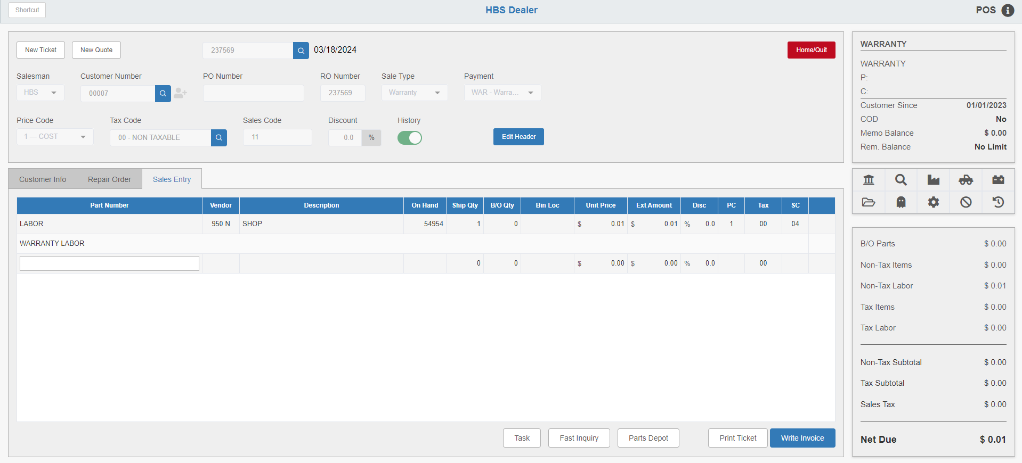

Labor Charges: To enter labor charges on a warranty shop ticket, use the part number defined in the dealership’s unique system for warranty labor.

