Journal Names (JNAM)

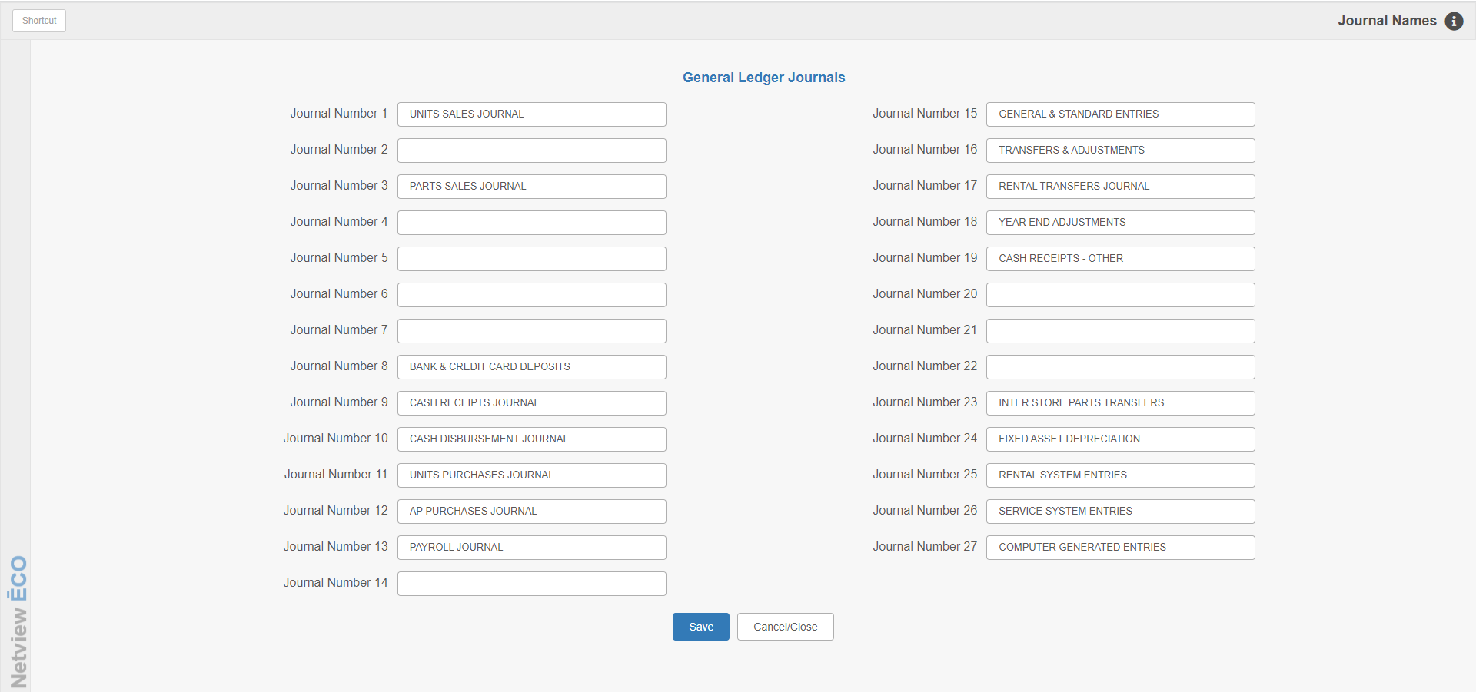

Journal Names (JNAM) lets you define the different Journal numbers in use on the system. There are up to 27 Journals available for use. A number of these are only used by specific HBS systems, but most of them are multi-purpose, i.e. available for any function you deem appropriate.

This topic offers a sample Journal Names screen to help you better understand how the application works; the Journal definitions will obviously differ from business to business depending on the individual dealer’s needs.

To access this function, you can either:

- Select “System Maintenance” from the menu. Choose the “Company File” submenu and click “Journal Names.”
- Type “JNAM” in the Shortcuts Bar.

Sample Screen Fields:

Journal 1 (Unit Sales Journal): For this sample screen, the Journal is used by the system if you process Units/Wholegoods Sales through Unit Sales (US).

Journal 2: This Journal is not used by the system in this sample, but could be used for manual Journal entries.

Journal 3 (Parts Sales Journal): For this sample screen, the Journal is used by the system if you process Parts and/or Service transactions through the Point of Sale (POS) program.

Journal 4: This Journal is not used by the system in this sample, but could be used for manual Journal entries.

Journal 5: This Journal is not used by the system in this sample, but could be used for manual Journal entries.

Journal 6: This Journal is not used by the system in this sample, but could be used for manual Journal entries.

Journal 7: This Journal is not used by the system in this sample, but could be used for manual Journal entries.

Journal 8 (Bank & Credit Card Deposits): For this sample screen, the Journal is not used by any automated system functions. As the title indicates, you could use it to record manual bank, cash, or credit card deposits.

Journal 9 (Cash Receipts Journal): For this sample screen, the Journal is used by the system if you process payments on account through the Cash Applications (CA) program.

Journal 10 (Cash Disbursement Journal): For this sample screen, the Journal is used by the system if you process vendor payments in A/P through the Print Checks (PC), Manual Checks (MC), or On Demand Checks (ODC) programs. It may also be used to record cash disbursements via manual Journal entries.

Journal 11 (Unit Purchases Journal): For this samples screen, the Journal is used by the system when you use Unit Purchase (UP/BIP) in the Units module.

Journal 12 (AP Purchases Journal): For this sample screen, the Journal is used by the system when you process Accounts Payable purchases.

Journal 13 (Payroll Journal): For this sample screen, the Journal is used by the system if you process Payroll in the Payroll module.

Journal 14: This Journal is not used by the system in this sample, but could be used for manual Journal entries.

Journal 15 (General and Standard Entries): For this sample screen, the Journal is not used by any automated system functions. As the title indicates, you could use it to record manual entries that can’t be categorized in other Journals.

Journal 16 (Unit Transfers & Adjustments): For this sample screen, the Journal is not used by any automated system functions. It is the default Journal to use whenever entries are made in Enter Transfers and Adjustments (ETA) for Units.

Journal 17 (Rental Transfers & Adjustments): For this sample screen, the Journal is not used by any automated system functions. It is the default Journal to use whenever entries are made in Rental Transfers and Adjustments (RTA).

Journal 18 (Year End Adjustments): For this sample screen, the Journal is not used by any automated system functions. As the title indicates, it could be used to make year-end adjustments.

Journal 19 (Cash Receipts-Other): For this sample screen, the Journal is not used by any automated system functions. As the title indicates, it could be used to process payments in an alternate way from Cash Applications.

Journal 20: This Journal is not used by the system in this sample, but could be used for manual Journal entries.

Journal 21: This Journal is not used by the system in this sample, but could be used for manual Journal entries.

Journal 22: This Journal is not used by the system in this sample, but could be used for manual Journal entries.

Journal 23 (Inter-Store Parts Transfers): For this sample screen, the Journal is used by the system if you process parts transfers between multiple locations on the system. NOTE: If you are not a multiple-location dealer, we recommend that you do NOT use a Journal with this system-assigned definition for manual purposes.

Journal 24 (Fixed Asset Depreciation): For this sample screen, the Journal is used by the system if you are utilizing the Fixed Asset Management (FAM) program. The depreciation entries made by this module are directed to the designated Journal. NOTE: If you are not utilizing this module, we recommend that you do NOT use a Journal with this system-assigned definition for manual purposes.

Journal 25 (Rental System Entries): For this sample screen, the Journal is used by the system if you have the Rental package to manage Rental sales. NOTE: If you are not utilizing this module, we recommend that you do NOT use a Journal with this system-assigned definition for manual purposes.

Journal 26 (Service System Entries): For this sample screen, the Journal is used by the Service package. NOTE: If you are not utilizing this module, we recommend that you do NOT use a Journal with this system-assigned definition for manual purposes.

Journal 27 (Computer Generated Entries): For this sample screen, the Journal is used by the system for automated entries. Finance charges are placed in this Journal by the system.

