Labor Comeback Report (LCR)

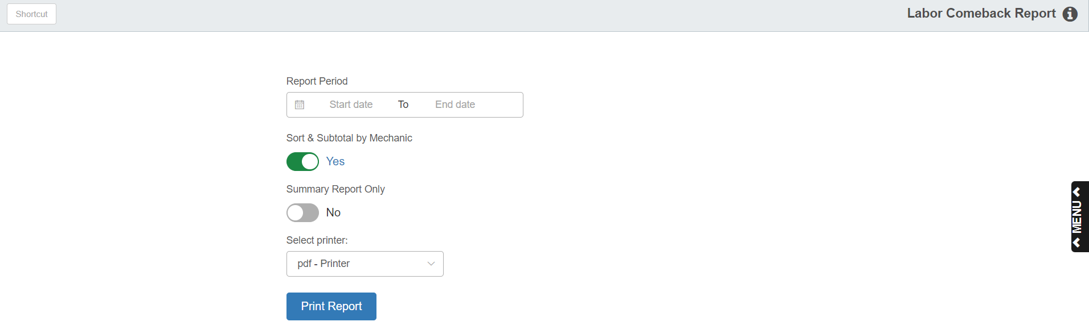

This program lets you view and print the Service Labor Comeback Report.

To access this function, type “LCR” in the Shortcuts Bar.

Field Definitions:

Report Period: Select the starting and ending dates of your report period typing the dates into the fields. You can also select them from the calendars attached to the fields.

Sort & Subtotal by Mechanic: Set this option to Yes to have the report organized by Mechanic, with subtotals provided for each mechanic.

Summary Report Only: Set this option to Yes to print the Summary Report instead of the Detail version. The default is No (program prints the Detail Report).

Select Printer: Select a printer from the drop-down menu. Select the pdf printer to view a copy of the report.

Click Print Report to print the report.

Sample Unsorted Detail Report

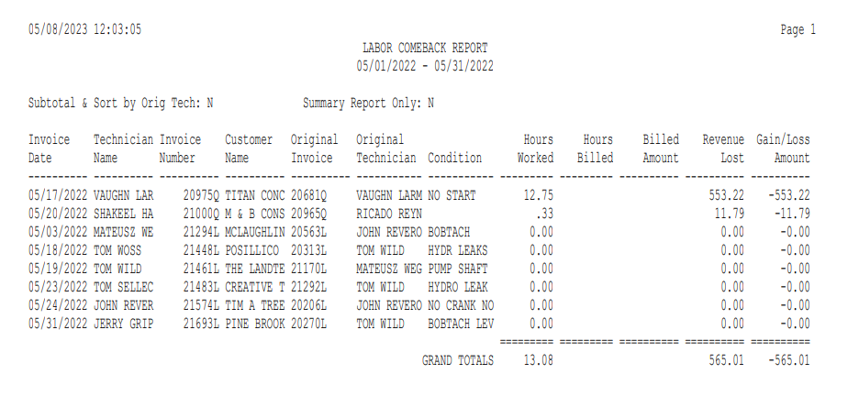

Sample Unsorted Summary Report

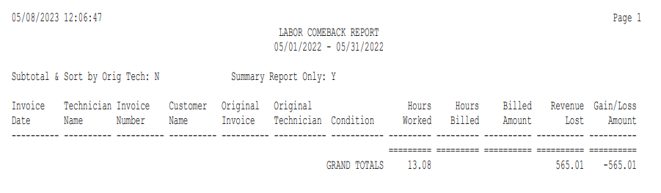

Sample Sorted & Subtotaled Detail Report

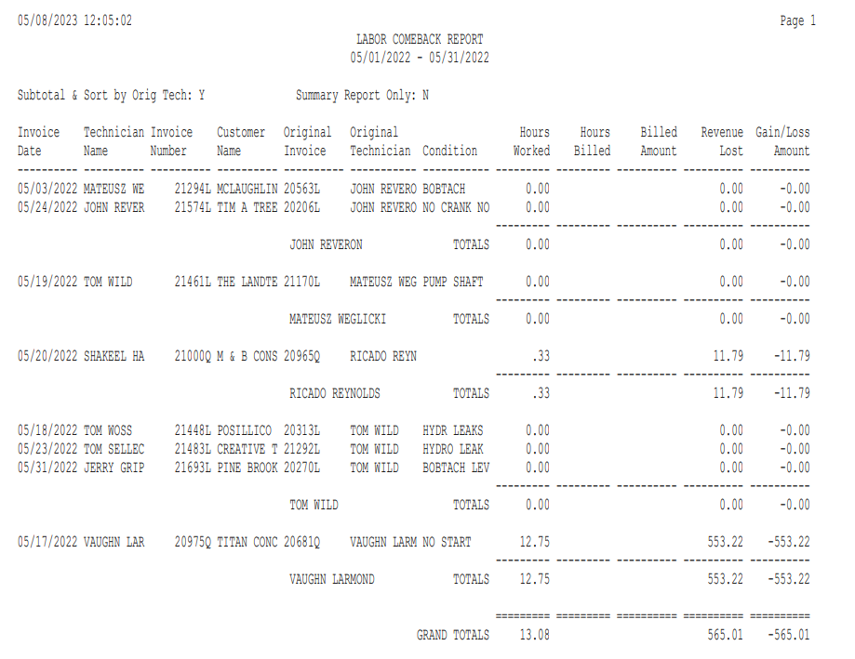

Sample Sorted & Subtotaled Summary Report

