Login Rules for CRM

Your Netview Login must now MATCH your Salesman ID for use in CRM. The login and Salesman ID must be 3 characters and can be alpha/numeric. Your Salesman ID will now be available in POS and US via a drop-down menu.

- Access the User and Permission File Setup (PERM) screen to add or change logins.
- Select the correct location for the login. NOTE for Multi-location users: Set the permissions by specific location. In addition, Sales Managers will want to add the Consolidated locations so they can view details across locations.
- On the right hand side of the screen you will see the button for CRM.

- Click on the button to see the details.

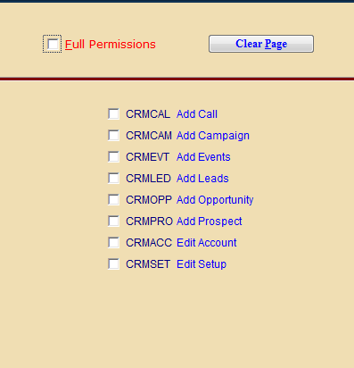

- Choose the appropriate permissions for the login.
  - The last 2 selections (Edit Account and Edit Setup) are usually management functions.
  - For a management login, the Full Permissions selection on the top of the page would be appropriate.
- Save the CRM selections, then save the permissions on the main login screen.

