Memo A/R Statements:

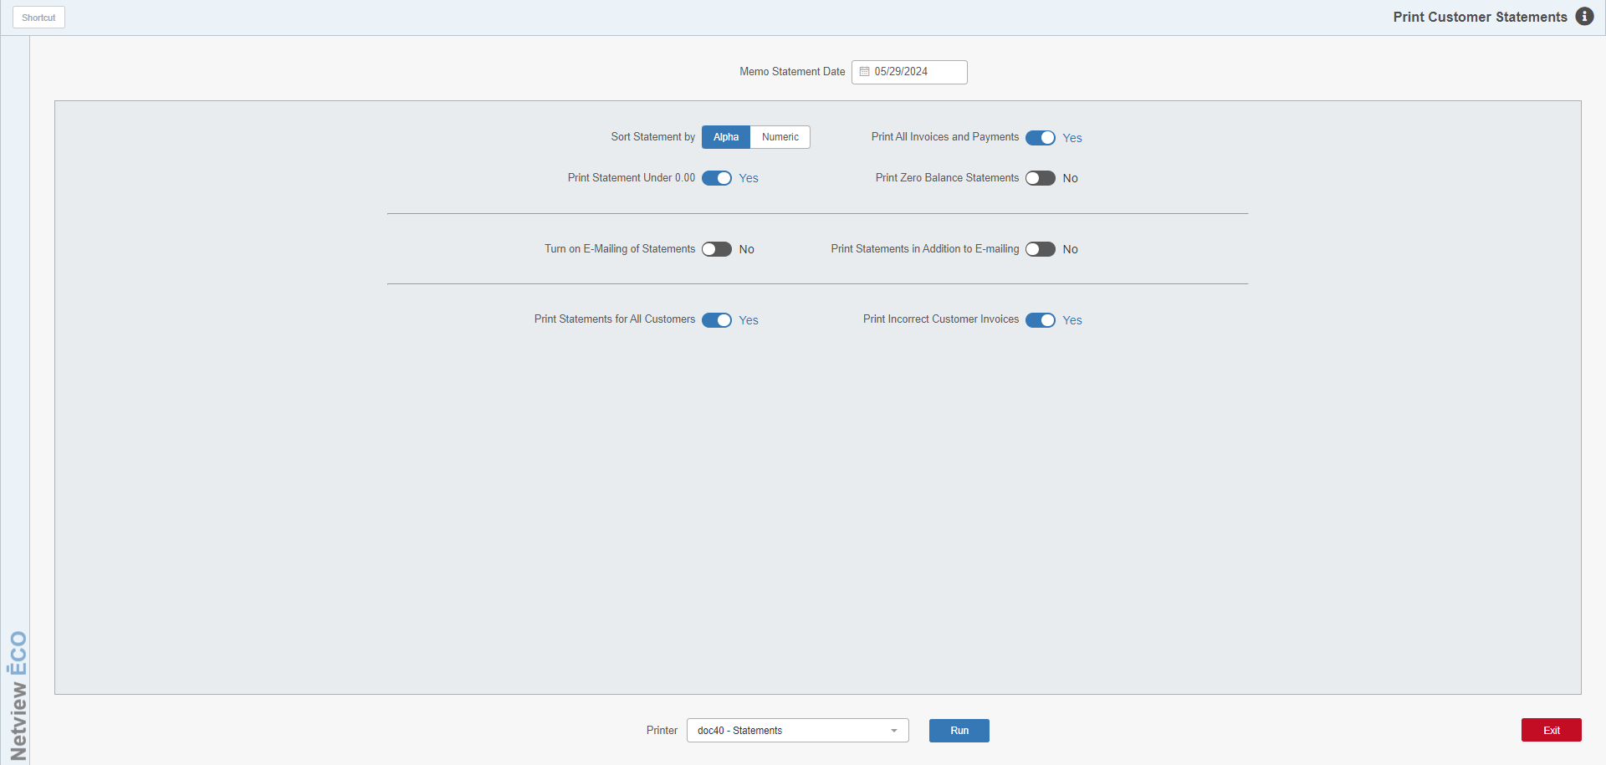

This feature gives you the ability to run all or specific customer statements at a time other than the monthly statement run. It prints the customer’s statement as of the run date.

To access this function, either:

- Select “Accounts Receivable” from the menu and choose the “Memo Reports” submenu. Click on “A/R Statements.”
- Type “MARS” in the Shortcuts Bar.

TIP: Some dealers find it beneficial to run a “second” printing of customer statements for some or all months. Running a second batch of them at perhaps mid-month may provide a new cash flow to the dealership as some of the customers may pay their bills as the mid-month statements arrive. The extra run of statements, of course, will NOT assess any finance charges.

Field Definitions

Memo Statement Date: Enter the cutoff date for the memo statements here. The current date will pre-fill in the field, but you may change it as desired.

Sort Statements by:

Select Alpha to have the statements sort alphabetically based on the Alpha Sort field in the Customer Master.

Select Numeric to sort them numerically in customer number order.

Print All Invoice & Payments:

- Set this option to Yes to show ALL activity on the statement (invoices and payments for paid and unpaid items).
- Set it to No to show only the outstanding (unpaid) invoices.

Print Statements Under [Amount]: This option is controlled by the “Minimum Statement Amount” setting in Tax Rates and Messages (TRM), which sets the minimum dollar amount for statements. The field title will change to show the dollar amount listed in that field.

- Set this option to Yes to print statements with a balance under the minimum statement value.
- Set it to No to print only statements with the minimum balance or higher.

Print Zero Balance Statements:

- Set this option to Yes to print statements for those who have a $0.00 balance but have paid any outstanding invoices since the last statement.
- Set it to No to skip those with a zero balance.

Turn on E-Mailing of Statements: Set this option to Yes to enable the system to directly email customer statements. NOTE: This will only work if you have already set up the system’s emailing functions in Email Maintenance (EM).

Print Statements in Addition to E-Mailing: Set this option to Yes to print a hard copy of a statement as well as emailing it to the customer.

Print Statements for All Customers:

- Set this option to Yes to print statements for ALL customers.
- Set it to No to print statements for specific customers.

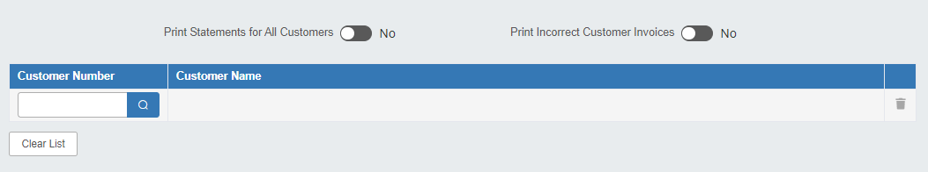

Select Customers: When you set “Print Statements for All Customers” to “No,” this screen appears. Select the customers to be printed here by typing in a customer number or looking it up using the Customer Search attached to each field.

- You may enter up to 100 customer numbers.
- Remove a customer at any time using the trash can icon next to their name.
- Click Clear List to remove all selected customers at once.

Print Incorrect Customer Invoices: This question asks if you want to print statements for customer numbers that have accounts receivable activity, but no longer have a Customer Master recorded in the system. Set the option to Yes to print statements for customers with activity who were inadvertently deleted before their detail cleared. It is always wise to enter “Yes” to see if you have any of these accounts.

Printer Name: Select the printer to receive the printout. A default printer name is pre-filled, but can be changed as necessary using the drop-down menu. NOTE: You will only be able to print statements to a physical .doc printer.

Run: Press this button to print the statements based on the selections you have made. If any errors occur during the print run, you will be able to reprint the batch of statements at any point necessary.
Exit: Clicking this button will close the program and return you to the main Desktop.

