Manual Checks (MC)

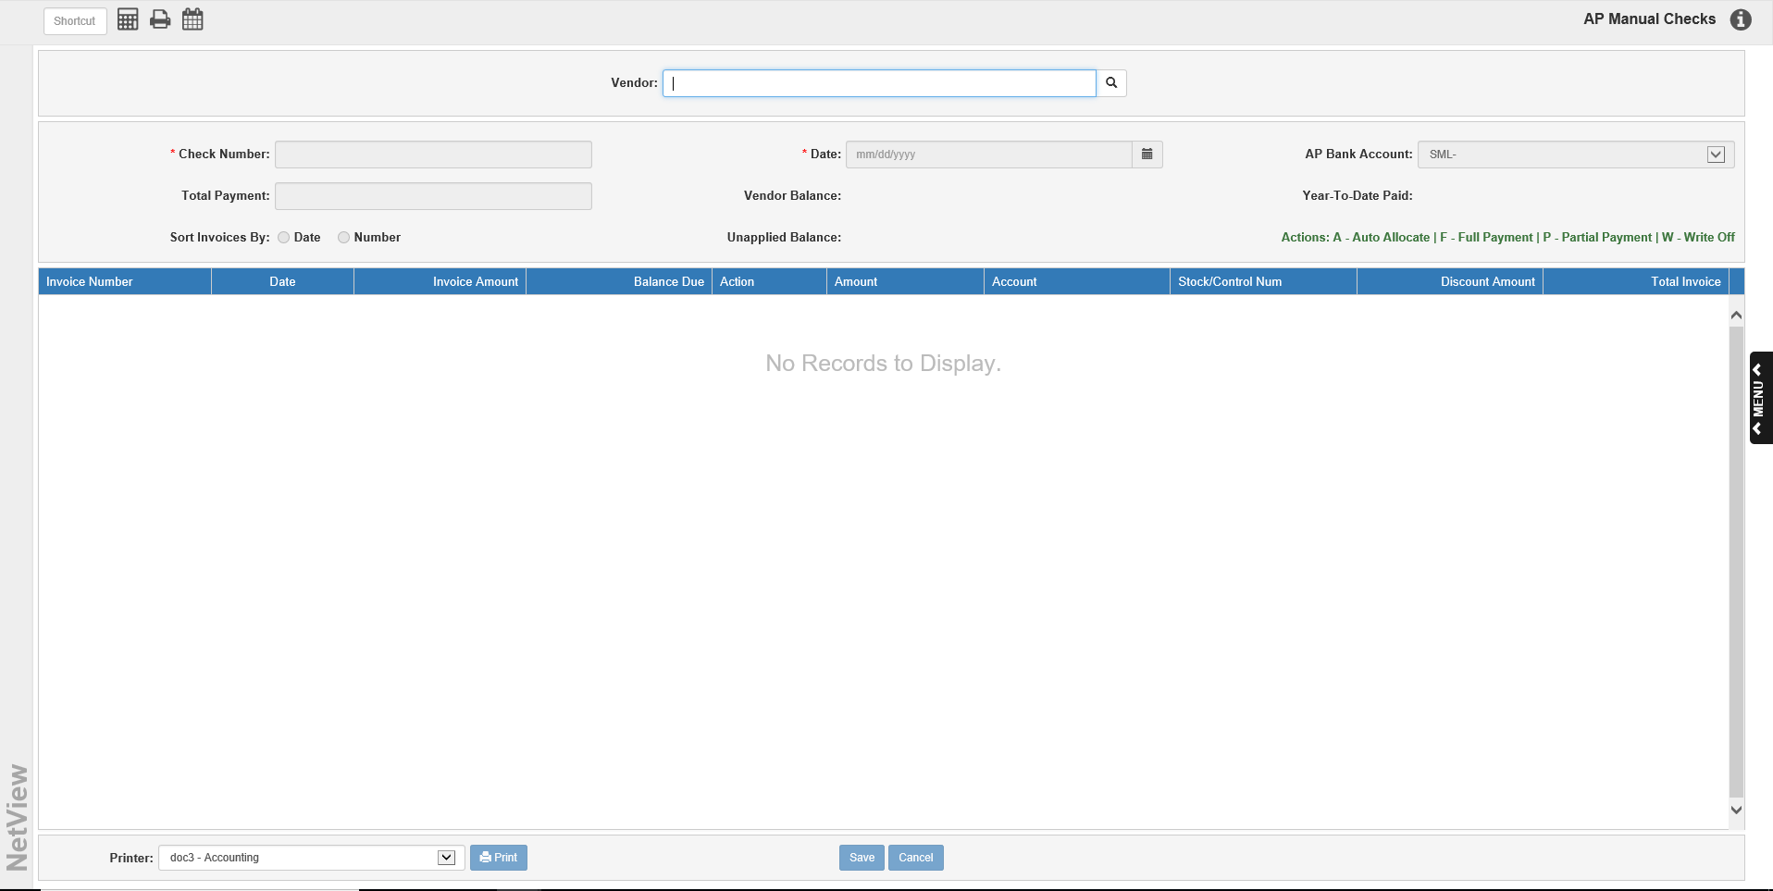

Manual Checks (MC) allows you to make and record payments made with handwritten checks or electronically paid invoices that are in A/P. Using MC, you can record full or partial payments to vendors, or write off part or all of an invoice. MC can access any invoice already present in the A/P System, provided it is not selected for payment in Select A/P Invoices (SIBD/SIBN).

To access this function, you can either:

- Select “Accounts Payable” from the menu and choose the “Process Checks” submenu. Click on “Manual Checks.”
- Type “MC” in the Shortcuts Bar.

TIP—Posting Manual Checks Entries: All of the entries you make in Manual Checks are routed to the Cash Disbursements Journal (Journal 10). Please remember that you must post these transactions through Disbursement Journal (DJ) as part of your End of Day routines.

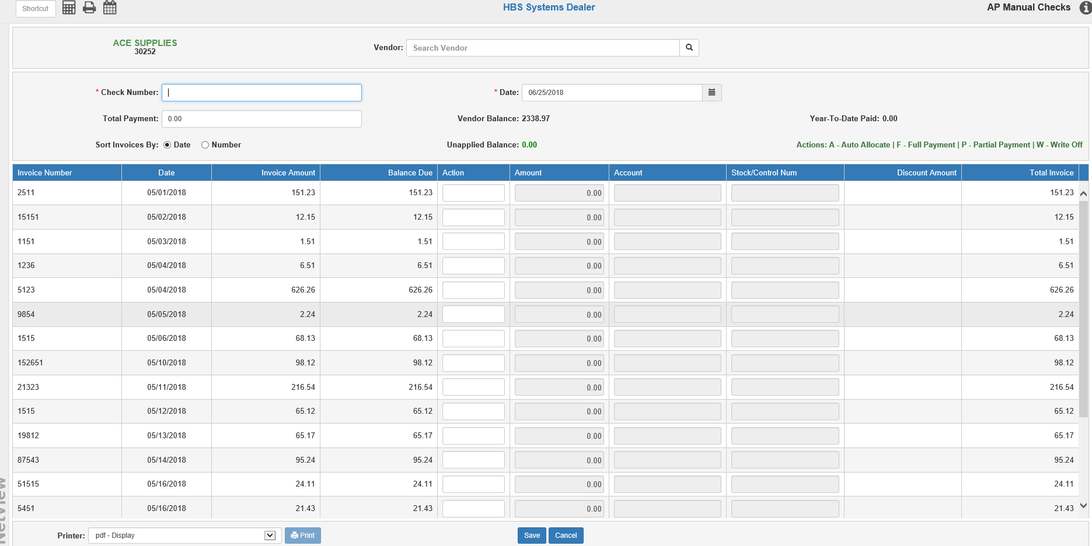

Field Descriptions:

Vendor: Use this field to select the vendor record. You may search for the vendor by typing in all or part of the vendor’s name, then press “Enter” or click the Search icon. Click on it in the search results to select it. This will populate the screen with the vendor’s unpaid invoice information. You can click on the vendor’s name to view their Vendor Insight (VI) page.

NOTE: If you have the Multiple A/P Accounts feature turned on in Information Defaults (ID), the vendor’s default A/P account as recorded in Vendor Information (VIM) will also show in the header.

Check Number: Type the number of the handwritten check or electronic payment reference. If doing a write-off, enter a meaningful write-off document number in this field.

Date: Type the date entered on the handwritten check or electronic payment. The field will show the current date by default, but you may change it as needed.

AP Bank Account: Use the drop-down menu to select the A/P bank account for the check payments if multiple bank accounts are in use. The default account is selected automatically but can be changed as needed.

Total Payment: Enter the amount of the handwritten check or electronic payment. This amount should be after any discounts have been taken. For write-off payments, this field should be left at 0.00. If you are making a payment transaction that also includes a partial write-off, only enter the check payment amount.

Vendor Balance: This field shows the vendor’s current balance amount.

YTD Paid: This field displays the total amount paid to the vendor since the beginning of the calendar year.

Sort Invoices By:

- To sort the unpaid invoices by invoice number, choose Number.
- To sort the invoices in date order, choose Date.

Unapplied Balance: This field shows the remaining portion of the payment specified that has not be applied. To complete the transaction, this field must be 0.00.

Payment Grid Columns: Each line on the grid represents one invoice line.

Invoice Number: This column lists the invoice number.

Date: This column lists the original invoice date.

Invoice Amount: This column lists the original amount of the invoice.

Balance Due: This column shows the net amount due on the line (original amount less any payments).

Action: Use this column to indicate if the invoice line is part of the payment transaction. If you enter a command in error, you can remove it by highlighting it, then either pressing the “Delete” key or typing the letter “C.” This will clear the field. You can also simply highlight the command and type in a different one.

- A - Automatic Allocation: A will apply the Total Payment amount to the invoice line where the cursor is and to all following lines until the full amount has been applied.
- F - Full Allocation: F will select the invoice line to pay in full.
- P - Partial Allocation: P will apply a partial payment to the invoice line. Fill the amount of the partial payment in the Amount field to the right.
- W—Write Off: W indicates you want to write off part or all of an invoice line. You can enter a write-off as part of a check entry or by itself. On this line you will need to specify:
  - The amount being written off
  - The G/L account number to receive the write off
  - A stock or control number if it is tied to a unit or subledgered

Amount: This column holds the amount of the line that will be paid or written-off, depending on the selected action. The field is active if you select the P or W actions.

Account: In the case of a write-off, this column holds the General Ledger account number that will receive the write-off payment.

Stock/Control Num: If the write-off account requires a stock or control number, enter that number in this column. For a stock number, you can use the Search icon to search for the number if needed.

Discount Amount: This column shows the amount of any discount for this invoice line. If changes are needed for the discount, those changes must be made in Enter A/P Invoices (EAPI).

Total Invoice: This column shows the total amount for the invoice the line belongs to.

Save: Press this button to save your payment/transaction.

Cancel: Click this button to cancel the transaction and clear the screen. The following warning will appear:

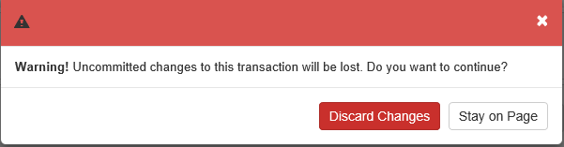

- Click Discard Changes to cancel the transaction.
- Click Stay on Page to return to the screen.

Printer/Print: After you click Save, you can generate a proof sheet of the actions you just saved. Select a printer to receive the printout and click Print to receive the proof sheet.

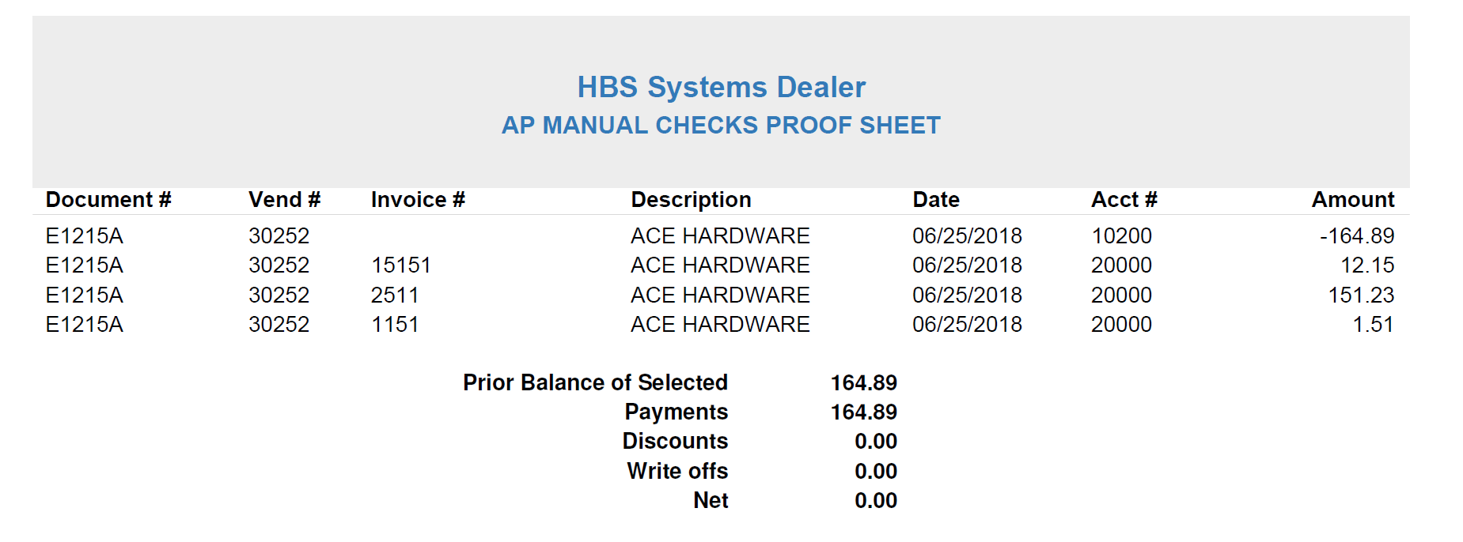

AP Manual Checks Proof Sheet: The proof sheet summarizes your actions to this point in the current MC session.

Document #: This column holds the check or write-off number.

Vend #: This column shows the vendor number for the document.

Invoice #: This column shows the invoice number affected by the payment or write-off.

Description: This column shows the invoice header description.

Date: This column shows the document date for the payment or write-off.

Acct #: This column shows the G/L account number for the payment or write-off.

Amount: This column shows the amount of the payment or write-off.

Prior Balance of Selected: This field shows the total balance of the selected payments before they were made or written off.

Payments: This field shows the total amount of payments.

Discounts: This field shows the total amount of discounts.

Write offs: This field shows the total amount of write-offs.

Net: This field shows the net amount of the transactions.

