Manufacturer Control Table Maintenance (MCTM)

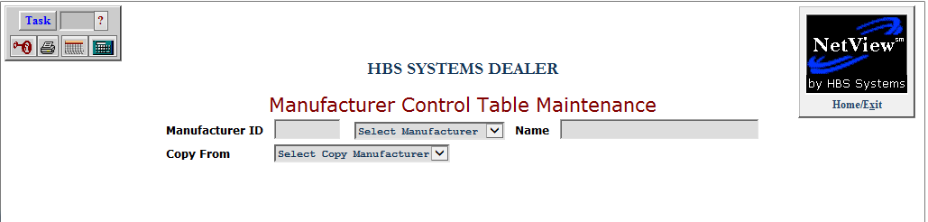

This program allows you to create and maintain records for manufacturers with specific requirements for the Service department, specifically in the cases of makes, G/L accounts, and sales codes.

To access this function, type “MCTM” in the Shortcuts Bar.

Manufacturer ID/Select Manufacturer: You can either type in a Manufacturer ID or select a manufacturer from the drop-down menu. If adding a new manufacturer, you will have to enter an ID for them in the Manufacturer ID field.

Name: The manufacturer’s name will display in this field if it is already in the system. If you are adding a new manufacturer, you will need to enter the name manually.

Copy From: When adding a new manufacturer, you can copy an existing manufacturer’s information to make your creation process easier. Select the existing manufacturer to copy from this menu. We recommend you use the “MISC-Miscellaneous” option. You can then make any adjustments to the information required to match your new manufacturer’s actual requirements.

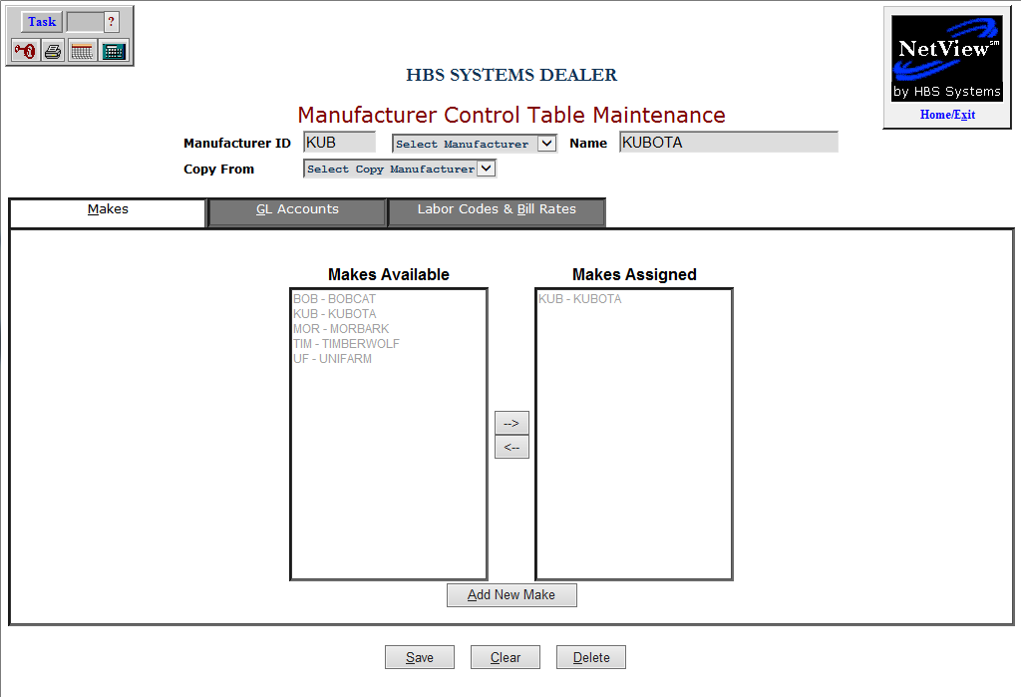

Makes Tab:

Makes Available: This contains a list of all makes available for addition to the record.

Makes Assigned: This contains a list of all makes currently assigned to the record.

Save: Click this button to save your changes.

Clear: Click this button to clear all fields on the page.

Delete: Click this button to delete the current record and clear the screen.

Add New Make: Click this button to add a new make to the application using the screen shown below.

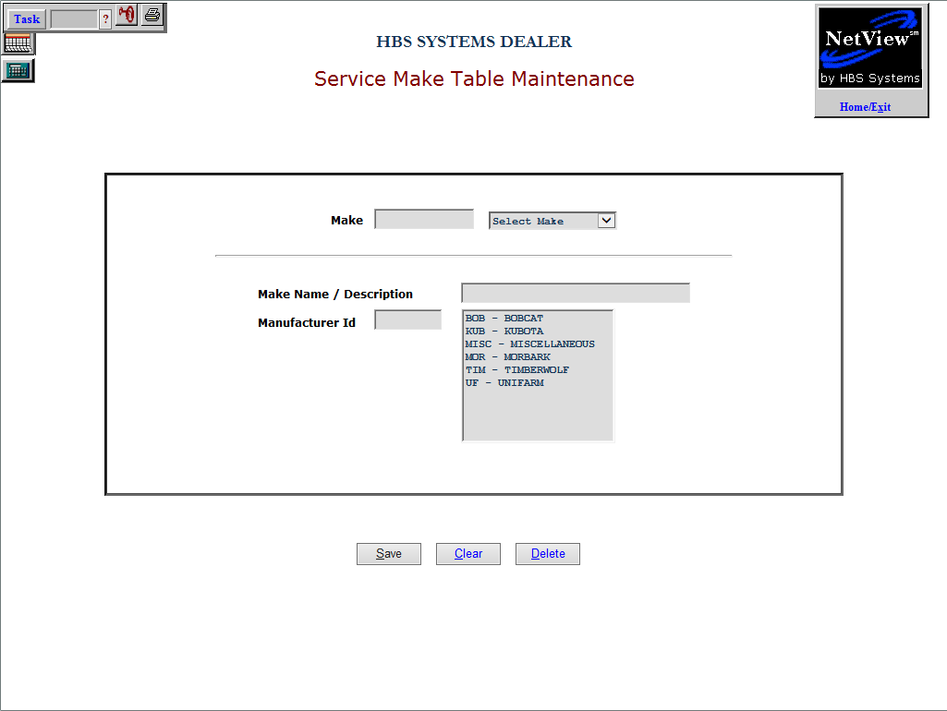

Make/Select Make: Enter the make here or select it from the drop-down menu.

Make Name/Description: Enter a name or description for the make here.

Manufacturer Id: Choose a manufacturer from the list to the right of this field to associate its ID with this make.

Save: Click this button to save your changes.

Clear: Click this button to clear all fields on the page.

Delete: Click this button to delete the current record and clear the screen.

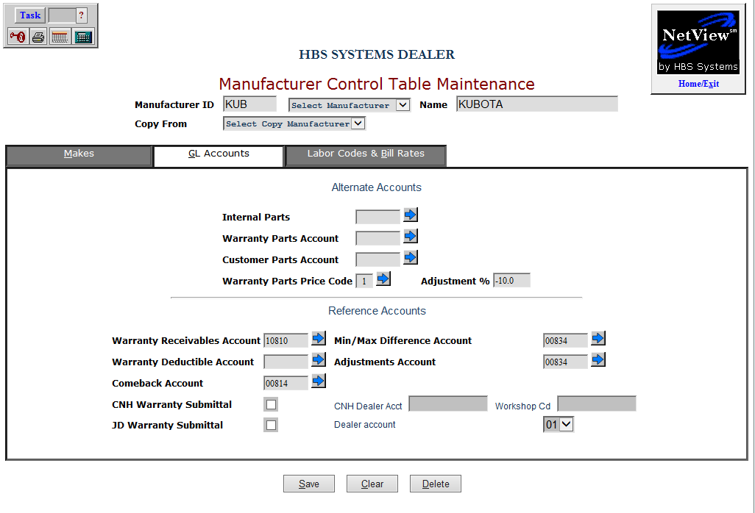

GL Accounts Tab:

Alternate Accounts:

Internal Parts: Enter or select an Internal Parts account.

Warranty Parts Account: Enter or select a Warranty Parts account.

Customer Parts Account: Enter or select a Customer Parts account.

Warranty Parts Price Code: Enter or select a Warranty Parts Price Code.

Adjustment %: Enter an Adjustment percentage.

Reference Accounts:

Warranty Receivables Account: Enter or select a Warranty Receivables account.

Warranty Deductible Account: Enter or select a Warranty Deductible Account.

Comeback Account: Enter or select a Comeback account.

Min/Max Difference Account: Enter or select a Min/Max Difference account.

Adjustments Account: Enter or select an Adjustments account.

CNH Warranty Submittal: Check this box to connect the manufacturer to an outside CNH interface, if applicable.

CNH Dealer Acct: Enter the CNH dealer account, if applicable.

Workshop Cd: Enter the CNH Workshop code, if applicable.

JD Warranty Submittal: Check this box to connect the manufacturer to an outside John Deere interface, if applicable.

Dealer account: The John Deere dealer account will appear here.

Save: Click this button to save your changes.

Clear: Click this button to clear all fields on the page.

Delete: Click this button to delete the current record and clear the screen.

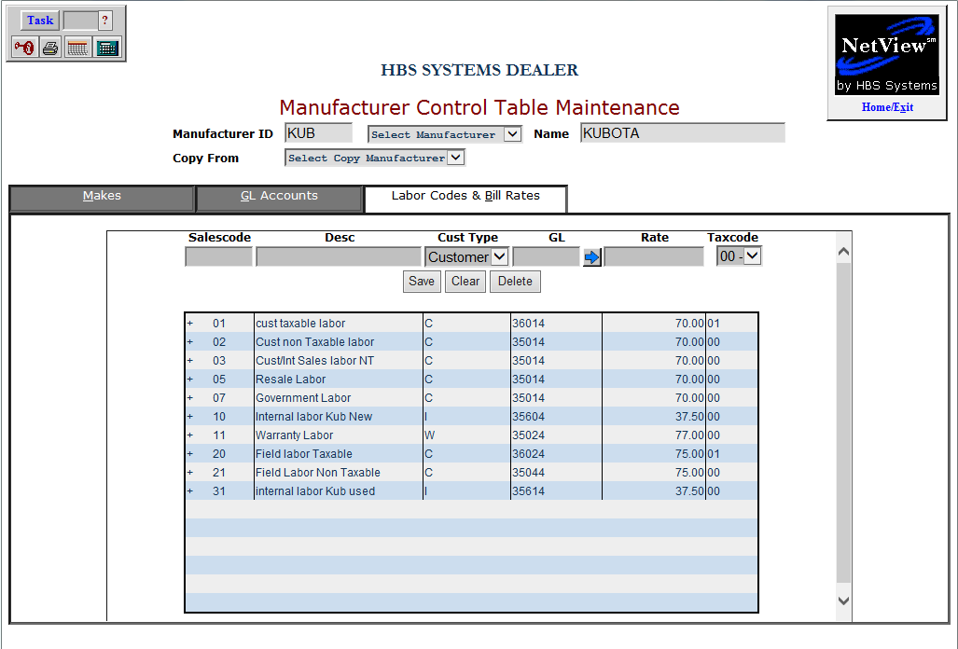

Labor Codes & Bill Rates Tab:

Salescode: Enter the salescode here.

Desc: Type a description for the salescode here.

Cust Type: Choose the customer type from the drop-down menu.

GL: Type or select the GL account.

Rate: Enter a rate here.

Taxcode: Select the tax code from the drop-down menu.

Save: Click this button to save your changes.

Clear: Click this button to clear all fields on the page.

Delete: Click this button to delete the current record and clear the screen.

