Memo Finance Charges (MFC)

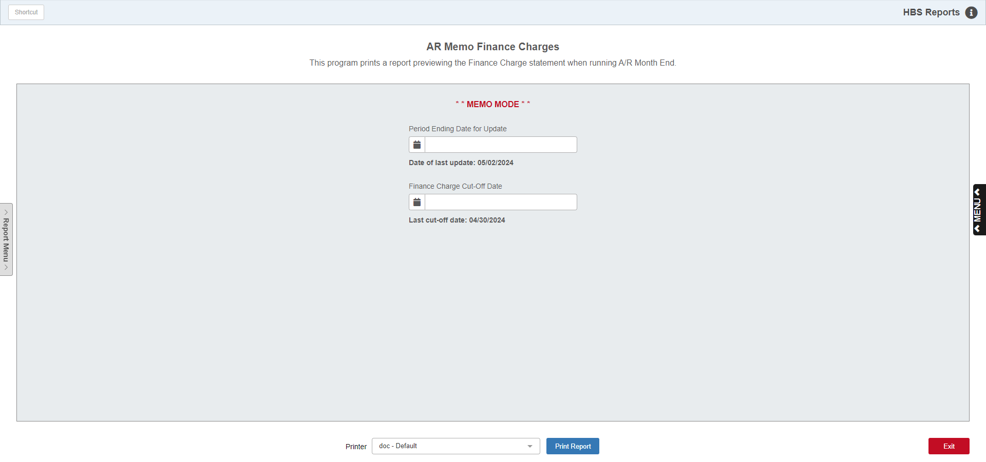

This report is included on the steps to processing A/R Month End/Statements. The report shows you what finance charges will be calculated if you run A/R Month End/Statements. If the report shows an unusually large quantity of customers with finance charge amounts, it may indicate that you have entered the wrong "Finance Charge Cut-off Date." Just re-run the report with the appropriate date.

TIP: After you verify that the Memo Finance Charges Report is correct, use the same dates when you run A/R Month End & Statements.

To access this function, either:

- Select “Accounts Receivable” from the menu and choose the “Memo Reports” submenu. Click on “Memo Finance Charges.”
- Type “MFC” in the Shortcuts Bar.

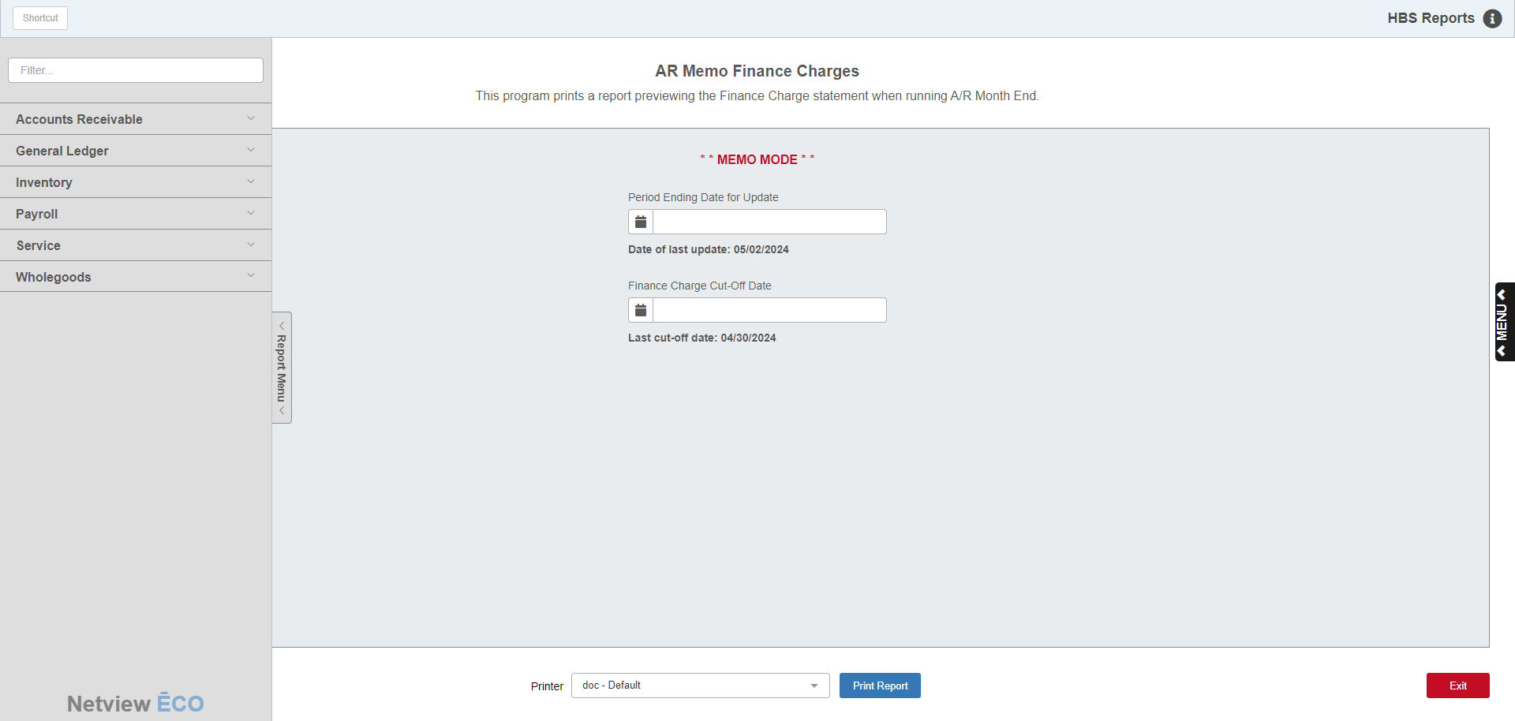

Reports Navigation Menu: This new menu appears on the left side of the screen for all reports and allows the user easy access to all report programs in the system. It is collapsable and can be easily hidden.

Field Definitions:

Period Ending Date for Update: Enter the Ending Date (or cut off date) for the upcoming statements. The date you last ran statements shows on the line below as "Date of the Last Update." Typically, it will be a month later than last time. Consistency in these days will ensure that equal grace periods will be used on each statement process.

Finance Charge Cut-off Date: Enter the cut-off date for finance charges. In other words, enter the date that tells the system that invoices older than this date are now eligible for finance charges (usually the day after the last statement date). For example, if the statement date is 06/30/10, then the Finance Charge Cut-off Date should be 06/01/2010, based on a 30-day grace period before adding finance charges to old invoices. You can modify the "grace period" to match your dealership's requirements. The date you used shows on the line below as "Last Cut-off Date." Typically, it will be a month later than last time.

Printer: Select the printer to receive the printout. A default printer name is pre-filled, but can be changed as necessary using the drop-down menu. Use the pdf printer to view the report on the screen without printing a copy of it.

Print Report: Click this button to run the report based on your selected dates.

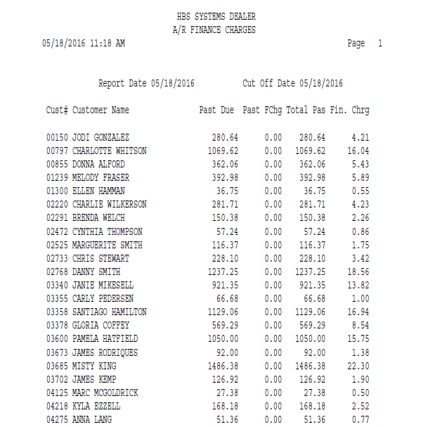

Report Field Definitions:

Cust #: This field shows the customer number.

Customer Name: This field shows the Customer Name of those who will receive finance charges if you run statements with the same date selections as this report.

Past Due: The amount in this column represents unpaid invoices that are over 30 days old.

Past FChg: The amount in this column represents unpaid finance charges that are over 30 days old.

Total Pas: This column is the total of unpaid invoices plus unpaid finance charges that are past due.

Fin. Chrg: This column shows the amount of finance charge that will be added to their account if you run statements with the same date selections as this report.
NOTE: If the program finds any existing invoices without a customer number, the program will print an Error Report along with the main report listing those invoices:

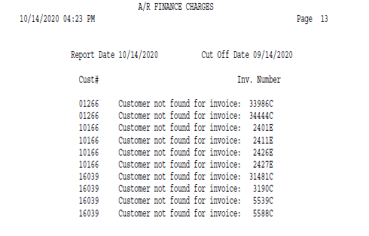

TIPS - Using the Finance Charge Report

Review the Report Date and Cut Off Date at the top of the report: Verify that you used the right dates for this report.

Read through all the Customer Names listed on the report: If you notice some customers printed on this report that don't seem to feel right, check their invoice/payment detail on the Aging Report or through the Customer Balance Inquiry program.

Review large Finance Charge amounts: If a few of your hard-core late payers (i.e. past 120-day due) are starting to accrue large Finance Charges, this report will show those large amounts so you can take further action (i.e., change the customer's Credit Limit or his COD Status to Yes).

Review small (or minimum) Finance Charge amounts: Check why the minimum Finance Charge will be assessed against these customers' accounts. You may want to disable the Finance Charge Code on these customers' accounts temporarily, which will save you from having to write off the finance charges later. Note: Change the Finance Charge Code to "00" before running A/R Month End & Statements. After completing the month-end process, change the Finance Charge Code to 01 (or whatever the original code was).

Make all appropriate changes in the customers' accounts BEFORE running the A/R Month End program: This includes changing Finance Charge Codes (and rates) and entering all payments on their account. Note: After you run A/R Month End, don't forget to reset Finance Charge Codes, etc.

