Multi-Store Inventory/Order Comparison (MIC)

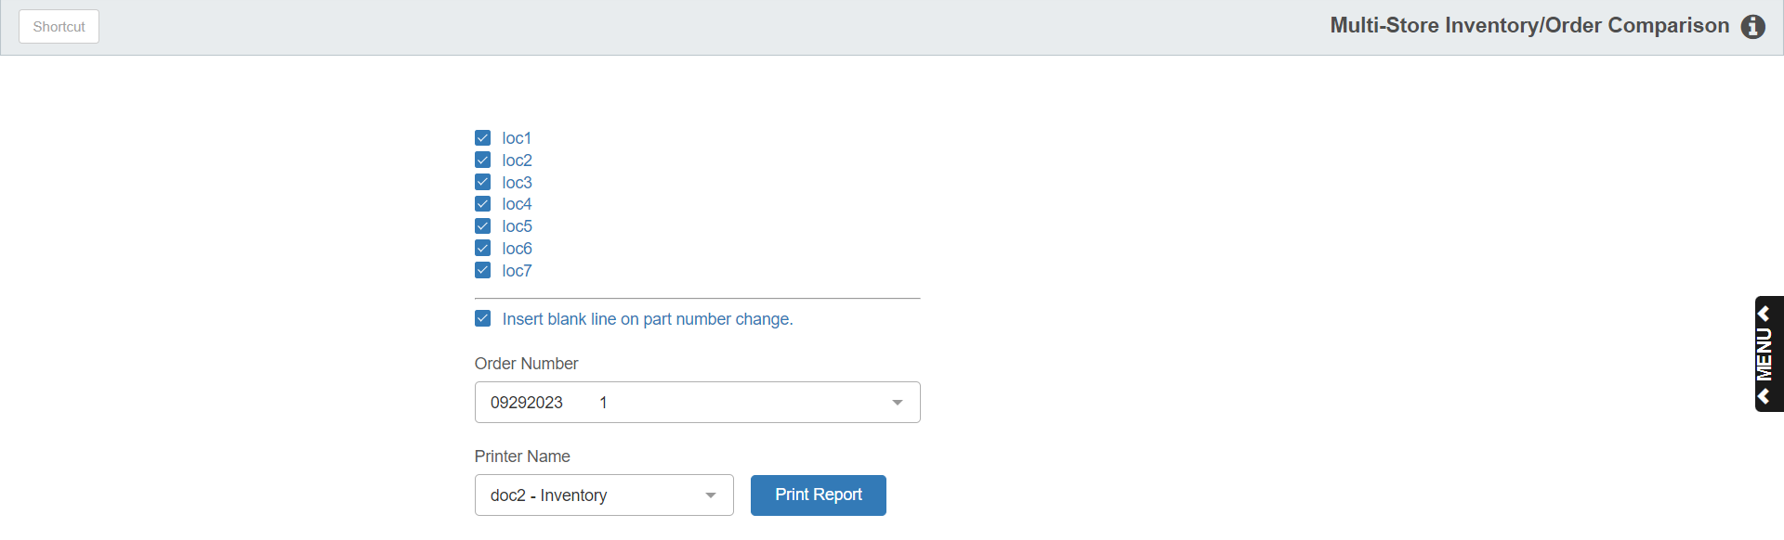

This program provides multi-location dealers the option to compare open orders between selected locations. Choose an open order in a location, then select one or more of your other locations to compare. This can assist in stock redistribution or possibly combining orders. You can use this program to print or view any of the open orders.

To access this function, you can:

- Select “Inventory” from the menu. Choose the “Multi-Store Processing” and click “Multi-Store Inventory/Order Comparison.”
- Type “MIC” in the Shortcuts Bar.

Field Definitions

Location Selection: Choose the locations to include. Click on the locations to compare.

Insert Blank Line: Click this box to insert a blank line between part numbers on the printout. The extra line makes the report much easier to read.

Order Number: Select the order number to compare.

Printer Name: Set the printer to receive the report. Use the pdf printer to display the report.

Print Report: Click this button to run the comparison report.

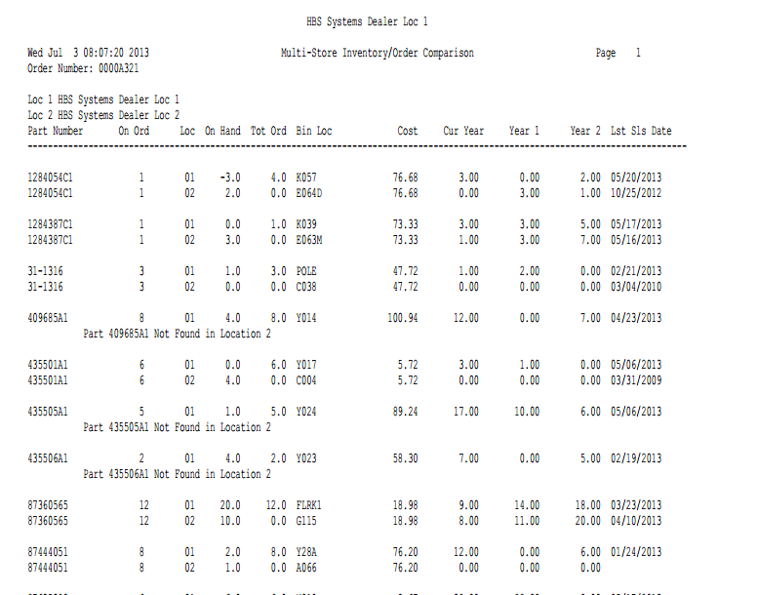

Order#: This is the order selected for comparison. It appears at the top of the report.

Report Columns:

Part Number: This is the part number on the order.

On Order: This is the quantity on this order.

Loc: This is location number. The locations are listed by number at the top of the printout.

On Hand: The shows the On Hand quantity for this part in the identified location.

Tot Ord: This is the total on order quantity for this part in the identified location.

Bin Loc: This shows the primary Bin Location for the part in this location.

Cost: This shows the cost for the part number.

Cur Year: This field shows the number of sales in the current calendar year.

Year 1: This field shows the number of sales in the past calendar year.

Year 2: This field shows the number of sales in the calendar year, year before last.

Lst Sales Date: This field shows last sales date for this part.

