POS—Multi-Location Parts Transfer

If you are a multi-location dealership, you can now utilize an inter-store Parts Transfer when making a backorder on a Point-of-Sale ticket. This feature allows you to see if the part you are backordering is available at any of your dealership’s other locations, and if so, lets you transfer the part while writing the ticket so it takes the place of the backorder.

NOTE: This feature will only work for a multi-location dealership.

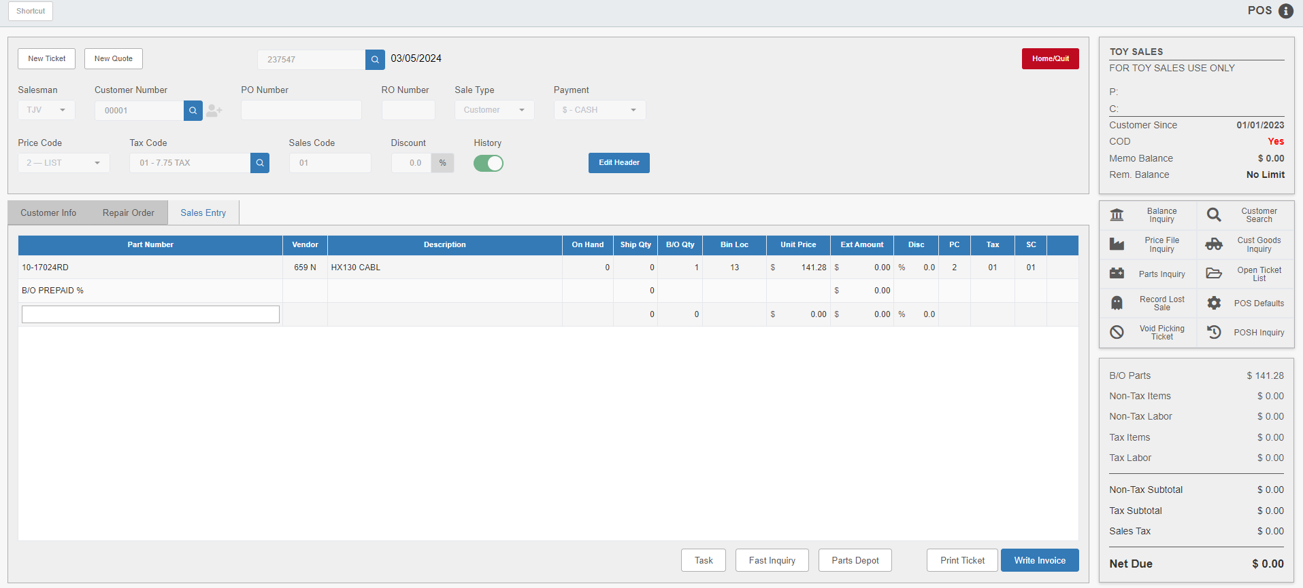

Adding Backorder Parts to Ticket: To trigger this feature, enter the backorder quantity in the B/O Qty field and hit the “Enter” key, as you normally would when creating a backorder. The following window will appear:

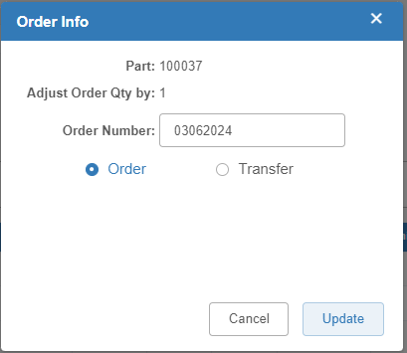

Select the Transfer option at the bottom of the window to open the Multi-Location Parts Lookup.

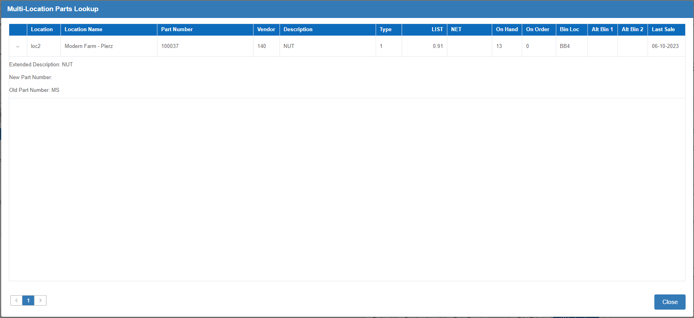

Multi-Location Parts Lookup: The Lookup displays a list of your dealership’s locations and shows which stores have your particular part in inventory. The other location will only show up in the results if it has a non-zero quantity of the part on hand.

Check the other locations’ on-hand quantities to see if they have the part amount you require. If they don’t, click Close to return to the main screen and proceed with the backorder as normal. If they do, and you wish to transfer that quantity to your location to fulfill your order, click on the part listing. The program will return to the ticket screen and automatically add a backorder line for the part.

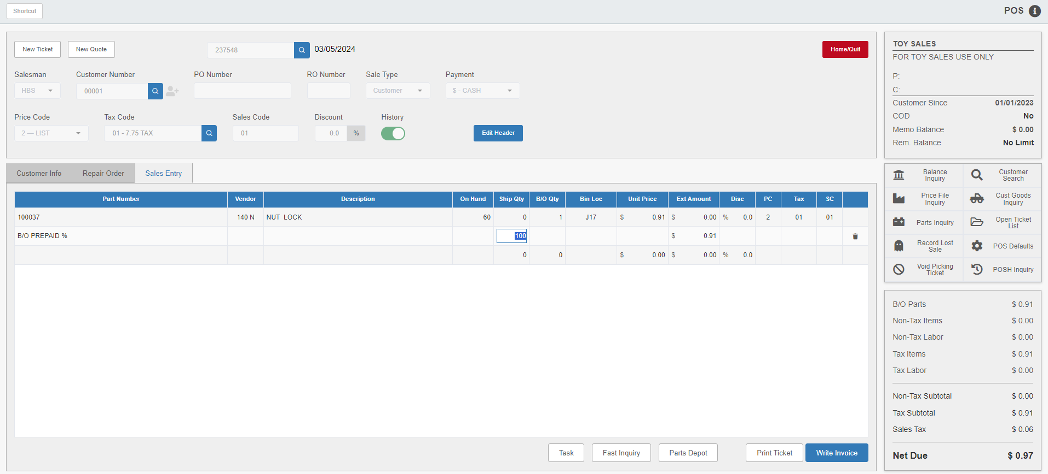

Completing the Transfer: When you finish working on the ticket and either go to write it or to exit the program, the following warning will appear:

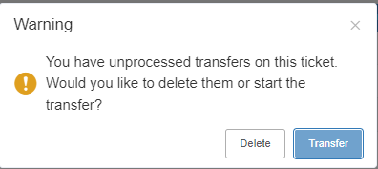

Click Transfer to complete the transfer process. The following window will appear:

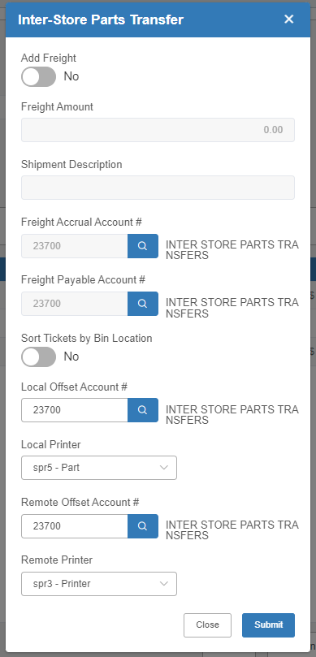

Add freight (and a description) if desired, check that the accounting is correct, and specify the printer(s) to receive the transfer reports at the local and remote store. Press the Submit button to process the transfer and receive the Transfer Report.

