Method of Disbursement (MOD)

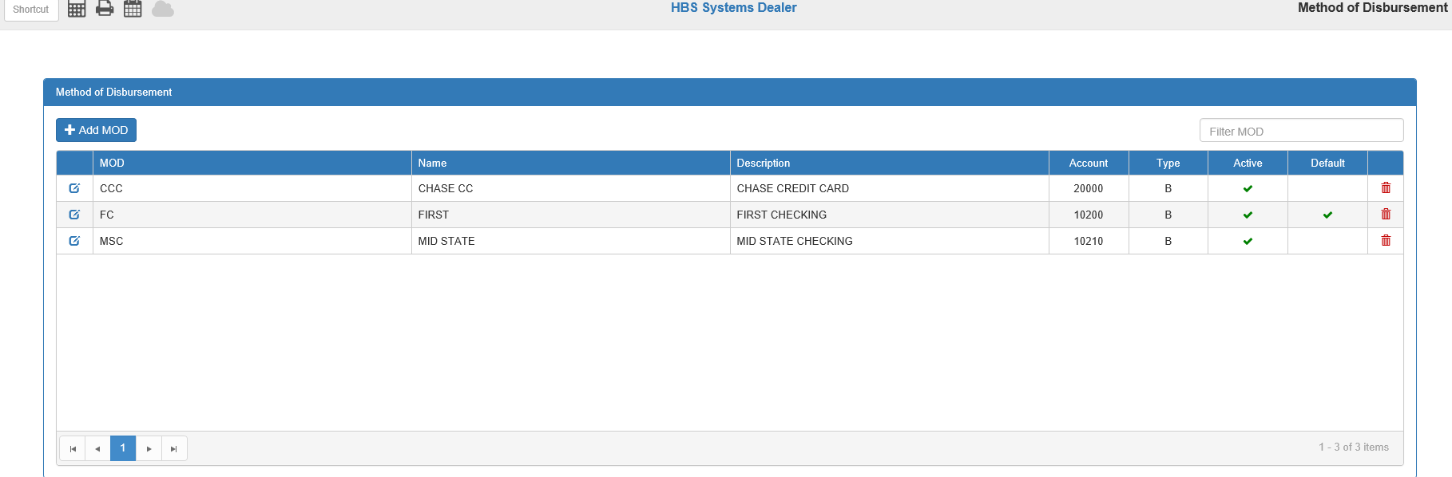

The Method of Disbursement component of A/P provides the ability to generate checks for more than one back account AND the ability to pay A/P invoices with a credit card. This screen (MOD) defines the methods of disbursement that will be available for use in the A/P checking programs and in the Payroll check program (PPC).

To access this function, you can either:

- Select “System Maintenance” from the menu and choose the “Company File Maintenance” submenu. Click on “Method of Disbursement.”
- Type “MOD” in the Shortcuts Bar.

Add MOD: To add a new method of disbursement, click this button to open the Add MOD window.

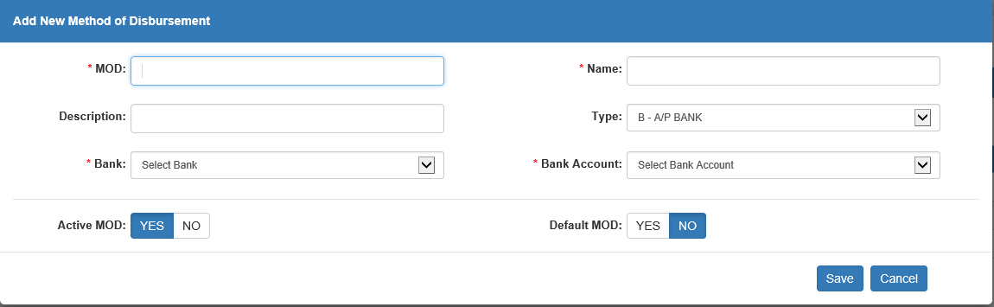

MOD: Choose a 3-character name for the method being defined.

Name: Enter up to a 10-character short name for this method.

Description: Enter an optional description of the method being defined.

Type: Choose the type or “use” from the drop-down menu.

- Choose B-A/P Bank for pre-printed checks, e-forms checks, or credit cards to be used in A/P.
- Choose P-P/R Bank for pre-printed checks or e-forms checks to be used in Payroll.

Bank: Choose the corresponding “bank” name from the drop-down menu.

Bank Account: Choose the bank account number defined in the Bank Setup (BANK) that corresponds with the chosen bank.

Active MOD:

- This field must be set to Yes if the method is to be available for A/P or Payroll.
- If you change banks in the future, you can simply set this to No to remove it from the choices when paying in A/P or Payroll.

Default MOD: This field must be set to Yes for the methods you want as the defaults: one for A/P and one for Payroll. The one(s) selected will appear as the default method in A/P or Payroll but can be changed as needed.

Press the “Save” button to save your method.

MOD Grid: All methods of disbursement stored in the system will be listed in this grid. You can reorder them by clicking the column headers to sort the entries in order by that column’s contents or use the Filter MOD field to show only methods containing specific information.

Edit: Click the icon in the far-left column of the grid to edit the existing MOD. The fields will be the same as those in the Add MOD window.

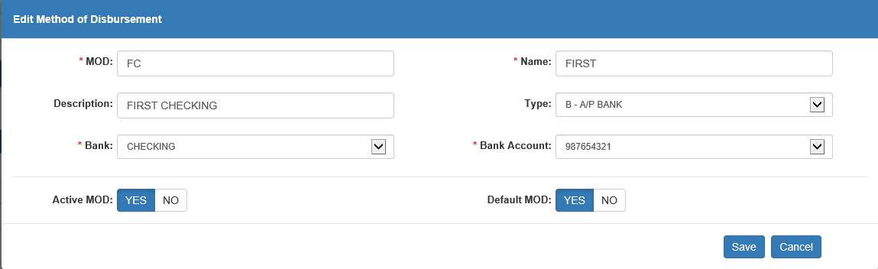

Be sure to click Save after making any changes.

MOD: This column shows the 3-character MOD designation.

Name: This column shows the full name of the MOD.

Description: This column can hold a full description of the MOD, provided one exists, as having a description is optional.

Account: This column shows the account number for the MOD.

Type: This column shows the MOD’s type:

- B (A/P Bank)
- P (Payroll Bank)

Active: This column shows a checkmark if the MOD is active.

Default: This column shows a checkmark if the MOD is marked as default.

Delete: Click the trash can icon in the far-right column to delete the MOD. The following warning will appear:

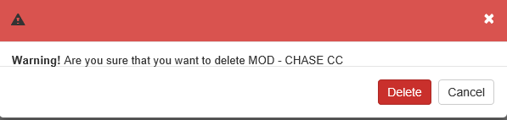

- Click Delete to delete the MOD.
- Click Cancel to return to the main screen without deleting the MOD.

Using the defined Methods of Disbursement: In each of the check printing or paying programs, there is a drop-down menu with the methods defined in MOD. The choice you designated as default is the one that will show but you may choose another as needed.

ODC – On Demand Checks:

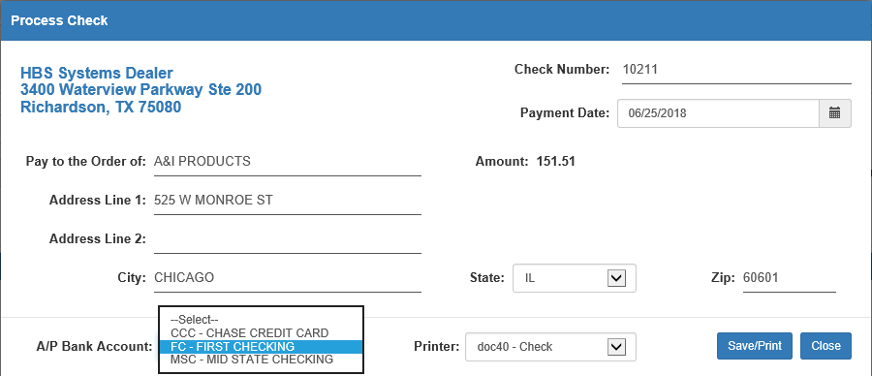

When the Disbursement Journal (DJ) is run, the payment will credit the G/L account associated with the selection made in ODC at the Process Check stage.

MC – Manual Checks:

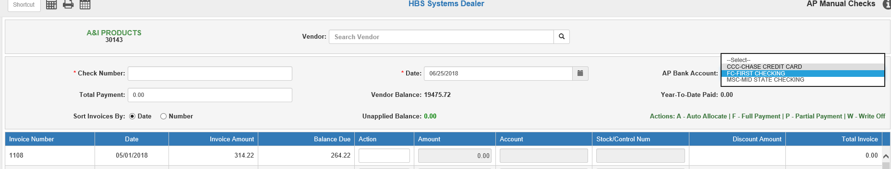

When the Disbursement Journal is run, the payment will credit the G/L account associated with the selection made in MC.

PC – Print Checks:

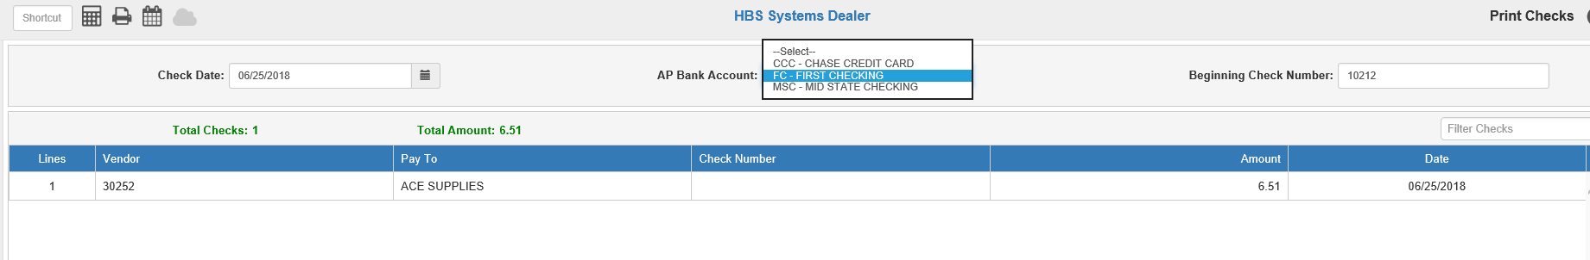

When you reach the PC portion of an A/P check run, the AP Bank Account drop-down menu provides the choices for payment methods. When the Disbursement Journal is run, the payment will credit the G/L account associated with the selection made in PC.

NOTE: The selection you make for MOD applies to the A/P check run. If you need for some vendors to be processed through one account and some through another, they will have to be handled as separate check runs.

PPC – Print Payroll Checks:

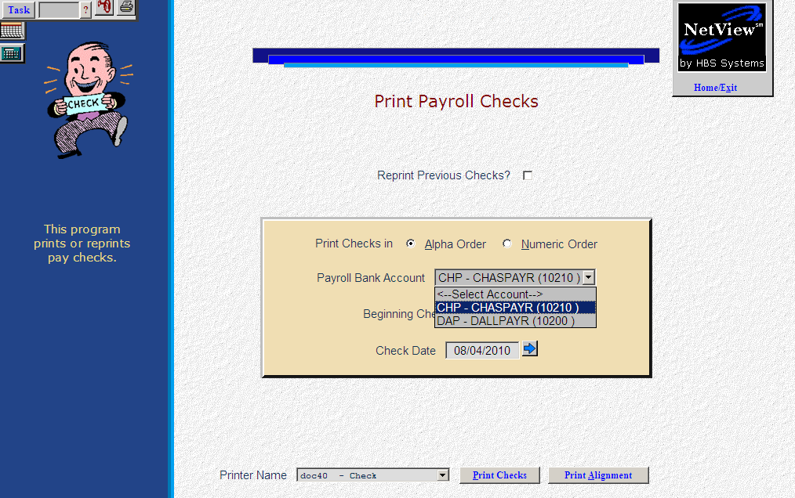

When you reach the PPC portion of the Payroll process, the PR Bank Account drop-down menu provides the choices for payment methods. When the Payroll Journal (PPJ) is run, the payment will credit the G/L account associated with the selection made in PPC.

NOTE: The selection you make for MOD applies to the entire Payroll run. If you need for some employees to be processed through one account and some through another, they will have to be handled as separate runs.

MOD and Paying A/P Invoices with a Credit Card: Select the invoices to pay with an A/P check run or using MC, or run an On Demand check for an item that is not in A/P. If you create an A/P check run, remember the entire check run will be “paid” with the credit card selected.

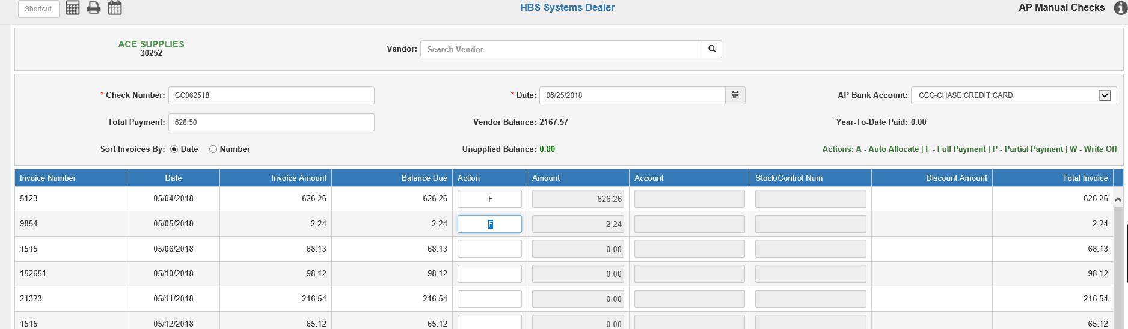

When the transaction is saved, it creates TWO sets of journal entries. One set is created in the Disbursement Journal to pay the invoices selected and then “credit” the method of payment.

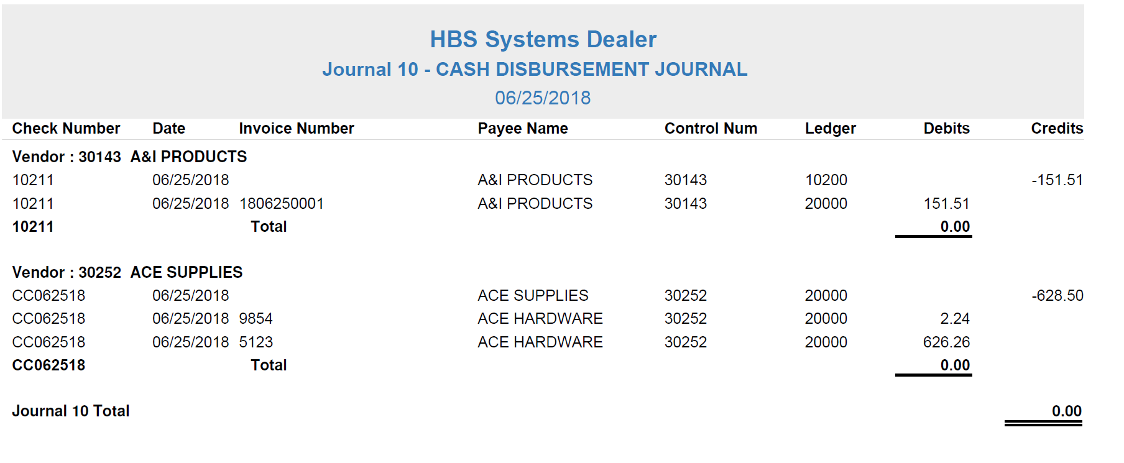

The other set is created in the A/P Purchase Journal when the new “invoice” is created to show that you have added to the balance of what you owe on the credit card vendor.

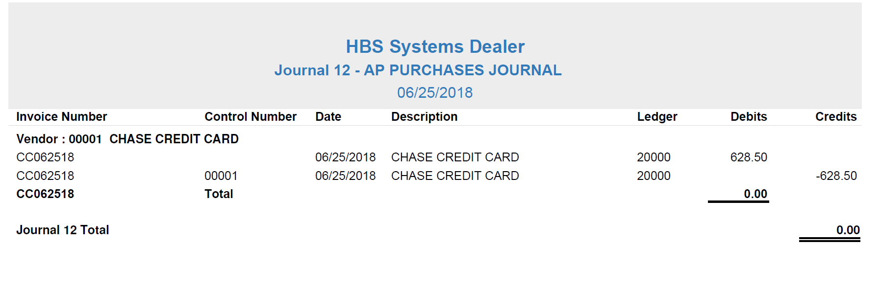

A new invoice is added to the vendor for the credit card, as shown below:

