Method of Payment (MOP)

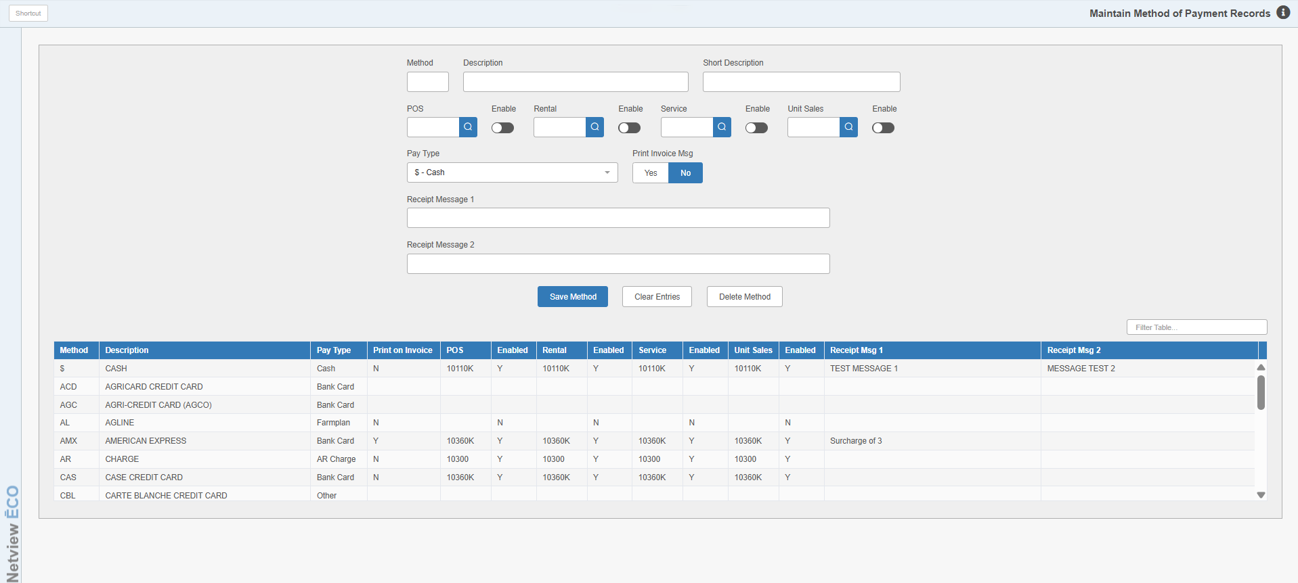

This maintenance screen is used to define the possible ways your customers settle or pay for purchases in Point of Sale (POS), Repair Order Maintenance (ROM), Rental (RENT), and Unit Sale (US). Examples: Cash, Checks, Customer Deposits, Charge (A/R), Credit Cards, Financing (Contracts), etc.

We suggest that you make descriptions something understandable by the customer. Example: “Cash” means more to a customer than “Cash On Hand,” the actual description of the account number. “Charge” means something to a customer instead the actual description of “Accounts Receivable.”

To access this function, you can either:

- Select “System Maintenance” from the menu. Choose the “Company File” submenu and click “Method of Payment.”
- Type “MOP” in the Shortcuts Bar.

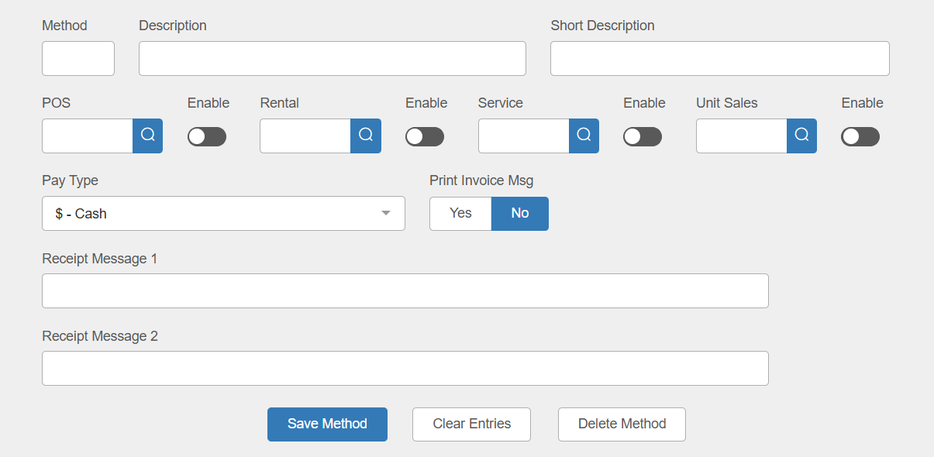

Field Definitions

Method: This is a three-character code for the method of payment defined. It is used for record maintenance and does not appear in the invoicing programs.

Description: This field holds the description of the method of payment that will print on the invoice.

Short Description: This field holds a short version of the description that displays in selection boxes. You can enter up to 11 characters here.

Account: This field defines the General Ledger account that will receive the amount specified for this method of payment. Choose the appropriate General Ledger account for each invoicing program for this method of payment. The fields that are ACTIVE at this time are:

POS

Rental

Service

Unit Sales

Enable: Switch on this option to the right of each General Ledger account to use it in the identified invoicing screen. For example, if you want to have the method available for us in POS, make sure the “Enable” switch is turned on next to the box.

Pay Type: This field identifies the type of payment defined. Select the desired value for the method from the drop-down menu. Several choices for this field trigger the selection to work with interfaces to the HBS system, which are:

B-Bank Card

D-Debit

F-Farmplan

U-AGCO Plus

Print Invoice Msg: This choice is generally only set to “Yes” if the payment is Farm Plan, but can be turned on for any method if the user wants to add additional messages to their invoices for this chosen method.

Receipt Msg 1 & 2: These fields hold any invoices messages that will print when the method is used for payment, provided that the “Print Invoice Msg” option is set to Yes.

Save Method: Click this button to save the method. It will be added to the grid at the bottom of the screen.

Clear Entries: Click this button at any time to clear the entry fields. This will not save any changes made to the method whose information was displayed at the time.

Delete Method: Click this button to delete the method. The following warning will appear:

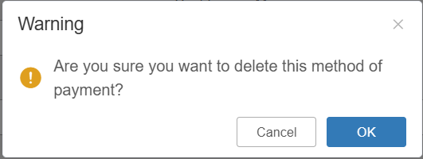

Click OK to delete the method and close the prompt. The method will then no longer appear in the grid.

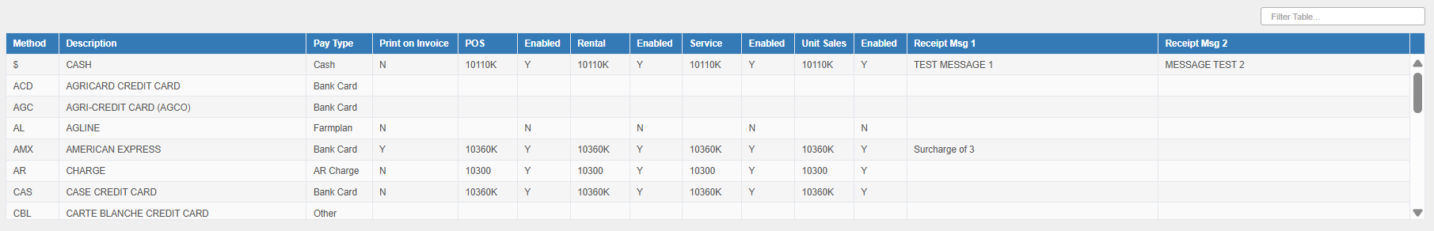

Method Display Grid: The grid lists every available method of payment in the system. You can click on any method to edit it using the entry fields above. You can also use the Filter field above the table to find a specific method by entering information listed in the method’s entry.

