Manual Price File Update (MPFU)

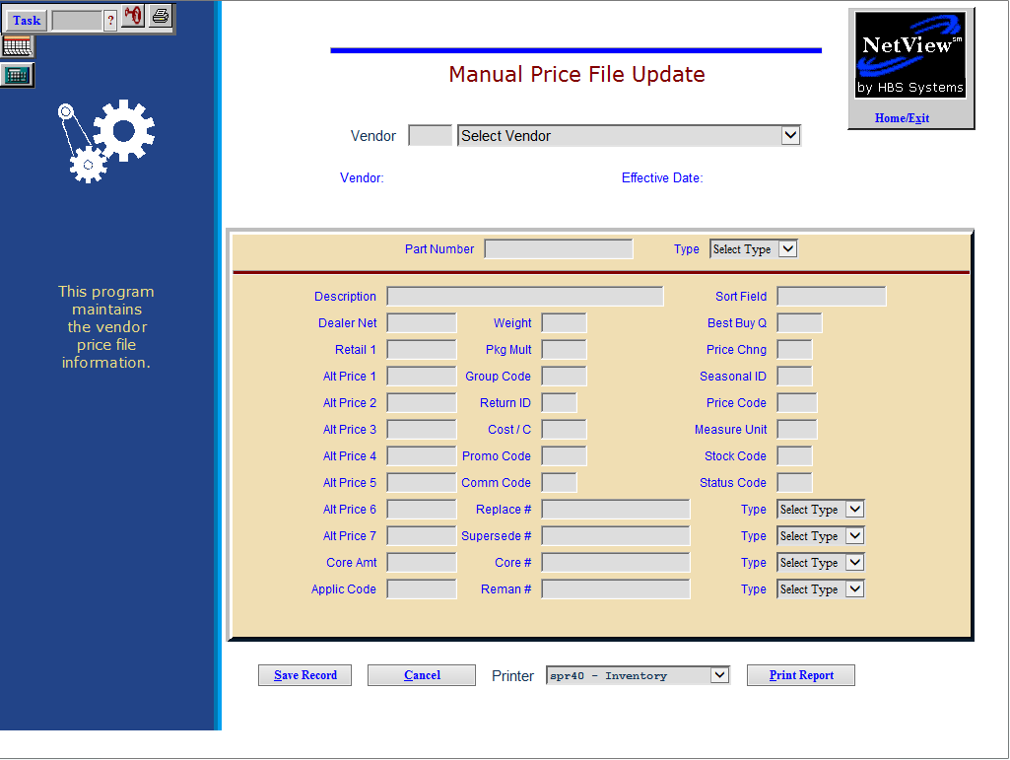

Manual Price File Updates (MPFU) lets you change the Price File information for any part number on the manufacturers Price File. MPFU can be used to update the information on the Price File itself if you receive manual notices of intermediate price changes from a vendor. The changes you make can be applied to parts in inventory when you follow up with Price Update and Variance (PUV).

- To access this function, either:
  - Select “Inventory” from the menu. Choose the “Price Files” submenu and click “Manual Price File Update.”
  - Type “MPFU” in the Shortcuts Bar.

Field Definitions

Vendor: Enter or choose a vendor number here.

Select Vendor: Select the vendor number of the price file you wish to update.

Effective Date: This field holds the date that the price files are updated.

Part Number: Enter the part number you want to update.

Type: Enter the type of the part you want to update by using the arrow at the end of this field for a drop-down menu.

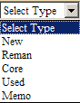

Description: This description of the part can be updated.

Dealer Net: This field holds the Mfr Cost of the part.

Retail 1: This field holds the MSRP or Mfr list price of the part.

Pkg Mult: Enter the package multiple, if any, for this part number.

Remaining Fields: The remaining fields on the screen will vary from one price file to another, depending on the information supplied by the manufacturer. Any additional fields shown on the screen may also be modified.

To apply any price changes made in the Price File to your parts in inventory, you must now run Price Update and Variance Report (PUV) to update the Parts Masters.

Print Report: The “Print” button will begin the printing of a report showing all updated part records. The printout simply shows the details of the part numbers you changed. It provides the details of the records AFTER the changes have been applied. The fields on the printout will vary from price file to price file based on the information provided by the manufacturer.

Price Files with LIST ONLY Provided

Vendor# Vendor Name
136 Artsway
161 Schaeff
194 Briggs & Stratton
257 Gehl
266 Kinze
291 Simplicity
300 Toro
308 Orthman
310 Great Plains
312 Badger
313 Kuhn-Farm
337 Krause
345 Toro-Lawnboy
353 Wilrich
354 Miller Pro
355 Patz
357 Fermec
365 Freeman
378 Walker Mower
379 Murray
394 ASV
396 Mustang
430 Rhino
431 Alamo
485 Stihl-Some have List only
488 Grasshopper
522 Hardi Sprayer
525 Landpride
545 Knight
546 Apache
549 Raven
550 Teejet
564 Ferris
584 Tigercat
647 Manitou
690 Vicon-TSC
720 Tecumseh
725 Hardee

