Manual Price Update (MPU)

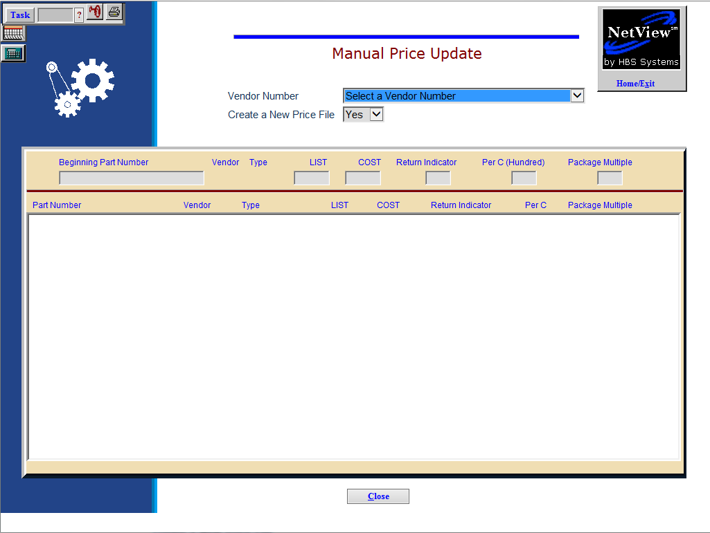

Manual Price Update (MPU) lets you maintain parts costs and pricing for vendors who do not provide a price file.

- To access this function, either:
  - Select “Inventory” from the menu. Choose the “Price Files” submenu and click “Manual Price Update.”
  - Type “MPU” in the Shortcuts Bar.

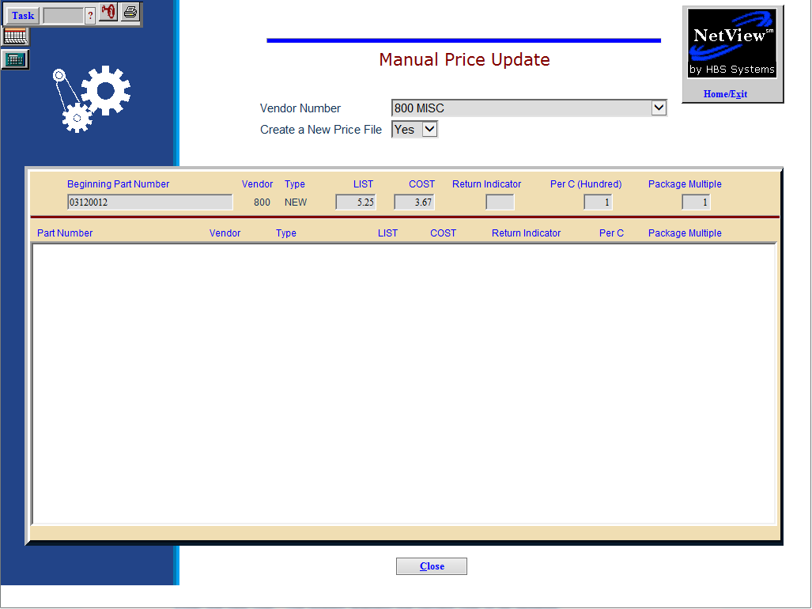

Field Definitions

Vendor Number: Enter the vendor number of the manual price file to modify or press the arrow at the end of the field to display and select a vendor name.

Create a New Price File:

The first time you access this function for a particular Price File, select Yes. This will build the price file on the system.

To maintain an existing manual Price File, choose No.

Beginning Part Number: Enter your beginning part number for this vendor, or press enter to start at the first part number in the file.

Vendor: When you have selected a vendor, the number displays here.

Type:
This field shows the part type for the part number. It could be:

- New
- Used
- Reman
- Core
- Memo

LIST: Enter the new list price. The system displays the current list price to be updated.

COST: Enter the new cost. The system displays the current cost to be updated.

Return Indicator: Enter the new Return Indicator. If there is no Return Indicator, press “Enter.”

Per C (Hundred): The system pre-fills this field from the Cost per C field in the Parts Master. Change this value if necessary.

Package Multiple: Enter the new package multiple, if any, for this part number. Each record is saved as you press “Enter” after the Package Multiple field.

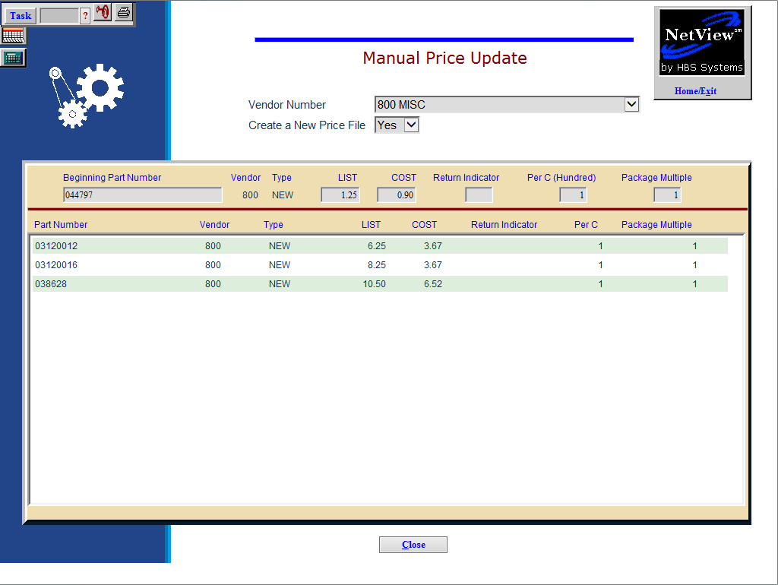

Updating more part numbers: Once a record is updated, the next sequential part number for the vendor is brought up. You can use this screen to update selected or all records for the vendor, in part number order. Each record that is adjusted is added to the running display at the bottom of the screen.

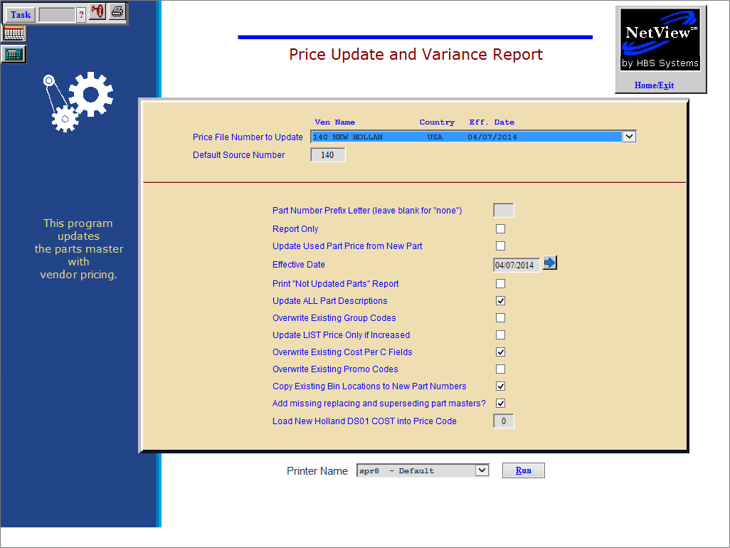

When all adjustments have been entered, you must run PUV to apply the changes to the existing part numbers.

