Merge Return Numbers (MRN)

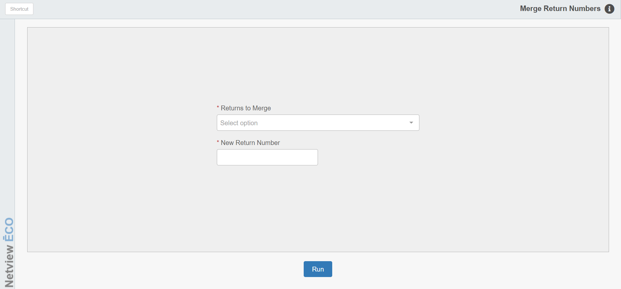

If you created two or more Returns for the same Vendor, you may use Merge Return Numbers (MRN) to create only one Return from the separate returns.

To access this function, you can either:

- Select “Inventory” from the menu. Choose the “Returns” submenu and click “Merge Return Numbers.”
- Type “MRN” in the Shortcuts Bar.

Field Definitions

Returns to Merge: Here you select up to five separate Return numbers for the same vendor. You can select an existing Return number from the drop-down menu or you can type one in.

New Return Number: Enter the new Return number for the merged files.

Run: Click this button to merge the returns into the new file.

