Mobile Unit Inventory Report (MUIR)

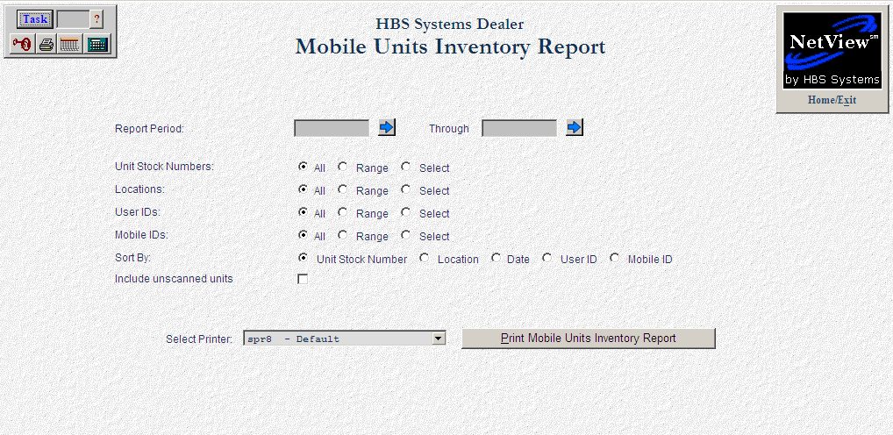

The Mobile Unit Inventory Report is only functional for dealers with the Mobile Inventory guns. The guns collect the information about the inventory that is scanned and presents that information via a report from the system.
Using the Gun For
Units Inventory

Tap the MOBILE UNITS button twice with the stylus.

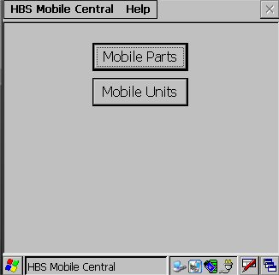

You may be asked to enter a password. Enter it and press the ok button. The inventory screen will open.

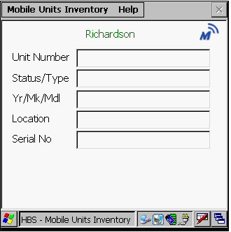

IMPORTANT: You must download the unit files before beginning your inventory so that the units can be recognized. Press “HBS Mobile Central” at the top of the screen. Select DOWNLOAD UNIT FILE from the drop-down menu. Wait for the file to download.

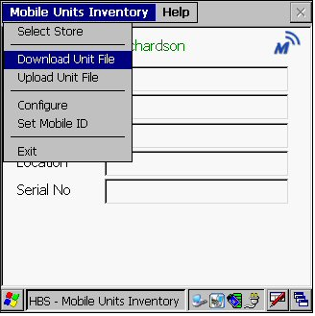

Point the inventory gun at the barcode and squeeze the handle. The information describing the unit will fill the fields allowing you to confirm the unit. When the scan has been successful, “Scan Recorded” will appear on your screen.

This is an example of a successful scan:

HBS Mobile Central Help
Unit Number
  40385
Status/Type
  New Loader
Yr/MK/Md
  2008 NH 110TL
Location
  CONSOLIDAT
Serial No.
  39847890

SCAN RECORDED
HBS Mobile Central

To scan another unit, use the stylus to drag across the current unit number and darken it. Scan the next unit.

Units Inventory
Reporting

Parts Inventory

When you have completed your inventory, you will need to upload the inventory file to the system.

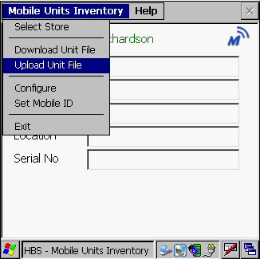

Run the Mobile Units Inventory Report for the unit inventory just completed.

- To access this report, you can either:
  - Select “Units” from the menu. Choose the “Reports” submenu and click “Mobile Units Inventory Report.”
  - Type “MUIR” in the Shortcuts Bar.

Field Definitions

Report Period: Define the dates for the period of time to be included in this report. Choose a starting and ending date, or use the arrow to the right to access a calendar.

Unit Stock Numbers: This selection lets you refine the details for the report. For the date range selected, you may choose:

All stock numbers

A range of stock numbers

Up to six individual units

Location: For the date range selected, you may choose:

All locations

A range of locations

Up to six specific locations

User Ids: For the date range selected, you may choose:

All user IDs

A range of user IDs

Up to six specific user IDs

Mobile Ids: For the date range selected, you may choose:

All mobile IDs

A range of mobile IDs

Up to six specific mobile IDs

Sort By: Choose the method of sorting for the report:

Stock number

Location

Date

User ID

Mobile ID

Include unscanned units: This report can include the details of units that were not scanned with the Inventory gun.

Click on this box to include them.

Leave it blank to exclude them.

Select Printer: Select the printer to receive the printout. A default printer name is pre-filled, but can be changed as necessary using the drop-down menu. Use the “see” printer to view the report on the screen without printing a copy of it.

Print Mobile Units Transaction Report (Alt P): Press this button to print the report.

Example of Mobile Units Inventory Report sorted by Stock Number

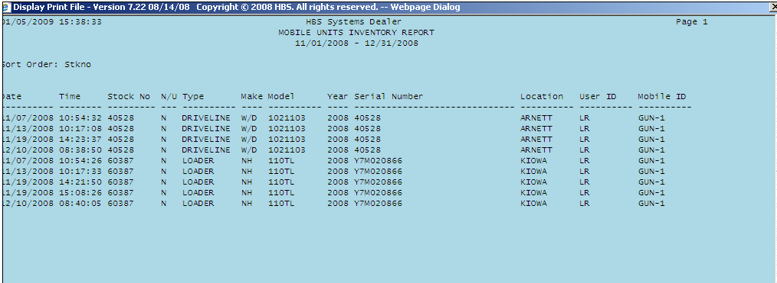

Example of Mobile Units Inventory Report showing unscanned units.

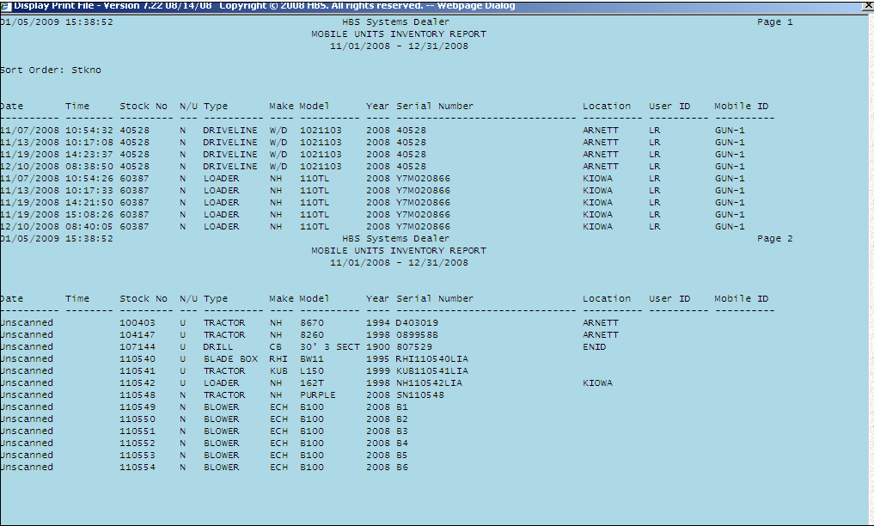

Report Fields

Sort Order: This is the sorting selection for the report.

Date: The date shown is when the inventory was taken.

Time: This shows the time of day the inventory was taken.

Stock No: This is the stock number that was counted.

N/U: The status of the unit shows here:

N=New

U=Used

R=Rental

O=Ordered

Type: This field identifies the type of equipment.

Make: This is the manufacturer of the unit.

Model: This field shows the model number of the piece of equipment.

Year: This is the model year of the unit.

Serial Number: This is the serial number for the unit.

Location: For multi-location stores, this field likely shows where the unit is located.

User ID: This is the logon of the person who took the inventory.

Mobile ID: This is the identification assigned to the Mobile Unit.

