Other Charges Maintenance (OCM)

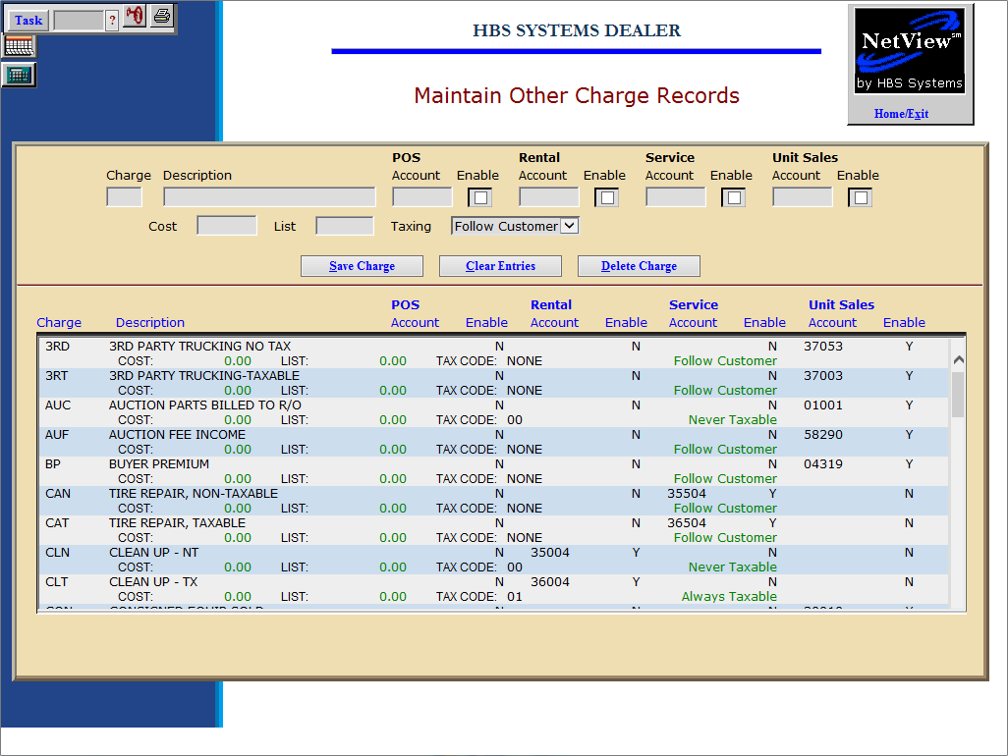

This maintenance screen is used to define additional charges for the invoicing screens:

- POS
- Rental
- US
- ROM

These additional charges are line items that can be added to the invoice. Examples: Sales Tax, Delivery Fees, Fuel, Set-Up, UCC Fees, Extended Warranty, Trade Pay Off, etc.

- To access this function, you can either:
  - Select “System Maintenance” from the menu. Choose the “Company File” submenu and click “Other Charges.”
  - Type “OCM” in the Shortcuts Bar.

Field Definitions

Charge: This is a three-character code for the other charge defined. It is used for record maintenance and does not appear on the invoice.

Description: This field holds the description of the other charge that will print on the invoice.

Account: This field holds the general ledger account that will receive the amount for this method of payment. Click on the “Enable” field to its right to activate it. Choose the appropriate General Ledger account for each invoicing program for this method of payment. The fields that are ACTIVE at this time are:

POS

Rental

Service

Unit Sales

Enable: Click on this field to the right of the General Ledger account to use it in the identified invoicing screen.

Cost: This field can hold the cost of the Other Charge. It should only be filled in if the cost is ALWAYS the same.

List: This field can hold the selling price of the Other Charge. If the price of this Other Charge is always the same, it could be entered here.

Taxing: This field can indicate the Other Charge’s taxable status. If the taxable status is always the same, it could be entered here. The options are:

- Always Taxable
- Never Taxable
- Follow Customer

Press the Save Charge button (Alt S) to save the record.

