On Demand Checks (ODC)

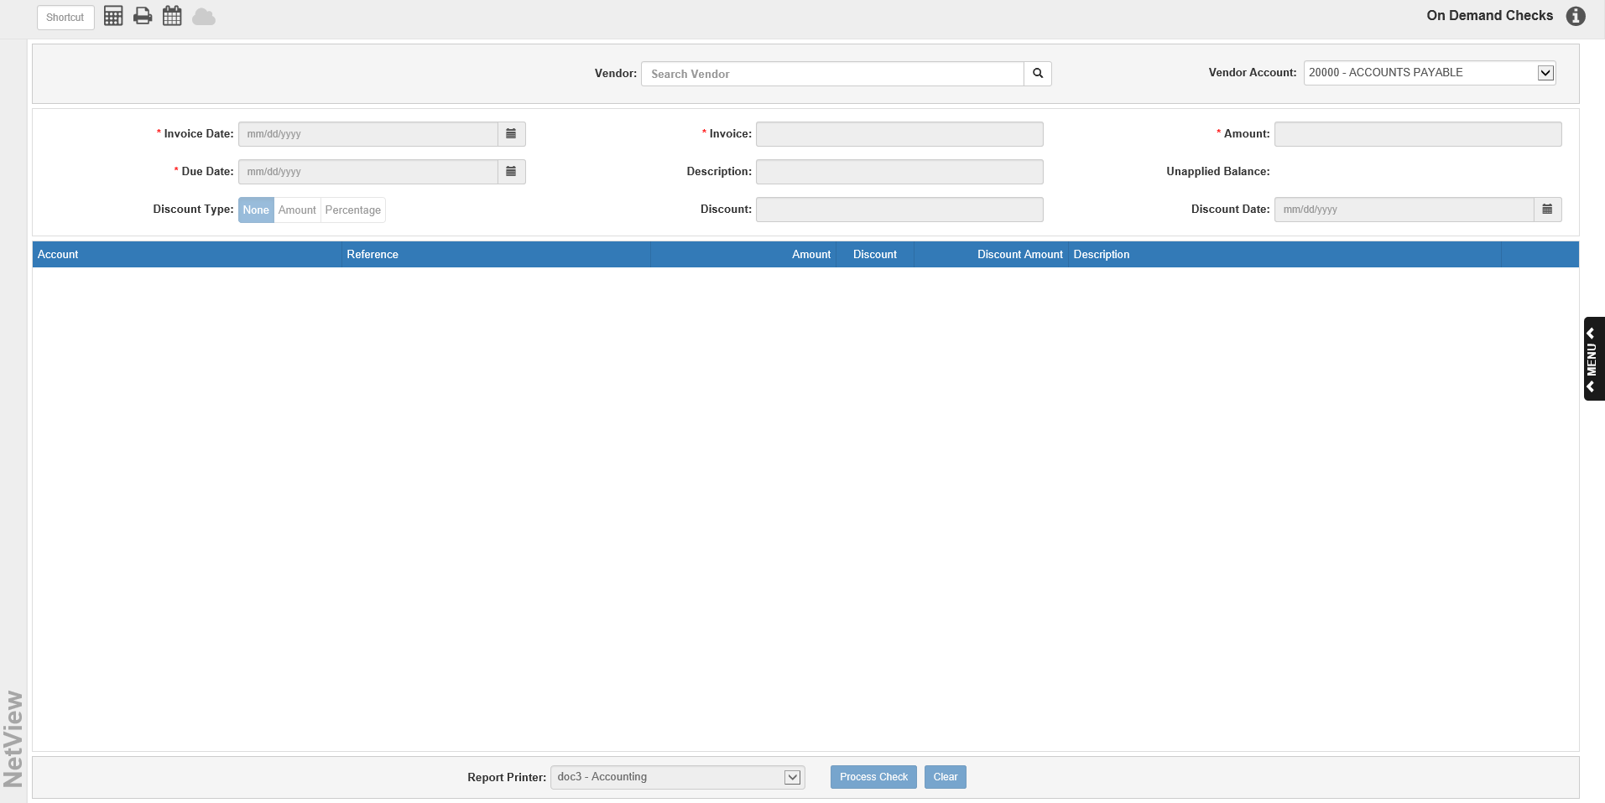

On Demand Checks (ODC) lets you print checks for invoices or statements that have not been entered into Accounts Payable. Using ODC you can, in a few moments, create a purchase invoice document, post the Purchase Journal, and print a check.

To access this function, you can either:

- Select “Accounts Payable” from the menu and choose the “Process Checks” submenu. Click on “On Demand Checks.”
- Type “ODC” in the Shortcuts Bar.

TIP—On Demand Checks: You cannot use On Demand Checks to pay invoices that are already entered into A/P. To pay these invoices, use Print Checks (PC) or Manual Checks (MC). You should use ODC only when paying invoices that HAVE NOT BEEN entered into A/P.

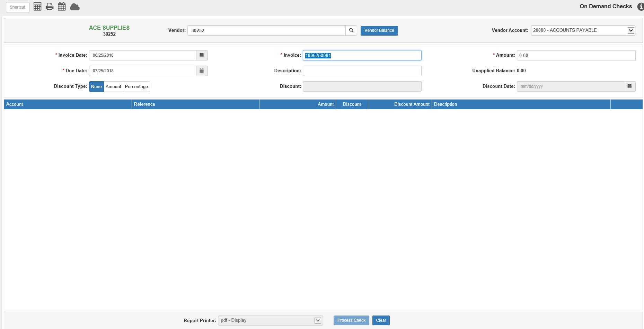

Header Descriptions:

Vendor: If the bill you are processing is for an existing vendor account, type that vendor number or do a Vendor Search. If the vendor is not set up in A/P, use the miscellaneous vendor number. Type MISC in this field to find the vendor number or type it in if you already know it. Once selected, the vendor’s name and number will display to the left of the field.

Vendor Balance: This button only appears after you have selected a vendor. It opens the vendor’s information in Vendor History (VH), so you can view the vendor’s current balance, year-to-date paid amount, and other related information.

Vendor Account: If you have the Multiple A/P Accounts feature turned on in Information Defaults (ID), you can use this field to select the specific A/P account you want to use on the invoice. The field will default to the account listed in the Vendor AP Account field on the vendor’s page in Vendor Information (VIM). If you do not have the feature turned on, the field will display the default A/P account (20000-ACCOUNTS PAYABLE).

Invoice Date: Enter the invoice date. This date determines the accounting period where the invoices will appear. The system pre-fills the current date but it can be changed as needed. NOTE: Remember that you cannot enter an invoice into a closed accounting month.

Invoice: A pre-filled invoice number is supplied based on the current date and a four-digit value but you may change it as needed (the value shown above is 180625001 which translates to YYMMDD invoice 0001). Invoice numbers must be unique in A/P History; you cannot create two invoices with the same number, vendor, and invoice date.

Amount: Enter the total amount of the invoice (the total includes discounts not received).

Due Date: Enter the due date for this invoice. A suggested due date will show but it can changed as necessary.

Description: This field can hold a description for the invoice header.

Unapplied Balance: This field displays the running invoice balance. Once you enter the invoice amount, this field will default to that value. As you specify the accounts where the invoice value is to go, this field will change.

Discount Type: This indicates what type of discount applies to the invoice. Click on:

- None
- Percent
- Amount

Discount Percentage/Amount: This field is active if Percent or Amount is chosen.

- If Percent is chosen, enter a percentage.
- If Amount is chosen, enter a dollar amount.

Discount Date: This field is active if Percent or Amount is chosen. Enter the discount date here or select it from the calendar.

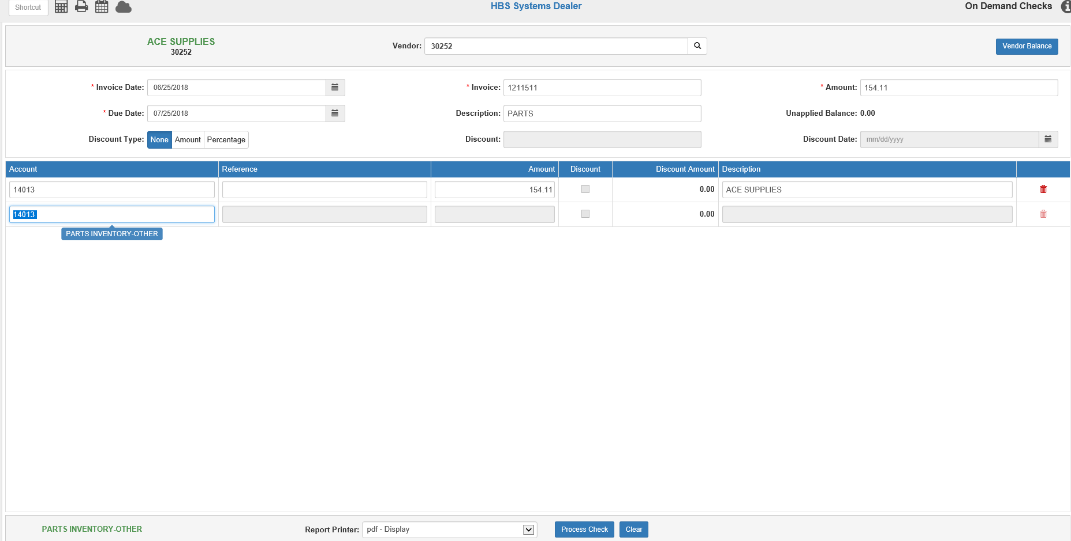

Invoice Details:

Account: This field holds the account where the invoice dollars are being sent. A default number may appear here if it is specified in VIM. NOTE: You may need multiple lines to cover all aspects of the invoice. For instance, if you are billed for parts and freight from ABC Company, your invoice entry has two lines: Parts Inventory and Cost of Freight/Freight Expense.

If you don’t have a default account set or want to use a different account, type in the desired account or search for it by partial account number or by description. You can click on a selection from the search results to use it.

Reference: This is an optional field and is not required, unless the account number for this line has a subledger or is related to a specific unit.

- For a subledgered account, enter the control number.
- For a Unit account, enter the stock number or look it up in Unit Search.

Amount: Type the amount for this line of the entry. The amount will default to the current Unapplied Balance amount but can be changed as needed.

Discount/Discount Amount: When a discount percentage applies to the invoice, use the Discount field to determine which lines are eligible for this discount. A check will appear on the line if the discount applies to it. The Discount Amount field will then show the calculated discount for the line. Remove the check if this line does not qualify for the discount. NOTE: If the discount in the header is a flat dollar amount, the Discount field on the line will not be active and the line discount will remain at “0.00,” as the amount will be applied to the entire invoice instead of individual lines.

Description: This field pre-fills with the Vendor Name but can be changed as needed.

Delete Line: Click the trash can icon on the right to delete the line.

Clear: Click the Clear button at any time during invoice creation to clear the current screen of all unsaved information. The following warning will appear:

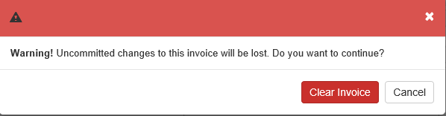

- Click Clear Invoice to clear the invoice and start over.
- Click Cancel to return to the main screen without clearing it.

Process Checks: Once you finish entering the invoice and are ready to create the check to pay it off, set the Report Printer to receive both your Enter A/P Invoices (EAPI) proof sheet and your A/P Purchase Journal (APPJ) printout. Click Process Checks to print both reports and open the Process Check window.

Sample EAPI Proof Sheet:

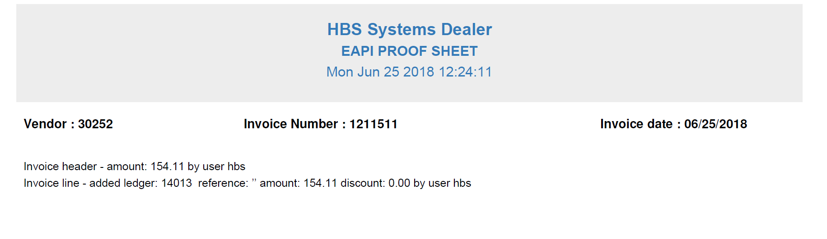

Sample Purchase Journal:

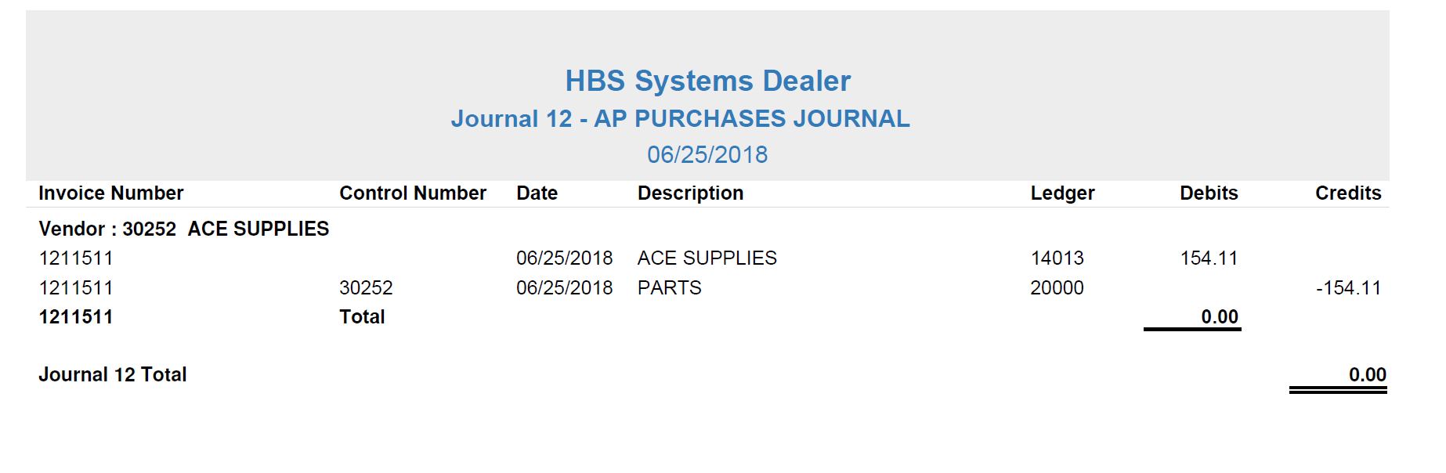

Check Creation:

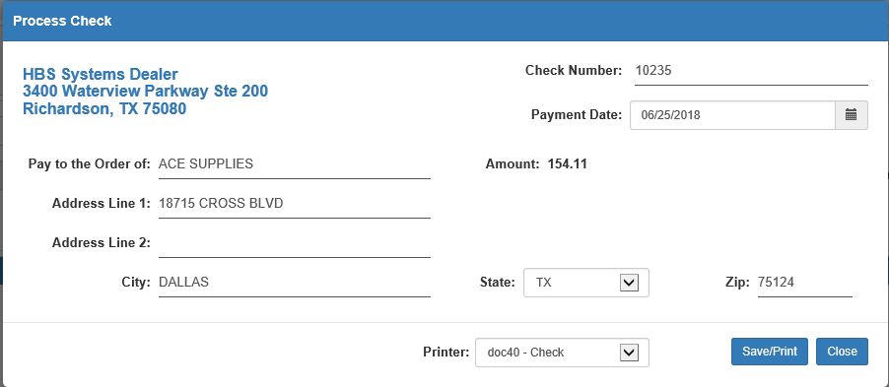

Use this window to fill in the required information to print your check. The dealership’s name and address will automatically appear on the upper left-hand corner.

Check Number: The next check number for the chosen bank account will appear, but you can change it if necessary.

Payment Date: The current date appears in this field, but it can be changed as needed.

Amount: The check amount automatically defaults to the full amount of the invoice.

Pay to the Order of: The vendor’s name and address as recorded in Vendor Information (VIM) will appear here. You can modify the payee's name and address as needed, especially if you used the Miscellaneous Vendor. Your entry in the Pay to field also becomes the Description field entry for the Journals, and all information entered in these fields will print on the check.

AP Bank Account: Use the drop-down menu to select the A/P bank account for the check payments if multiple bank accounts are in use. The default account is selected automatically but can be changed as needed.

When you are ready, click “Save/Print” to create the check.

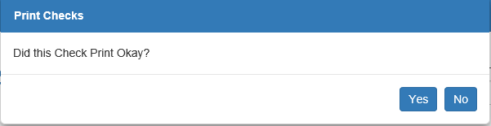

Did the check print OK: Examine the check that printed. Click Yes if it is correct or No to reprint it if there was a problem with the check.

- If you answer Yes, you will be redirected to the main ODC screen, with all fields cleared except the vendor, the invoice date, and a proposed invoice number, allowing you to start another new transaction if desired.
- If you answer No, you will be returned to the Process Check window, and the next check number for the account will automatically appear in the Check Number field. Make sure the check information is still correct, then click Save/Print again to reprint the check. You can return to this screen as many times as necessary to successfully reprint the check.

Note about checks with Alphanumeric Check Numbers: ODC will allow alphanumeric check numbers. However, you must keep the following in mind with these values:

- Check numbers will not be incremented in case voids occur in the case of stub lines printing on multiple pages.
- Checks will be forced to the standard template used for pre-printed laser checks as they are printed on either blank paper or as a PDF.
- The next bank check number will not be incremented.
- If you choose to Reprints the check, it will suggest a numeric check number once again. You can change the check number needed as before.

